A Trip Is Not a New Life
Camps, the Body, and the Earth You Do Not Abandon
Lothar J. Musiol

A Trip Is Not a New Life: Camps, the Body, and the Earth You Do Not Abandon
Copyright © 2026 Lothar J. Musiol. All rights reserved.
Look First, Volume 2.
Photograph credits for agency and Creative Commons stills appear in the Amazon product description for this edition, not under the figures.

Contents
How to Read This Book
Claims Guide
This Book Stands Alone
Author’s Note
PART I — Dirt, Delay, Dates
1. The Airlock Still Sticks
2. A Program Is Not a Poster
3. How Dates Slip
PART II — The Moon First
4. The Moon First, Because It Is Close
5. What Has Already Flown
6. The Next Crew Around the Moon
7. A Landable Year Is Not a Town
8. Gateway and the Architecture Fights
9. Other Flags, Other Ledgers
PART III — Vehicle, Not City
10. Starship as a Vehicle, Not a City
11. Mars Rhetoric vs Mars Engineering
12. Three Nouns: Sortie, Outpost, Settlement
PART IV — Who Stays
13. Who Stays
14. The Clocks of Recovery
15. Leaving Is Not a Cleanup
16. The Bill of Going
PART V — The Classroom on the Close Rock
17. A Suit Is a Spacecraft
18. Two Weeks of Night
19. The Ice Has to Pay for Itself
20. Dust Is Not Dirt
21. The Dose
22. Abort Is a Path
23. Nobody Owns the Crater
24. What a Program Costs
PART VI — The Long Ticket
25. Crews That Do Not Sleep
26. A Library of Earth
PART VII — Local Fixes, Not Fountains
27. Her Hands Still Age
28. Lifespan Is Not Healthspan
29. Many Clocks, Not One Fuse
30. Every Clock Has a Cousin
31. Local Fixes
32. The Reset That Isn’t
33. Not a Fountain
PART VIII — The Organ You Already Use
34. We Already Use the Organ
35. Cognitive Enhancement, Two Temperatures
36. The Carrot Has No Off-Switch
PART IX — Not a Straight Line
37. The Last Fifty Years Were Not a Straight Line
38. S-Curves and Invoices
39. Ten Thousand Years Is Not ×200
40. A Fast Trip Is Not a Long Life
41. A Long Sleep Is Not a Long Life
42. Coordination, Wars, Institutions
PART X — The Honest Body
43. Medicine’s Invoices
44. Adjusting Is Not Spare Capacity
45. Copies, Uploads, and the Continuity View I Defend
46. The Honest Body
APPENDIX
APPENDIX — The Scientific Detail
How to Read These Notes
A0 / A1. Delay, Dirt, and Why a Kitchen Is Not a Loaf
A2. What Counts as Flown Hardware
A3. Slip as Invoice: Historical Pattern
A4. Three Days, 1.3 Seconds, One-Sixth g
A5. Uncrewed Loops, Landers, Sample Returns
A6. Artemis-II-Class: Sortie, Not Town
A7. HLS / Starship-Class Long Poles
A8. NRHO, Stations, and Floor Plans
A9. Chang’e-Class, ILRS, Partner Camps
A10. Mass, Cadence, and the Unpaid Routine
A11. Windows, EDL, ISRU, Light-Time
A12. The Cut-Cable Test
A13. Headcount, Tickets, and Why “We” Is Rude
A14. Air, Ice, Plastics, Extinction
A15. Settlers vs CO₂; Collapse vs Cleanup
A16. Rockets, Metals, and the World with a Staff
Equations at a Glance
A17. Pressure, Heat, and Why a Glove Is a Workplace
A18. The Fortnight, the Polar Bargain, Three Ways to Hold the Night
A19. The Ratio, the Cold, and Why a Deposit Is Not a Well
A20. Charge, Sharpness, and Why a Lasting Print Is Not a Charm
A21. Drizzle versus Storm, and Why the Hat Is Mass
A22. Free Return, and Why a Later Abort Is a Burn
A23. Non-Appropriation, and the Resource Fight as Warm
A24. Program-Scale Money against a City and against the Furnaces
A25. Dose and Travel Time for a Crew That Does Not Sleep
A26. Genome Size, Synthesis, and the Protection Categories
APPENDIX — The Body Notes
How to Read the Body Notes
A27. A Local Dose Is Not a Species Change
A28. Life Expectancy, HALE, and the Supercentenarian Tail
A29. Hallmarks, the Dish Fence, and Why One Switch Is Not on the Counter
A30. Naked Mole Rats, Greenland Sharks, and the Limits of “No Aging”
A31. CRISPR-Class Edits: This Gene, This Tissue, This Invoice
A32. Four-Factor and Three-Factor Reprogramming: Papers, Dates, and the Teratoma Bill
A33. Cancer, Plumbing, Neurodegeneration: Many Doors
A34. The Ten-Percent Sentence, Lesions, and the Energy Bill
A35. Tools with Invoices: Sleep, Hearing, Stimulants, Implants
A36. Wanting, Liking, and Mismatch with More Calendar
A37. Vaccines, Packets, Sequence, Compute — and Named Walls
A38. Logistic Growth, Moore’s Bend, Sequencing’s Collapse
A39. Why 10,000 / 50 Is Arithmetic, Not a Method
A40. Proper Time, Time Dilation, and the Gravity of Clocks
A41. Torpor, Therapeutic Hypothermia, and What Slowing Metabolism Buys
A42. Meetings, Ledgers, Famines, Fronts
A43. Trials, Harm, and Who Pays for the Local Fix
A44. Plasticity Is Real and Expensive
A45. File and Worldline: The Continuity View
A46. Inventory of Claims, by Temperature
Equations at a Glance, Continued
Further Reading (tiered)
Glossary
Notes
List of Figures
Index of Key Concepts
About the Author
Also by Lothar J. Musiol

How to Read This Book
Every claim in these pages wears a temperature. The difference matters more than any date on a slide.
Hot — established. Measured, repeated, and used to predict new measurements. Light to the Moon takes about a second and a third. Light to Mars takes minutes. A Hohmann path between the two planets is a season, not a weekend. Most humans will stay on Earth for any leaving we can actually staff. Lifespan and healthspan are different pots. The sentence that we only use ten percent of the brain is false. A sickle-cell-class gene edit can correct a broken instruction in a lineage of cells that will keep the correction. The last half-century produced real, uneven gains: vaccines, a genome you can read, packets, cheaper compute.
Warm — working account, real gaps. A crew around the Moon this decade is a class of mission, not a month. A landing attempt in the 2030s is the honest noun for a cabin that still owes a demonstration of the ugly parts. Aging is many clocks, not one fuse. Modest further gains in healthy years this century, in rich-country medicine, if institutions hold. Progress that is more often an S-curve than a ray.
Cold — speculation sold as inventory. A city on the Moon or Mars this decade. Leaving as a cleanup. A body-wide rewind. A scheduled 150-year or thousand-year ape. A hidden ninety percent of mind. Last fifty years times two hundred as the furniture of the year 12,000. A required last mind at the end of time.
Contested — serious people disagree, and evidence alone has not settled it. Some questions are not waiting on a better instrument. They are waiting on an argument. What consciousness is, and whether a copy of a mind would be the same person, are contested. So are long-range economic scenarios — what a tonne to orbit will cost in 2050 — and social forecasts about who will want to live where, and under what law. On these, this book takes a side and says so. It gives the strongest rival view first. A contested tag is not a cold tag. Cold means the evidence is against a schedule. Contested means reasonable readers, holding the same evidence, still land in different places.
Helium, in this book, is shorthand for a hope held sincerely and sold too early: a scheduled immortality, a downtown by Friday, a spare mind. The people who hope for these things are often the reason the tools get built at all. A hearing aid is not helium. A vaccine is not helium. Those are tools, and tools have invoices. Helium is what a slide asks you to wait for instead of the tool.
A temperature can change. A stack that has flown is hotter than a rendering. A local gene fix that was a paper can become a clinic. A slipped date is not, by itself, a con, and it is not destiny. It is an invoice the slide did not want to show.
On one standing rule. String theory, if it is named in this book, cannot currently be tested. It will barely be named. Camps need dirt, delay, and dates. Bodies need clocks you can already count.
A few scenes are stories: a woman in a habitat on Mars, an airlock that sticks, basil under an LED, a radio that answers late, a meeting that tries to fuse three nouns. They are thought experiments with dirt on them. The numbers in them are real. The people are invented.
The main chapters keep the math in the sentence. Numbered relations live in the Appendix. Small raised numbers point to the Notes at the back, where each key factual claim has a source you can open; every note links back to the page you came from. A Claims Guide follows this section, and an Index of key ideas closes the book.
You do not need a physics degree or a medical degree. You need a willingness to let a downtown wait, and to let a miracle come apart into pots.

Claims Guide
One page, so you can see the book’s bets before you read its arguments. Temp is the temperature from How to Read. Note points to the source list at the back; a chapter number means the reasoning is worked there.
Claim | Temp | Evidence | Uncertainty | Where
Light takes about 1.3 s to the Moon and 3–22 min to Mars | Hot | Physics, measured | Negligible | Chapter 1
Open lunar surface dose is about 1.37 mSv a day | Hot | Surface dosimeter | Varies with the solar cycle | Note 16 Chapter 21
Four people flew around the Moon in April 2026 | Hot | Flown mission | None | Note 7 Chapter 6
A crewed Moon landing attempt around 2028 | Warm | Agency plan | Large; dates have slipped | Note 3 Chapter 7
A city on the Moon or Mars this decade | Cold | Renderings, stated goals | No loop closed | Chapter 12
No off-Earth camp yet closes any of the seven loops | Hot | Program records; Biosphere 2 | Low | Note 12 Chapter 12
Cost per tonne and who pays, mid-century | Contested | Economic scenarios | Very large | Chapter 24
Who will choose to live off Earth, under what law | Contested | Social forecasts; treaty text | Very large | Note 17 Chapter 23
Lifespan and healthspan are different measures | Hot | Demography | Low | Chapter 28
A sickle-cell gene edit works in the edited cells | Hot | Phase 3 trial | Long-term follow-up | Note 26 Chapter 31
Partial reprogramming will rejuvenate people | Warm in mice; untested in humans | Animal studies; first human safety trial | Very large | Note 30 Chapter 32
Anti-amyloid drugs slow decline by about a quarter to a third | Hot as measured | Randomized trials | Size of benefit to patients debated | Note 31 Chapter 33
A scheduled 150-year human life | Cold | Extrapolation | No intervention shown | Chapter 33
“We use ten percent of the brain” is false | Hot | Imaging, lesion studies | Low | Chapter 34
Treating hearing loss lowers dementia risk | Warm | Commission review of cohorts | Causation not proven | Note 33 Chapter 35
A moving or lower clock ticks less | Hot | Atomic-clock tests | Negligible | Note 37 Chapter 40
Induced human torpor for long flights | Warm to cold | Animal data; cooling trials | Large | Note 40 Chapter 41
What consciousness is | Contested | Philosophy; neuroscience | Open | Chapter 45
An uploaded copy would be you | Contested; the book argues no | Thought experiments | Open | Chapter 45

This Book Stands Alone
This is Volume 2 of Look First. It is a complete book. You are not being assigned homework.
It used to be two later kitchens: a trip that is not a settlement, and a longer life that is not a new body. They are one book now, because they are one invoice. You do not get a new world by boarding, and you do not get a new body by waiting. The Earth you already staff does not get cleaner because someone has a bold plan elsewhere. The hands on the airlock still age after a useful dose.
A longer book already retired a cosmic “now” and treated elsewhere as a permit: The Universe Has No Now. You do not need it. The permit here is simpler. A world you can weigh. A delay you can time. A date that will slip. A morning you would vote to repeat.
Two chapters in the middle — a crew that does not sleep, and a library of Earth — used to sit in that cosmology book, because they were the far ticket. They sit here now, after the near ticket has been priced. Ice oceans, leftover glow, and a second dictionary stay in the other book.
You can stop here. The airlock will still stick tomorrow. Her hands will still age.

Author’s Note
Most people meet leaving, and the future of the body, in the wrong order.
First comes a picture. Then a year. Then a city. Then a headline about a gene, a chart that goes up and to the right, and a sentence that says the other ninety percent of the mind is a tank. Earth is treated as a kitchen you can abandon. DNA is treated as a fountain. Time is treated as a fuse someone confident can name.
The people who make those pictures are not, mostly, fools or frauds. Many are engineers and doctors who know the invoices better than I do and have decided that a bold picture is how you get anyone to pay them. Sometimes they are right; a bold picture is part of how the Moon was reached the first time. This book argues with the order, not with the hope.
It runs a different sequence on purpose. It starts with dirt, delay, and dates, because those are what a program actually is. It keeps three nouns apart — sortie, outpost, settlement — because fusing them is how a flyby becomes a school district. It prices the Moon, the vehicle, Mars, the people who stay, and the classroom the renderings skip. Only then does it take up the far ticket: a crew that can wait, and a library you do not pour into a sea you have not tasted. The second half is the body on the same invoice. Lifespan is not healthspan. A gene fix is local. The organ is already in use. Ten thousand years is not a straight line. And on the question of whether a copy of you would be you, the book states the view it defends, gives the best rivals their due, and marks the whole question contested.
John D. Barrow’s short books are still the formal model: brief chapters, no swagger, a clean line between a measurement and an idea. Neighbors in this lane treated a camp as a bill, a biosphere as a clock, a gene as a local object, and a brain as an energy bill. They are used. They are not copied. Where a year will move, the year is written as a kind of clock. This kitchen is dated October 2026.
A book like this should succeed if a sequence of recognitions arrives and stays:
that a slipped date is an invoice, not a scandal;
that the Moon is first because it is close, not because it is a spare Earth;
that a landable year is not a town, and a large cheap stack is a vehicle;
that sortie, outpost, and settlement are three different nouns;
that most of us stay, and leaving is not a cleanup;
that flesh will not take a century cruise, and a library is not a flag;
that you look first and seed later;
that years on a wall clock are not years you would vote to repeat;
that a gene fix is this tissue, this invoice;
that the ten-percent sentence is false;
that the last fifty years were real and are not a method;
that a copy is, at the least, a second runner, and whether it is you is an argument, not a product;
and that the world which already has a staff, and the morning which is still worth logging, are the product.
That last recognition is not a counsel against going, and it is not a counsel of despair. Look first. Seed later. The basil still has to live. The joint, if you paid for the joint, is allowed to be the win.

PART I — Dirt, Delay, Dates

1. The Airlock Still Sticks
The airlock sticks on cold mornings. She hits it with the heel of her glove, the way you hit a jammed kitchen drawer, and it sighs. Inside, the greenhouse is the only room that smells like a lie: wet soil, torn basil, a sweetness that does not belong to this planet. The lie is maintained with LEDs the color of an overcast noon and a tray of water she melted, yesterday, from a vein of ice the color of dirty chalk.
Outside, the sky is butterscotch and thin. A radio sits on the workbench. When she talks to the orbiter, she talks to twenty minutes ago, or four, depending on the week. The orbiter talks to Earth, which talks back in more minutes. There is no conversation. There is a stack of monologues that eventually, if everyone lives, amount to a plan.
On the delay this morning, Houston — or a contractor who has borrowed Houston’s tone — is still selling a year as if a year were a landing gear. The year has already slipped once. She can hear the slide in the voice: the old date, the new date, the sentence that treats the difference as weather. She does not vote. She names the basil, which is sentimental, and logs the pH, which is not. On a dead world, sentiment is allowed as long as it does not get to vote.
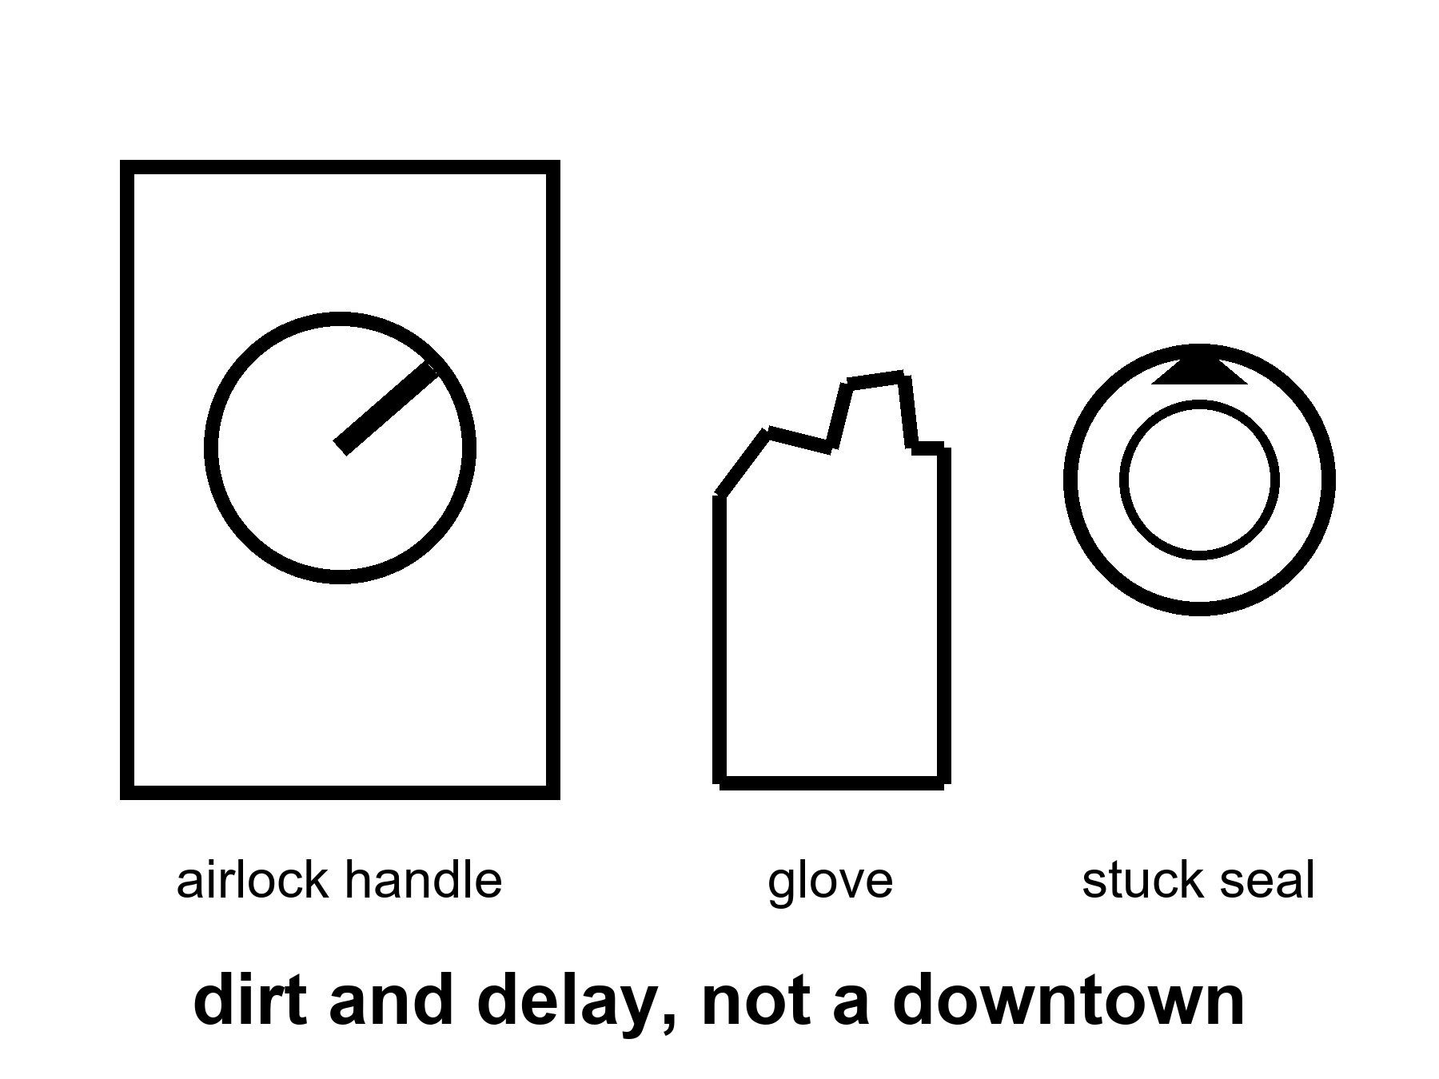
Figure 1. An airlock handle in hard daylight, a glove, a stuck seal. Dirt and delay, not a downtown.
This is the only honest picture of somewhere else this book will allow in the near term. The world is Mars. A dead world, close enough that light-minutes, not light-years, set the lag. A body you can weigh. An ice vein you can steal. Machines that do not sleep parked in the driveway. A human worldline that has to eat. A date on a slide that will move.
She is not waiting for a miracle. She is waiting for a launch window. The next cheap path home — the one that lets a ship fall most of the way instead of burning a fortune — opens in twenty-six months, give or take the mood of the two orbits. Until then the potatoes either make starch or they do not. The universe does not have an opinion. The dirt has a chemistry, and the chemistry can be bullied.
Three words are on the cover of this part, and each is a measurement before it is a mood.
Dirt is what the ground actually is. Not soil. A mineral flour with a tax in it: perchlorate salts at something like half a percent to one percent by mass in the finest grains, an oxidizer — a chemical that gives up oxygen easily — that is rude to a gut and useful to a chemist who needs oxygen in a pinch. Iron oxide for the color. Ice, where there is ice, as a vein or a frost or a bright rumor in a radar return, not as a pond. A root can be argued into it with water, a buffer, and weeks. A town cannot.
Delay is a number you can time with a wristwatch and a patient friend. Light to the Moon: a second and a third. Light to Mars: between about three minutes and about twenty-two, one way, depending on where the two orbits have put the planets this month. The number drifts through the year the way a tide drifts through a day. On the kind side of the cycle she can almost pretend the orbiter is a slow colleague. On the rude side she is writing letters.
Dates are the only one of the three that a human can move. A slide can print a year. A legislature can fund it or not. A review board can find a crack. The window cannot be moved by any of them. It is a fact about two ellipses, and it repeats about every twenty-six months whether the slide is ready or not.
A synodic period is the time for two planets to return to the same lineup — for Earth and Mars, about 780 days.
Her day is not an Earth day either. A sol here runs about twenty-four hours and forty minutes. The extra forty minutes sound like a gift. Over a month they are a slow drift that unhooks her body from the clocks on the radio. The orbiter keeps one time. Earth keeps another. The dirt keeps the sol. She keeps the sol, because the dirt is the party that can kill her.
This book is dirt, delay, and dates. It is not a loaf.
If you have Volume 1 of this series, you have already spent a long kitchen on a clock that pretended the universe shared a now. You do not need those pages. One courtesy, then we put the loaf down: elsewhere, in that book, was a permit — a band of starlight, a squeeze under ice, a chemistry that might copy — not a downtown as a product. This book is the permit after someone has printed a ticket. The ticket is real. The downtown is not on it.
If you have never met that book, you have not missed a homework assignment. You need three temperatures, a woman who logs pH, and a habit of not fusing three nouns. How to Read This Book already has the temperatures. You have the habit by the end of Part I.
She is an invented person. The numbers around her are not invented.
A radio lag of four minutes, or twenty, is a fact about two orbits and the speed of light. It is not a metaphor for loneliness, though loneliness will use it. A pH log is a fact about a nutrient film and a plant that will die if the film goes wrong. A launch window of roughly twenty-six months is a fact about Earth and Mars lining up so a ship can fall most of the way. Appendix A1 writes the light-times and the window. Here, keep the stuck drawer.
Call her Mara if you need a name on a form. She will not use it much. The orbiter’s voice calls her by a shift number. The slide on Earth, if it mentions her at all, calls her a “surface asset,” which is a way to say a person without paying the person the courtesy of a Tuesday. She has a colleague on the other side of the tin, Rohan, who is better at the pumps and worse at the basil. She has a sister, Priya, who runs a clinic on a genuine coast and still thinks “we” includes a ticket. Priya will not get a ticket. Almost no one will. What Priya wants is smaller than a species-move: a fridge that holds its temperature, a surgeon who shows up for the operation already on her board, and a Tuesday in which her own hands can still open a jar. She has written Mara about the date. The answer has not come back.
Eli’s letter, when it comes, is only a time. The casserole came out at half past seven, his clock. She writes the time beside the pH and does not answer it with a childhood.
That is the first rude fact this book is here to keep in the room. A camp on a dead world is a staffing choice for a few thousand worldlines, maybe tens of thousands if the boldest plans have a lucky decade. It is not a migration. It is a field trip that forgot to end. Chapter 13 is that sentence with the lights on. Chapter 1 is the picture you need before anyone is allowed to say we left.
Look first.
That rule, in The Universe Has No Now, meant do not plague a dark sea because you were lonely for a cousin. Here it means two ruder things at once. Do not call a flag a biosphere. Do not treat the kitchen you already staff as a write-off because a dead world has been named a spare. Seed later is a rule for a sea that has never seen the Sun. It is also a rule for a biosphere you have not finished killing.
She hits the airlock again on the way out to the ice. The seal has a personality. Hardware that has a personality is hardware you can live with, if you stay honest about what it is. A seal is not a city. A greenhouse is not a school district. A slipped date on the radio is not a landing gear.
A word about mass, so the later chapters do not have to invent it.
Throwing a kilogram to low Earth orbit is a sport with a price that has come down in the lucky decades and is still not a bus ticket. Throwing that kilogram to the Moon is a ruder sport. Throwing it to Mars, and slowing it so it does not become a crater, is ruder still. The woman in the tin is a hundred kilograms of wet meaning plus a house that weighs tonnes. The house is the unpaid character in every downtown still. Renderings draw faces. Programs are houses. Houses are mass, power, leaks, and a toilet that must work when the radio is twenty minutes late.
She has a spare pump on a shelf that came up on a cargo that cost more than her sister’s street will see in a year of municipal budgets. That sentence is not a reason to cancel the pump. It is a reason not to call the pump a species-move. The pump is a sortie tool. The street is the staff.
The price of a kilogram is worth one paragraph of real numbers, because the rest of the book leans on it.
Getting a kilogram to low Earth orbit cost on the order of tens of thousands of dollars in the era of the Shuttle. A modern commercial stack has pushed the advertised figure toward a few thousand dollars per kilogram, and the lucky decades may push it lower. That is real progress, and it is still not a bus ticket. Landing a kilogram on the Moon under the current commercial delivery contracts has run on the order of a million dollars per kilogram of payload, once you divide the contract by what actually rode. Putting a kilogram softly on Mars costs more, because the thin air has to be argued with and the slowing has to be bought with mass you carried all the way. So a spare pump is a serious sentence. A greenhouse kit is a very serious sentence. A school is a sentence no ledger has yet finished writing.
Rohan keeps a list on the wall of the tin, in marker, under the heading things that would have to be true. It is not a manifesto. It is a shopping list for the middle noun, the outpost, and he keeps it honest by refusing to write the third noun on it at all. Power through a dust week. Water that is not a heater and a prayer. A second airlock that does not stick. A doctor, or a machine that is a doctor on the kind days. Spares for the spares. A calendar of cargo that a planner would bet on. Every line is mass. Every line is a launch window.
Mara adds one line at the bottom, in smaller letters, and then rubs half of it out. It said basil that does not need me. She left the first word.
What the delay does to a Tuesday.
A twenty-minute lag is not a mood. It is a schedule. She does not ask questions the way her sister asks them, one at a time, waiting for the face across the table to answer. She batches. Every question that can wait is written into a packet, the packet goes up to the orbiter on the morning pass, the orbiter throws it at Earth, and the answers come back — if they come back — after lunch, in a bundle, addressed to problems that have already changed shape. A pump that was making a noise at breakfast is either fixed or dead by the time Earth suggests a bearing. The suggestion is filed. It will be useful the next time a pump makes that noise. That is what advice is on a dead world: a library that arrives late.
Medicine is the rude edition of the same schedule. A person who is bleeding does not have forty minutes. The protocol on the wall — a real protocol, written by people who knew the radio would be late — assumes the two of them are the hospital. Earth is a textbook with a delay. Rohan can set a bone from a video he watched on a Tuesday that Earth sent on a Monday. He cannot ask a surgeon to look at the bone while he sets it. The surgeon will see the bone twenty minutes after the bone has been set. That is not a design flaw. That is two orbits and the speed of light, and no amount of money has ever changed it.
The orbiter, for its part, is the honest staff. A machine that does not sleep, parked overhead, relaying, photographing, running its own small errands. It has been there longer than she has and will be there after she leaves. It does not need a childhood. It does not need a school district. The longer book already noticed that crews which do not sleep can wait. This book adds the smaller point: they can also carry the mail.
The ice matters here because the basil keeps coming up.
The vein is not a lake. It is dirty ice mixed with a dust that has its own chemistry, and the chemistry is not friendly. The soil on the neighbor world carries perchlorate salts — a fraction of a percent by mass, enough to be a poison and enough, in a lucky mood, to be an oxygen source if you own the right chemistry set. She does not own the chemistry set. She owns a scraper, a heater, a filter, and a notebook. The ice is chipped, hauled, melted, and washed. The wash water is the expensive part. Every liter she spends cleaning a liter is a liter she cannot drink. The ledger is written in the same notebook as the pH, because on a dead world water is not a utility. It is a shift.
The pH itself is a small number with a large temper. The tray is a nutrient film, a thin stream over roots, and the roots want a slightly sour water — a little under six on the scale a school chemistry class teaches — or they stop taking up what they need and the leaves tell you a week later. A week later is too late. So she logs the number every morning, the way a night nurse logs a pulse. It is the least glamorous sentence in the book. It is also the only sentence in the book that keeps a plant alive.
None of this is a downtown. It is the size a program actually is when a person is inside it: a scraper, a filter, a sour number, a radio that answers late.
A word about the date on the cover, because it will be wrong.
This kitchen is written in October 2026. Some of the years quoted in the next chapters will have moved by the time the page is read. A crew may have flown. A lander may have tipped, or stood, or not been built. A company may have named a new year, having quietly retired the old one. This is not a flaw the book can fix by being careful. It is what a program is. So the book does a different thing on purpose. It writes kinds of clocks — a light-time, a transfer season, a launch window, a class of mission — and it treats the official year as a weather report. A weather report is useful. It is local. It is wrong tomorrow.
If a year in these pages has already slipped when you read it, you have not caught the book out. You have caught the pattern. Chapter 3 bills that pattern as an invoice. If a year has already arrived — a crew has looped, a boot has touched dust — you own a flown class of mission, hotter than the page. You still do not own a town. That sentence does not date.
Power: nothing else in the tin works without it.
The panels outside are not the rectangle of gold foil a rendering shows. They are a field, tilted to chase a sun that moves slowly and sets for weeks at a stretch if the site is wrong, and every watt they make has already been spent twice before it reaches the pump: once on the batteries that have to carry the tin through a shadow, once on the losses no wire is honest about. Mara’s morning ritual, before the pH, before the airlock, is a glance at a number on a panel that tells her what the night cost. Some mornings the number is a shrug. Some mornings it is a decision: the heater on the water line can wait, the grow lights cannot, and a length of pipe two meters long becomes the day’s small emergency.
A reactor would change this arithmetic, and reactors are not a rumor — small ones, sized for a camp rather than a city, have been designed, ground-tested in pieces, and argued over in budget rooms for longer than this book has existed. None has flown to do the job this book is describing. Until one does, the sun is the furnace, and the sun on a dead world is a furnace with opinions: it sets, it dims through a dust season, it does not negotiate. A camp’s whole day is downstream of that one number. So is a marriage of two invented systems Mara has learned to think of as her actual family: the drawer that sticks and the panel that answers.
The instruments nobody photographs.
A pressure gauge on the wall reads a number that would end her afternoon if it dropped fast. A CO₂ sensor reads a second number that would end it slower, more quietly, the kind of ending where you get sleepy before you get worried. A third gauge, for the water reserve, is the one she actually watches, because water is the currency every other system spends and none of them earn back in full. None of these instruments are dramatic. All three are why the tin has not killed her yet, and all three are why “look first” is not a slogan in this kitchen. It is a rota of glances, repeated until it is boring, because boring is what safety looks like when it is working.
She thinks, some mornings, about the people who will read a chapter like this one and imagine the drama of a leak, a fire, a decompression — the emergencies a film would show, if this book allowed films. The real emergency, most weeks, is smaller and slower: a filter that is seventy percent clogged and will not announce itself until it is ninety, a seal that has lost a millimeter of give and will not announce itself until it is gone. Catastrophe is a film’s problem. Degradation is a kitchen’s problem, and degradation is what the whole book has actually been describing since the first page.
The log matters because a kitchen’s honesty lives in its paperwork.
Mara’s actual morning log, if you could read it over her shoulder, is a table with four columns and no poetry in it: time, reading, instrument, action. 06:04, pH 5.4, tray sensor, added buffer. 06:11, O₂ tank 61%, cabin gauge, no action, note tomorrow. 06:19, seal torque, airlock, sighed but held, log for maintenance week. It is the least romantic document in this book, and it is also the only document in this book that has never once been wrong about whether she would live through the day, because it does not editorialize. A slide editorializes; that is its job. A log cannot afford to, because a log that lies to itself is a log that kills the person keeping it.
This is worth dwelling on because the whole argument of the book compresses into the difference between a log and a slide. A slide is written to be shown to someone else, and writing for an audience changes what gets included. A log is written to be read by the same person who wrote it, tomorrow, when the writer has forgotten today’s mood and needs today’s numbers. Programs that survive contact with reality are, without exception, programs with a real log somewhere underneath the slide — a change-control record, a test database, an anomaly tracker — that the slide is required, by policy or by conscience, to actually match. Programs that fail tend to be programs where the log quietly stopped being consulted, months before the failure, by people who had learned that the log’s answer was not the one the slide wanted.
The crop, at last, named. “Basil under an LED” has earned a real botany.
Basil is a forgiving plant, which is precisely why an early camp grows it rather than something more useful: fast germination, a wide tolerance for the nutrient swings a first-generation hydroponic loop cannot yet control, and a root system that punishes a bad pH slowly enough to give a person a day or two to notice and correct rather than losing the crop overnight. Lettuce, the other early favorite in real orbital and analog greenhouse trials, shares the same forgiving profile. Neither crop feeds a person in any meaningful caloric sense — a full tray of either is a garnish, not a meal: calories will turn out to be the row that stays empty longest. What basil actually grows is not calories. It is competence: a crew’s working knowledge of their own loop’s failure modes, purchased cheaply, in a crop nobody will starve without.
The LEDs themselves are tuned, in real hardware flown to the station over Earth and tested in ground analogs alike, toward the red and blue wavelengths chlorophyll actually uses, skipping the green light a human eye needs to see color but a plant mostly reflects rather than absorbs — which is why a genuine growth chamber often looks, to a visitor, like an unsettling magenta box rather than the warm gold a rendering prefers. A rendering draws the color that sells a feeling. A grow light is tuned to the color that grows a leaf.
The kitchen has a name. It is Mars.
A butterscotch sky, a pressure you cannot breathe, a sol of about twenty-four hours and forty minutes, a cheap path home about every twenty-six months, perchlorate in the fines, a one-way radio between about three minutes and about twenty-two: those are Mars measurements. This book will not peel the label off to sound more general. Sites and official years will move. The class will not. One-sixth of Earth’s gravity is the Moon, and the Moon is named when this book is on the Moon. This camp does not borrow that number. Mara is invented. Mars is not.
The drill, timed. A sticking airlock is not the emergency described so far.
The actual emergency drill Mara runs, monthly, whether or not the seal has behaved that week, is a suited egress from a cold start: alarm to airlock, fully suited, checked, and cycling, inside a target window measured in single minutes, because the scenarios that drill is built for — a fire, a rapid pressure loss, a toxic leak from a scrubber gone wrong — do not wait for a comfortable pace. The first several times she ran it, in training, on Earth, in a mockup with an instructor holding a stopwatch and a clipboard, she missed the window by enough that the instructor made her run it again immediately, sweating, before her heart rate had recovered from the first attempt. That is not cruelty. It is the same principle Chapter 6’s checklist rehearsal already described: a body under real alarm behaves differently than a body reading a manual, and the only way to know the genuine number is to make the body do it, badly, until it does it well.
The published timeline for a station-class suit is not a hero’s minute. Suit donning and the leak check, in NASA’s EVA operations account, run on the order of an hour. Airlock egress, once the suit is already on, is about fifteen minutes. Pre-breathe is a separate clock and often longer. Appendix A17 keeps the hour. Mara’s single-minute target is what a fire wants. The suit we have actually flown does not grant it.
Appendix A1 writes delay, dirt, and why this kitchen is not a loaf. Here, keep the heel of the glove. The rest of the book is the argument that this is not small-mindedness. It is the only size a program has ever reliably sold.

2. A Program Is Not a Poster
A funded program and a pretty picture are different objects. That is the first temperature.
Hot: people and firms are spending real money to put crews around the Moon, to land on it, to throw a heavy stack that might, if it learns manners, throw more mass than the old horses. Uncrewed landers have already kissed dust in this century. Sample capsules have already come home. China has picked up far-side rock and talked, with partners, about a camp they name like a station. The American ledger has a name too, and a habit of printing a date that later needs a new page. The hardware is not a rumor. The downtown is.
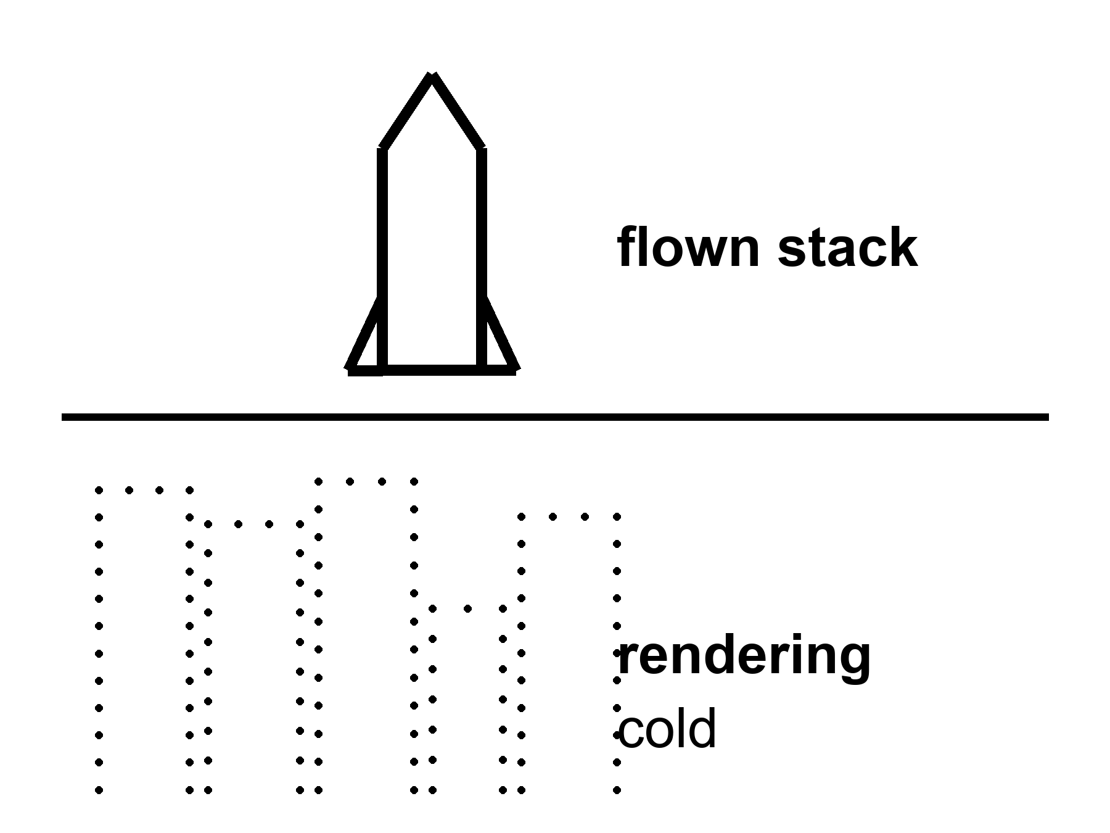
Figure 2. Two stacked panels: a flown stack on a pad in daylight; a skyline rendering. The first is inventory. The second is a wish.
A poster is a rendering of a downtown that has not yet hired a plumber. Glass, flags, a child who will never need a cargo ship, a dome that has already solved dust, radiation, law, and boredom. Posters are allowed. They are how a legislature is asked for money and how a company is asked for a valuation. They are not inventory. Treating them as inventory is how a flyby becomes a school district in a single slide.
Be fair to the people who draw them first. The strongest case for the poster is not vanity. Nothing gets built without a picture someone will fund. A bold public goal pulled real hardware forward in the 1960s, and in this century it pulled reusable boosters from a joke to a routine landing. People who refuse to picture anything until it is proven tend to wait forever. And many of the people drawing domes are sincerely trying to buy the species a second chance. All of that is fair, and some of it is true. This book keeps one narrow objection: a picture asks for the money. It does not show that the work is done. You can admire the asking and still refuse to count it as a part.
A program is uglier and better. It is a stack that has a serial number. It is a heat shield with a scorch from a test that did not kill anyone, or did. It is a suit whose gloves still fight you. It is a budget line that can be raided when a different emergency is louder. It is a weld, a software load, a supplier who missed a month, a review board that found a crack and did not pretend the crack was a vibe.
Reviews run for a living. The room is not invented. Fluorescent light, a table that has heard too many dates, a wall with a patch that used to be last year’s milestone and is now this year’s “replan.” The rule that does not get written on the slides: if it has not flown, it is a story with a purchase order. If it has flown once, it is a dare. If it has flown until the news stopped covering it, it is beginning to be a truck.
Most of what the public is shown is still a story with a purchase order.
A rendering has a tell, once you know where to look. It is always clean. Dust has never found the seals. The regolith — the technical word for the dirt this book keeps using — is a tidy floor. The light is a photographer’s late afternoon, not the flat hard glare of a world without air to soften it. There are no cables. Real hardware is mostly cables and the places cables chafe. There are no tanks, because tanks are ugly and a settlement rendering does not want to explain why the tanks are larger than the town. There is no dosimeter on the wall, because the dosimeter is the whole argument against the glass.
A flown stack has the opposite tell. It is scorched. It has a serial number and a scar. Someone has written on it with a marker. There is a photograph of it on a pad at dawn that nobody chose for beauty, taken by a person who needed to check a cable.
The review keeps a rule for the room that photographs badly: the stack goes on the left, the rendering goes on the right, and the review starts on the left. If the meeting begins on the right, it will end on the right, and the year will be a mood by lunch.
What counts as flown?
A Saturn-class stack that put people on the Moon and brought them home is flown. That is last century, and it is still the only time flesh walked on another world and returned. It was a sortie. It was not a town. The last person to leave that dust left in 1972. The pictures did not stop. The shifts did.
An uncrewed loop around the Moon that comes home without a crew is flown if the stack, the heat shield, and the entry were the ones you said you would use. Artemis I, in late 2022, was that kind of morning: a cabin without people, a long cold loop, a splashdown that let a lot of engineers sleep. Hot as a class. Not a town. Not even a sortie. A dress rehearsal that cost what dress rehearsals cost.
A lander that kisses dust and phones home is flown. Some of this century’s kisses have been tidy. Some have been a tip-over, a lost solar panel, a hard landing that still counts as “arrived” if you are generous and “failed” if you are the person who needed the payload. Chang’e-class sample returns — near side, then far side — brought rock to a desert in China and put it in a box you can weigh. That is flown. Chandrayaan-3 put a lander and a rover on the southern near side and drove. That is flown. Commercial landers have begun to try the same dirt with mixed manners. Mixed manners are data. They are not a downtown.
A heavy stack that has lit, flown, and come back in some pieces, some of the time, is flown as a vehicle in progress. It is not flown as a city. Chapter 10 is that distinction with the tanks on the table. Here, notice that a successful hop, or a noisy orbital test, or a catch that makes a clip, is still a vehicle fact. A vehicle fact is allowed to be exciting. It is not allowed to launder a school district.
Gateway was drawn as a station in an odd lunar orbit. Its modules were real metal in clean rooms. In March 2026 the agency paused it in that form and pointed the money at the surface instead (Chapter 8). A module in a clean room is hotter than a rendering, even when the program around it changes shape. A downtown is still cold.
A short ladder, so the word flown has rungs.
Rung one: a drawing. Anyone can draw. Rung two: a contract, which means a drawing that someone has agreed to be embarrassed by. Rung three: hardware in a clean room, which is a drawing that now has mass and can be dropped. Rung four: a test article that has been fired, frozen, shaken, or blown up on purpose. Rung five: a flight that did the job once. Rung six: a flight that did the job so many times that the news stopped coming. Rung seven: a roster. People who rotate through the thing on a schedule and complain about the food.
Apollo climbed to rung five and was cancelled before rung six. The International Space Station sits at rung seven and has for a quarter of a century. Most of the lunar hardware in this kitchen sits between rung two and rung five, depending on which piece you point at. A downtown sits at rung one and is drawn as if it were on rung seven. The ladder is not a sneer. It is a way to read a press release without being sold a floor you cannot stand on.
Where does the money sit on the ladder? Mostly at rungs two through four, because that is where money turns into embarrassment. That is also where the years slip, because rungs three and four are the ones that find the cracks. A budget line is hot as a fact about spending. It says nothing about which rung the spending has reached.
The laundering has a few favorite costumes.
The artist’s cut. A glass dome, a flag, a child. The caption says 2035 the way a restaurant says seasonal. Seasonal means the chef has not decided. 2035, on a poster, often means the same.
The year-as-landing-gear. A leader names a year. Sometimes that is a deliberate forcing function — a deadline that makes a team move faster than comfort would — and it has worked before. The costume starts when the year is treated as a demonstration, as if saying it tightened a bolt. Years do not tighten bolts.
The flag-as-shift. Someone has been there; therefore someone lives there. Apollo is the permanent victim of this costume. Twelve men walked. They left. The walk was a masterpiece of a certain kind of engineering. It was not a lease.
The stack-as-city. A ship is large. A large ship looks like a building. A building looks like a town. The eye does the fusion. The eye is wrong. A ship is a vehicle. A vehicle that is also a house for six months is still a vehicle. Chapter 12 will give you three nouns and refuse to let them marry.
The review meeting has a fourth costume, quieter and ruder: the budget-as-destiny. Money is being spent; therefore the downtown is selected. Money is a temperature, not a destination. Money has been spent on flying cars, on a permanent Moon base in every decade since the 1960s, on a Mars mission “in this decade” so many times the phrase has a patina. Spending is hot. Arrival is a different measurement.
There is a fifth, and it wears a lab coat: the study-as-schedule. A well-drawn architecture study, with mass budgets, a Δv table — a ledger of how much speed the mission must buy at each step, and what that speed costs in fuel — and a launch manifest, looks like a plan. It is a plan the way a recipe is a dinner. Agencies have produced beautiful studies for a crewed Mars program in most decades since the 1960s. They were honest studies. Several were excellent. None of them was a dinner, because the ingredients — a heavy lander, a routine tanker, a surface power plant, a crew that had survived a year of deep-space dose — were not in the kitchen. A study tells you what it would take. It does not tell you that the taking has started.
Hardware that has flown is the only costume-proof thing in the room. Everything else is a temperature you have to keep checking.
She hears the rendering on the delay. Someone has sent a still of a dome that does not exist, over a horizon she can see by walking to the inner pane. The horizon is dust and a pump that needs a bearing. The dome is a kindness the slide is doing to itself. The basil does not care which logo paid for the LED.
A program can be proud of what it has actually flown and still be allowed to want more. This book is not a counsel against wanting. It is a counsel against mislabeled inventory. If you remember one sentence from this chapter, make it the title. The rest of the book is what happens when the picture is billed as if it were the part.
A ledger you can keep on an index card.
You do not need to be an engineer to read a program page. You need five words and the habit of asking which one applies.
Rendering. A picture. Cold, whatever the year in the corner says.
Contract. A promise with a purchase order. Warmer than a picture, because someone has agreed to be embarrassed. Still not a part.
Article. A thing you can touch: a test tank, a structural mock-up, a pressure vessel in a clean room, a suit on a mannequin. Warm. Articles fail. That is their job.
Test. An article asked to do the job, or a piece of the job, in public or in a record you can request. A static fire. A wet dress rehearsal, where a stack is filled with propellant and counted down to the last seconds and not lit. A drop test. A pour of cold propellant from one tank to another. Tests are the oven being opened. A test that fails is hotter than a rendering that succeeds.
Flight. The job, done, with a serial number and a result. Flown once is a dare. Flown until the news stops covering it is a truck.
Every slide you will ever be shown is a mix of these five, and the sales art of a slide is to put a flight-shaped feeling on a rendering-shaped object. The review lead’s trick is to ask, for every object on the page, which card. The room does not enjoy this. The room is not supposed to enjoy it.
The chapter keeps promising a coupon. Here it is.
When the empty cabin came home from its long loop in late 2022, its heat shield had done the job. The crew, had there been one, would have lived. That is the headline and it is true. The record underneath the headline is the part this book wants you to learn to read. The shield’s charred outer layer had come away in more places, and in larger pieces, than the models said it should. Nobody died. Nothing was hidden. The program spent the better part of two years understanding why — gas trapped in the char, a heating profile that let it build pressure and pop pieces loose — and then decided how to fly the next cabin with people in it: keep the shield already built, change the way the cabin comes through the air so the heat arrives differently, and redesign the material for the cabins after that.¹
You can dislike that decision. Engineers did, in public. What you cannot say is that the oven was hidden. A coupon was shown. A cause was named. A trade was made and written down. That is what an invoice looks like from the inside. A brochure would have kept the splashdown and left out the char.
Learn to look for the coupon in every program you are sold. When a company shows a clip of a hull lighting and does not show the tank that split the week before, you are looking at a rendering with a soundtrack. When an agency shows a slipped year and a paragraph about what failed and what the retest is, you are looking at the oven. Neither picture tells you the downtown is coming. One of them tells you that someone is cooking.
A purchase order is not the part.
People who are new to programs make one particular error, and the error has a shape. They see that money has been awarded — a lander contract, a suit contract, a station module, a rover — and they move the object on the slide from rendering to article in their heads. Money does not do that. Money buys the attempt. The article arrives, if it arrives, years later, and it arrives with the manners of a first article, which is to say it leaks, it is overweight, it is late, and it teaches. Programs that are honest say so up front. Programs that are selling a year say the award is the milestone.
Every review keeps one slide of its own. It has two columns. On the left: awarded. On the right: flown. The left column is long and has good logos on it. The right column is short and has scorch marks. The left column is not a lie. It is a list of ovens that have been switched on. The roast is in the right column, when it is anywhere.
The vendor slide, so the room has a face.
A vendor comes to the review lead’s table with a lander. The lander is beautiful. It has a year on it and a flag on it and a ladder down to dirt that has been painted the color of the real dirt. The vendor is not a liar. The vendor has a tank in a building that has held cold propellant for eleven minutes without the sensors screaming. Eleven minutes is a genuine number. It is in the record. It is an article that has passed a test.
The review asks for the card. The vendor says flight. The room waits. The vendor says test. The ladder and the flag and the dirt move to a different slide, the one labeled what this would be if the tank held for a season. Then the engines that have to light in a well with no air, the leg that has to find a slope, the pour that has to happen in orbit before any of this is a landing — and the vendor answers each honestly: article, contract, rendering. Nobody is fired. The year goes from a landing gear to a mood. The lander is still worth building. It is just not yet a lander.
That is the entire method of this book, done once, at a table. Which card. Then the year.
A program office does not run one review. It runs a stack of them, nested like drawers, and the drawer that matters most to the public is usually the one that matters least to the schedule. A press conference is a review with cameras. A change-control board is a review without them, and it is the change-control board that actually decides whether a bracket gets redesigned or waived. Elena sits on both kinds, in this story, and has learned to read the difference in the room’s temperature: the press conference room is warm with hope, the change-control room is cold with math. The math wins. It always wins. The press conference is where the math gets a haircut before it goes outside.
An independent review board — a panel with no stake in the program’s survival, brought in specifically because it has no stake — is the coldest room of all, and the most useful. Its job is to say the sentence nobody inside the program wants to say first: this schedule is a wish, this budget is a wish, this risk has not been retired. Programs that survive contact with such a board tend to survive contact with reality later. Programs that route around it tend not to. This is not a guess. It is a pattern old enough to have its own name in the literature that studies large engineering failures, and Chapter 3’s appendix will not be the first place to write it down.
What an overrun actually is, once you stop treating it as a scandal.
A cost estimate made before hardware exists is a bet on the future price of steel, labor, software, and luck, made by people whose job depends on the bet sounding confident. Every large program in the history of the subject — civilian, military, national, commercial — has overrun its first estimate by a wide margin, and the pattern is so reliable that economists have given it a name: optimism bias, sometimes paired with its uglier cousin, strategic misrepresentation, which is the polite term for lowballing a number because a true number would not have been funded. Neither term excuses a program that hides its own oven. Both terms explain why almost every oven, hidden or not, runs hotter than the first slide promised.
Read an overrun the way Chapter 3 taught you to read a slip: ask what changed, not just how much. A program that overruns because a partner delivered a can late is telling you about a partner. A program that overruns because the first estimate never survived contact with a wind tunnel is telling you about physics. A program that overruns and cannot say why, in public, in a sentence with a noun in it, is telling you it has stopped being a program and started being a hope with a logo.
Three programs, three overrun ratios, so the pattern has numbers attached.
The Apollo program, priced at its outset in the early 1960s, ultimately cost several times its first public estimate by the time the last crew came home in 1972 — a figure often quoted around twenty-five billion dollars of that era’s money, against initial estimates that had been a fraction of that, though contemporaries mostly remember the program as a triumph rather than an overrun, because it delivered the promised result on a schedule close enough to the promised year that the cost overrun never became the story. The International Space Station, first proposed in the 1980s at a cost estimate in the low tens of billions, had by its substantial completion in the following decades accumulated a total cost — across all partner nations, over its full assembly and operational life — that runs well past one hundred billion dollars, an overrun ratio far steeper than Apollo’s, on a program that also delivered its promised result, just on a schedule and a budget that bore little resemblance to the first slide.
A space telescope, not a crewed program at all but instructive for the same reason, was first estimated in the 1990s at roughly five hundred million dollars and a mid-2000s launch date; it launched, finally, on the day after Christmas 2021, at a total cost past ten billion dollars — a twenty-fold overrun in dollars and a fifteen-year overrun in schedule, on a program that, once it finally flew, performed so far beyond its own specification that the overrun is now rarely mentioned in the same sentence as the results. Three programs. Three ratios, each worse than the last. Two of the three are now remembered as triumphs. The lesson is not that overruns do not matter. It is that the public’s memory of an overrun is almost entirely a function of whether the thing, eventually, worked.
One historical case shows the log-versus-slide problem at its most lethal: a teleconference.
The night before a launch in January 1986, engineers at the contractor that built the solid rocket boosters held a conference call with program managers, raising a specific, documented concern: the rubber O-rings sealing the booster’s joints had never been tested at the unusually cold temperature forecast for the next morning’s launch, and data from a previous cold-weather flight showed those seals performing worse as temperature dropped.² The engineers recommended, in that call, against launching. Program managers, under schedule pressure that a subsequent investigation documented in detail, asked the contractor to reconsider its own engineering recommendation — an inversion of the usual chain, where the people closest to the hardware are overruled by the people closest to the calendar. The contractor’s management, after an internal debate its own engineers later described as agonizing, reversed the no-launch recommendation. The launch proceeded. A seal failed exactly as the cold-weather data had predicted, and seven people died seventy-three seconds after liftoff.
The subsequent investigation’s most quoted finding was not a single villain but a structural one: a normalization of deviance, the process by which a program that survives a warning sign once begins treating that sign as acceptable risk rather than as a warning, until the accumulated acceptances add up to a disaster nobody individually chose. This book asks you to read a slip as an invoice rather than a scandal. That advice has a dark twin, and this chapter is the place to state it plainly: reading every warning as merely another invoice, forever, without ever letting an invoice actually stop a countdown, is its own failure mode, and it has a body count. The oven has to stay open. Sometimes the correct reading of an open oven is: not today.
Not every coupon is dramatic. A supplier once delivered a batch of fasteners that tested within specification on every measured dimension and still failed in the field, months later, because a heat-treatment step — invisible to the standard inspection, caught only by a more expensive test nobody had budgeted for that batch — had been performed slightly out of tolerance. The failure cost a redesign of the inspection process, not the fastener, and the redesign is now standard practice across the industry that learned it. This is the least glamorous sentence in the whole book, and it belongs here anyway: most of the invoices a program pays are this small, this boring, and this permanent. A program that pays them is not failing. It is doing the actual job.
A launch commit is not one person’s decision. It takes two keys.
The formal review that clears a vehicle for its final countdown — the flight readiness review, in the vocabulary this chapter’s programs actually use — is not a single signature. It is a poll, item by item, of every technical area’s own leadership, each required to stand behind their own system’s readiness in a room where a single dissenting “no-go,” documented and unresolved, is enough to hold the whole review open until the dissent is either satisfied or escalated to a level with the authority to accept the risk formally, in writing, with a name attached. This is the institutional version of the coupon this chapter has been insisting on: a review with no mechanism for a lone dissent to be simply outvoted and forgotten is a review that has learned, the expensive way, from every program named so far where a dissent was overruled instead.
The mechanism is imperfect and this book will not pretend otherwise; a documented dissent can still be overruled by someone with the authority to do it, and the January 1986 case described above is exactly that failure, happening inside a process built to prevent it. A good process reduces the odds of that failure. It does not retire them to zero. Nothing in this book has ever promised zero.
Appendix A2 writes a short ledger of what has actually flown in this century — loops, landers, samples — and what has not. Here, keep the two panels. The pad is inventory. The skyline is a wish.

3. How Dates Slip
Hot as a pattern: dates slip.
Heat shields, suits, refueling, politics, a weld, a budget. A slip is not destiny. It is not, by itself, a con. It is an invoice the slide did not want to show.
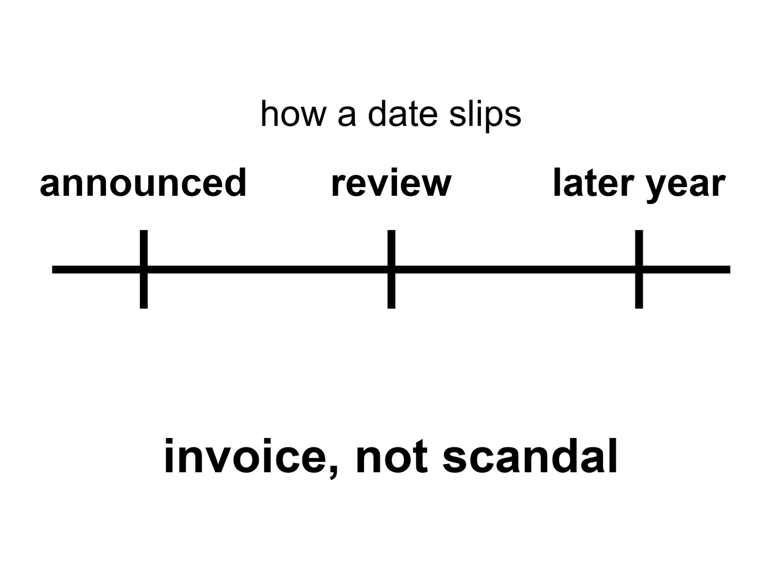
Figure 3. One horizontal line, three large ticks: announced year, review, later year. The label is invoice, not scandal.
The radio is late, as always. On the good weeks it is four minutes. On the rude weeks it is twenty. Someone on Earth is still selling a year as if a year were a landing gear. The year in this morning’s packet is not the year in last year’s packet. Mara does not gasp. She has been in this kitchen long enough to treat a date as a weather report: useful, local, wrong tomorrow.
Official slips are engineering plus politics. Both words have to sit still.
A slip is a moved official date for a named class of mission — not a mood, not a conspiracy proof, not a destiny.
Engineering is the part the brochures skip because it is a list. A heat shield that charred too deep. A valve that iced. A suit whose bearings seize in dust that has no water to be polite. A refueling rehearsal that leaked, or did not light, or lit and then taught you a new way to be afraid. Software that raced a race it was not supposed to win. A supplier that could not find a forging. Radiation that a paper said was fine and a phantom that a crew doctor will not sign. None of these is a morality play. Each is a thing that takes calendar.
Politics is the other half of the same invoice. A legislature that wanted a landing in a term it could campaign on. A new administrator who inherited a stack and a story and changed the story. A partner nation that delayed a module. A contractor who bid a number that was a wish. A war, a pandemic, a different agency’s emergency, a launch that failed two pads over and made every review board sit up. None of these is proof that the Moon is a hoax. None of these is proof that the downtown is inevitable “once they stop lying.” They are how a species that does projects with other people actually does projects.
The two halves talk. A technical delay becomes a budget fight. A budget fight becomes a technical delay, because people leave and drawings freeze and a test stand sits idle. Treating the pair as a scandal is a way to keep the slide innocent. Treating the pair as destiny — it always slips, therefore it never happens — is the other innocence. Things that slipped have also flown. Apollo slipped and then walked. Shuttle slipped and then flew, and then taught a ruder lesson about wishing a date harder than a tile. Artemis-class dates have slipped in public, more than once, in the decade that leads into this kitchen. The slipping is the pattern. The walking is still a warm class of mission, not a cancelled species of event.
Dates get written for a living. The job is real and has a nicer name on the org chart. The review has a spreadsheet with three columns: announced, internal, what I would bet. The third column is not allowed on the screen. The third column is why a conscience still fits in the room.
He has watched a year move the way a casserole estimate moves when you open the oven and the middle is still soup. The honest sentence is: we opened the oven. The slide’s sentence is: the dinner is still at eight, we have redefined eight. Both can be said without fraud. Fraud begins when the oven is empty and the slide still has a roast.
How do you tell an invoice from a con?
A con hides the oven. It will not show the heat-shield coupon, the suit’s dust trial, the refueling attempt, the missed weld. It updates the year and updates the rendering and calls the pair “on track.”
An invoice shows the coupon. It says: this part failed, this is the retest, this is the new earliest morning that is not a wish. It may still be optimistic. Optimism is not a crime. Optimism plus a locked press kit plus a punishment for the person who reports the coupon — that is how invoices go bad.
Why do honest people print optimistic years in the first place? Because a program that prints its true expectation loses the room. This is a hot pattern in every large engineering ledger ever audited, not a lunar disease. Big projects — dams, tunnels, rail lines, software, stacks — come in late and over budget far more often than they come in early. The people who plan them are not liars. They are estimating the parts they can see and treating the parts they cannot see as smaller than history says they will be. The best planners do a rude thing about it: they look up what happened to the last twenty projects of the same class and pull their own year toward that record, no matter how good their drawing is. That is called taking the outside view. It is the reason Tom’s third column exists.
The outside view is the year you would bet on if you were only allowed to look at the record of similar programs, not at the slide.
A year printed from the inside view is a mood. A year printed from the outside view is an invoice with a range on it. The second kind sounds worse in a hearing and is far kinder to the people who have to live in the tin.
This book will not run a courtroom for any one logo. Logos change. The pattern does not. If you want a morality play, write a different book. If you want to know how soon, learn to read a slip as information. A slip that names the long pole — the lander has not demonstrated the last kilometer; the suits are late; the tanker has not transferred — is a gift. A slip that names only “integration” is a fog. Fog is not fraud. Fog is what a program sounds like when it has not yet chosen which invoice to show.
A date is a kind of clock. It is not the only kind.
The Moon is three days away at the speeds we actually use, and a second and a third at the speed of light. Those clocks do not slip when a review board meets. Mars is minutes away by radio and a season away by a cheap path, and twenty-six months away by the next cheap path if you miss this one. Those clocks do not slip either. They are orbits. Orbits are rude and fair.
The clocks that slip are the human ones: when a stack is ready, when a suit is wearable, when a tanker can pour, when a legislature will pay, when a partner will deliver a can. Confusing the two families is how a named year becomes a landing gear. The orbits do not care who named it. The person who named it can still be useful; a hard date has driven real teams to real hardware. Usefulness is not a demonstration of a downtown.
The two families meet in one place that deserves its own sentence: the window. A human clock that slips by a month costs a month on the Moon. A human clock that slips by a month at the wrong moment on the road to Mars costs twenty-six months, because the orbits do not hold the door. That is why Mars dates slip in lumps and Moon dates slip in dribbles. A program that has promised a Mars window and finds a crack in May has not lost a summer. It has lost a cycle. The slide will call it a summer. The orbits will call it a cycle. Read the orbits.
She hears the new year on the delay. She writes it in the log under Earth says, next to the pH, which is a number the dirt actually offered. She does not vote for the year. She votes for the seal on the airlock, which is either going to sigh or not.
A crew around the Moon this decade remains warm as a class. The exact month remains a mood. A landing attempt in the 2030s remains warm as a class. A city this decade remains cold. None of those temperatures is a function of how loudly someone is disappointed. Disappointment is not a thermometer.
A pattern-book, so the next chapters do not have to re-teach the oven.
Apollo announced mornings that moved, then walked. The walk did not make the slips imaginary, and the slips did not make the walk a con. Shuttle announced a truck and delivered a thoroughbred that flew, killed, flew again, and taught a civilization that wishing a date harder than a tile is a way to hold a funeral. Constellation printed a return to the Moon and was cancelled as a program. Cancellation is not a proof that the Moon is unreachable. It is a proof that a ledger can fire a floor plan. Artemis-class crew dates have moved in public, more than once, in the decade that leads into this kitchen. A commercial heavy stack has moved in public, more than once, for the same reasons a casserole moves: the middle was soup when the oven was opened.
Tom keeps a fourth column he does not show: what would have to be true for the announced year to be a landing gear. Suits wearable in dust. A pour that has manners. A shield that has a coupon. A partner can that has left a factory. A legislature that has not raided the line. If three of five are stories, the year is a mood. If four of five have serial numbers, the year is still allowed to slip, because the fifth can still be a weld.
Mara’s log has a page for Earth says and a page for dirt says. The first page is crowded. The second page has pH, ice mass, a bearing temperature, a seal that sighed or did not. She trusts the second page. She reads the first so she knows what the radio will ask her to celebrate.
The oven, by the numbers.
A pattern is only worth the name if it holds across decades and logos, so here is the pattern with the dates left in. They are last century’s dates and this century’s, and they rhyme.
A president said, in 1961, that a person would walk on the Moon before the decade was out. That was a year printed in public, and it was kept — July 1969 — by a program that spent, at its peak, several percent of a national budget, and that buried three men in a cabin fire on a pad in early 1967. The fire cost about twenty months. Nobody at the time called those twenty months destiny. The oven was opened; the wiring and the pure-oxygen cabin were shown; the cabin was rebuilt. The walk still happened. Slip and walk are not opposites.
The Shuttle was sold in the early 1970s as a truck: cheap, frequent, routine. Its first flight, penciled for the late 1970s, flew in April 1981. It then flew 135 times over thirty years and was never cheap, never frequent by the brochure’s standard, and never routine in the way a truck is routine. It killed two crews — one on the way up in 1986, one on the way home in 2003 — and each time the inquiry found a piece of hardware that had been talking for years and a schedule that had learned not to listen. The tile-and-wish lesson is that a date pressed harder than a part is a way to hold a funeral. It is not that trucks are impossible.
A return to the Moon was announced in 2004 with a year attached. By 2010 the program was cancelled as a program, its rockets over budget and its lander unfunded. The cancellation did not prove the Moon unreachable. It proved that a ledger can fire a floor plan, which Chapter 8 will meet again.
The current American return was announced with a first crewed landing in 2024. That year moved to 2025, then 2026, then 2027. In February 2026 the mission that had carried the landing became a crewed rehearsal in Earth orbit, and the first landing attempt moved to the flight after it, publicly aimed at 2028.³ A commercial heavy stack has named, in the same decade, a cargo landing on Mars for windows that have since opened and closed without a hull in them. None of that is a con. None of that is destiny. Each of those years was a mood printed in a good font. The rhyme is the point.
How to read a slip in thirty seconds.
Tom does this for a living and says it can be taught in a lunch. When a date moves, ask four questions, in order, and stop when you run out of answers.
What is named? A slip that names a part — the shield charred, the suits are late, the tanker has not poured, a partner’s module missed its ship — is an invoice. A slip that names integration or replanning or a more sustainable cadence is fog. Fog is not fraud. Fog is a program that has not yet chosen which invoice to show you.
What was retested? If a coupon failed and a retest is scheduled, the program is cooking. If nothing was retested and the year simply moved, the program is waiting for money, or for an election, or for a review it has not held. Waiting is legal. It is not the same clock as cooking.
Did the rendering move too? An honest slip updates the year and leaves the picture alone, because the picture was never the point. A dishonest slip updates the year and updates the picture and calls the pair on track. Watch the picture.
Who is allowed to say it? If the person who found the crack is on the stage, you are in a program. If the person who found the crack has been reassigned and the stage has a press kit, you are in the brochure business, and the year in the brochure is a fiction with a legal department.
Four questions. If a slip survives all four, it is an invoice, and you should read it the way you read any invoice: with irritation, and with the knowledge that the work it bills is real.
Mara, on the slip that arrives with a part attached.
The good packets, she has noticed, are the ones that bring bad news with a noun. The landing is later; the pour did not hold. She can do something with that sentence. She can look at her own pump and think about what a pour is, and how a tank behaves cold, and why an orbit is a rude place to move a liquid. The sentence has dirt on it.
The bad packets bring a year and a feeling. We remain committed. The timeline has been refined. She cannot do anything with that. Neither can Rohan. Neither can the basil. She files it under Earth says and moves on to the ice, because the ice has a number and the packet does not.
She is not cynical about Earth. She is precise about it. A slip with a noun is a colleague. A slip with a feeling is a slide. Both come up on the same radio, twenty minutes late, in the same voice. Learning to tell them apart is not a skill for engineers. It is a skill for citizens, because citizens are the ones who pay for the oven, and the ones who are asked to be disappointed on schedule.
A slip, worked from the inside, so the mechanism is visible.
A heat shield supplier misses a delivery date by four months because a supplier two tiers below them — a company that makes a resin nobody outside the industry has heard of — had a fire in one furnace and no second furnace to fall back on. The prime contractor did not lie about the four months. The prime contractor did not know about the fire until the shipment failed to arrive, because a schedule built from a thousand promises rarely audits the thousandth promise until it breaks. This is not a hidden oven. This is an oven with a door nobody thought to check, three rooms away, in a building the program office has never visited.
Multiply that single resin furnace by the actual count of suppliers behind any heavy program — thousands, for a vehicle with a million parts, each one a small company with its own fires, its own furnaces, its own single points of failure — and the slip stops looking like negligence and starts looking like arithmetic. A schedule with a thousand independent chances to slip a month will, on any reasonable model of how often things go wrong, slip. The question this book keeps asking is not whether it will slip. It is whether the program tells you which room the fire was in.
Reading a slip like a supply chain, not a scandal.
Ask, when a date moves: is the named cause upstream or downstream of the prime contractor’s own choices? A slip caused by the prime’s own design change is a decision, and decisions can be second-guessed. A slip caused by a sub-tier fire, a strike, a sanctions regime that suddenly restricted a chemical, is weather, and weather cannot be second-guessed, only insured against. Programs that build in slack for the weather they cannot control tend to hold their public dates better than programs that assume every supplier’s every promise will land on time. That slack costs money before anything goes wrong, which is why it is the first thing a budget fight cuts, which is why the programs that cut it are, on a long enough clock, the ones that slip hardest in public. The invoice was always going to arrive. Cutting the slack only chose which decade it would land in.
Tom keeps a private column for this, next to his three others: not what failed, but how many tiers down. A prime-tier failure gets flagged in red. A sub-tier failure two or three levels down gets flagged in yellow, because it is real and it is still, in a strict sense, not the prime’s fault, and the distinction matters for whether a program’s leadership deserves the sentence the press conference is about to hand them. He has learned, watching this column fill in over years, that the yellow entries outnumber the red ones by a wide margin. Most slips are not lies. Most slips are furnaces, three rooms away, that nobody thought to check.
Why round numbers get picked: anchoring is not an accident.
A leader who names 2030 is usually not naming an engineering estimate. Psychologists who study how people generate numbers under uncertainty have a name for what is actually happening: anchoring, the tendency for a first-guessed number — often the nearest round one — to distort every subsequent estimate, even estimates made by people who know the anchor was arbitrary. A round decade-mark is psychologically cheap to say and psychologically expensive to abandon, because abandoning it later reads as a failure, even though the number was never an engineering output to begin with. A program that instead names an odd, specific year — say, 2031, or a range like “the early 2030s conditional on the pour” — is usually signaling something real: an actual bottoms-up schedule estimate, built from actual task durations, that happened not to land on a round number because reality rarely does.
A short checklist for reading a program’s year, distilled from everything this book has argued so far: is the year round, or specific? Was it named before or after the hardware that determines it existed? Did the year move toward a round number over successive revisions, or away from one? A year that keeps sliding toward the nearest round decade-mark on each revision is behaving like an anchor being defended. A year that moves in odd increments, tied to named test results, is behaving like a schedule. Neither guarantees the outcome. Both tell you, cheaply, which kind of number you are looking at before a single dollar has been spent finding out.
Two coupons, compared, so the difference is visible in a single pair.
This book has already shown you the honest coupon: Artemis I’s heat shield char loss, published, understood, and used to redesign the next flight’s entry profile before it flew people. Set beside it, for contrast, a coupon from the previous chapter’s case: the O-ring cold-weather data existed, was raised, and was overruled rather than published as a stop-work finding, in a room where the incentive to launch on schedule outweighed, for that one conference call, the incentive to let the coupon speak. The technical facts in both cases were comparably clear. The organizational response was not. One coupon changed a flight profile. The other was argued out of the room.
The difference is not a difference in the honesty of the engineers involved, in either case. It is a difference in what the program, at the moment of decision, allowed the coupon to do. A coupon that can stop a countdown is a coupon with power. A coupon that can only be logged, filed, and revisited after the fact has all the honesty and none of the authority a coupon needs to actually do its job. Read every program in this book, past and future, against that single question: when the coupon spoke, could it stop anything, or could it only, eventually, be right.
A last worked date, chosen because it slipped the other direction.
Not every slip moves later. A crewed mission once moved its target earlier by several months after an unusually smooth test campaign retired risk faster than the original schedule had assumed — a slip in the direction nobody plans for, precisely because a schedule built with slack for bad news rarely has a mechanism for cashing in good news early. Read it the same way as any other slip: what changed, and was the change published with a reason attached. An early date with a named cause is exactly as trustworthy as a late one with a named cause. It is simply rarer, because good news moving a schedule earlier requires everything to have gone right at once, and everything going right at once is, on the evidence of this whole chapter, the least common outcome a program ever actually produces.
A short glossary of the words a slip wears, so the vocabulary is not left to guesswork.
“Replan” usually means a schedule has been rebuilt from a changed assumption, honestly or not, and deserves the same four questions laid out earlier. “Integration challenges” usually means two systems built by two teams do not yet agree with each other, a fog-shaped phrase that deserves a second question rather than a first conclusion. “Aggressive schedule” is a phrase program offices use about their own plans and almost never about a rival’s, and the asymmetry is telling: a schedule is aggressive when it is yours and ambitious to be admired, or reckless when it is a competitor’s and ripe for a headline. None of these words are lies by themselves. All of them reward the same four-question test from earlier, applied one more time, on the actual sentence in front of you rather than the year attached to it.
The examples so far have leaned heavily on one nation’s programs. Here is a slip from a different ledger.
A European heavy-lift rocket’s successor, intended to replace an earlier vehicle that had itself flown reliably for decades, slipped its debut by several years past its original target, driven by a redesigned engine, a redesigned launch pad, and a funding structure spread across a consortium of national space agencies whose individual budget cycles did not always move in step with each other — the same multi-partner friction Chapter 8 will describe again for a lunar station. The vehicle eventually flew, successfully, years after its first announced date, at a moment when the agency operating its predecessor had genuinely run short of options, because the predecessor’s own final flights had already been scheduled and there was, for a stretch of months, no European heavy-lift capability available at all — the exact capability gap this chapter’s supply-chain arithmetic warned a program office to insure against.
The lesson generalizes past any one nation’s ledger, which is the entire point of naming it here. Every spacefaring program this book has described — American, Chinese, European, Indian, Japanese — has slipped a major vehicle’s debut at some point in its history, for reasons this chapter has spent its pages teaching you to read rather than to be shocked by. A slip is not a flaw in one nation’s institutions. It is a flaw, if it is a flaw at all, in the act of building something nobody has built before, on a schedule anyone was ever willing to print in advance.
Appendix A3 writes a short pattern-book of public slips — Apollo, Shuttle, Constellation, Artemis-class, a commercial heavy stack — without turning any line into a sermon. Here, keep the three ticks. Announced. Review. Later. The space between them is where the work lives. The work is allowed to be slow. The slide is not allowed to call the slowness a landing.
Rule: Dates slip. Slip is a temperature, not a scandal. Log the delay; keep building.

PART II — The Moon First

4. The Moon First, Because It Is Close
The Moon is first because it is close. That sentence is allowed to be boring. Boring is how you do not die of a schedule.
Three days, not months. A second and a third for the radio, not four minutes, not twenty. One-sixth of the weight you grew up in, which is a kindness to the legs and a rudeness to the dust: everything you kick stays in the conversation longer than you wanted. A test kitchen, not a spare Earth.
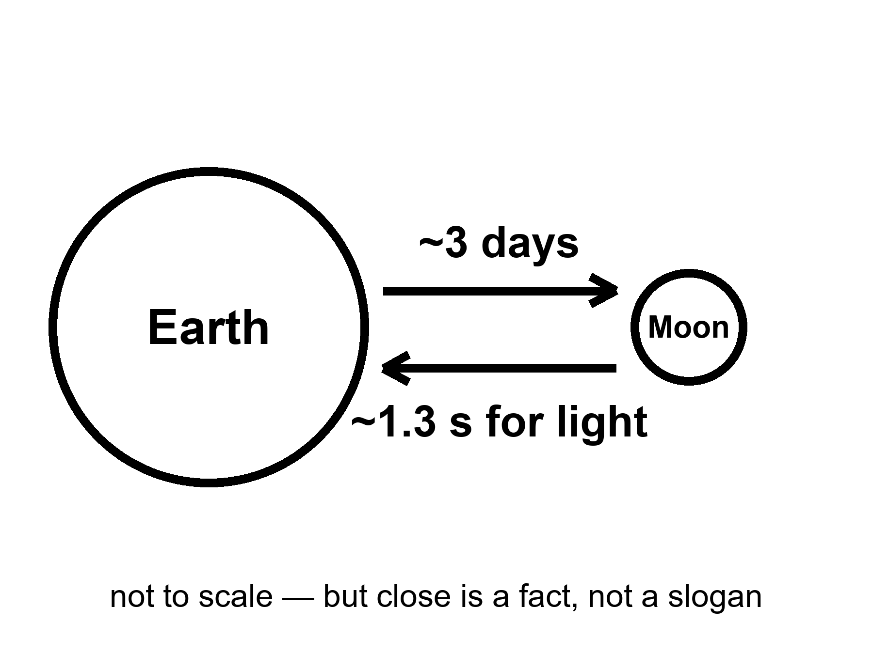
Figure 4. Earth and Moon on a simple line; a three-day tick, a 1.3-second tick. Close is a clock, not a romance.
Light-time to the Moon is about 1.3 seconds one way — a delay you can talk through, if you are patient, and still call a conversation.
Mars will not give you that. Mars gives you a monologue with a pause that can eat a lunch. The Moon gives you a slightly drunk phone call. That difference is not poetry. It is why a medical emergency, a jammed airlock, a software load that needs a human who is still on Earth, is a different sport at three days than at a season.
The cheap path to the Moon is not a Hohmann argument with a twenty-six-month sulk. You wait for a monthly-ish window, you light, you coast a few days, you arrive in a gravity well that is shallow compared with home and still perfectly able to kill you if you arrive wrong. Abort, in many of the early hours, still means fall back to Earth with a heat shield and a prayer that is really a number. Abort from a Mars transfer, once you are weeks in, is a different novel. Chapter 11 writes that novel. This chapter writes the reason the novel is not the first homework.
Close is not kind. Close is reachable.
The Moon has no air you can hire. It has a vacuum that will boil your spit and a dust that is glass, not potting soil. The dust is electrostatic, sharp, and in love with seals. It will find the airlock that already sticks. It will find the pump. It will find the lung if you let it. The temperature swings like a door left open on a winter night and a summer noon, because there is no blanket of air to argue with the Sun. Two weeks of day, two weeks of night, if you sit on the equator like a tourist. The poles, which the current plans favor, have a different kitchen: low Sun, long shadows, craters that have not seen light since before anyone named a king, ice in the dark if the maps are right,⁴ and a power problem the moment the Sun sits on the horizon like a stingy coin.
Ice at the poles is the sentence that turned the Moon from a flag stand into a maybe-kitchen. If the ice is there in useful amounts, and if you can mine it without spending more water than you gain, you have propellant and drink and air, in principle. In principle is not a tank farm. ISRU — in-situ resource utilization, the kitchen word for make it there — is the middle noun trying to become the third. Papers and prototypes exist. A city does not.
One-sixth g is a playground and a clinic. Bones and legs that spent a career under Earth will not thank you for a long stay unless you work them. Fluids shift. Dust hangs. A fall is slower and still a fall. The playground photographs well. The clinic is why a winter-over is a medical program, not a camping trip.
Radiation is the unpaid guest. The Moon has no magnetic kindness worth mentioning and no air to spend the first of the particles. A solar storm can arrive as a homework assignment you fail with your bone marrow. A habitat is a pile of dirt, or water, or regolith bags, or a lava tube if you are lucky and the tube is not a fairy tale for your latitude. Apollo stayed a few days and came home. A few days is a sortie. Months is a different dosimeter.
Why first, then, if it is a vacuum with a dust problem?
Because every ugly part of going somewhere else is cheaper to learn three days away than a season away. Landing. Leaving. Suits. Dust. Power through a night. A radio that is almost a conversation. A missed landing that is still a missed landing, but the inquiry can have the people in the same room as the families within a week. A test kitchen is where you burn the first loaf. You do not rent a hall for a wedding and then learn to bake.
The Moon is not a spare Earth. It will not take the species if the kitchen at home fails. It has no biosphere to recover, no forest to grow back, no grandmother of a bird to un-extinct. It is a rock with a useful well, a useful ice rumor, and a useful closeness. Calling it a spare is how you stop washing the one you have. Chapter 15 is that sermon’s funeral. Here, keep the three days.
Mara is not on the Moon. She is on the ruder neighbor, or on a thought-experiment that wears the neighbor’s butterscotch sky. The book keeps her there so the delay stays honest. The Moon would have given her a radio that almost answered. Close does not make a downtown. Close makes a classroom.
Mars-first advocates make a serious case, and it deserves a straight answer. Mars has days that last about a day, a little carbon dioxide you can point a box at, ice at the poles and in the dirt, and a romance that photographs in butterscotch. The Moon has none of that romance and a radio you can almost use. The first kitchen you burn a loaf in should be the one you can phone from, and abort from, and hold an inquiry in without a twenty-six-month sulk. Those are real advantages, and the people who press them are not dreamers; several of them built the robots that taught us Mars. The answer is still about lessons, not romance. That is how you do not spend a crew on a first lesson that could have been a third-day lesson. If a later decade makes Mars a sortie, it will still have been cheaper that the suits, the dust, the leave, and the habit of not fusing nouns were learned on the close rock.
What close buys that romance cannot.
A medical board on Earth can still be in the loop while a glove is failing. A software patch can ride a radio that is almost a conversation. A family can sit in a room with the inquiry within a week of a bad morning. Those are not soft benefits. They are why the first burnt loaf belongs on a rock you can phone. Some will call that timidity. Timidity is refusing a window that is open. Looking first is refusing to spend a crew on a lesson a three-day classroom could have taught.
Polar ice is the sentence that keeps getting promoted. Maps are warm. A drill that works, a mine that does not drink more water than it returns, a tank that does not leak through a two-week night — those are the unpaid lines. Until they are paid, ice is a rumor with a latitude. A rumor with a latitude is allowed to move money. It is not allowed to move a downtown.
Mara will never get the 1.3-second kindness on her butterscotch world. The book keeps her rude on purpose. The Moon chapter is the classroom she does not sit in. If you remember only one number from it, make it the second and a third. Close is a clock.
A classroom with a kill switch.
Abort modes that still mean fall home are a kindness the Mars transfer will not sell you after week three. Suits that fail on the Moon fail in a delay you can almost talk through. Power through a polar dusk is still ugly; it is ugly with a spare radio that answers before lunch is over. That is the whole argument for first. Not romance. Reachability with an inquiry that can still gather in one room.
The three-day classroom has a syllabus the renderings skip.
Landing without air to bite. Leaving without a crane that has already practiced on this dirt. Suits whose bearings meet glass. Power when the Sun is a stingy coin on a polar rim. A radio that is almost a conversation, so a medical panic is not a monologue with a twenty-minute hole. Each item is cheaper to fail here than on a Hohmann sulk. That is not a preference for flags. It is a preference for inquiries that can still gather while the families are in the same week as the wreckage.
Close also means the Moon will never be a spare Earth. No biosphere. No forest to grow back. No grandmother of a bird to un-kill. Useful well, useful ice rumor, useful closeness. Call it a classroom and you will wash the kitchen at home. Call it a spare and you will stop washing.
Close, in numbers you can carry.
The Moon sits, on average, about 384,000 kilometers away — thirty Earths laid side by side, a little less. Light crosses that in a second and a quarter. A cabin on the paths we actually fly crosses it in about three days, because we do not go straight and we do not go fast; we go on a curve that a modest engine can afford, and we arrive with enough left to slow down. Apollo took about three days out and three days back. A modern cabin takes about the same, because the orbits did not change and the engines are not magic.
The trip is set by fuel, not by distance — a faster path exists and costs more than any stack wants to carry.
The well is shallow. To leave the Moon entirely you need a little under two and a half kilometers a second of speed, against Earth’s eleven. That is why a lander’s ascent stage can be a small fierce thing instead of a skyscraper, and why the whole enterprise is possible with chemistry. It is not why it is easy. The ledger from a low Earth orbit to the lunar surface and back is on the order of six kilometers a second of change, paid in pieces: a burn to leave, a burn to be captured, a burn to come down, a burn to come up, a burn to come home. Every piece is propellant. Propellant is mass. Mass is the invoice Chapter 10 keeps mentioning.
Windows are gentle here. The Moon is always roughly where it was last month. A polar landing site wants a particular lighting and a particular alignment, which turns any day into a few days a month, but the sulk if you miss is weeks, not years. That gentleness is a large part of why first. A missed lunar window is an annoyance. A missed Mars window is a chapter.
The two weeks of night.
A lunar day is about twenty-nine and a half Earth days long. At the equator that is two weeks of a Sun that will cook a surface past the boiling point of water, then two weeks of a night that will freeze it a hundred and thirty degrees below. A camp that runs on sunlight has to store two weeks of power or go to sleep and hope to wake. Small landers have tried the sleep. Most did not wake. The night is the exam that the daytime photographs skip.
The poles are the current answer, and the answer has a shape. Near the south pole there are ridges and crater rims where the Sun, skimming the horizon, never quite sets for most of the year — lit eighty, ninety percent of the time, with only short dark gaps. A few hundred meters away are crater floors the Sun has not touched in a billion years, colder than the surface of Pluto, cold enough that a molecule of water that wanders in stays. That is where the ice rumor lives.
Rumor is the wrong word by now, and city is still the wrong word. In 2009 an empty rocket stage was aimed into one of those dark craters and a following craft flew through the plume. The plume had water in it — a few percent by mass, at that spot, on that day. Orbiting instruments have mapped hydrogen signatures across the polar shadows since. So: ice, yes, in some form, in some places, in some amount. Whether it is a frost on grains or a slab you can mine, whether it is a percent or ten, whether the power to dig it in the dark costs more than the water is worth — those are the questions a maybe-tank asks. A tank farm is what you have after the questions have serial numbers. Nobody has the serial numbers yet.
Lunar dust is not dirt, and it will keep finding the seals. Dirt on Earth has been tumbled by water and wind until its edges are round. The Moon has neither. Its surface has been ground by four billion years of impacts into a powder of glass shards and mineral splinters that nothing has ever polished. It is sharp at every scale. It carries a static charge near the day-night line, so it floats and clings. The last century’s crews came back from three days with suits abraded at the joints, with zippers and seals that fought them, with dust in the cabin that smelled — several of them said — like spent gunpowder, and one of them with a reaction in his nose that sounded, on the radio, like hay fever. Three days. The suits were not built for a shift. The dust did not care.
Every mechanism a camp needs — a hinge, a bearing, a valve seat, a glove wrist, a radiator fin — is a place dust can get, and every place dust gets is a maintenance item, and every maintenance item is mass and time on a world where both are shipped. That is not a reason not to go. It is a reason the glove is a long pole, and Chapter 7 will bill it as one.
The clinic, with a number in it.
A dosimeter rode down to the far side on a Chinese lander in 2019 and sat in the open, measuring. It read a little over a millisievert a day on the surface with no roof — roughly a chest X-ray’s worth every few hours, or, put the other way, about half a sievert a year. An agency career allowance for a crew member is in the neighborhood of six hundred millisieverts, total, for a working life. One unroofed year on the surface spends most of that. The arithmetic is not a scandal. It is a floor plan: a camp that stays sleeps under something — bagged regolith, a berm, water tanks, a tube in the rock if the site happens to have one.
Then there are the storms. Between two of the last century’s landings, in August 1972, the Sun threw a burst of particles that would have given a crew on the surface a dose in the range where you are sick, and possibly worse, in the span of a shift. Nobody was there. That was luck, not planning. A modern camp plans: a shelter, a warning from a satellite that watches the Sun, a drill for getting into the shelter fast. Chapter 6 will find the crew practicing exactly that drill on a loop that never lands.
None of this makes the Moon a bad first kitchen. It makes it an honest one. Three days away, you can learn dust and night and dose with a return ticket in your pocket. A season away, each of those lessons has a funeral attached.
The sites, named, because a landing site is not a dot on a globe.
The south polar region the current programs favor is not one place. It is a shortlist of specific ridges and crater rims — a handful of named candidates, each scouted from orbit for the same three things: enough sunlight to survive a night, a slope gentle enough to land on, and a plausible walk or drive to a permanently shadowed crater floor where the ice rumor might turn into ice fact. Each candidate is a compromise. The ridge with the best sunlight often has the worst slope. The crater with the most promising ice signature is often the one you cannot safely walk to and back before a suit’s air runs out. Site selection is not romance. It is three spreadsheets arguing with each other, and the argument has been public, published, and revised more than once as better orbital data arrived.
This matters for a reason beyond trivia. A rendering shows one perfect site, lit forever, ice a shovel’s reach away, as if the Moon had been designed for the convenience of the mission. The real Moon was not designed. It was hit, for four billion years, by everything the solar system had to throw, and the sites that survive an engineer’s spreadsheet are the ones that lose the fewest arguments, not the ones that win every one. A camp that lands at the winner of that argument still lands somewhere with a real slope, a workable power budget, and an honest walk to the thing it actually wants.
What a landing site tells you about a program’s honesty.
A program that has narrowed its site list, published the finalists, and explained why each one lost or survived is doing the oven-opening this book keeps asking for. A program that shows one gorgeous rendering of an unnamed ridge, lit gold, with no coordinates attached, is still selling a picture, whatever else it has flown. Check the coordinates. If a program cannot point at a real crater on a genuine map and tell you why that crater and not its neighbor, the landing year attached to the picture is decoration.
Walking is not the only way to cross a crater rim. There is also the rover.
Apollo’s last three missions carried a small open-topped electric buggy that let a crew range several kilometers from their lander — a real increment over the earlier missions’ walking radius, and still, by any modern camp’s standard, a toy: no pressure cabin, meaning the crew stayed suited the entire drive, no shelter from a solar event, no capacity to sleep aboard if a return to the lander became impossible. A modern polar camp’s mobility plans call for something closer to a modest pressurized vehicle — a camper, in effect, that a crew could live inside for days at a time, driving between a landing site and a shadowed crater’s rim without returning to the lander each night. Prototypes of such a vehicle have been built and tested in terrestrial analog sites, desert and arctic both, and at least one international partnership has committed hardware development toward flying one later this decade.
The difference between a buggy and a pressurized rover is the difference between a sortie’s mobility and an outpost’s, and it maps precisely onto this book’s own three nouns. A buggy extends a sortie’s radius without changing its nature: you still go, you still come home on the same schedule Earth owns. A pressurized rover, if it flies and works, is itself a small outpost — its own umbilical, its own air loop, its own version of everything Chapter 12’s seven rows will eventually ask about — driven around on wheels instead of parked on a pad. Building one is not building a settlement. It is building a slightly larger, slightly more mobile tin, subject to every clock this book has taught you to read.
The Moon does not sit still either. There are quakes.
Seismometers left behind by four of the crewed landings operated for years afterward, recording thousands of moonquakes before the last instrument was switched off in 1977 to save the ground team’s dwindling budget for monitoring other experiments. The data surprised the scientists who analyzed it: the Moon, despite having no plate tectonics and no molten mantle churning the way Earth’s does, rings like a bell after an impact or a deep-interior slip, with vibrations that persist for far longer than a comparable Earth tremor, because the Moon’s dry, unweathered rock does not damp seismic energy the way Earth’s water-soaked crust does. Some moonquakes, a smaller and rarer category, appear tied to the Moon’s own gradual cooling and contraction — the crust cracking, slowly, the way a drying mud flat cracks, over geological rather than human time, but occasionally producing a jolt large enough that a lunar structure would need to be designed to survive it.
A permanent camp inherits this data directly. A habitat that would be over-engineered against seismic risk on Earth’s more forgiving, faster-damping ground may be under-engineered on the Moon’s ringing, long-persisting one, and the actual design margins any real architecture uses trace back, in the published literature, to exactly this decades-old seismometer data — instruments switched off for budget reasons half a century before anyone had a serious reason to build on top of what they recorded. Inventory, this book has argued from its first page, outlives the program that gathered it. The seismometers are the cleanest case in the whole book: a experiment shut down for a budget line item, its data quietly waiting, for fifty years, until someone needed it to build a wall.
A shorter clock this chapter has not yet named: the eclipse season.
Twice in every lunar year, the Moon’s orbit carries it through Earth’s shadow or lines it up to cast one of its own, and a lunar eclipse — the Moon passing through Earth’s shadow, visible from the whole night side of Earth at once — can leave a surface camp without direct sunlight for a few hours in the middle of what should have been a working day. It is a small clock next to the two-week night this chapter already spent pages on, and it is exactly the kind of modest clock a first-time planner forgets, because it does not show up in the headline numbers the way day length does. A camp’s own power budget has to know both clocks, the long one and the short one, or the short one will find the gap the long one’s planning left open.
The smaller danger nobody paints: the grain too small to see.
Beyond the abrasive glass-shard dust described above, the lunar surface receives a steady rain of micrometeorites — particles from dust-grain to sand-grain size, arriving at speeds of tens of kilometers a second, too small individually to threaten a hull but frequent enough, over months and years, to slowly sandblast any exposed surface: a solar panel’s face, a visor’s outer coating, a seal’s exposed lip. Earth’s atmosphere burns almost all of this material up as the shooting stars a clear night shows for free. The Moon has no atmosphere to spend it on, so every micrometeorite that would have burned up over Earth simply arrives, unfiltered, on whatever happens to be facing the sky.
This is not a dramatic risk in the way a large impact would be; the odds of a strike sizable enough to breach a hull, over any single mission’s duration, are low enough that no program treats it as a top-line concern. It is a slow risk, the same category this book keeps arguing matters more than the dramatic one: a coating that degrades a fraction of a percent per month, a solar panel whose output quietly declines across a multi-year mission, a visor that needs replacing on a schedule no first-time visitor would have guessed. A camp meant to last does not just fight the dust it kicks up. It fights the dust the sky sends down, continuously, for free, whether or not anyone is watching.
Appendix A4 writes the 1.3 seconds, the three days, the one-sixth, a sketch of lunar Δv, and why polar ice is a maybe-tank, not a city charter. Here, keep the line with two ticks. Close is a clock. Romance can sit in the hall.

5. What Has Already Flown
Uncrewed loops, landers, sample returns. A flag is not a shift. A kiss of dust is not a lease.
Hot: this century has already put machines on the Moon, driven them, failed in public, succeeded in public, and brought rock home from both the familiar face and the face we used to call the back. That sentence should be taught before any announced year. The hardware is not a rumor. The downtown is.
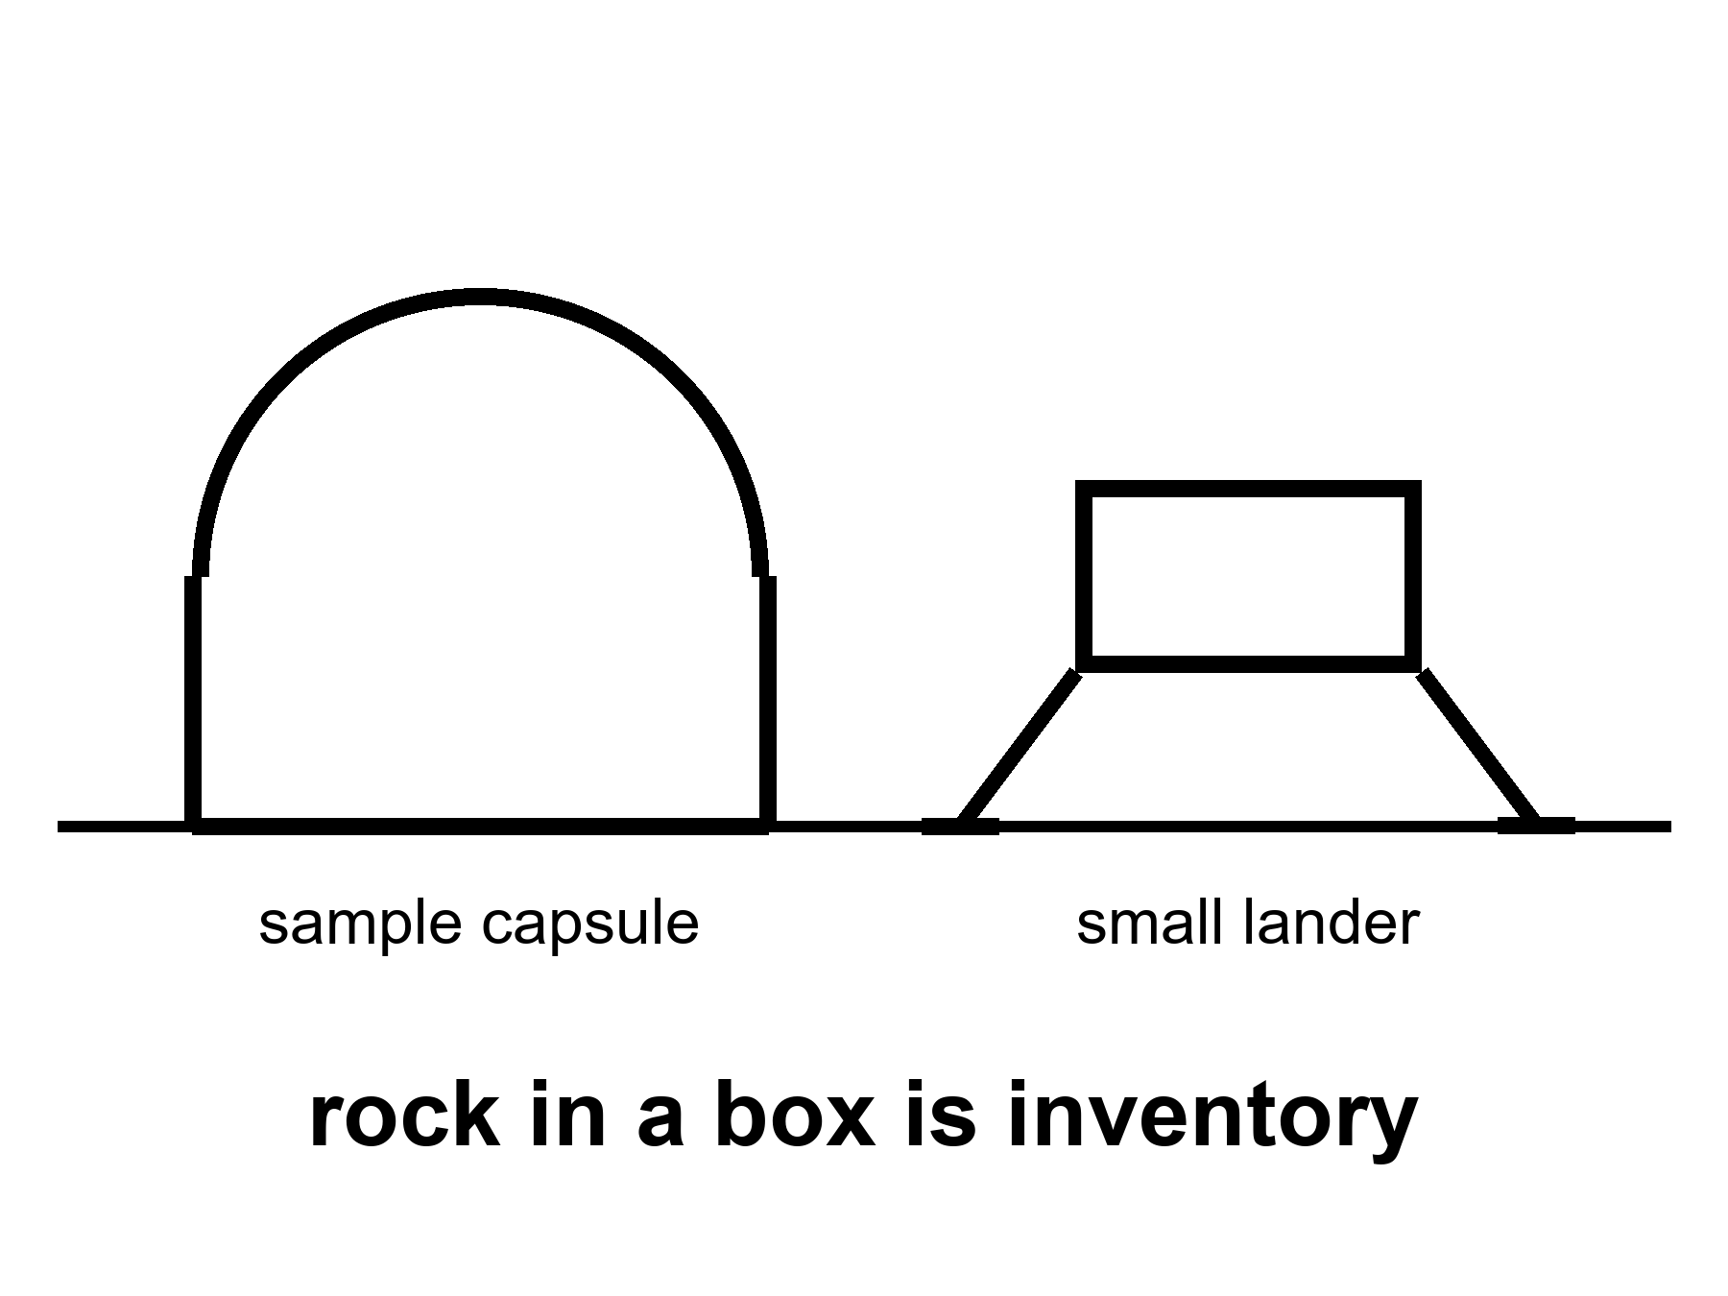
Figure 5. A sample capsule and a small lander, both large in frame, on bright ground. Rock in a box is inventory. A skyline is not.
Start with the loops, because a loop is the dress rehearsal people skip when they are in a hurry to walk.
A cabin that flies a long cold path around the Moon and comes home without a crew is a test of stack, shield, software, and the habit of hitting the thin air of Earth at a speed that will kill you if the shield is a story. Artemis I did that in 2022. Other nations have sent uncrewed craft on lunar paths for decades. The new fact is not that a loop is possible. The new fact is that a crew-shaped cabin, on a stack meant to carry people later, has done the loop and splashed. Warm as a step. Hot as a class of thing that has now happened. Not a sortie. The seats were empty on purpose.
Landers are ruder than loops. Loops do not have to negotiate the last kilometer of a well with no air to help you regret. The last kilometer is a sport. Some of this century’s landers have been tidy: Chang’e-class craft that set down, deployed rovers, and, in the sample-return editions, threw a bit of the Moon into a can and sent the can to a desert you can drive to. Chang’e-5 brought near-side rock home in 2020. Chang’e-6 brought far-side rock home in 2024. Those are flown facts. They are not shifts. No one stayed. The rock is in a box. The box is hotter than a rendering of a dome.
Chandrayaan-3 landed near the south in 2023 and drove a rover. Japan’s SLIM arrived with a precision dare and a landing that taught a lesson about ending up on your head and still phoning home. Commercial landers — an American class that wants to be a truck service — have begun to try the same dirt. Some have stood. Some have tipped, leaked, or gone quiet. Mixed manners are what a new truck service looks like. They are not a proof that “the Moon is open for business” in the sense a Chamber of Commerce means business. They are a proof that kissing dust is no longer a national once-a-decade miracle. It is becoming a thing companies fail at in public. Failure in public is how trucks get better. It is not a town.
A sample return is a special kind of flown.
You must land, or at least collect. You must launch again from a well, or throw the can to a waiting orbiter. You must hit Earth’s air and not cook the rock. You must find the can. The rock, once you have it, is a library: isotopes, water histories, a date, a fight about whether the poles are a tank farm. Chang’e-class returns are the modern masters of this sport. Apollo brought more mass, and also people, and also a flag. Apollo is last century. This century’s returns are robots. Robots are the honest near-term staff. Chapter 25 says a crew that does not sleep can wait. The same crew can also fetch a box so a person in a desert can open it.
What has not flown, while we are cleaning the inventory:
A crew around the Moon in this century, as of this kitchen. That is still a warm class, not a photograph.
A crew landing in this century. Warm as an attempt in the 2030s. Not flown.
A winter-over. Not flown.
A tank farm of lunar ice turned into a tanker of oxygen. Not flown. A small experiment that makes a breath of oxygen from lunar dirt or from a box of regolith in a lab is a paper and a prototype. Keep it warm as a class of trick. Do not cash it as a city.
A child. A school. A law court. A farm that feeds a town without a supply ship. Cold. Not flown. Not scheduled as a product this decade.
Rohan, on the other side of Mara’s tin, used to work payloads. He still flinches when a slide shows a flag and a skyline in the same frame. He has opened boxes that came from space and found, inside, a gram of something that cost a career. He respects the gram. He will not let the gram rent a halo.
A flag is a photograph of a sortie that ended. A shift is a roster that repeats, a pump that has a spare, a person who is replaced when the person is spent. The Moon has had flags. It has not had shifts. This century’s robots are the beginning of a shift for machines. A machine shift is not a town. It is how you learn the dirt before you ask a body to tend a tray for a year.
She hears, on the delay, that another lander has tipped. Someone on Earth is already writing the sentence that the tipped lander means the program is a con, or the sentence that the tipped lander means the downtown is one failure closer to being inevitable. Both sentences are costumes. The tipped lander means the last kilometer is still a sport.
Inventory before announced years.
Teach the boxes before the skyline. A loop that came home empty is hotter than a dome that has not left the slide. A gram in a desert can is hotter than a thousand seats that have not been welded. Tip-overs are inventory too: they are how a truck service learns the last kilometer without pretending the last kilometer is a solved noun.
The century’s robots are the honest staff. They kiss dust, phone home, tip, die, and sometimes bring rock. They do not vote for a school district. They do not need a childhood. They are how you learn seals and slopes before you ask a body to log pH for a year. A machine shift is not a town. It is the difference between a flag and a spare pump.
When a lander tips, two costumes arrive in the same hour: the program is a con and the downtown is inevitable. Both are weather. The tipped lander is a sport still being learned. Mara hears the costumes on the delay and writes neither. She writes the pH. The tray does not require a Chamber of Commerce.
Flown is a verb with dirt on it.
Apollo is inventory and history. This century’s returns are robots and boxes. Both matter. Neither is a lease. Commercial tip-overs are not a morality play; they are a trucking company’s first year. Teach them before you teach anyone’s downtown. The gram in the can is the lesson. The skyline is the costume.
Clean the inventory before the year.
What has flown: crew-shaped empty loops; Chang’e-class landers and returns from near side and far side; Chandrayaan-3’s southern drive; precision dares that phone home from awkward attitudes; commercial trucks that stand, tip, leak, or go quiet. What has not: a crew around the Moon in this century as of this kitchen; a crew landing in this century; a winter-over; a polar ice tank farm; a child; a school; a farm that feeds a town without ships.
Robots are the honest near-term staff. They fetch boxes so a person in a desert can open a gram that cost a career. Respect the gram. Do not rent it a halo. A flag is a photograph of a sortie that ended. A shift is a roster that repeats. The Moon has had flags. It has not had shifts. Machine shifts are beginning. Machine shifts are not towns.
Rohan still flinches when a flag and a skyline share one frame. He has opened space boxes and found a career’s gram. The gram is hot. The halo is cold. When the delay carries another tip-over, two costumes arrive: con, or inevitability. Both are weather. The last kilometer is still a sport. Mara writes neither costume. Teach flown hardware first and the downtown has to wait its turn in the temperature column.
The ledger, with manners left in.
A list is the honest form for this chapter, so here is the list, as classes with a few names attached. The names will rot. The classes will not.
The far side was landed on for the first time in early 2019, by a Chinese lander with a rover, made possible by a relay satellite parked where it could see both the hidden face and Earth. The rover drove for years. Hot: the far side is no longer a mute.
Near-side rock came home in December 2020 — a little under two kilograms, scooped and drilled, thrown to an orbiter, dropped into a desert. Far-side rock came home in June 2024 — a little under two kilograms again, from an ancient basin near the south pole that nobody had touched. Those cans are now the youngest and, respectively, the strangest lunar samples on Earth. They are inventory in the most literal sense. You can weigh them.
An Indian lander, on its second try — the first, in 2019, had ended in a crash in the last seconds — set down in August 2023 farther south than anyone had before, and let out a small rover that drove about a hundred meters. Both went to sleep for the lunar night and did not wake. That is not a failure. That is the night doing what the night does to hardware that was not built to survive it.
A Japanese lander in January 2024 hit its target to within about fifty-five meters, an extraordinary piece of aiming,⁵ and then, an engine nozzle having failed on the way down, came to rest on its nose. It phoned home anyway. It woke up after a lunar night when nobody expected it to, and then another. Mixed posture; honest data.
Then the trucks. A private Israeli lander crashed in 2019. A private Japanese lander misjudged a crater rim and crashed in 2023, and its successor crashed in 2025. An American commercial lander in January 2024 sprang a propellant leak hours after launch and never got near the Moon. Another American commercial lander in February 2024 came down too fast, snapped a leg, tipped, and still worked for a week on its side. Its successor, in March 2025, tipped into a crater, could not charge in the shade, and died within a day. And a third American lander, in March 2025, stood up straight, worked for two weeks, photographed a solar eclipse from the surface and the Sun going down, and then, as designed, died in the night.
Stand, tip, quiet. That is what a truck service looks like in its second year. The lesson is not that the Moon is closed. The lesson is that the last kilometer is a sport, that every logo will play it in public, and that a landing which stands is now a business event rather than a national miracle. Business events are not towns.
Why robots first is not a sermon.
There is a tone people take about robots — either that a machine on the Moon is a poor cousin of a boot, or that a machine on the Moon is the enlightened alternative to boots. Neither is this book’s tone. A machine is the honest first shift because it is cheap to lose. A lander that tips over teaches the same lesson about slopes and sensors as a lander that tips over with a crew, without the funeral. A rover that dies in the night teaches the night. An instrument that sits in the open for a year teaches the dose. The century’s machine shift is a curriculum, and the curriculum is being paid for in small hulls by many ledgers at once, which is exactly the right price for a first draft.
The rule from the longer book — a crew that does not sleep can wait, and can look first — was written for a dark sea that might have its own chemistry. On a rock with no biosphere the rule is simpler and ruder. The machines are not protecting the Moon from us. They are protecting us from a first attempt at mass. Every tipped lander is a slide that did not get to bury a crew under a year.
The box, for scale.
The last century brought home about three hundred and eighty kilograms of the Moon, in six visits, carried by people. The Soviet program, without people, brought home about three hundred grams in three visits. This century has, so far, brought home a little under four kilograms in two visits, without people. Those numbers are small next to a skyline and enormous next to nothing. A gram of the far side is a gram no laboratory on Earth had ever seen. The papers that come out of it will make polar ice a little hotter or a little colder as a tank, will move the date of an ancient basin, will argue about volcanoes that should have been dead. That is what inventory does. It changes temperatures.
What a box of rock does not do is stay. Nobody has stayed. The far side is not staffed. The south pole is a place where three hulls lie on their sides and one stands, and all of them are silent. The shift has not started. The flags are photographs of shifts that ended, and the boxes are photographs of shifts that were never people.
Rohan, on the gram.
He tells Mara, on a slow evening when the pumps are behaving, about the time a can came back from somewhere far and was opened in a room with more air filters than people. The scientists wore gloves under gloves. Nobody spoke above a murmur. In the middle of the tray was a smear of gray that cost, if you did the accounting honestly, about what a small hospital costs. He says he felt two things at once and has never quite separated them. One was that the smear was worth it. The other was that anyone who put a skyline next to that smear should be made to weigh it first.
She says the basil is worth it too, and the basil would also lose to a skyline. He says the basil is a shift. The smear was a sortie. Then he goes to check the pump, because a sortie does not need checking and a shift does.
The failures nobody paints, because failure is where the curriculum lives.
A Mars orbiter, decades ago, was lost entirely because one team’s software did its arithmetic in one system of units and another team’s software did its arithmetic in a different one, and nobody caught the mismatch until the spacecraft, following instructions that were quietly wrong by a factor tied to the difference between a pound and a newton, dove into the atmosphere at the wrong altitude and was never heard from again. The mission cost real money and taught a genuine lesson, repeated in engineering courses ever since: a program is not undone by a single dramatic failure so much as by a thousand small handoffs, any one of which can carry an error nobody thought to check twice. Lunar programs inherit that lesson whether they want to or not.
A lander, closer to this century, was lost on a bargain budget built explicitly to prove that “faster, better, cheaper” could replace “slow, careful, expensive.” It could not. The program that flew it lost two spacecraft in one year to two different, unrelated failures, and the phrase “faster, better, cheaper” quietly disappeared from the agency’s vocabulary for a decade afterward, not because speed and thrift are vices but because speed and thrift, pursued without the ordinary discipline of checking your own arithmetic twice, are a recipe for exactly the kind of failure a poster never shows. The failures that mattered were boring. A missing heat-shield test. A thruster left un-safed. Nothing a film would want.
What a graveyard of hardware actually teaches.
Read a failed mission the way this book has taught you to read a slip: not as a scandal, not as proof the whole enterprise is cursed, but as an invoice for a lesson that a simulator could not teach cheaply enough. Every crater on the Moon or Mars with a piece of somebody’s spacecraft in it is a paid tuition bill. The tuition is expensive. It is also, on the evidence of every program that has flown since, the only tuition that actually works. A simulation tells you what you expected to find. A crash tells you what you did not know to look for.
Budgets, compared honestly, because inventory has a price tag too.
The current American lunar program’s public budget runs in the range of seven to ten billion dollars a year across its combined elements — crew vehicle, heavy lander, ground systems, science payloads — a figure that is a small fraction of one percent of that nation’s total federal budget, though it is often discussed as though it were a much larger share. China’s civil space budget is not published with the same line-item transparency; independent analysts, working from launch cadence, facility construction, and comparable program costs elsewhere, have estimated it at a broadly similar order of magnitude, though direct comparison is difficult precisely because one ledger publishes its ovens and the other does not.
This matters for the pattern this book keeps returning to. A program that will not publish its budget cannot be read the way Chapter 3 taught you to read a slip, because a slip is legible only against a public baseline. Watch, instead, for the proxy this book has used throughout: what has flown, publicly, with a serial number, regardless of what the budget behind it cost. A ledger that hides its numbers can still be read by its hardware. The hardware does not lie the way a budget line can be made to.
What the far-side basalt actually said, once the lab finished with it.
The rock the 2024 far-side sample return brought home turned out, on isotopic dating, to be roughly two point eight billion years old⁶ — meaningfully younger than most of the volcanic rock the near-side missions of the previous century had sampled, and a real surprise to planetary scientists who had expected the far side’s volcanic activity to have shut down earlier than the near side’s, not later. The finding matters for a reason with no publicity value at all: it means whatever process kept the Moon’s interior warm enough to produce lava mattered differently on the two hemispheres, and the leading explanation on the table involves a difference in the concentration of heat-producing radioactive elements between the near and far crusts, a chemical asymmetry baked in since the Moon’s formation and still not fully explained.
None of this changes any temperature this book has assigned. It is inventory, exactly the kind Chapter 5 asked you to respect: a gram in a can, weighed, dated, argued over in a journal, quietly rewriting a textbook paragraph nobody outside planetary science will ever read. The rock does not care about a settlement. The rock is the actual product of the mission that fetched it, and the actual product, this time, was a correction to fifty years of assumption about how a whole hemisphere cooled.
Not every mission is a return. Some rock never comes home.
Several rovers and landers, beyond the sample-return missions credited above, carry instruments that analyze material in place rather than bringing it back — a spectrometer that reads a rock’s chemistry from a meter away, a drill that samples a few centimeters down and feeds the result straight into an onboard laboratory, never touching a return capsule at all. In-place analysis is cheaper, faster to results, and permanently blind to whatever a distant Earth laboratory, with instruments too large and too precise to fly, might eventually have found in the same rock. Both methods are real inventory. Neither replaces the other. A return sample is a library. An in-place reading is a fast, honest paragraph from a librarian who never got to open the whole book.
A sample’s story does not end when the can is opened. It continues in the clean room.
Lunar and Martian material, once it reaches Earth, is not simply unpacked on a lab bench. It enters a curation facility built specifically to keep terrestrial contamination — Earth’s own dust, moisture, and biology — from corrupting a sample that took years and enormous cost to collect uncontaminated. Real astromaterials curation labs operate under nitrogen atmospheres in some cases, with technicians working through built-in glove ports rather than opening the chamber directly, cataloguing every sub-sample’s chain of custody with a rigor closer to a crime lab’s than a typical geology department’s, because a sample cannot be re-collected if a bad handling choice ruins it. Decades-old lunar samples from the last century’s crewed missions are still, today, dispensed from this same curation system to qualified researchers in tiny allotments, some of it deliberately held back, unopened, on the theory that a future decade’s instruments will be able to ask the rock questions this decade’s instruments cannot.
This is the least photographed room in the entire inventory Chapters 1 through 5 have been cataloguing, and it is arguably the most consequential: every fact this chapter has given about lunar chemistry, water-ice signatures, and basin ages passed through a room like this one first, where a single sneeze in the wrong place could have erased a measurement no launch will ever recollect.
Appendix A5 writes a ledger of this century’s loops, landers, and returns — successes, tip-overs, boxes in deserts — without turning any logo into a hero. Here, keep the capsule in the frame. Rock in a box is inventory. A skyline is not.

6. The Next Crew Around the Moon
Warm: a crew around the Moon this decade — a flyby, a cabin, a look at a dead close world that is three days away, not three seasons. Call it an Artemis-II-class morning. The exact month is a mood. The class is the fact: flesh, cis-lunar — a path that stays within the Earth-Moon system rather than landing — home in a week if the stack behaves. That is a sortie. It is not a town.
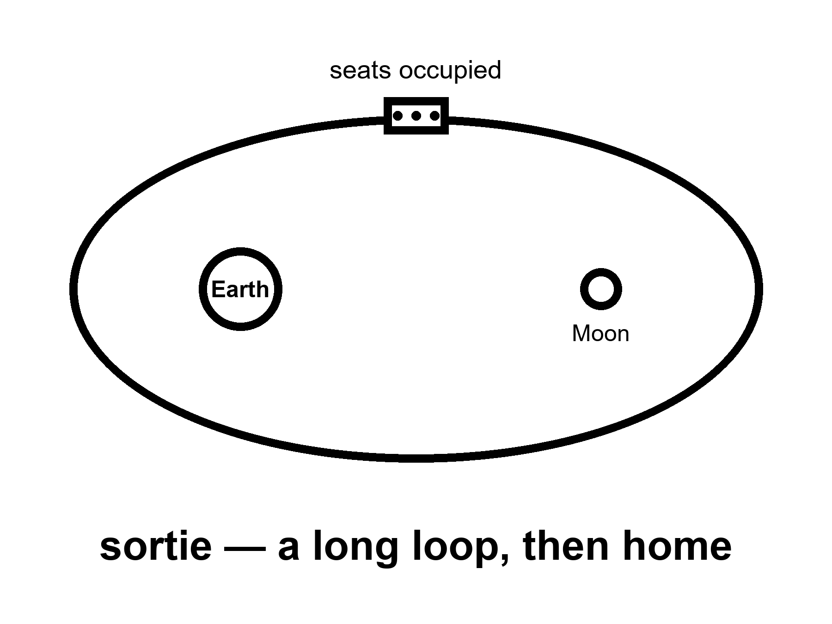
Figure 6. A cabin on a long loop, Earth and Moon both small. Seats occupied. No dome.
The seats, this time, are not empty on purpose. That is the whole increment. Four bodies, or a number like four, in a cabin that has already flown empty. They will see the Moon as a disk that grows, then as a wall, then as a disk that shrinks. They will not land. They will not log a pH on the dirt. They will test the life-support the empty cabin could not confess: the smell, the CO₂, the toilet, the tempers, the suit drill that is a pantomime of a later morning. They will come home, if the shield and the numbers hold, and they will be called pioneers, which is a kindness, and a crew on a sortie, which is the noun.
A flyby is a crew sortie. It is not a town.
Keep the three nouns apart even here, before Chapter 12 makes a courtroom of them. The people in the cabin go, they work, they come home, or they die on a schedule Earth still owns. That is the first noun. The slide will try to marry it to the third. Refuse the marriage. A photograph of four faces in a window with the Moon in it is a masterpiece of a certain kind of engineering. It is also a week. A week is not a school district.
Why does the month stay a mood?
Because the stack that throws the cabin is a machine with a temper, and the cabin is a machine with a temper, and the two must agree, and the abort modes must be more than a slide, and the suits — even if they are not walking — must not be a rumor, and the weather in the political kitchen must hold long enough for a count-up. This kitchen is dated October 2026. The morning this chapter describes arrived six months before that date, on schedule, on its most recent printed schedule. Official pages had named earlier years that needed new pages first. The class did not care. The class was: flesh, around the Moon, home in days. That warm bet has since gone hot.
The chapter is not wasted on a reader meeting it after the fact. You own a flown sortie. You still do not own a town. The temptation will be to treat the splashdown as a lease. It is a splashdown.
If you are reading this before a later landable-year morning has happened, you still own the empty-cabin loop, this flyby, the landers, the boxes of rock. You own a warm class for the landing. You do not own a fraud just because that date moved. Chapter 3 already billed that invoice.
Jules Adeyemi is the invented name on a crew-shaped roster. He runs, in this story, the kind of checklist that makes a cabin less likely to kill you with a valve. He does not think of himself as a founder of a city. He thinks of himself as a person who will be very far from a hospital and very close to a heat shield. That is the correct self-portrait. A launch-day photo will paint a grander one. The photo is not invited on the stack.
What the sortie is for, if you want a purpose that is not a sermon: to make the next landing attempt less of a first time. Life support with breath in it. Navigation with a crew that can be sick. A communications stack that has to carry a voice, not a beep. A public that has to remember that spaceflight is a sport in which the ball can kill you. Those are program reasons. They are enough. They do not require a downtown on the far side of the loop.
Mara hears the crew on a relay that is not for her. Someone reads a name. Someone reads a slipped date for a later landing that the flyby was supposed to make inevitable. Inevitable is not a temperature we use. The basil is a little too alkaline. That is a problem she can bully. A town on the Moon is not.
What the empty cabin could not confess, and why flesh is the increment.
A cabin that flew empty already proved heat, software, stack manners, and a splashdown that did not cook the seats. It did not prove the smell of four bodies in a closed volume for days. It did not prove a toilet that must work when pride is thin. It did not prove a CO₂ scrubber that has to keep up with temper and exercise and a bad night of sleep. It did not prove a crew that can be sick at the same moment the checklist wants a calm voice. Those are not romantic gaps. They are the reason the next morning is warm as a class and still owed as a flight.
A suit drill on a flyby is a pantomime with a purpose. Nobody is walking on dirt. Somebody is still learning how long a glove takes, how a helmet fogs, how a checklist sounds when the person reading it is also the person whose ears are ringing. The pantomime is inventory for a later morning. It is not a lease on the crater.
Communications change when the payload is a voice. A beep can wait in a buffer. A voice wants a path that does not chew the consonants, a delay that is still a conversation, a ground room that has rehearsed the habit of not talking over a one-second lag as if it were a glitch. The Moon’s 1.3 seconds are a kindness compared with Mara’s minutes. They are still a sport. Jules will learn that sport the way a person learns a kitchen that answers slightly late: by not filling the silence with panic.
Radiation on a loop is a different guest than radiation on a winter-over, and still not nothing. A few days in cis-lunar space is a dosimeter chapter, not a career. The cabin’s walls and the timing of the path do some of the work. A solar storm that arrives mid-loop is a homework assignment with a shield and a schedule. The assignment is why the morning is a crew flight and not a tourist brochure. The brochure will still call them pioneers. Jules will call them a shift that ends.
Home in a week is the sentence that keeps the clock honest. Three days out, a look, a few days back, a splashdown Earth still owns. Abort, in many of the early hours, still means fall home with a heat shield and numbers. That is why this chapter sits before the landable year and before the porch fight. The species is relearning a short leash before it asks for a long one.
The slide will try to sell you one year. This book keeps several kinds of clocks instead.
There is the light-time clock: a second and a third. There is the transfer clock: days, not seasons. There is the stack clock: the temper of machines that must agree. There is the political clock: a budget, a review, a vote that can move a count-up without moving an orbit. There is the body clock: sleep, CO₂, a stomach that does not care about a logo. Official pages name a year. The year is a weather report about the political clock and the stack clock. It is not a landing gear. It is not a town charter. If the weather is kind, the morning happens. If the weather is rude, the class remains warm and the date moves. Chapter 3 already wrote the invoice for that move. This chapter only refuses to let the move erase the class, or to let the class print a downtown.
What the morning is not asked to demonstrate, so the handoff stays clean: a landing, a leave from dirt, a suit that works for a shift on glass dust, a tank farm of polar ice, a child, a school, a law court, a farm that feeds without a supply ship. Those are later kitchens, later temperatures, later refusals. A flyby that tries to carry all of them on its back will break its back on the first slide.
Jules Adeyemi, the night before a count-up that may or may not hold, does not write a speech. He writes a valve. He checks a seal the way Mara hits a drawer. He thinks about a hospital he will be three days from, which is still a hospital he can almost phone. That almost is the whole point of the Moon first. Mars will not give him almost. The press kit will give him a skyline. He leaves the skyline in the hall.
On the delay, Mara hears a cheer that is not for her greenhouse. She does not envy the cheer. She envies the radio that answers in a second and a third. The tray does not require a pioneer. It requires a number that is not lying.
What the cabin has to confess.
An empty cabin can prove a heat shield, a stack, a guidance load, a parachute. It cannot prove the thing that makes it a cabin. Life support is the confession the empty loop could not make, because life support is a conversation with bodies and there were no bodies.
Bodies exhale carbon dioxide, a little under a kilogram each per day, and in a sealed can that gas climbs until it makes you stupid and then sick. So the cabin scrubs it — beds of a material that grab the gas when the air is pushed through and let it go when exposed to vacuum, swinging back and forth, all day, with fans and valves that have to keep working and have never, until this loop, worked with the load of four sets of lungs for ten days. Bodies drink, and the water has to be stored and rationed and, in a longer mission, recovered from breath and urine. Bodies use a toilet, and a toilet in free fall is a machine with a vacuum in it and a reputation for teaching engineers humility. Bodies sweat and shed and smell, and the air has to be moved so nobody suffocates in a bubble of their own exhaled evening. Bodies sleep badly in a can with four people in it and a Moon in the window.
None of that is romantic. All of it is the reason the sortie exists. A landing cabin a few years later will carry the same machines, farther, for longer, with a well at the bottom. You do not want the first ten-day trial of those machines to happen at the bottom of the well.
Home in days is the entire increment.
Read the trajectory the way a cook reads a recipe. The stack throws the cabin toward the Moon on a path that, if every engine on board went silent at the worst moment, would still swing the cabin around the far side and drop it back into Earth’s air a few days later. That is a free return, and it is the kindness this class is drawn to keep. The last century’s stranded crew had already left that path when the service module died. A burn put them back on a road that falls home. The kindness was reachable. It was not the road they were already on. It is why this class of sortie is a sortie and not a bet. The crew does not need the Moon to cooperate. They need the shield and the air to hold, and a few days of patience.
On the far side of the loop they will be farther from Earth than any people have been — the record stood, before this kitchen, at a little over four hundred thousand kilometers, set by the crew that was trying to get home. They will lose the radio behind the Moon for a stretch and talk to nobody. They will see, from a distance, the ground that later crews are supposed to stand on. They will not stand on it. The whole point is that they cannot.
A landing has no free return. Once a lander commits to the last kilometer, the only way home is up, on an engine that has to light. That is the difference between the first noun and the first noun with dirt on it, and it is why this loop has to happen first, and why it is enough to be a loop.
The drills nobody photographs.
Somewhere in the ten days the crew will practice hiding from the Sun. A warning comes — in the drill, a pretend one — that a solar storm is on its way, and they have a short window to turn the cabin into a shelter. They do it with what they have: stowage bags, water, the cabin’s own mass, arranged into a nest with the most stuff between them and the outside. It takes minutes if it has been rehearsed and much longer if it has not. Chapter 4 already billed the storm of August 1972, which fell between two landings on the luck of a calendar. This drill is the difference between luck and a plan.
They will fly the cabin by hand for a while, to prove that a human can, in case the computer stops being trusted. They will practice moving near another object in orbit, because a landing architecture will need a cabin to meet a lander and hold still beside it. They will talk to the ground through the big dishes that also talk to the machines around Mars, and the ground will learn what four people sound like on that link, which is not the same as what a beacon sounds like. They will be sick, some of them, for the first day or two, because most people are, and they will do the checklists anyway, because the checklists are the mission.
Every one of those items is small. None of them is a town. Together they are the reason a later crew’s bad day is survivable instead of fatal. That is what a sortie is for.
The morning happened.
Four people — three from the American ledger, one from the Canadian — launched on this class of mission on April 1, 2026.⁷ They made their closest pass by the Moon five days later, at a distance of a little over six and a half thousand kilometers, farther out than the surface but close enough that the disk filled a window. They came home on April 10, splashing down in the Pacific after a flight that took them farther from Earth than any crew before them, past the record an Apollo crew set by accident in 1970 while nursing a dying service module. The heat shield — the same Avcoat material that lost char unevenly on the empty 2022 loop, flown this time on a steeper entry profile chosen because of that earlier failure — came home, on the first public look, with no unusual conditions and far less char loss than the empty flight. By early September a safety-panel count put the loss at about nine sites, against more than a hundred on the empty loop. A fuller cut-up, including x-ray of the material, was still owed.
Update the temperature. This class of mission is hot now, not warm. Do not update the noun. It was a sortie the morning before, and it is a sortie the morning after. The photographs were magnificent. Within the week, someone had called it the return of a spacefaring civilization, using a third-noun word for a first-noun object, which Chapter 12 forbids at a table. The seats were full. Nobody got out. Nobody was asked to.
If a later morning — a landing, an outpost’s first winter — arrived differently for you, a slip or a scrub or a failure worth a review, the rule still stands. A slip is an invoice. A failure is a coupon, and a coupon is a thing you learn from in public. Neither changes what the next crew is for.
Jules, on the last night before the count.
He is invented, and the checklist is not, and the checklist is what he is thinking about. Not the Moon. Not the flag on the patch. He is thinking about a valve that has a history, and about which of the four of them is most likely to be sick on day one, and about whether the shelter drill can be done faster if the bags are stowed in a different order. He knows the public will see four faces in a window with a gray disk behind them and will feel something, and he thinks the feeling is fine. He would like the feeling to stop at the window.
Mara, on the delay, hears the crew’s names read out on a relay that is not for her. One of them is from a country that bought its seat with a robotic arm, which is how legislatures pay for mornings. She thinks that is fair. She thinks it is also a sortie, and she thinks that is fair too. The basil is drifting alkaline again. That, at least, is a problem she can fix by lunch.
What the public actually watched, and what it missed.
The broadcast the world saw was ten minutes of a splashdown and a photograph of four exhausted, grinning faces stepping onto a recovery ship’s deck. What the broadcast did not show, because it is not a broadcast-shaped fact, was the six months of simulator time each of those four people had logged before the count-up: full mission days run start to finish in a mockup cabin, with instructors deliberately breaking systems at random to see whether the crew’s hands found the right switch before their brains had finished being afraid. A crew’s real qualification is not the flight. It is the thousand hours nobody filmed, spent failing safely, over and over, in a building that will never make a highlight reel.
This is worth saying plainly because the public conversation after a flight like this one tends to flatten into two costumes, the same two this book has been refusing since Chapter 2: either the flight proves the species has returned to greatness, or the flight was a stunt that changed nothing. Both costumes skip the actual content of the six months, which is neither greatness nor a stunt. It is a checklist, rehearsed until boring, executed under real stress, that did exactly what the checklist was built to do. The chapter’s rule holds: a sortie is a sortie. Add one thing to it now that the sortie has actually flown: a very large pile of boring, expensive, unglamorous rehearsal, finally spent.
What a body actually reports back, in a crewed cabin, on a loop like this one.
Beyond the checklist and the valve, the crew on a flight of this class wears real instrumentation: a biomedical harness recording heart rate and rhythm continuously, a cabin dosimeter logging the actual radiation dose accumulated on the far side of the loop where Earth’s magnetic shielding no longer reaches, sleep-tracking sensors meant to catch the fatigue that a checklist alone will not confess. None of this is dramatic. Most of it produces a flat, boring line for the entire flight, which is the correct and desired outcome — a biomedical harness that produces an exciting readout is a harness reporting an emergency.
The actual radiation dose measured on a flight of this class, across the several days spent beyond Earth’s protective field, has historically come in at a small fraction of a percent of a career limit — real, measured, nonzero, and nowhere close to the dose a longer lunar stay or a Mars transit would accumulate. This is precisely the kind of number this chapter has argued a sortie exists to collect: not proof that longer stays are safe, but a genuine data point that the longer stays’ own risk models can be checked against. An untested model is a guess with good production values. A model checked against this flight’s dosimeter reading is closer to an engineering input.
This flight had its own Earthrise, and the comparison is instructive.
The most reproduced photograph from the crewed lunar program’s first loop around the Moon, on Christmas Eve 1968, shows the blue Earth rising over a gray lunar horizon, taken almost by accident by a crew that had trained obsessively for lunar navigation and barely at all for photography, in a moment one of them later described as the crew scrambling for a color film magazine because none of them had expected the sight to matter as much as it instantly did. That photograph is widely credited, by historians of the modern environmental movement, with meaningfully accelerating public concern for Earth as a single, finite, fragile object — an irony with a date on it: a mission built entirely to look outward produced, as its most lasting cultural artifact, a reason to look back down.
This flight’s own crew, more than half a century later, radioed home their own description of the view, and the imagery released afterward was, by any technical measure, sharper, in higher resolution, and more thoroughly documented than the 1968 original. It did not produce a comparable cultural shift, and the reason is not a failure of this crew or this photograph. The 1968 image worked because it was new — the first time most of the species had ever seen its own planet as a whole object, small, alone, undefended. A second, better photograph of the same fact, however technically superior, cannot recreate a first. This is not a criticism of the flight. It is a reminder that a mission’s scientific and engineering value does not always translate into a cultural value on the same schedule, and a program should be judged on the former even when the latter, fairly or not, fails to arrive.
The broadcast only shows the countdown’s last ten seconds. Here is what “go” actually sounds like.
The real countdown for a flight of this class runs many hours before the number most broadcasts show, through a sequence of polled status checks — dozens of stations, each reporting a single word, “go” or “no-go,” for one system apiece: propulsion, guidance, weather, range safety, the crew’s own medical status — any single “no-go” enough to halt the whole sequence at any point up to the final seconds. The public sees ten seconds of drama. The room sees hours of a checklist being confirmed, item by boring item, by people whose entire job that morning is to be the reason the flight does not happen if their one system is not ready. It is the same discipline this book has praised in every chapter about ovens and coupons, compressed into a single morning, performed by dozens of people at once, each one empowered to stop a rocket with one word.
Quarantine, before the flight rather than after it.
Crews assigned to a flight of this class enter a formal health-stabilization period in the days immediately before launch — a controlled quarantine, limiting contact with anyone who has not also been screened, precisely to prevent an ordinary cold or flu, harmless on Earth, from becoming a mission-ending medical event in a sealed cabin with no hospital reachable in less than days. The practice traces back to the same lesson this book keeps repeating in different rooms: a small, boring, unglamorous discipline, maintained without exception, is cheaper than the dramatic failure it prevents. A crew member who develops a fever during quarantine is not flying that week, however painful the schedule consequence, because the alternative — flying sick, in a sealed cabin, days from help — is exactly the kind of risk this book’s entire method exists to refuse.
The last century’s program, after one crew brought a case of German measles home from a pre-launch visit with an unvaccinated family member, delayed a mission by days rather than risk exposure, and the practice has only tightened since, not loosened. A broadcast shows the launch. It has never once shown the quiet, guarded dormitory in the days before it, where an entire flight’s schedule quietly depends on nobody in the immediate vicinity of the crew sneezing at the wrong moment.
Appendix A6 writes what an Artemis-II-class morning has to demonstrate and what it is not asked to demonstrate. Here, keep the cabin on the loop. Seats occupied. No dome.

7. A Landable Year Is Not a Town
Warm: a landing attempt in the 2030s — a cabin that goes down and is supposed to come up, a lander that still owes a demonstration of the ugly parts: refuel in orbit, survive the last kilometer, light the engines in a gravity well with no atmosphere to help you regret. HLS, Starship-class, whatever logo wins the week. “Attempt” is the honest noun. A flag is not a greenhouse. A greenhouse is not a school district.
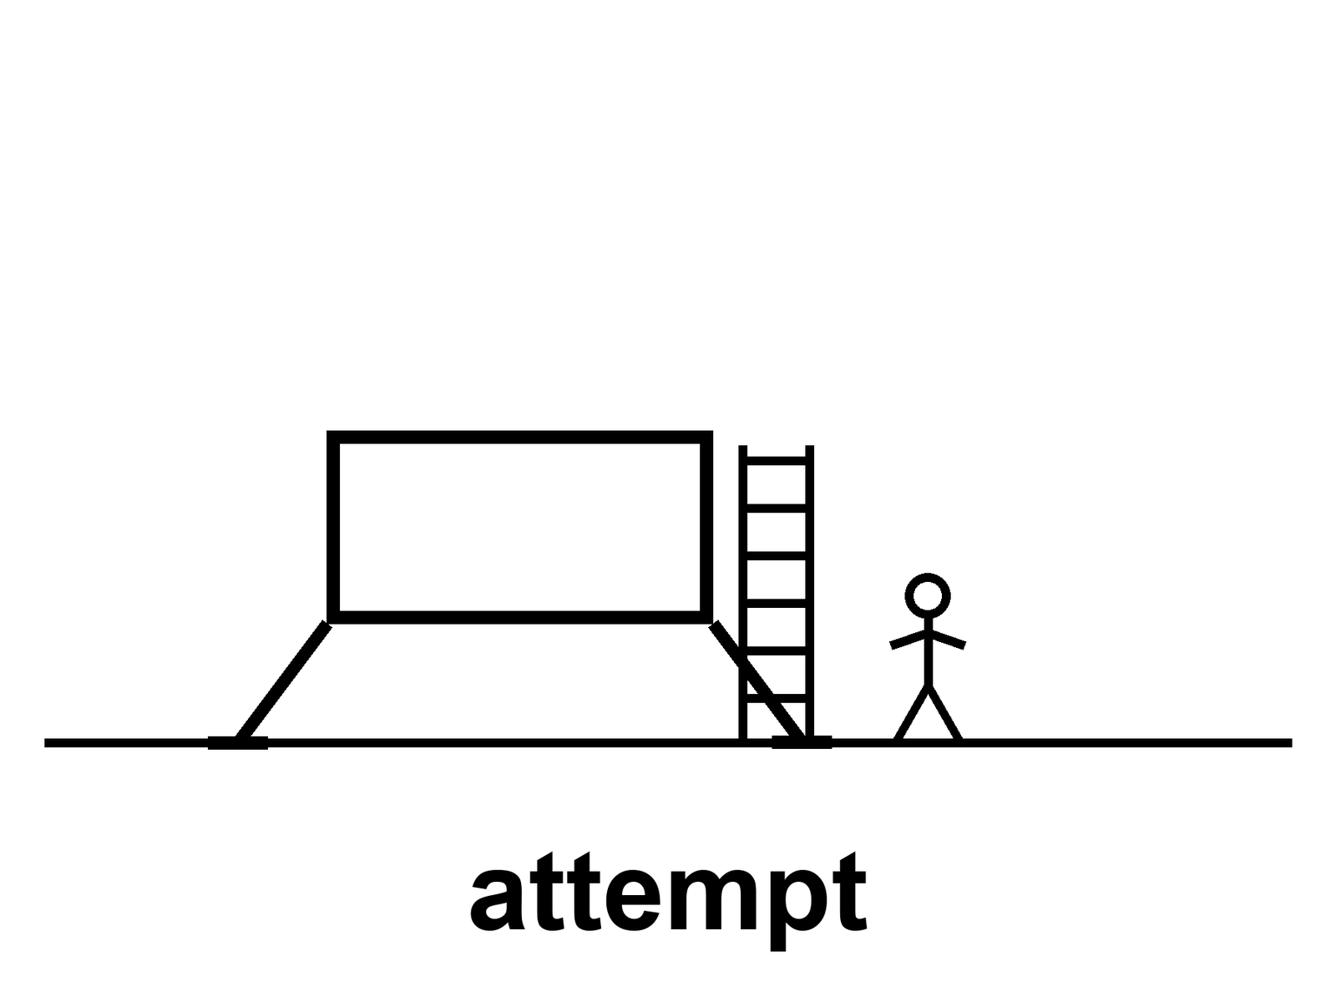
Figure 7. A lander on bright dirt, one figure, a ladder. The caption: attempt. No skyline.
The long poles have names. They do not have a single year that is a landing gear.
Refuel. If the lander is a heavy stack that arrives in pieces, someone must pour propellant in orbit the way you pour a second pot of coffee: many times, without making a bomb. That pour has been a paper, a test, a hope, a clip. Routine pours are the unpaid invoice. One pour is a dare. A campaign of pours is a trucking company. Chapter 10 is the trucking company. Here, notice that a landing architecture that requires the pour cannot honestly print a month before the pour has manners.
The last kilometer. No air to bite. Engines that must throttle or stage or both. Dust that will sandblast the vehicle you need to leave in. A slope that was a pixel on a map and is a decision at ten meters. Abort, this close, is a different novel than abort on the way out from Earth.
Leave. The part the flag photographs skip. You must light again, from a well, with a vehicle that has sat in dust and cold and a night, and you must meet the cabin that will take you home, or be the cabin that will take you home. Apollo’s leave was a small, fierce, already-demonstrated trick by the time the public saw the flag. A new heavy lander’s leave is a new trick until it is not.
Suits. You must walk, bend, see, pick up, not cook, not freeze, not fill the bearings with glass dust, and get back in. A suit is a spacecraft you wear. Spacecraft slip. The glove is a workplace. The workplace has not yet done a shift on this dirt in this century.
The rest of the house. Power through a polar night or a polar “day” that is a long dusk. Navigation without a kindly GPS constellation, unless you brought one. A habitat that is the lander itself, or a can you sent ahead, or a tin that has not flown. Medical. Waste. The pH of something you are trying to grow, if you are arrogant enough to grow. Arrogance is allowed in a test kitchen. It is not a town charter.
“Attempt” is the word that keeps the temperature honest.
A program that says we will land in year X is printing a mood. A program that says we will attempt a landing in this class of years, once these poles are paid is printing an invoice. The second sentence can still be wrong. It cannot be as wrong as a downtown.
If the attempt happens and the crew walks and comes home, you have a flown sortie on dirt. Hot, the morning after, as a class of event that has rejoined the inventory. Still not a town. Apollo already taught this, and the century forgot it on purpose because forgetting is how you sell the next slide.
If the attempt happens and fails, you have a funeral or a miracle of abort, and a review, and a slip. The slip will be called a scandal by people who needed the downtown for a feeling, and a destiny by people who needed the failure for a feeling. Chapter 3 already refused both feelings as thermometers.
If the attempt has not happened when you read this, you are in the same kitchen this chapter was written in. The poles are still the poles. The year is still a mood.
Suit gloves have a designer. The dust is not invented. A box of lunar simulant that is not the Moon is still rude to bearings. A clean-room glove fails after an hour of glass. That failure is the long pole that photographs badly. The photograph wants a face in a gold visor. The visor is easy. The glove is the town, if there is ever a town: a person who can work. Work is not a flag. Work is a shift.
Mara’s airlock is a glove problem in a different gravity. She hits it. She thinks of a glove designer she has never met, and of a year on a slide, which she has met too often. The landing year, if it arrives, will not water the basil.
How to read a landable year without buying a downtown.
A year on a slide is a mood about several unpaid poles agreeing to be paid in the same season. Refuel with manners. A last kilometer that ends upright. A leave that lights after dust and cold have had their turn. A suit that is a workplace, not a costume. Power, navigation, a tin that is either the lander or a can that arrived earlier and did not become a fairy tale. Medical. Waste. A pH, if anyone is arrogant enough to grow. Any one of those can slip without being a con. Several of them slipping is what a program looks like when it is awake. A downtown requires all of them plus a school district. The slide will try to sell you the downtown as a free gift with the attempt. Refuse the gift. Buy the attempt as an attempt.
The leave deserves a second paragraph, because the flag photographs skip it on purpose.
Walking is the postcard. Leaving is the invoice. The vehicle that walked you down must sit in a vacuum that hates seals, in a dust that loves bearings, in a night or a long dusk that hates batteries, and then it must become a rocket again. Apollo’s leave was small, fierce, and already a demonstrated trick by the time the public learned the word egress. A new heavy lander’s leave is a new trick until a serial number has done it and come home. Until then, landable is a hope about going down. Returnable is the hope that keeps the attempt from being a one-way costume. This book will not let the costume wear a halo.
Refuel, again, because the architecture that needs it cannot hide behind a month.
A pour in orbit is not a garden hose. Cold propellant, zero-g, tanks that want to make weather inside themselves, a docking that must not become a collision, a campaign of pours if the lander is thirsty enough to need a trucking company. One successful dare is warmer than a paper. A calendar a planner can bet a crew on is hotter still and, as of many kitchens, still unpaid. If your landing story requires the pour, your landing month is a weather report about the pour. Say so. Do not print the month as if the pour were a footnote.
What a walked sortie buys, and what it still is not.
If boots touch and the leave works and the splashdown happens, you own a flown class: flesh on this century’s dirt, home on a schedule Earth still owns. Hot, the morning after, as inventory. Still a sortie. Still not a shift that repeats without a supply line. Still not a child. Still not a law court. Apollo already sold this lesson and the century returned it for a refund of feeling. Feeling is allowed. Feeling is not a thermometer.
The suit glove box sits under a lamp that is kinder than the Moon. The simulant is still rude. She times how long a bearing lasts. She writes the number on a card and tapes the card where a glossy print cannot cover it. The visor is a photograph. The glove is a shift. A shift is how a camp begins to stop being a jewelry box. A shift is still not a town. A town is closed loops and a childhood. The glove desk is not paid to invent a childhood. It is paid to keep a hand from becoming a failure mode.
On the delay, someone reads a landable year as if it were a casserole timer. Mara writes it under Earth says, next to a suit date that also slipped, next to a pour that is still a dare. She hits the airlock. The year, if it arrives, will be a morning. Mornings end. The tray does not care which morning.
If the attempt has already happened when you read this, you own a flown dirt sortie. You still do not own a school district. If it has not, you own the poles. Either way, refuse the marriage of ladder and skyline.
The heavy-stack lander at the front of the current American ledger does not arrive at the Moon full. It cannot. A hull that size, launched full, would not reach orbit; a hull that size, launched empty, reaches orbit with nothing to land on. So the architecture is a trucking company before it is a landing: launch the lander empty, launch a tanker, pour, launch another tanker, pour, and keep going until the lander has enough to go down and come up. How many tankers is a number the ledgers argue about in public — a dozen, more than a dozen, a number that depends on how much boils away while you wait and how much each tanker can actually deliver. Nobody outside the program has a serial number for it. That is not a scandal. It is an unpaid clause.
The pour itself is a sport nobody has played at this scale. Propellants this cold — liquid oxygen, liquid methane — want to boil; in orbit, in sunlight, they do. In free fall a liquid does not sit at the bottom of a tank; it floats in blobs and clings to walls, so the two hulls must nudge themselves gently to settle it before it can be moved. A leak in orbit is not a puddle. It is a cloud. The first attempts at moving propellant between tanks on a single hull have been made. A hull-to-hull pour, repeated as a routine, is the invoice Chapter 10 bills as routine, and it comes due here before anyone touches dust.
A landing that needs fifteen launches is fifteen chances for a slip. That arithmetic is why the honest noun is attempt, and why any program that prints a month before the pour has manners is printing a mood.
There is no satellite navigation at the Moon unless you bring it, and nobody has yet. A lander comes down on its own sensors — a radar, a laser rangefinder, cameras matching craters to a map — and on a computer that must decide, in the final minute, whether the ground below is a landing site or a boulder field. The site was chosen from orbit at a resolution where a slope that will tip you looks like a shadow. The decision is made at a few hundred meters, at a few tens of meters, and then it is no longer a decision.
A tall lander makes the problem harder. The heavy stack is a tower. A tower on a slope, on legs, in one-sixth gravity, has a center of mass that is a long way up and a footprint that is not wide. Landers this century have tipped at the mass of a car. The engines are the other issue: a rocket plume close to the surface digs, throws glass at the speed of a bullet, and can excavate a pit under the vehicle you need to leave in. So the designs put engines high on the hull, or use small ones for the last meters, or accept the pit. Every one of those is a choice with a test behind it or a test still owed.
There is no abort to orbit in the last few seconds. You are landing, or you are a crater.
Leaving, which the flags skip.
The last century solved leave with a small engine that used propellants that light on contact — no igniter to fail, no pump to seize, one chance, and it worked six times. A modern heavy lander leaves on the same engines it landed with, engines that have sat in dust and cold, that have been sandblasted by their own plume, and that now have to light and throttle and steer a tower off a slope and up to a meeting with a cabin that is coming around every couple of hours. If the meeting is missed, there is a second pass, and a third, and a life-support clock that is running.
Apollo’s ascent was rehearsed uncrewed, in orbit, before anyone trusted it with people. The new lander’s leave will be rehearsed the same way — a full uncrewed landing and ascent is part of the ledger — and until that rehearsal has a serial number, leave is a contract.
The suit, which is a spacecraft you wear.
A suit for the surface has to do everything the cabin does — pressure, air, cooling, communication, a place for the waste — and it has to bend. The last century’s suits bent badly and abraded in three days. A modern suit for a polar shift has to bend well for hours, in glass, at temperatures that swing across two hundred degrees between sunlight and shadow, and let the person inside see, reach, pick up a rock, climb a ladder, and fall over safely. Then it has to get back in the airlock without bringing the dust in with it, which the last century never solved and which Mara’s airlock, on a different world, is still failing at.
The gloves are the worst of it, which is why a glove lab exists in this book. A pressurized glove wants to be a balloon. Every time a hand closes, it fights the balloon. Hours of that and the fingertips bruise and the nails lift; the last century’s crews lost fingernails. Add dust in the wrist bearing and the fight is against grit as well as air. The glove lab’s box of simulant is not the Moon. It is close enough to seize a bearing in an afternoon.
Suits, as a class, have slipped in public. That slip is a noun. It is a good slip to read, because it tells you exactly what the program is waiting for: not a year, a wrist.
Two landers, so the pour is not the only story.
A second lander, from a second logo, is on the same ledger for a later attempt — smaller, differently fueled, its own pour problem in a different currency. That is not redundancy for its own sake. It is a legislature refusing to hang a landing on a single trucking company. Two ledgers of lander mean two sets of long poles. They do not mean the poles are shorter.
In a lab that smells of powdered basalt, a suit tech runs a wrist through its thousandth cycle in the dust and writes the number down. On the delay, Mara hears that the landing has moved again, and that the sentence attached to the slip names the suits. She is almost glad. A slip with a wrist in it is a colleague. She hits the airlock. It sighs. Nobody has solved the seal on either world.
Two ledgers building landers is not an accident. That is the competition.
A single-provider architecture is a single point of failure with a launch schedule. The current program’s decision to fund two independently developed landers — different companies, different fuels, different approaches to a refueling problem this chapter keeps returning to — was not generosity. It was a lesson learned from the era when a single shuttle program’s fleet was grounded for years, twice, after single failures, with no backup vehicle able to fly a single American astronaut to orbit in the interim. A program with one lander is a program that stops entirely the day that lander has a bad morning. A program with two landers, competing on separate technical paths, can lose one and still have a path forward, at the cost of paying for two development efforts instead of one.
This is expensive. It is also, on the evidence of the shuttle era, the cheaper of two expenses, because the other expense is a gap: years with no capability at all, paid for in political capital, in international partners’ patience, in a workforce that scatters to other industries and has to be rebuilt from nothing when funding returns. Redundancy is not a headline word. It is an insurance policy, and like every insurance policy, it looks like waste right up until the year it is not.
The suit contract, as its own small drama.
A separate competition, run in parallel to the landers, exists for the suits themselves, because a lander that reaches the surface with no suit a person can actually work in has landed a very expensive empty room. Two firms, again, were funded to develop competing designs, for the same redundancy logic as the landers: a suit is not a costume, it is a spacecraft, and a program with one supplier for its only spacecraft small enough to wear is a program betting its entire surface mission on one company’s bearings never failing in the field. The glove, as earlier chapters have said, is the unphotogenic long pole. It is also, on paper, now a two-horse race, which is the correct number of horses for a race you cannot afford to lose.
An abort, walked through in the order it would actually happen.
Picture the descent, not the brochure’s version but the checklist’s: engines lit, the lander falling toward a chosen site, altitude and velocity both dropping on a curve the computer is tracking against a pre-loaded profile. At any point before the final seconds, an abort means firing the ascent engine, separating from the failing descent stage, and climbing back to a rendezvous with the orbiting cabin — a maneuver rehearsed, uncrewed, as part of the same test campaign already described, because a crew’s first abort cannot be the first time the maneuver has ever been attempted. In the final tens of seconds, close enough to the surface that a climb-out is no longer survivable, the abort options narrow to almost nothing: the crew is committed to landing, on whatever ground is beneath them, however the sensors last described it.
This is the part of “attempt” that the word itself is doing real work to convey. An attempt with a genuine abort envelope, rehearsed and published, is a different temperature than an attempt where the abort envelope is still a paper diagram. Ask, of any landing architecture that names a year: has the abort sequence been flown, even once, even uncrewed? If yes, the attempt has earned a shade more warmth. If the answer is still a rendering with arrows on it, the year is decoration on an untested parachute.
The seals are not defenseless forever. Dust can be fought back.
Electrodynamic dust shields — thin, transparent electrode grids laid over a solar panel or a visor, pulsed with an alternating electric field that lifts charged dust particles and sweeps them off the surface — have been tested in laboratory chambers and on at least one small flown experiment, with published results showing a meaningful fraction of accumulated dust cleared within seconds of activation. The technology traces back to industrial electrostatic precipitators, the same physics that scrubs particulate pollution out of a power plant’s smokestack, repurposed for a much smaller and much more expensive problem.
It is not yet a suit-integrated system flown on a real EVA glove or a flight-tested airlock seal, which is exactly why this chapter has spent so many pages calling dust the unphotogenic long pole rather than a solved footnote. A laboratory demonstration is warm, in this book’s vocabulary: a genuine trick, promising, not yet inventory in the sense a flown, field-tested, multi-cycle seal would be. Mara’s airlock, on a different world, would not be helped today by a demonstration in a vacuum chamber on Earth. It would be helped by a seal that has done the job in that actual dust, on a mission, more than once. That flight has not happened yet.
This chapter introduced the word “attempt” to describe a landing that has not yet flown, and the word outlives that first use. It is worth noticing that the word does not retire once a landing succeeds. Every subsequent landing, at a new site, in a new season, with a new crew, is its own attempt, because the last kilometer’s risk does not amortize the way a manufacturing cost does. A program that has landed once safely has retired some risk — proven the vehicle, the software, the suits — and still owes the word to the next site, the next slope, the next dust condition nobody has flown into before. “Attempt” is not a temporary hedge this book will eventually let go of. It is the honest permanent name for what a landing is, on any world without an air traffic control tower to certify the runway first.
Not every emergency happens in the air. Some are pad aborts.
Beyond the in-flight abort just described, a crew capsule of this class is built to survive a failure on the pad itself, in the seconds before or during ignition: a dedicated abort system, separate from the main engines, capable of pulling the capsule and crew clear of a failing rocket at high acceleration, deploying parachutes, and landing safely, all within a span of well under a minute from the moment the abort is triggered. Real abort-system tests, flown specifically to validate this capability before it is ever trusted with a bad morning, have demonstrated the sequence working exactly as designed, at full acceleration, launched from an actual pad, with an instrumented but uncrewed capsule standing in for the crew the system exists to save.
A pad abort is, in a strict sense, the least glamorous possible use of a vehicle’s most dramatic-looking hardware: an escape system built, hoped-for, tested at real cost, specifically so that it is never actually needed for the reason it was built. A program that tests its abort system and never has to use it in anger has not wasted the test. It has spent money precisely the way this book has argued money should be spent throughout: on the invoice for a lesson nobody wanted to need, paid in advance, so the actual bill, if it ever arrives, is smaller than it would otherwise have been.
Appendix A7 writes the long poles — refuel, last kilometer, leave, suits — as a list you can keep when the logo changes. Here, keep the ladder and the word attempt. A landable year is not a town.

8. Gateway and the Architecture Fights
A station in lunar orbit is a choice, not a law. Camps have floor plans that change.
Warm-to-cold: a winter-over. Months. Cargo from Earth. A Gateway or a surface tin that changes drawings because architecture is a fight, not a destiny. The fight is allowed. Treating the current drawing as a city charter is not.
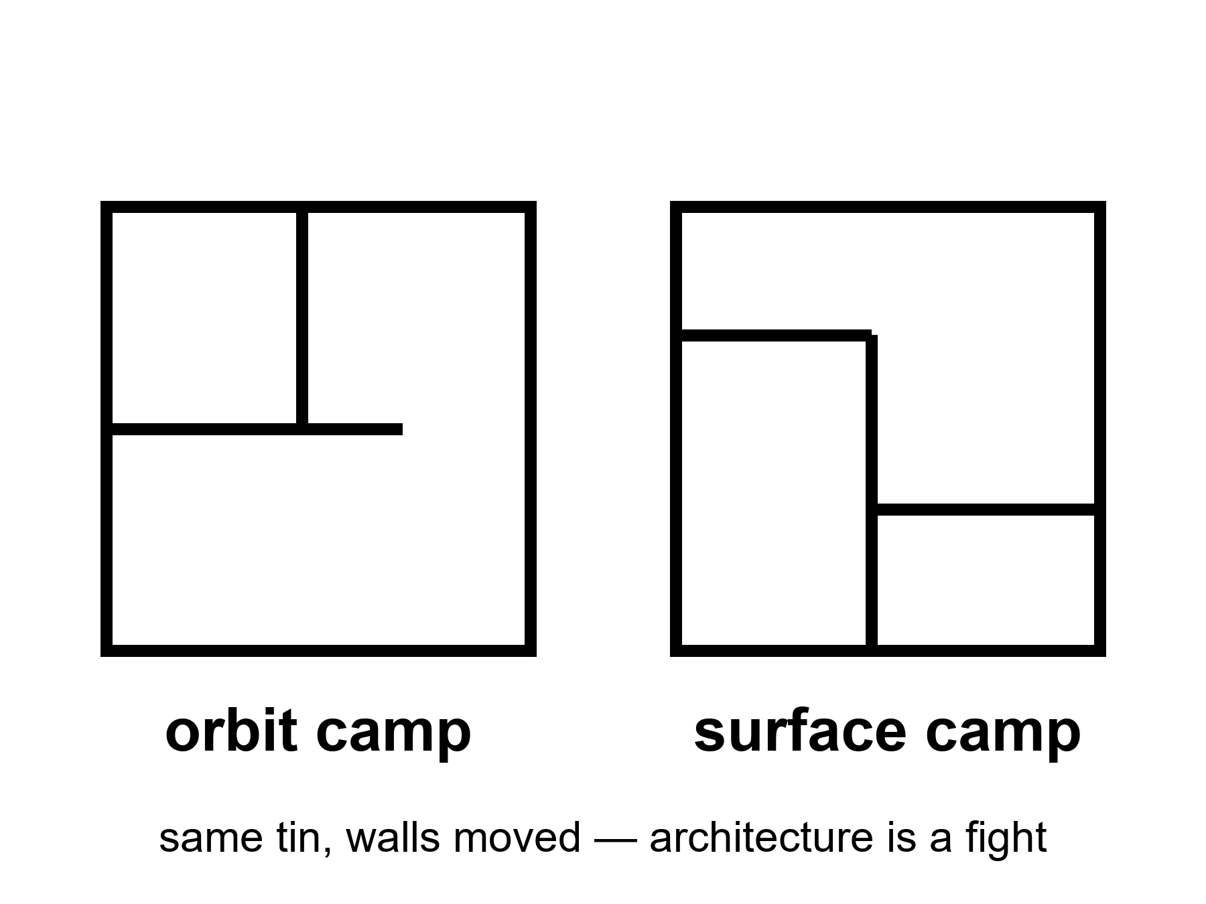
Figure 8. Two floor plans, same dirt: a can in a high odd orbit; a tin on the ground. A fight, not a law.
Gateway, in the American ledger and its partners’ ledgers, is a small station in a near-rectilinear halo orbit — a path that is a compromise between seeing the Moon, seeing Earth, and not spending a fortune every time you want to go down or go home.
NRHO is a high, lopsided lunar orbit that stays in view of Earth for long stretches and is not “low Moon” in the postcard sense.
A can in that path can be a staging porch: park, refuel, wait, send a lander down, catch a lander up, hide from a solar storm, run a science rack, let a crew sleep somewhere that is not the lander. It can also be a porch you paid for and then found you did not need, if the lander can go from Earth-side to dirt and back without the handshake. That sentence is the fight.
Surface-first people say: every kilogram in the halo can is a kilogram that is not a tin on the ice, not a rover, not a power cable. They say a porch is how you never arrive. Orbit-first people say: every crew that has no porch is a crew with one failure mode away from a very long wait, and a lander that is also a house is a house that must also be a rocket. Both are engineering sentences. Both can be true in different decades. Neither is a law of nature. A law of nature does not issue a contract amendment.
Architecture fights are how you know you are in a program and not a brochure. A brochure has one floor plan. A program has a graveyard of floor plans and a meeting that is late.
What a station is not.
It is not a town. The International Space Station is the existence proof: a magnificent, expensive, continuously staffed outpost in a well we already own, with a supply line from Earth that has never been optional. People have lived there for months. Children have not been raised there as a civilization. The umbilical is the point. Cut the cargo and the outpost becomes a problem, then a wreck. A lunar Gateway would be a smaller, farther, colder cousin of that outpost. Months, if it is lucky. Cargo from Earth. A science rack. A porch. Warm-to-cold as a sustained camp in the 2030s–2040s, because the fight can move a decade and the cargo still has to climb a well.
It is not required by physics. Physics requires a path, a Δv, a place to stand. Physics does not require a particular can in a particular halo. If a later architecture fires the porch and lands from a different path, the porch will have been a choice that was useful or not, like a kitchen island. Kitchen islands are not laws.
It is not a moral. People will try to make it one: we must build the station or we are not a serious species. Seriousness is a habit of invoices. It is not a floor plan.
The station fight has a wall of versions. Version 3 had a habitat the size of a bus. Version 6 shrank it. Version 8 added a partner’s module that then slipped a year. Version 9 asked whether the landing needed the handshake. Nobody hates any version. Everybody should hate the sentence “the architecture is settled.” Settled is what you say about a house you are no longer allowed to improve. Camps should not be settled. Camps should be honest about being camps.
Mara does not have a Gateway. She has a tin and a delay. On the delay, someone is still arguing about a porch she will not see. The argument does not water the tray. The argument might, someday, change whether a person like her has a spare can to run to when the seal fails. That is a real stake. It is still not a city.
What the fight is actually about, once the logos sit down.
Mass. Delay. Failure modes. Who owns the spare.
Surface-first says the halo can is a tax on every kilogram that could have been a tin on ice, a cable, a rover, a bag of dirt for a roof. Orbit-first says a crew with no porch is a crew whose lander is also their only house, and a house that must also be a rocket is a house with one bad morning between a person and a very long wait. Both sentences can be true in different decades. Both can be wrong for a particular stack. Neither becomes a law because a contract was signed in a kind year.
NRHO is a compromise orbit, not a romance. High, lopsided, kind to Earth view for long stretches, not “low Moon” for a postcard. It is a porch height chosen so the handshake is affordable and the radio is not a sulk. If a later lander can go dirt-to-Earth-side without the handshake, the porch’s job shrinks. If a later lander cannot, the porch’s job grows. Architecture is allowed to notice which decade it is in. Destiny is the word that forbids noticing.
A winter-over — months, not a week — is the temperature that turns a porch or a surface tin from a sortie prop into a camp question. Cargo from Earth stops being a nice-to-have and becomes the umbilical. Power through a polar night or a long dusk stops being a slide and becomes a failure mode with a name. Dust finds every seal that a week-long visit could ignore. Medical becomes a library and a protocol, not a phone call with a surgeon on the line in real time — though the Moon’s second-and-a-third is still a kindness Mara does not have. Warm-to-cold as a sustained camp in the 2030s–2040s means: the fight can move a decade, the cargo still has to climb a well, and the camp is still a camp. Months are not a childhood. Months are a roster with a return ticket, if the ticket holds.
ISS as a cousin, not a template for a skyline.
People have lived on the International Space Station for months and years of cumulative time. That is hot as a fact about continuous staff in a well we already own. It is also the existence proof of the umbilical: cargo, spares, a politics of resupply, a toilet that has a spare philosophy. Cut the cargo and the outpost becomes a problem, then a wreck. A lunar Gateway would be smaller, farther, colder, and still married to Earth for its groceries. Using ISS to prove that “we already live in space, therefore a downtown is next” is a costume. Using ISS to prove that sustained presence is an outpost craft is a temperature. Keep the temperature. Refuse the costume.
The version wall is not indecision. It is the program being awake. Version 3’s bus-sized habitat was a bet about mass and partners. Version 6’s shrink was a bet about cost and schedule. Version 8’s partner module was a bet about who pays and who slips. Version 9’s question — does the landing need the handshake — is the only question that can retire a porch without a scandal. Settled architecture is what you say when you want the meeting to end. Camps should not end the meeting. Camps should show the invoice for each floor plan and let a later decade pick without calling the pick destiny.
Kinds of clocks, again, because architecture fights love a single year.
There is the orbit clock: how often you can go down and come up without spending a fortune. There is the cargo clock: how often a well can be climbed with groceries. There is the partner clock: modules that arrive when nations and firms agree. There is the lander clock: whether the handshake is still required. Official pages will name a station year. The year is weather about those clocks agreeing. It is not a city charter. If the weather is rude, the porch slips and the dirt tin grows, or the dirt tin slips and the porch grows. The fight continues. That is allowed. Treating the current drawing as the only adult drawing is how you get a brochure with a serial number.
Mara, on a morning when the seal sticks harder than usual, thinks of a spare can she does not have. She does not need the can to be in a halo. She needs it to exist. Whether Earth builds it as a porch or as a surface tin is a fight among people who still have air. She hits the drawer. The fight can wait until the number is written.
The porch, walked once.
The near-rectilinear halo orbit that the current American ledger picked for its station is a strange path and it was picked for reasons. It is a long loop, about a week around, that swings close over the Moon’s south pole — a few thousand kilometers up — and then far out over the north, to something like seventy thousand kilometers, moving slowly there like a ball at the top of its throw. Because of the shape, a can in that orbit can see Earth almost all the time, avoids the Moon’s shadow for most of the year, and needs only small nudges to stay put. Those are engineering virtues. They are real.
The cost is the fight. From that orbit, going down to the surface and coming back costs more speed change — more propellant, more mass — than it would from a low, close orbit. So every lander that uses the porch pays a toll for the porch’s convenience, and every kilogram of toll is a kilogram not on the surface. The surface-first people did that arithmetic and did not like it. The orbit-first people did the arithmetic on a crew stuck on the surface with a broken lander and no porch, and did not like that either. Both did arithmetic. Neither found a law.
A floor plan is a set of trades that can be re-traded — and a law of nature is a thing that cannot.
The porch’s ledger, as of this kitchen.
Two modules first — a power-and-propulsion tug and a small habitat — built, delayed, built some more. Partner nations’ cans behind them: a larger habitat from Europe, life-support pieces from Japan, a robotic arm from Canada, which is how a legislature buys a seat in a cabin. Launch years that moved. And, in the budget year this book was written in, a proposal from the executive to cancel the porch outright, which the legislature declined to fund as a cancellation, so the modules stayed in their buildings and the fight stayed a fight. A porch that can be fired by a budget memo and rehired by a committee is warm-to-cold by definition. It is also, and this matters, a porch that exists as hardware in a room. That is warmer than most of the drawings it competes with.
The honest cousin, in numbers.
The station over Earth has been continuously staffed since November 2000 — more than a quarter of a century of somebody always being up there, in shifts of about six or seven, for about six months at a time. It weighs something over four hundred tonnes. It makes its own oxygen by splitting water with electricity and recovers most of its water from breath and sweat and urine — better than ninety percent, on a good year — which is a magnificent piece of plumbing and still not a closed loop, because the water it splits and the food it eats and the spare parts it breaks all come up on ships. Several ships a year. A few tonnes each. Cut them and the station has months, not years.
It is the most successful outpost in the history of the species, and it is scheduled, around the end of this decade, to be pushed into the sea by a tug built for the purpose. Outposts end. They end when the ledger that feeds them decides the porch is done. That is not a tragedy. It is what the middle noun is. A lunar porch would be the same thing, smaller, farther, colder, with a longer cargo line and a worse power problem and no possibility of a crew coming home in a few hours if the air goes bad.
People will ask about Antarctic manners.
There have been people at the bottom of the world every winter since 1957. The station at the pole itself winters about fifty; the big coastal base runs to a thousand in summer and a couple of hundred in winter. Its floor plan has been rebuilt three times — a buried camp, then a dome, then a building on stilts that can be jacked up as the snow rises. Nobody has ever called it a city. Nobody has ever called it a spare continent. Nobody has raised a child there as a civilization. It has a cargo calendar, a fuel tank the ships must fill, and a rule about when the last plane leaves before the dark. That is an outpost being honest about being an outpost. Its floor plans changed because floor plans change. The ice did not issue a contract amendment.
A lunar camp with those manners — a winter-over, a cargo calendar, a plan for the last plane — would be a magnificent middle noun. The slide keeps trying to give it a school district.
An architect, at the version wall.
She has nine drawings on the wall and a tenth in her head. The tenth has no porch. She does not love the tenth. She loves that she is allowed to draw it. When a junior engineer asks which version is the architecture, she points at the wall and says: the one with the most scorch marks, once there are scorch marks. Until then, they are all floor plans, and the fight is the program.
On the delay, Mara hears a committee has funded a porch for one more year. She thinks about a spare can, high over a pole she will never see, and about whether a person like her would have somewhere to run to when a seal finally fails. She would like there to be a porch. She would like it to be honest about being one.
The fight resolved, for now, the way these fights resolve: with a memo, not a law.
In March 2026, the American ledger’s administrator paused the halo-orbit station in its existing design and redirected its budget toward hardware on the ground — a phased surface plan costing about twenty billion dollars over roughly seven years, opening with a stream of robotic landings and aiming, once crewed landings begin around 2028, for one about every six months.⁸ The two modules already built for the porch did not go to a scrapyard; they went into a drawer marked repurpose, the way a floor plan that loses a fight often does. Partner nations that had built pieces for the porch were left to decide, on their own clocks, whether their hardware still had a home. One partner agency gave itself until June to decide.
Read this the way the chapter has taught you to read everything else in it. The fight did not end because someone found a law of nature. It ended because a ledger changed its mind about which kilogram was worth flying, which is exactly the kind of decision this chapter said the fight was always going to come down to. Surface-first won a round. It has not built a settlement. It has not even built the outpost yet; it has built a decision to try. The porch is not dead as an idea — a future architecture could still want one — but the specific can in the specific halo that this chapter described as a live fight was, as of this kitchen, no longer being funded to fly in that form. Update the temperature. The three nouns did not move.
A station is more than an orbit. It is also a habitat.
A can in a halo orbit is not a single object. It is a stack of modules, each built by a different partner, each with its own life-support contribution, its own docking standard, its own political owner back on Earth. The habitat module at the center of the design — the part a crew would actually live inside during a stopover — was contracted separately from the power-and-propulsion module that flies it, on the theory that distinct partners are good at separate things and a station built entirely by one country’s contractors is a station one country’s budget fight can kill outright. This is the same redundancy logic Chapter 7 just walked through, applied to diplomacy instead of engineering: spread the dependency, and no single failure, political or mechanical, ends the whole program.
It is also, this chapter has to admit, the same logic that makes the whole structure fragile in a different way. A station built by five negotiating partners is a station that can be delayed by any one of the five, and has been, more than once, by exactly that mechanism: a module slips because a partner’s own budget cycle slipped, and the slip ripples through a schedule that was never really one program’s to control. The 2026 pause this chapter’s closing section already described did not happen because the engineering failed. It happened because one partner, holding the purse for the whole architecture, decided the porch was not worth building yet. The other partners are still deciding, on their own clocks, what their own modules are for now.
What a partner’s hardware becomes when the plan changes.
A module built to dock with a station that is no longer being funded does not disappear. It sits in a clean room, fully built, fully tested, waiting for a decision that is not its builder’s to make. This has happened before, in other programs, and the hardware has sometimes found a second life — repurposed onto a different vehicle, donated to a distinct mission, occasionally simply mothballed until a later decade’s architecture finds a use for it. A piece of flight hardware, once built, is one of the most expensive objects a species has ever manufactured. Nobody scraps it lightly. It waits. That is the honest fate of most of the porch’s built pieces as of this kitchen: not cancelled, not flying, waiting.
A station has to move itself into place first. That is the power-and-propulsion element’s job.
Before a habitat module can be lived in, something has to fly it to its orbit and keep it there, and the module built for that job on the halo-orbit station uses solar electric propulsion: large solar arrays feeding electric thrusters that produce a whisper of thrust — a fraction of a newton, comparable to the weight of a few sheets of paper — sustained continuously over months, rather than the brief violent burns a chemical engine delivers. The physics trade is real: electric propulsion is dramatically more fuel-efficient per unit of thrust, which matters enormously for a station that needs to reach a distant orbit and then maintain it for years, and dramatically slower to act, which is why chemical thrusters still handle any maneuver that needs to happen quickly.
The module was built, tested, and — as of this kitchen, following the pause described in this chapter’s closing section — sat largely complete, its fate tied to whichever architecture eventually claims it. It deserves its own mention, separate from the habitat it would have carried, because it is a genuine technology demonstration in its own right: continuous, months-long electric propulsion at this scale is not something every spacefaring nation has flown, and the module’s engineering achievement does not evaporate because the station it was built for got paused. A flown technology is flown inventory, in this book’s accounting, whether or not the program around it survives intact.
A porch is not only a place. It is also a phone line — a relay.
Separate from the habitat-and-propulsion architecture described above, several partner agencies have committed to a shared lunar communications and navigation relay concept — a constellation of small satellites in lunar orbit, functioning for the Moon roughly the way a GPS constellation functions for Earth, providing both a positioning signal a lander could use for precision touchdown and a relay for data that does not require a direct line of sight to Earth. One agency’s version of this concept has flown a technology-demonstration payload already, proving out elements of the navigation signal in lunar orbit ahead of a fuller constellation.
The relay concept matters here because it answers a question the porch-versus-surface fight leaves open: even in an architecture with no crewed halo station at all, something still has to orbit the Moon to make a positioning signal and a communications relay possible for a busy surface program running multiple camps and multiple ledgers at once. A relay constellation is a porch in the narrowest possible sense — infrastructure in orbit that a surface program depends on — without any of the habitat mass, the life support, or the crew rotation that made the larger station such an expensive fight to have. It may turn out to be the piece of the porch that survives the pause described above, precisely because it is the cheapest piece and the hardest one to do without.
A last floor plan, sketched only to be refused.
A third architecture, discussed less publicly than the halo-orbit porch or the direct surface approach, would place a station not around the Moon at all but at one of the gravitationally balanced points between Earth and the Moon, where a spacecraft can sit with minimal propellant for years — real orbital mechanics, genuine papers written about it, no hardware committed to it by any current program. It belongs on the list for the same reason every other floor plan does: not because it will fly, but because its existence as an option proves, one more time, that no single architecture is a law of nature. The fight has more chairs at the table than the two discussed here. Most of those chairs remain empty. Emptiness is not the same as impossibility.
This is not the first station to be traded for a new architecture. There is a precedent.
An earlier orbital station, operated by a different nation’s program across the 1980s and into the following decade, was itself the product of an architecture fight not unlike this chapter’s own: multiple modules, added over years, repurposed and reconfigured repeatedly as the program’s ambitions and budget both shifted beneath it, before the whole assembly was finally deorbited in a controlled reentry once its successor program — the same International Space Station discussed at length above — made continuing to fund two stations at once impractical. Its final crew left it not because it had failed, but because the ledger funding it had decided, plainly, that a newer floor plan was worth more than an older one still technically working.
The pattern this chapter has spent its pages describing is not new to this decade’s halo-orbit pause. It is the oldest pattern in the whole subject: a station is a floor plan, a floor plan is a choice, and a choice, once made, can be unmade by the next ledger that inherits the bill. The modules built for the paused porch are not the first flight hardware to wait in a drawer for an architecture to want them again. They are simply the most recent.
Appendix A8 writes NRHO, the porch-versus-dirt fight and its 2026 resolution, and why ISS is an outpost with an umbilical, not a template for a downtown. Here, keep the two floor plans. A fight, not a law — including the fight that just ended.

9. Other Flags, Other Ledgers
China, ILRS, partners: real precursors; a 2030s station is still a camp on paper.
Warm as intent and precursors; cold as a city. Chang’e-class work is hot. A research station named like a destination is still a camp.
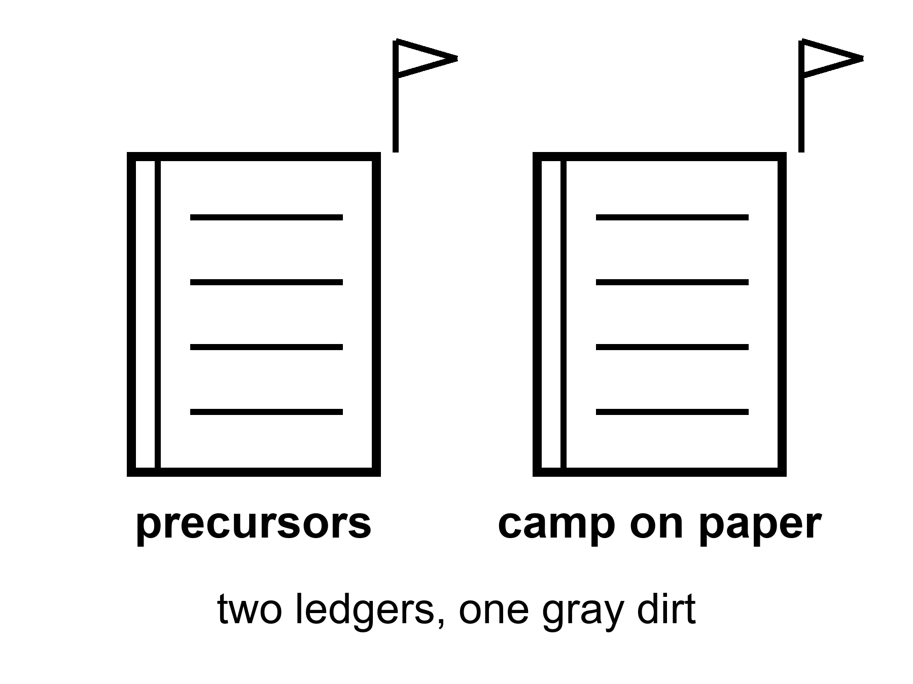
Figure 9. Two ledgers, two flags, one gray dirt. Precursors on the left. A camp on paper on the right.
The American ledger is not the only kitchen.
Chang’e-class landers and sample returns are flown facts, already billed in Chapter 5. Rovers on the familiar face and the far face. A relay satellite that made the far face less of a mute. A plan, with partners, for a camp they name the way you name a station: International Lunar Research Station, ILRS, on paper a 2030s presence at the south, after more precursors — a surveyor, a heavier lander, a cargo trick, a habit of showing up.
Intent is warm. Precursors that have already returned rock are hot. A multinational camp with a name is a drawing. Drawings are allowed. A drawing is not a downtown. A drawing of a research station is, at best, the middle noun: an outpost with an umbilical, weeks to months, cargo from Earth, a science rack, a flag that has company. Company is not a civilization. Company is how you split a cargo bill.
Other ledgers exist and will exist. India has landed and driven. Japan has dared a precision set-down that ended rude and still phoned home. Europe writes modules and rides. Commercial trucks want a service. A later decade will have more logos on the dirt. More logos is a temperature about access. It is not a temperature about children who do not need a supply ship.
Two ledgers do not make a city by addition.
People who like races will say the race is the settlement. A race is a reason a legislature pays. It is not a biosphere. Two outposts that cannot feed themselves are two outposts. They can even be useful to each other — a spare pump, a radio, a political reason not to be reckless — and still be camps. The cut-cable test does not care how many flags are in the photograph. The test is: if the ships from Earth stop, do the babies still eat? Chapter 12 is the test. Here, notice that a second flag is often sold as the moment the first flag became a town. It is the moment the dirt got busier.
Look first, on a rock that never had a biosphere, still means: do not pretend the camp is a spare Earth, and do not treat the Earth you left as already written off because a rival’s slide is prettier this year. The basil does not care which language is on the packet.
A far-side operator is an invented payload scientist in a desert who opened a far-side box and did not sleep. The rock does not belong to a downtown. The rock belongs to a measurement. She will write a paper that makes polar ice a little hotter or a little colder as a tank farm. She will not vote for a skyline. She has seen too many skylines in the hall outside the lab.
On Mara’s delay, a slipped date arrives in a language she does not speak, then in one she does. The date is a camp on paper. She writes it under Earth says, next to the other Earth’s date, which also slipped. Two ledgers. One tray. The dirt is the same dirt.
Kinds of clocks across ledgers, because dates love to impersonate destiny.
There is the precursor clock: landers and boxes already home. There is the partner clock: who signs, who slips, who brings a module. There is the south-pole clock: ice as a maybe-tank, power as a stingy coin, darkness in a crater that has not seen noon since before kings. There is the political clock in more than one capital. Official years will be named in more than one language. They will move in more than one language. The class does not care which language moved. The class is: precursors hot, paper camps warm, cities cold.
A far-side operator sleeps after the far-side box, finally, and dreams of a skyline she did not vote for. She wakes and writes a paragraph about water histories instead. On Mara’s delay, two slipped dates sit side by side in the log, like two weather reports for the same dirt. She hits the airlock. She logs the pH. The tray is one tray. The dirt was never a race.
Access is not a biosphere.
More logos on the dirt raise the temperature of getting there. They do not raise the temperature of staying without ships. Two outposts that cannot feed themselves can share a spare pump and still fail the cut-cable test the moment Earth goes quiet. A race can fund a legislature. A race cannot grow a grandmother of a bird on a rock that never had one.
ILRS on paper is a drawing with partners. Drawings buy metal sometimes. Metal is an outpost’s friend. Metal is not a civilization. a far-side operator’s far-side box is hotter than any named station that has not yet had a winter-over. Keep the box in the inventory. Keep the name in the wish column until a roster repeats.
Mara files two slipped dates from two ledgers. The tray is one tray. The dirt does not speak either language.
Partners are a cargo bill, not a biosphere.
Splitting a cargo bill is how outposts stay honest. Splitting a cargo bill is not how settlements are born. A second ledger’s surveyor is hot when it returns data. A second ledger’s named station is warm as intent. Keep the temperatures on separate lines so a race cannot launder a camp into a civilization.
Two ledgers, one cut-cable test.
A race funds metal. Metal can be an outpost. An outpost with company is still an outpost. The test does not care how many flags are in the photograph. The test is whether babies eat if Earth goes quiet. Keep precursor rock in the hot column. Keep named stations in the warm-intent column until a winter-over is inventory. Do not let a prettier rival slide write off the kitchen you already staff.
The other ledger, itemized.
The Chinese program has a habit this book respects: it announces less than it does, and then it does it. A far-side landing with a relay in 2019, when nobody had tried. A near-side sample return in 2020. A far-side sample return in 2024 from a basin near the pole, with a second relay to carry the signal. Two rovers that outlived their warranties. That is the hot column, and it is not a rumor.
The warm column is longer and dated, and the dates will move, but the classes are clear. A polar survey mission in the class of this year or next with a lander, a rover, and a small hopping craft meant to jump into a shadowed crater and sniff for ice. A follow-on in the class of the late 2020s that carries experiments in making things from dirt — bricks, oxygen, the first modest tricks of the middle noun. A crew program with a new cabin and a new lander, both of which have had ground tests and abort tests in public, aimed at a crewed landing in the class of before 2030. And a paper station, the International Lunar Research Station, announced in 2021 with Russia as first partner and a list of others that has grown since, with a basic version in the class of the mid-2030s and an expanded version a decade after.
Read it with the index card from Chapter 2. Landers, rovers, cans of rock: flown. Cabin and lander for a crew: articles and tests. The station: a drawing with signatures. A drawing with signatures is warmer than a drawing. It is an outpost on paper, which is to say it is a promise to build the middle noun, and it is not the third noun by any addition of flags.
There are more than two ledgers here.
India has landed and driven, has a crewed program in low orbit that has slipped in the ordinary way, and has said out loud that it wants a person on the Moon by about 2040. That is a class of intent with real precursors behind it. Japan has landed on its nose and phoned home, has bought seats in the American cabin with hardware, and is building a pressurized rover — a small camper for the surface — that is a genuinely new object and also not a town. Europe builds the service module that pushes the American cabin around and has a lander of its own on paper for about the end of this decade. South Korea has an orbiter. The Emirates have flown a rover that did not get the chance to drive. Commercial trucks from several countries want a service and are learning, in public, how to stand up.
More logos on the dirt is a temperature about access. It says: the last kilometer is becoming a thing many ledgers can attempt, which lowers the price of a lesson. It says nothing at all about whether babies eat when the ships stop. Access is the middle noun’s umbilical getting more suppliers. Suppliers are not a biosphere.
What a race buys, and what it does not.
The last century ran a race, and the race bought a walk. Then the race ended, because races end when someone wins, and the walks ended within three years of the first one. The hardware was scrapped or put in museums. The shifts never started. That is the cleanest lesson in the history of the subject and it is the one the race enthusiasts skip: a race is how a legislature pays for a sortie, and a sortie is what a race delivers. Nobody ever won a kitchen.
This century’s two big ledgers will be described as a race by people on both sides, because the word moves money. Fine. Let it move money. Just do the accounting. Two outposts in the 2030s, if both arrive, will be two outposts. They may share a radio frequency and a rescue protocol and a habit of not being reckless within sight of each other, and all of that is good, and none of it closes a loop.
One paragraph of law, because a flag is not a deed.
The treaty that every ledger has signed, since 1967, says that no state may claim the Moon or any other body as its own. Flags are photographs. Footprints are photographs. Under the law as written, nobody owns the dirt. Two newer sets of principles — one American-led, one Chinese-and-Russian-led — try to say how camps should behave near each other and whether a company may keep what it digs. They disagree politely. They have not been tested, because nothing has been dug. Law is a temperature too: hot that nobody may claim, warm that someone may mine, cold that anyone owns a town. When a slide shows a national color on a lunar map, remember that the color is a wish about a treaty, not a fact about a rock.
A sample scientist, with the box open.
She does not think about flags when the lid comes off. She thinks about the fact that the material in the tray is older than most of the rock she has ever held, and that it comes from a hole in the Moon so large it changed the shape of the far side. She will spend a year on a few grams. Someone in the hall will spend an afternoon on a skyline. She knows which of the two will still be true in a decade.
On the delay, Mara gets two slipped dates in one packet, in two languages, for two camps she will not visit, and writes both under Earth says. Then she writes the pH under dirt says. Two ledgers. One number that is actually hers. The dirt, on every world, keeps a single set of books.
A partner list is a real document, not a mood. That is the Artemis Accords.⁹
Beyond the hardware ledgers named above, a separate framework — a set of nonbinding principles for how nations should behave while operating near each other on the Moon, first signed in 2020 and added to by dozens of countries since — exists specifically to answer the question this book keeps circling: what happens if two camps, from two ledgers, end up close enough to argue over the same crater. The Accords ask signatories to register their activities, to avoid interference with each other’s operations, and to establish safety zones around their own hardware without claiming the underlying territory, a careful distinction meant to stay inside the 1967 treaty’s ban on national appropriation. It is a promise, not a wall. It has not yet been tested by an actual dispute over an actual crater, because no two camps have yet built hardware close enough together to have the argument.
A separate, non-overlapping set of signatories has assembled around the rival station framework this chapter’s own appendix already named, and the two lists share almost no members, which is its own kind of data: the split is not merely technical, it is diplomatic, and a partner nation’s choice of which list to sign is now a foreign-policy decision as much as an engineering one. Read a partner’s signature the way this book has taught you to read everything else. It is warm as intent. It is not yet an outpost, and it is certainly not yet a settlement. It is a name on a document, next to a name on a different document, and the crater both documents are theoretically about has, as of this kitchen, no hardware on it at all.
The comparison people reach for is usually wrong. Look at budgets as a share of the whole instead.
Apollo-era spending peaked, in the mid-1960s, at a little under four and a half percent of the entire federal budget of the nation running it — a figure so far beyond anything spent on civil space since that it functions, in most people’s minds, as the baseline against which “how much do we spend on space” gets measured, and is also, precisely because of that, deeply misleading. Current civil space spending, across the same nation’s budget, runs closer to four-tenths of one percent: roughly a tenth of the Apollo-era peak, as a share of a federal budget that has itself grown enormously in absolute terms since. A commentator who compares “we used to spend so much on Apollo” to “we spend so little now” is comparing a wartime-footing anomaly to an ordinary peacetime program, and the comparison, however emotionally effective, is not the fair one.
The fair comparison is harder to make and less often made: what would it actually cost, as a share of a modern budget, to fund a program at Apollo’s old intensity, and is any nation currently choosing to do that. No major spacefaring nation, as of this kitchen, is spending anywhere near Apollo’s peak share on civil space, China included, by every public and independently estimated figure available. The race framing refused earlier gets easier to refuse once the actual spending is on the table: two nations spending a few tenths of a percent of their respective budgets are not locked in an Apollo-scale race. They are two ordinary programs, funded at ordinary peacetime levels, that a great many slides would like you to imagine as wartime.
The trucks keep teaching the same class. Here is a commercial lander’s own hard lesson.
A Japanese commercial company’s first lunar landing attempt, in 2023, misjudged its altitude during the final descent — its onboard software, encountering a crater rim its terrain-matching system had not expected, discarded a valid altitude reading as erroneous, then ran out of propellant still believing itself higher above the surface than it actually was, and struck the ground in a free fall from several kilometers up. The same company’s second attempt, in 2025, using a redesigned guidance approach built specifically to fix the first failure’s identified cause, again failed during descent, for a different documented reason involving a laser rangefinder that returned data inconsistent with the vehicle’s actual altitude in the final phase.
Two failures, two different root causes, from a company that had, by every public account, taken the first failure’s lesson seriously and engineered directly against it. This is the least comfortable honest fact this chapter can offer: fixing the cause of one failure does not retire the risk of landing at all. The last kilometer, this book has said from its first mention of the phrase, is a sport, and a sport with this few attempts flown does not yet have a track record long enough to distinguish bad luck from a still-undiscovered systemic flaw. Both companies and both nations involved in this pair of failures are, as of this kitchen, still trying. That, more than either failure alone, is the actual hot fact worth keeping: the trucking company has not yet quit the route.
Not every nation has to pick a side. Some partners choose neither list.
Several spacefaring nations have, as of this kitchen, signed neither of the two competing partnership frameworks this chapter’s own appendix has already named, choosing instead to fly bilateral agreements with individual missions on a case-by-case basis — a rover seat here, an instrument contribution there, unattached to either larger architecture’s long-term commitments. This is not indecision. It is a third temperature this book has not yet named directly: access without alliance, real inventory without a flag planted in either camp’s future. A nation that flies this way accumulates genuine hot facts — flown hardware, actual data — while keeping its options for the following decade entirely open. It is, on the evidence of this whole book’s argument about slips and architecture fights, possibly the most honest posture on the table.
A satellite needs a reason on the ground too. That is the relay’s other half.
A lunar relay network of the kind Chapter 8’s appendix describes only earns its keep if enough traffic exists to relay — enough landers, enough rovers, enough surface camps from enough ledgers generating enough data that a shared constellation is cheaper than each program building its own single-purpose antenna. This is itself a bet on the traffic this chapter has been cataloguing: more logos, more landers, more precursors, adding up not to a settlement by addition — that arithmetic was refused two chapters back — but to a genuine shared utility that only makes engineering sense once enough independent programs exist to share it. A relay constellation, in other words, is one of the few pieces of lunar infrastructure whose case for existing gets stronger, not weaker, the more separate ledgers are operating on the same rock. Access is not a biosphere. It can still, occasionally, be a shared phone line worth building together.
The phrase “safety zone” does real and contested work. Examine it closely.
The framework this chapter’s appendix has already named permits a signatory to establish a “safety zone” around its own operations — a notification area, not a claim of territory, meant to prevent another nation’s uncoordinated activity from interfering with sensitive hardware nearby. Critics, including officials from nations that declined to sign the framework, have argued in public forums that a safety zone, however carefully worded to avoid the language of territorial claim, functions in practice as a soft version of exactly that: an area another actor is expected, by informal pressure if not by binding law, to simply avoid, which is most of what a claim would have accomplished anyway, dressed in more careful language.
The framework’s defenders respond that the alternative — no coordination mechanism at all, with every camp free to land wherever it chooses, including immediately adjacent to another nation’s existing hardware — is worse, and that a notification-based safety zone is a genuinely modest tool next to an actual claim of sovereignty, which the 1967 treaty cited earlier still flatly prohibits regardless of what any later framework says. Neither side of this argument has yet been tested by an actual crater with two nations’ hardware close enough together to force the question. Read the debate the way every other unresolved fight in these pages should be read: as a real disagreement, warm as a diplomatic question, with no hot answer yet, because no ships have actually had to share a neighborhood.
Appendix A9 writes Chang’e-class facts, ILRS as a paper camp, and other partners as a list that will rot and be replaced. Here, keep the two ledgers. Precursors are inventory. A name on a station is a wish that has started to buy metal. Metal is not a city.
Rule: More flags are access, not a biosphere. Precursors are inventory. Metal is not a city.

PART III — Vehicle, Not City

10. Starship as a Vehicle, Not a City
A ship that is large and, one day, cheap per tonne is a vehicle. If Starship-class flight becomes routine — cadence, refuel, a hull that does not make the news every time it lights — the mass you can throw changes. That is warm. Routine is the unpaid invoice.
A vehicle does not print air. A vehicle does not print a law. A vehicle does not print a childhood that can survive the week the cargo does not arrive.
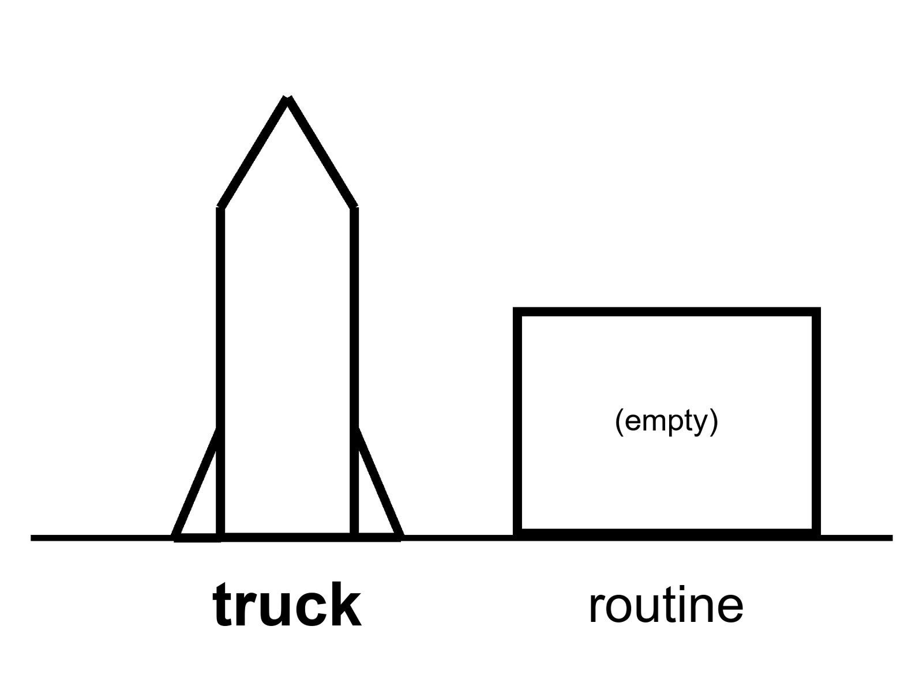
Figure 10. A large hull on a pad, daylight, no skyline. The label: truck. Routine is an empty box beside it.
The eye wants to fuse. A hull the size of a building looks like a building. A building looks like a block. A block looks like a town. The fusion is how an announced year becomes a downtown in a single still. Refuse it. Size is a mass budget. A mass budget is a wonderful thing if it is real. It is not a biosphere.
What “cheap per tonne” would actually change, if the unpaid invoice is paid:
You could throw tanks, not thimbles. You could throw a tin that is a room, not a closet. You could throw spare pumps, spare suits, a pile of dirt-moving machines, a nuclear kettle, a greenhouse kit that is not a metaphor. You could, in a lucky decade, throw the first cargo of a camp that is trying to become the middle noun. That is a real increment. It is why this chapter exists instead of a sneer. A species that can throw mass like a drunk trucking company is a different species of project than a species that throws a few tonnes a year and calls each one a jewel.
What it would not change:
The six millibars of excuse on Mars. The last kilometer. The twenty-minute argument. The twenty-six-month sulk if you miss the window. The ice that must be mined, cracked, stored, and not lost to a leak. The dust. The dosimeter. The pH. The fact that a baby is a life-support system with opinions. The fact that a town is a web of invoices — food, law, medicine, boredom, spare parts — that a hull cannot print by being large.
Routine is the word that has to sit still.
Routine means: lights, flies, lands or is caught, is filled again, does this on a calendar that a cargo planner can bet a camp on, and does not make the news every time.
One loud flight is a dare. A dozen loud flights are a test campaign. A hundred quiet flights are the beginning of a truck. We have, in this kitchen, a vehicle class that has lit, flown, broken, taught, and sometimes come back in ways that make a clip. We do not have, as of this writing, the quiet hundred. By the time you read this, the count may be kinder. The temperature of routine should still be earned, not declared. Declaring routine is how a slide cashes an invoice it has not paid.
Refueling is the other unpaid line. A heavy lander or a Mars stack that needs to be filled in orbit is a stack that needs a tanker company, not a tanker occasion. Transferring cryogenic propellant in zero-g without making a fountain or a bomb is a sport. The sport has papers and tests. A camp that depends on the sport cannot print a month that the sport has not yet survived.
Reliability is the third line. A trucking company that loses one hull in twenty is a headline. A trucking company that loses one in twenty when the hull is also a house is a funeral program. The number that would make a planner sleep is ruder than the number that makes a clip.
A cadence board has a column for hoped and a column for flown and a column for still on the news. He is tired of people pointing at the hull and saying city. He likes the hull. He likes it the way a person likes a truck that might, if it learns manners, move a house. He will not live in the truck and call the parking lot a town.
Uncrewed Starship on Mars this decade because a year was announced: cold as a schedule, and in February 2026 the operator itself put the Moon first.¹⁰ The vehicle is real and unfinished. Mars EDL — entry, descent, landing, the last violent minutes of any arrival — life support, and ISRU are not promises you can cash. A lucky window might take a loud hull on a long fall and try to hit a thin air. That sentence is allowed as a dare. It is not a town. It is not even an outpost. It is a vehicle, thrown, if it is thrown.
Mara hears the clip on the delay — a catch, a light, a cheer in a room she will never sit in. She is glad for whoever keeps the cadence board, whom she has not met. The hull did not print the water. The ice did, yesterday, because she and Rohan bullied it.
What a planner actually bets on.
A cargo planner for an outpost does not bet on a clip. She bets on a rate: tonnes per window, windows per decade, losses per hundred lights, days to turn a hull around, whether the tanker company is a company or a dare. If any of those numbers is a wish, the outpost’s kitchen is a wish. ISS planners bet on a supply line that has already flown for a generation. They still lose sleep. A lunar or Martian planner who is asked to bet on a hull that still makes the news is being asked to staff a religion.
Mass is not only up-mass. It is down-mass if you want samples, and it is left-mass if you want a tin to stay. Left-mass is the unphotogenic increment a cheap stack would actually buy: a spare, a pile of dirt, a second pump, a kettle. Left-mass is how an outpost stops being a jewelry box. It is still not how a settlement starts. Settlement is closed loops, not a fatter umbilical. A fatter umbilical is a better outpost. Say so. Do not say city.
The count, so routine has a number to earn.
By this kitchen’s date, the heavy stack has flown a double-digit number of test launches from a single coastal pad. Several ended in the booster and the upper hull both being lost, on purpose or otherwise, in the ocean or the air, while engineers watched telemetry and called it data, which it was. Several ended with the booster caught back at the tower by the arms that launched it, a piece of engineering that looked, the first time, like a trick a slide would not dare to promise. The upper hull has reached orbital velocity, has opened and closed a cargo door in space, has restarted an engine in orbit, and has come apart on reentry more than once while its makers said the word “anomaly” and meant it.
That is a real column of flights. It is not yet the quiet column on the flight board. A quiet flight is one where nothing above makes the news, because the vehicle did exactly what a truck does: leave, work, come back, get filled again. Count the flights that were quiet in that sense and the number, as of this kitchen, is small. The count will grow. The chapter’s claim is not that it will fail to grow. The claim is that the size of the hull on the pad tells you nothing about which column you are counting from.
Reuse, which is the other half of cheap.
A rocket that is thrown away is a truck you buy new for every delivery. The economics of routine spaceflight depend on flying the same metal many times, the way an airline flies the same airframe for decades instead of scrapping it after one trip. The booster catch is aimed at exactly that: land the expensive first stage back at the pad, inspect it, refuel it, fly it again within hours or days instead of months. It has been done. It has not yet been done at a cadence a cargo planner could write into a contract with a straight face.
The upper hull is the harder half, because it goes faster, gets hotter coming home, and has to survive reentry with a heat shield made of tiles that must be inspected and, so far, partly replaced between flights. A tile that must be replaced after every flight is not reuse. It is a very fast way to build a new tile industry. The program has said, in public, that it wants tiles that need only inspection. It has not yet shown a hull that flew twice with the same skin.
What the cargo planner’s spreadsheet actually needs.
Take the four numbers from Chapter 10’s body — tonnes per window, windows per decade, losses per hundred lights, turnaround days — and note what each one is doing to an outpost budget, concretely. If a stack can throw a hundred tonnes to a lunar or Martian trajectory and does it reliably twice a year, an outpost planner can write a supply contract: this many spares, this many kilograms of food, this much left-mass, arriving on a date with an error bar she can insure against. If the same stack throws a hundred tonnes once every few years, with a coin-flip chance the flight scrubs or the hull is lost, she cannot write that contract. She writes a smaller, sadder one, built around a slower cadence with a fatter safety margin, which is the outpost we have already met in Chapter 8, and which is not waiting on this hull to exist.
The gap between those two spreadsheets is the entire distance between warm and cold in this chapter. It is not a gap the pad can close by lighting more often. It is a gap the pad closes by lighting the same way, on purpose, over and over, until “quiet” stops being a compliment and starts being boring. Boring is the goal. Nobody puts boring in a launch video.
A flight planner, revising the board.
He adds a fifth column this year: flew twice. It has one mark in it, for a booster. He does not add a column for the upper hull yet. He tells the junior engineer who asks why that a spreadsheet with an empty column is more honest than a spreadsheet that fudges the header. She writes “flew twice — upper stage” on a sticky note and puts it on the edge of his monitor, for the day it earns a column of its own. He leaves the note up. That is the correct way to want something.
Catching a booster is stranger than it sounds. Start with the tower.
A rocket the height of a forty-story building, descending under its own power, arrives back at the exact pad it left from and is caught, not by a net or a cushion, but by two mechanical arms mounted on the launch tower itself, closing around load-bearing points near the top of the booster in the last seconds before touchdown. The maneuver requires the booster to cancel almost all of its horizontal velocity, hit a vertical approach within centimeters of a fixed point in space, and time its final engine cutoff to the arms’ closing motion, all while carrying enough leftover propellant to make a mistake expensive in more than one sense. It has worked. It has also failed, publicly, more than once, and each failure has produced the same two costumes this book keeps refusing: the vehicle is a marvel, or the vehicle is a joke. It is neither. It is a difficult mechanical problem, solved often enough to be promising and not yet often enough to be routine.
The point of catching the booster at all, rather than landing it on legs the way the smaller, older vehicle in this same company’s fleet already does routinely, is mass. Legs and their supporting structure are dead weight on every single flight, forever, whether or not that flight lands. A tower’s arms are dead weight built once, on the ground, and reused by every booster that ever flies to that pad. The trade is real: more risk per landing, for more payload per flight, forever, if the risk can be brought down to an acceptable rate. Whether that rate has been reached is exactly the kind of number Chapter 10’s cadence relation was built to answer, and precisely the kind of number no sales deck will show you until the answer is flattering.
Starbase, as a place rather than a symbol.
The site where all of this happens is a strip of land on the Texas Gulf coast, built from nothing into a combined factory, test range, and small town over the course of roughly a decade, complete with its own zip code and, as of a 2023 municipal vote, its own incorporated city government. The site itself is part of the routine this chapter keeps demanding: a factory that can build a new booster in weeks rather than years is a different kind of industrial object than anything the Apollo or Shuttle programs ever operated, and the factory’s existence is real, hot, verifiable inventory, whatever temperature you assign to the vehicles it produces. A highlight reel shows the flight. It rarely shows the factory floor, stacked with hulls in various stages of assembly, that makes repeated flight even conceivable. The factory is the unglamorous half of “cheap per tonne.” It is also, on the evidence available, the half that is furthest along.
The fuel choice is an argument by itself. Start with the engine.
Every engine on the vehicle this chapter is describing burns liquid methane and liquid oxygen, a propellant combination chosen over the kerosene-and-oxygen mix that powered most of the previous century’s rockets for a specific, forward-looking reason: methane, unlike kerosene, leaves little to no sooty residue when it burns, which means an engine built to be reused dozens or hundreds of times does not need to be substantially cleaned or refurbished between flights the way a kerosene engine typically does. Methane is also, at least in principle, more plausible to manufacture from local resources on Mars than kerosene is — a chemistry that combines atmospheric carbon dioxide with hydrogen, extracted from ice, to produce both fuel and oxidizer, the exact trick this book’s Chapter 11 has already flagged as a hot miniature and a cold tank farm. The engine’s fuel choice, in other words, was made with a Martian return trip already in the design requirements, years before an uncrewed hull was anywhere close to flying.
Each of these engines produces on the order of two hundred thirty tonnes of thrust, and the booster stage carries thirty-three of them, clustered at its base, all of which must light, throttle, and in many cases steer in close coordination during ascent — a degree of engine-count complexity no previous vehicle has attempted at this scale, and a complexity that is itself a large share of why early flights lost engines mid-ascent without losing the whole vehicle: a design that can survive several engines failing out of thirty-three is a design with redundancy built into its very core count, a lesson borrowed, deliberately, from the way modern airliners are built to survive an engine failure rather than pretending one will never happen.
Payload, compared across the decades, so “large” has a number attached.
The Saturn V, the vehicle that threw crews toward the Moon last century, could lift on the order of a hundred forty tonnes to low Earth orbit — a figure that stood, unmatched by any operational vehicle, for over five decades after the program that built it was cancelled — the species built a machine, retired it for budgetary reasons having nothing to do with its capability, and then simply did not build anything as capable again for two generations. The vehicle at the center of this chapter is designed, in its fully reusable configuration, to exceed that figure once its reuse and refueling campaigns are genuinely routine — company-published targets have cited figures in the range of one hundred fifty to over two hundred tonnes to low orbit, expendable configurations reportedly capable of more still, though, in keeping with everything this book has argued about announced numbers, a company’s own target figure is a warm claim at best until a flight has actually thrown that mass and been weighed.
The comparison matters less as a contest between two eras’ engineering than as a check on the fifty-year gap itself. A species capable, once, of building a hundred-forty-tonne launcher did not lose the underlying physics knowledge in the decades it built nothing comparable. It lost the funding, the institutional will, and, arguably, the clear mission that had justified the first machine’s cost. The current vehicle’s target numbers are a bet that funding, will, and a plausible mission have all returned at once. The bet is not yet settled. The gap it is trying to close took fifty years to open.
A flight test is not a single binary result. That is what a test campaign actually tracks.
A single flight test in this vehicle’s development program is not read, by the engineers running it, as a pass-fail event the way a public broadcast tends to frame it. Each flight carries a list of specific objectives — did the booster’s boostback burn — the engine firing that reverses its flight path and sends it back toward the landing site — execute within tolerance, did a given engine’s throttle response match its model, did a heat-tile pattern survive a specific reentry condition — and a flight can achieve most of its objectives while still ending in a loss of the vehicle, or lose most of its stated objectives while technically completing its overall trajectory. A public audience, watching a live feed, tends to read the whole flight as one outcome: success or explosion. The engineers reading the same flight’s telemetry are reading a list, checking boxes, and a flight with a dramatic ending on camera can still be, on their own list, a genuinely good day.
A pad needs a government’s blessing before it needs a customer’s. That fight comes first.
Before the vehicle this chapter has spent its pages on could fly its early test campaign at all, its operator had to clear an environmental review conducted by the national aviation regulator, in consultation with wildlife agencies, covering the same coastal site this chapter’s own earlier note already named. The review process, spanning years and multiple public comment periods, weighed launch noise and heat against nesting shorebird populations, weighed increased traffic and light pollution against a protected wildlife refuge sharing a fence line with the pad, and ultimately approved an increased flight cadence with a list of required mitigations — some environmental groups, in public filings, argued the review had not gone far enough; the regulator and the operator maintained it had.
This is the same fight, in miniature and in advance, that Chapter 16’s later material describes at the industry scale. A single pad’s permit fight is not a footnote to the engineering story. It is a real gate a genuine program had to clear, argued in public, decided by regulators with no stake in the vehicle’s success. A reader who has only seen the flight footage has seen the part of this program that took the least legal effort to produce. The environmental review took years. The flight took minutes.
Appendix A10 writes mass, cadence, and why “cheap per tonne” is a conditional with three unpaid clauses. Here, keep the truck and the empty box. The box is labeled routine. It is still empty until a planner can bet a camp on it.

11. Mars Rhetoric vs Mars Engineering
Mars is where the boldest pictures live, and the people who draw them deserve a fair hearing. Their case is not silly. A second home for life would be insurance against a planetary catastrophe. Mars has the raw materials — carbon, water, nitrogen — that the Moon lacks. A frontier has, before, pulled talent, invention, and money that would not otherwise have moved. And a company that says Mars out loud has, in fact, built the most capable rocket of its era while saying it. This chapter grants the insurance motive, the chemistry, and the rocket. It asks only what the engineering asks: what has to work, in what order, before the picture is a place.
Rhetoric is a decade, a famous name, a child in a dome, a species that has become a two-world insurance policy. Engineering is a thin air, a fast arrival, a kitchen you have not built, a radio that is not a conversation, a window that is a fact about two orbits.
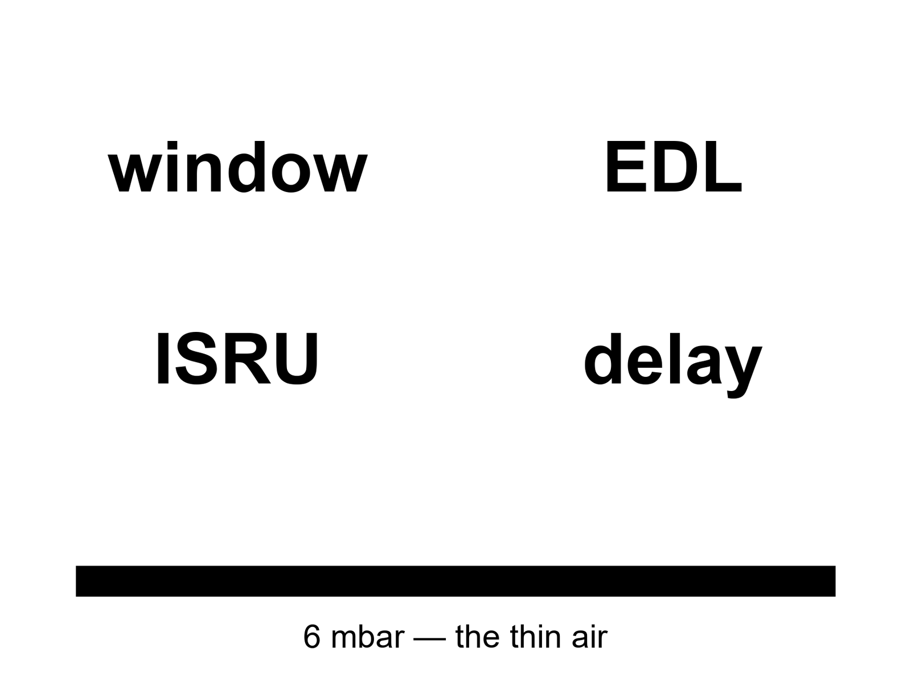
Figure 11. Four large nouns: window, EDL, ISRU, delay. No skyline. The thin air is a bar at the bottom.
Windows. A cheap path from Earth to Mars is a Hohmann-class fall: you leave when the planets are about to be kind, you coast most of a season, you arrive.
A Hohmann-class transfer is on the order of six to nine months, and the kind alignment — the synodic clock — repeats about every twenty-six months.
Miss the window and you wait on the clock, not on a mood. There is no “we will leave on Tuesday because the slide is lonely.” There is a season you can buy, then a long sulk. A camp that needs a resupply and misses a window is a camp that has just learned what an umbilical is. Twenty-six months is not a weather delay. It is a second calendar you do not get to vote off.
EDL. Entry, descent, landing. You arrive at a world with an atmosphere that is a rumor by Earth’s standards — about six millibars at the surface, a percent of a percent of what your lungs grew up in — and you arrive fast, because interplanetary falls are fast. You must spend that speed on a heat shield, a parachute that has almost nothing to bite, engines that must finish the job, a crane, a belly flop, a trick that has not yet been demonstrated at the mass of a house. Rovers have done a version of this at the mass of a car, with a decade of nerves and a sky crane — a hovering rocket stage that lowers the vehicle on cables, then flies off to crash somewhere safe — that still looks like a dare. A hull the size of a building is not a car. The thin air does not become thicker because the hull is famous.
Six millibars is the order of the surface pressure — a kitchen you cannot breathe, a parachute you can barely hire, a sky that is a lie the color of butterscotch.
ISRU. In-situ resource utilization: melt the ice, crack the carbon dioxide, print a spare, make the oxygen you will need to leave, make the methane if your engines drink that pair. MOXIE-class boxes have already, on a rover, made a breath of oxygen from the air that is mostly CO₂.¹¹ That is hot as a trick in miniature. It is not a tank farm. A tank farm is power, mass, a mine, a leak policy, a winter, a spare, a person who logs the numbers when the box sulks. Papers and prototypes exist. A city does not.
Delay. Light-time one way is about four minutes at a kind opposition — when Earth and Mars line up on the same side of the Sun, as close as the two orbits allow — and about twenty at the rude ends, when the Sun sits nearly between them.
The round trip is eight to forty-some minutes, and a conversation is a word you should retire.
You send. You wait. You receive a reply to a problem that has already become a different problem. Surgery, a software panic, a seal, a fight: you own them. Earth owns an archive of advice that arrives late. Mara already lives in this sentence. The renderings do not.
Crewed Mars landing in the 2030s: warm-to-cold. Allowed by hopium and by a lucky engineering decade. Not selected by present demonstrated pieces. The pieces we have photographed working are: rovers, a breath of oxygen, orbits, landings at car-mass, a vehicle class that is not yet routine, a species that has not yet walked on the Moon in this century. A lucky decade could stack those into a first foot. A first foot is a sortie. It is not a town.
Uncrewed hardware might be thrown in a lucky window this decade. Cold as a schedule if the reason is an announced year. Allowed as a dare if the vehicle earns the window and the EDL at that mass is not a wish. Still not a town.
A city this decade: cold. Children without a supply ship: cold. “Settlement” as a product you can buy by Friday: cold.
The rhetoric has a few favorite lies that are not quite lies.
Backup world. A backup is a copy that can run the job if the first copy dies. Mars, in the near term, cannot run the job. It cannot feed the species. It cannot take the leftover eight billion. It cannot even take a town without Earth in the inbox. Calling it a backup is how you stop washing the kitchen. Chapter 15 is the funeral of that sentence.
If we can go, we should, because the species must not keep its eggs in one basket. Eggs and baskets are a metaphor that photographs well. A basket that cannot hold the eggs is not a basket. A few thousand worldlines on a dead world are a field trip. They are not an insurance policy for a species.
The engineering is just details. Details is what EDL is. Details is what a six-millibar parachute is. Details is what a twenty-six-month miss is. Rhetoric calls them details when it wants a year. Engineering calls them the job.
EDL sims have killed more crews than a war, on paper, and saved none, on dirt, because the dirt has not yet been asked at this mass. He is not a pessimist. He is a person who has seen the thin air win. He would like the thin air to lose, once, in public, at a mass that matters. He will not call the loss a city.
Mara already knows the delay. She knows the window because her ride home is a window. She is tending the tray while a voice on Earth, twenty minutes ago, says a year that is a landing gear. She does not vote. The dirt does not vote. The orbits do not vote. The orbits are the only adults in the room.
Dust on Mars is not lunar glass and is still a personality. It is finer, magnetic in its moods, a thing that coats solar panels and lungs and the last kilometer of a landing that wanted to be tidy. A season-long dust event can turn a power budget into a dare. Opportunity — a rover, a car-mass, a saint of a machine — met a sky that would not clear. A house-mass camp meets the same sky with more to lose.
Power is the quiet long pole the renderings draw as a rectangle of gold foil. Gold foil is a rover trick. A tin that wants to melt ice, crack CO₂, run a greenhouse lie, and keep a person from freezing through a dust week wants a nuclear kettle or a farm of panels with a spare and a broom. The kettle has a politics. The farm has a dust. Neither is a skyline.
The EDL sims will not put a kettle on a slide that also has a child. They will put the kettle on a slide that has a dosimeter and a mass. That is the engineering. The rhetoric will sneak the child back in the hall.
Engineering keeps the four nouns in separate drawers.
Window is a synodic fact. EDL is thin air plus speed. ISRU is a miniature trick until it is a tank farm. Delay is a monologue. Rhetoric welds them into a decade and a child. Refuse the weld.
Backup-world talk fails the basket test: a basket that cannot hold the eggs is not a basket. A few thousand worldlines on a dead world are a field trip with good press. They are not insurance for eight billion ovens.
Earth and Mars line up favorably about every twenty-six months, because Mars takes roughly two Earth years to go around the Sun and the two planets slowly lap each other. Missions have left in these windows for decades: 2018, 2020, 2022, 2024, and on, each carrying orbiters, landers, or rovers from one or several nations, each riding the same free ride the orbits offer and nobody can move. A crewed mission that misses a window does not lose a season. It loses two years, because the next kind alignment is two years away and the one after that is two years past that.
A one-way trip in the window’s favor takes on the order of six to nine months, depending on how much propellant you are willing to spend to go faster. A round trip that also lets the crew come home in a following window, rather than waiting a season and a half on the surface for the planets to realign, tends toward missions of two to three years door to door, most of it in transit or waiting, a small fraction of it on the ground. That arithmetic is why every serious crewed Mars architecture, going back decades, keeps landing on numbers in that range. It is not a design choice. It is the solar system’s own calendar.
Stand on Mars and the air pressure is a little under one percent of sea-level Earth. At that pressure, water boils at body temperature; unprotected, a person’s saliva would begin to boil on the tongue within seconds, not from heat but from the absence of pressure holding it liquid. A parachute at that thinness has almost nothing to grab. Earth’s atmosphere lets a returning capsule shed most of its speed before the chute even opens; Mars’s atmosphere does not, so a lander arrives at the top of the chute-deployment window still going several times the speed of sound, and the chute, sized as large as engineers dare, still leaves the vehicle needing engines to finish the job in the final seconds.
A rover the mass of a small car has landed this way seven times, six of them successfully, using a heat shield, a parachute, and then — for the two most recent and heaviest — a hovering rocket stage that lowered the rover on cables and flew itself away to crash clear of the site, a maneuver named, with real affection by the engineers who built it, the sky crane. It has worked. It has also been described by its own team, before it flew the first time, as sounding “crazy” out loud, because it is.
A hull the mass of a house is not a scaled-up rover. The parachute that works for a car-mass lander does not scale linearly to a house-mass one; past a certain size, no parachute yet built is large enough, so heavier landers are expected to rely almost entirely on engines, firing through the last many kilometers of descent, burning propellant that has to have survived the whole trip from Earth. Nobody has landed a house-mass vehicle on Mars. The nearest anyone has come is landing a car-mass one, seven times, with one failure in the record.
ISRU, at the scale that would matter.
A washing-machine-sized experiment rode to Mars on the most recent rover and, over about two years, made oxygen from the Martian air in small test runs, a few grams at a time, proving that the chemistry works at that scale in that dust and that cold. Scaling it up to make enough oxygen to fuel a return rocket — tonnes, not grams — is not simply a bigger version of the same chemistry. It is a different machine, a separate power supply, another maintenance plan, and a new failure tolerance, because a life-support system that makes a little too little oxygen is an inconvenience and a return-fuel system that makes too little is a stranded crew. The experiment proved the trick. It did not build the tank farm. Chapter 7’s appendix already drew the same line for lunar ice; this is the same line, drawn again, elsewhere, with a thinner excuse.
The delay, lived rather than described.
At the kind end of the cycle, a radio signal takes a little under four minutes each way; at the far end, when the Sun sits nearly between the two planets, it takes over twenty, and for a stretch around that alignment the Sun’s own static drowns the signal entirely and nothing reliable gets through at all — a blackout window that mission planners simply build into the schedule, weeks at a time, during which a crew or a robot is genuinely alone. A round trip at the ordinary end of the range is eight to nine minutes; at the rude end, over forty. A surgeon on Earth watching a crisis unfold cannot offer anything faster than advice for a problem that no longer exists by the time the advice arrives. Mara already lives a smaller version of exactly this sentence. A Mars crew lives the large one, for years, not months.
An orbital analyst, running the numbers he does not enjoy.
He keeps a private tally, separate from the official one, of every EDL sequence that has ever been simulated for a house-mass vehicle and how many of the simulated failures happened in the last ninety seconds. The fraction is high, because the last ninety seconds is where the atmosphere runs out of ideas and the engines have to have every number right at once. He does not think this means it cannot be done. He thinks it means the first attempt at that mass, whenever it comes, deserves to be treated as the sortie it will be, not the down payment on a downtown a slide already promised.
He tells a colleague, once, that he would like to see the thin air lose, cleanly, in public, before he retires. The colleague asks what losing looks like. He says: a house-mass hull, intact, on the ground, with a crew or a full cargo inside it, having done nothing else yet. That is the whole ambition. It does not need a dome in the frame.
A catalog of the ways Mars has already said no.
Roughly half of all missions ever aimed at Mars, across every nation that has tried, have failed to reach the planet, enter orbit successfully, or land intact — a failure rate high enough that engineers in the field have, half-joking and half-not, called it the Great Galactic Ghoul, a standing bit of gallows humor for a planet that eats spacecraft with an appetite no other body in the solar system quite matches. A British lander, arriving on Christmas Day two decades ago, went silent seconds before its expected signal and was found, years later, in orbital photographs, sitting intact on the surface with its parachute nearby — it had landed, more or less, and then failed to phone home, for reasons never conclusively determined. A European orbiter’s own attempted lander, more recently, crashed after its guidance software convinced itself it had already landed while still a few kilometers up, and cut its engines early.
None of these are the failures a highlight reel shows. All of them are the actual record a house-mass crewed lander has to improve on, not the sanitized record of the missions that worked. The six successful car-mass landings credited earlier are real and they are also the minority outcome across the planet’s full history of visitors. Mars has been reached by robots from multiple nations. It has also refused more visitors than it has welcomed, and the refusals are not a curse. They are a planet with six millibars of air, unforgiving math, and no interest in anyone’s launch window.
A rover the size of a golf cart, solar-powered, operated for fifteen years against an original ninety-day warranty, an achievement its own engineers did not expect and the public rightly celebrated. It was ended, finally, not by a mechanical failure but by weather: a planet-encircling dust storm in 2018, thick enough to turn Martian noon into a darkness its own instruments measured as darker than a moonless night on Earth, starved its solar panels for weeks, and the batteries died a cold death from which the rover never woke. Its team’s last message, transmitted on its behalf and much repeated afterward, translated a final data readout into a human sentiment: my battery is low and it’s getting dark. The line was not written by an engineer for a press kit. It was read off a telemetry log by a person who had spent fifteen years talking to a machine and did not want to stop.
A house-mass crewed camp, dependent on solar power the way that rover was, inherits the same weather. A planet-wide dust event lasting weeks is not a rare tail risk. It has happened, publicly, within living memory, to hardware built by people who understood the risk perfectly well. Power through a dust week is not a chapter’s rhetorical flourish. It is a planet’s demonstrated habit, and any camp that plans around solar power alone is planning around a habit the planet has already shown it keeps.
The ghoul does not always win. Consider a cheap Mars mission that beat it.
An Indian orbiter, launched in 2013 on a budget publicly reported at a little under seventy-five million dollars — a figure repeatedly and correctly noted, at the time, as costing less than several Hollywood productions about space travel, a comparison this book will make exactly once and never again — reached Mars orbit successfully on its first attempt, making that nation the first in the world to succeed at Mars on a debut try, and doing it at a fraction of the cost any other successful Mars program had spent. The mission’s own budget discipline was real: a smaller instrument payload than most rivals, a longer, fuel-efficient trajectory rather than a faster and more expensive one, and a program office willing to accept a narrower science return in exchange for a launch that a national budget could actually approve.
The mission belongs here for the same reason the earlier failures do: it complicates any simple story. Mars is not simply a graveyard that expensive, careful programs escape and cheap, careless ones do not. A well-designed cheap mission, with modest ambitions honestly scoped to match its budget, can succeed where a more ambitious and better-funded one has failed. The lesson is not that cheap is safe. It is that ambition scoped openly to a budget is safer than ambition scoped to a leader’s hope, whatever the budget’s size, and the correlation between a mission’s price tag and its survival is weaker than either the boosters or the critics of any given program usually claim.
The phrase “seven minutes of terror” earned its fame honestly.
Engineers on the team that landed a rover in 2012 coined the phrase “seven minutes of terror” for the entry, descent, and landing sequence: the roughly seven-minute span between a spacecraft first touching Mars’s thin upper atmosphere and either a working rover on the ground or a smoking crater, during which the one-way light-time this book’s own appendix has already given you makes real-time control from Earth physically impossible. Every command for those seven minutes has to be pre-loaded, autonomous, and correct, because by the time a signal confirming atmospheric entry reaches Earth, the outcome — success or failure — has already been decided for several minutes. Mission control, during those seven minutes, is not flying the spacecraft. It is watching a recording of an event that has already finished, arriving late, the same structural fact Mara’s own tin has taught this whole book to respect.
Two landers before that one, in 1976, achieved the first fully successful landings and years of continuous operation on the surface, using a purely parachute-and-retrorocket sequence at a fraction of a later rover’s mass — proof, this early in the planet’s crewed-precursor history, that the six-millibar problem this chapter has spent pages on was solvable at small scale from the very first serious attempt. What has changed since is not whether landing works. It is how much mass landing works for, and the seven minutes have gotten no shorter, no less silent, and no less terrifying as the mass being risked in them has climbed from a car to, eventually, a house.
A last worked number: the parachute nobody talks about enough.
The supersonic parachute used on the two most recent car-mass rover landings deploys at roughly twice the speed of sound, opening in under half a second from a folded volume the size of a large duffel bag to a canopy over twenty meters across — an engineering feat significant enough on its own that a dedicated high-altitude balloon test program was built specifically to validate the design before it was trusted with an actual Mars landing, since no wind tunnel on Earth can fully replicate the combination of speed and thin air the real descent involves. The parachute is, by mass and by drama, one of the smallest components in the whole landing sequence. It is also, by the engineering team’s own account, one of the components they worried about most, because a parachute that fails to open correctly at that speed does not get a second attempt.
The rocks already collected, waiting for a ride that keeps slipping.
A rover currently operating on Mars has, across its mission, drilled and sealed dozens of core samples into small titanium tubes, left cached at points along its route specifically so a future mission could retrieve and return them to Earth — the actual sample-return half of the mission this chapter’s own inventory has already praised for its in-place chemistry. That retrieval mission, a joint undertaking originally planned for the current decade, has itself slipped repeatedly, its budget and architecture both revised more than once after independent review panels found its original cost estimate unrealistic by a wide margin, in exactly the anchoring pattern this chapter’s own appendix has already named.
The cached tubes are not going anywhere; Mars’s thin, dry atmosphere is, if anything, a better preservation environment for sealed metal tubes than most Earth storage would be. The real clock here is institutional, not physical: a return architecture that keeps slipping is a program that keeps re-arguing its own cost against competing priorities, the same fight this book’s Chapter 9 appendix has already shown you happening to a lunar station’s hardware. The rocks are patient. The budget process, on the evidence of this whole book, rarely is.
Appendix A11 writes the synodic clock, the Hohmann band, the six millibars, MOXIE-class oxygen, and light-time as a table that is allowed to sit still. Here, keep the four nouns. Window. EDL. ISRU. Delay. No skyline.

12. Three Nouns: Sortie, Outpost, Settlement
Three nouns. Keep them apart.
Sortie — you go, you work, you come home, or you die on a schedule Earth still owns.
Outpost — you stay a season with an umbilical.
Settlement — the umbilical can fail and the babies still eat.
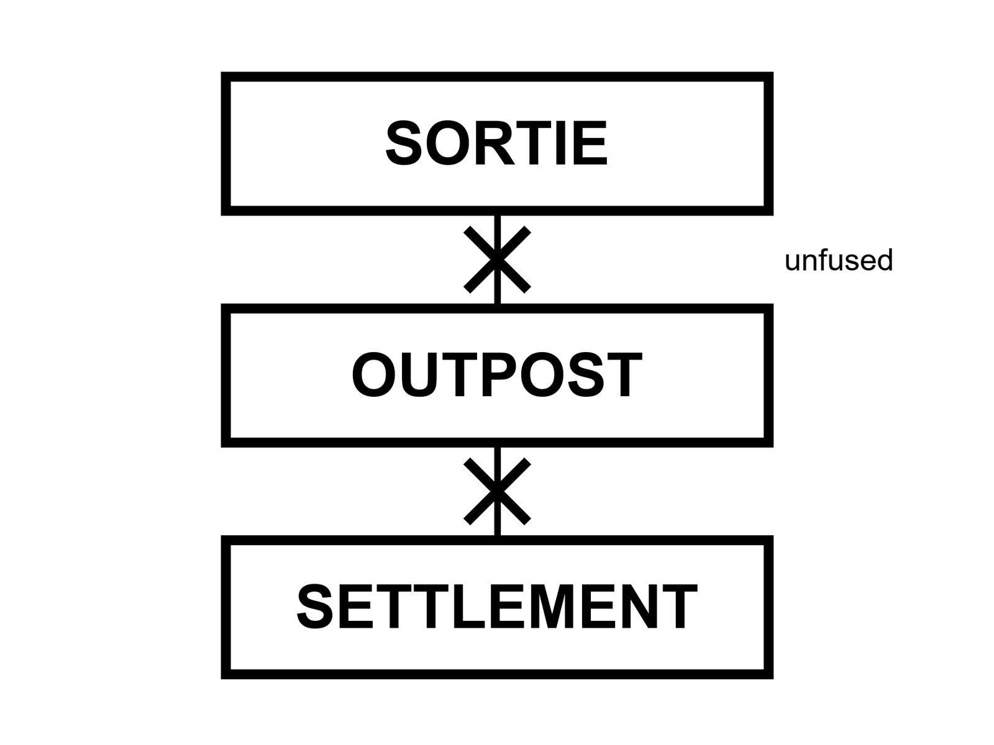
Figure 12. Three large words in a column, unfused. Sortie. Outpost. Settlement. A line through any pair that tries to marry.
This is the meeting-room chapter. The rest of the book has been refusing the marriage in pieces. Here the refusal gets a table and a test.
A sortie is Apollo. A sortie is an Artemis-II-class loop. A sortie is a landing attempt that walks and leaves. A sortie can be heroic, expensive, world-changing as a photograph, and still be a week or a month. The schedule Earth owns is the point. If Earth goes silent, the sortie is already a problem; if Earth stays loud, the sortie was never a civilization.
An outpost is a winter-over, a Gateway season, an ISS-class tin, a polar camp that eats cargo and returns science and rotates crews. The umbilical is the point. Cargo arrives, or the outpost becomes a dare. People can live months. People have lived months in Antarctica, on a station over Earth, in a tin that smelled like a locker. Months are not children. Months are not a farm that closes the loop. Months are the middle noun, and the middle noun is already a magnificent achievement if it is real. It is still not the third.
A settlement is the noun the boldest pitches borrow. The test is rude and clean. If the ships stop — a war, a budget, a plague, a missed window that becomes a missed decade — do the babies still eat? Not the adults on rations. The babies. A settlement has a closed-enough kitchen: air, water, calories, spare parts, medicine, law, a culture that can teach a child without a download from a dying Earth. No such kitchen exists on the Moon or Mars. No such kitchen is scheduled as a product this decade. Cold.
ISRU is the kitchen word for the middle noun trying to become the third: melt the ice, crack the CO₂, print a spare. Papers and prototypes exist. A city does not.
How the fusion happens in a room.
Someone shows a sortie photograph — a flag, a face, a loop — and says we are a spacefaring civilization. Civilization is a third-noun word. A photograph is a first-noun object.
Someone shows an outpost drawing — a can, a solar farm, a rover — and says the city begins here. Begins is a slide word. An outpost begins an outpost.
Someone shows a hull and says a thousand people. A thousand people is a cruise ship if the umbilical is fat, and a famine if it is not. Headcount is not the test. The test is the babies and the cut cable.
Someone says of course there will be cargo at first. At first is how the third noun is always promised and never billed. A settlement can have trade. Trade is not an umbilical that, if cut, ends the children. Earth’s cities trade. Earth’s cities also grow food in a biosphere that was not shipped last Tuesday. That biosphere is the unpaid character in every Mars downtown.
The cut-cable test, written so it can sit still.
A camp on a supply line is a camp whose kitchen depends on ships — the ships must come, the calendar of ships is the calendar of life, and the children eat the ships. There is nothing shameful in that. It is what an outpost is.
Antarctica is an outpost. It lives on a supply line and is honest about it. No one calls McMurdo a spare Earth.
ISS is an outpost. Cut the Progress, the Dragon, the Cygnus, and you have months of rations and then a problem.
A lunar polar camp in the 2030s–2040s, if it exists, will be an outpost. Warm-to-cold as a schedule. Honest if it says so.
A Mars town that cannot close air, water, and calories is an outpost or a sortie with a longer sulk. Calling it a settlement mislabels the inventory.
A review wall puts the three nouns up and will not let the slide use two in one sentence. The wall is a kindness. People who fuse the nouns are not always liars. They are often in a hurry. A hurry is how a flyby becomes a school district. The wall is the school.
Mara is the honest picture of how soon: not never, not downtown, a stuck drawer on a dead world, waiting on a window. She is an outpost of one tin, or two, with an umbilical that is a radio and a ship that has not yet left. She hits the airlock. She does not vote for the slide. The universe still does not have an opinion. The dirt does.
A meeting, written so you can steal it.
Three cards on the table. SORTIE. OUTPOST. SETTLEMENT. Point at the hardware on the slide and pick one card. If two fingers twitch, wait. If someone says “it’s a journey,” put the journey down and pick a card. Journeys are how nouns get married in the dark.
The room hates this for twenty minutes and then starts to tell the truth. The loop is a sortie. The polar tin with a cargo calendar is an outpost. The dome with the child is a wish. The hull is a vehicle that might feed the middle noun if routine is paid. Nobody is fired. The slide gets a rewrite. The rewrite is the book’s product: not a cancelled Moon, a refused marriage.
If you run a review and you cannot steal that meeting, you are still reviewing pictures.
Umbilical honesty.
ISS is magnificent and umbilical. Antarctica is magnificent and umbilical. Call them what they are and you can still love them. Call them settlements and you have promised something about babies that nobody can yet deliver. The wall with three cards is not anti-Moon. It is against mislabeling.
The test, made operational.
Three cards on the wall — SORTIE, OUTPOST, SETTLEMENT — are useful at a table. They are more useful as a checklist, because a checklist can be run against any program on any slide without needing the facilitator in the room. Here is the checklist, in the order a settlement would actually have to clear it, not the order a rendering shows it.
Air. Not a tank you refill from a ship. A loop: something growing, cracking, or scrubbing enough oxygen and carbon dioxide, at the mass and reliability of a system that does not get a spare part for years at a time if the ships stop, to keep the number of people you claim breathing.
Water. Not a cistern. A loop: recovery from waste and air at a rate that beats consumption, plus a source — ice, deep aquifer, whatever the local dirt offers — that does not run out on any clock shorter than the settlement’s own ambition.
Calories. Not a pantry. A loop: food grown, in enough variety and enough volume, under power that is also locally produced, on a cycle that survives a bad season without a resupply. No settlement anywhere on Earth or off it has ever run this loop without importing at least some inputs — but a settlement, as this book uses the word, means the loop can survive the imports stopping, not that the imports never happen.
Power. Not a battery. A source — solar with enough storage for the local night or dust season, or a reactor — sized to run the other three loops simultaneously, indefinitely, through the worst local weather on record, not the average.
Medicine. Not a first-aid kit shipped from Earth. The capacity to treat the injuries and illnesses a permanent population will actually have — including childbirth, including the diseases of age, including a surgical emergency — without a resupply, for as long as people are expected to be born and grow old there.
Spare parts and the tools to make them. Not a shipping container of spares. The capacity to manufacture replacements for the machines the other five loops depend on, from local material and local energy, because a settlement that must import every bearing is an outpost with a longer wishlist.
Law and culture that survive a cut cable. Not a flag. A way of teaching a child, governing a dispute, and holding a community together that does not require a download from a dying or absent Earth.
Score any real program against those seven rows. As of this kitchen, every human presence anywhere off Earth — the space station, every lunar or Martian mission ever flown, every polar base on Earth itself — scores zero on somewhere between five and seven of them. That is not a criticism of any program. It is the honest headline. Nothing yet built has attempted more than one or two of the seven loops, and none has closed even one of them without an ongoing subsidy from a place that already has all seven.
Why headcount is not one of the loops.
A slide will show a growing number — a hundred people, a thousand, ten thousand — as if the number itself were progress toward the third noun. It is not. A cruise ship carries thousands of people and closes none of the seven loops; it imports fuel, food, water, and spare parts on a schedule, and if the schedule breaks, the ship is a disaster, not a civilization. A city on Earth of ten thousand people is embedded in loops so vast and so invisible — a regional grid, a national food system, a planet’s atmosphere — that nobody notices them until one breaks. Transplant the same ten thousand people to a dead world with none of that invisible infrastructure and the headcount does not build the infrastructure. It just multiplies the number of mouths the seven loops have to feed, without multiplying anything that feeds them.
This is the fusion Chapter 12’s opening promised to refuse, made mechanical: a plan that says a million people on Mars by 2050 is naming a headcount, not a loop count. The people who say it may mean it as a direction rather than a date, and it is fair to take them at that word. Then ask, as a direction, how many of the seven rows the plan’s own engineering claims to close, and on what evidence, and the million collapses into the honest number, which is presently zero rows closed, some rows attempted, most rows not yet begun.
The meeting, run as a scoring exercise.
The wall now has the seven rows taped up next to the three cards. When a vendor or a program office brings a plan, she does not ask which card the whole plan deserves. She asks the room to score each row separately. A lunar polar outpost might score: air, attempted (paper ISRU); water, attempted (paper ISRU); calories, not attempted; power, in progress (solar plus storage, real hardware); medicine, not attempted beyond first aid; spares, not attempted; law and culture, not applicable at outpost scale. Seven rows, one genuine, several attempted, most empty. That is an honest outpost plan. It is not a lesser insult than calling it a settlement. It is a more useful sentence, because it tells the next engineer exactly which row to work on.
Nobody in the room finds this exercise fun. Several have told her so. She keeps doing it, because the alternative is a wall with one card on it and an announced year underneath, and the year is always a mood, and the card is always the third one, and the seven rows are always empty, and the room always claps anyway.
Mara, on the delay, hears a number — a headcount, a decade out, printed with confidence. She does not have a wall. She has a tray with a pH that is drifting again. She thinks about the seven rows without knowing she is doing it: her air comes from a tank and a scrubber that depend on a resupply; her water comes from ice she mines herself, which is one row, partly closed; her calories come from a tray that could not feed her without the tank’s oxygen and the resupply’s replacement parts. She scores herself honestly, in her head, and gets one row and a fraction. She is further along than most slides, and she knows it, and she still logs the number and does not call herself a settlement.
A worked scoring, so the seven rows are not only theory.
Take an invented but representative outpost plan — call it, for the exercise, a lunar polar camp funded for a mid-2030s crewed presence — and score it honestly against the seven rows laid out above, the way Elena’s wall would score it in a real review. Air: attempted, on paper, via electrolysis of mined ice, with a laboratory-scale demonstration flown but no continuous plant built. Water: same status, same caveat — a demonstrated trick, not a tank farm. Calories: not attempted beyond a greenhouse experiment flown on the station over Earth, itself still dependent on imported seed stock and imported nutrients. Power: the strongest row, with genuine solar hardware and actual battery mass committed, though the polar night problem remains a design choice rather than a solved equation. Medicine: a first-aid kit and an evacuation plan, no more. Spares: an import list, not a factory. Law and culture: not yet a meaningful category at outpost scale, since nobody has stayed long enough to need one.
Run the same exercise on a Mars settlement pitch and the scores get worse, not better, because every row that was merely thin on the Moon is, on Mars, additionally burdened by a two-year resupply clock instead of a monthly one. A missed lunar cargo window costs weeks. A missed Mars cargo window costs two years, and a settlement claim that cannot survive one missed window, on either world, has already failed the test this chapter exists to administer.
Steal the meeting, one more time, with a harder case.
Put a genuinely impressive program on the table — a lander that has flown, a habitat module that has flown, a greenhouse experiment that has produced real calories on a working station — and ask the room to score it anyway. The temptation, once a program has flown hardware, is to wave the scorecard away: surely all this metal means something more than an outpost. It does not, not automatically. Flown hardware raises a row from not attempted to attempted, which is genuine progress and still not closed. The scorecard’s entire discipline is refusing to let impressive metal skip a row. An outpost with excellent, well-funded, properly working air and power systems is still an outpost if its calories, medicine, and spares rows are empty. Impressive is not the same axis as closed. Keep them separate, especially when the hardware is good enough to make you want to stop counting.
Why this book does not say cargo cult.
Engineers have long borrowed that phrase for a system that copies the outward form of a working one while depending on a supply it cannot make. The phrase comes from mid-twentieth-century accounts of some Pacific Island communities after wartime airfields were abandoned, and anthropologists have argued for decades that the casual use flattens complicated religious and political responses into a punchline. Earlier drafts of this book used it anyway. This edition does not. The test needs no borrowed insult. Call it the cut-cable test: cut the supply line on paper and see which loops keep running. An outpost that depends on cargo and says so is honest. The failure mode worth naming is the other one: a camp that has built every outward form of a settlement — buildings, flags, a name — while still depending on a supply chain it cannot replace, and calling that dependency solved because the buildings look finished. The airstrip is not the airplane.
A closed-loop settlement has already been tried, on Earth. The result — Biosphere 2 — is instructive.
In 1991, eight people sealed themselves inside a three-acre glass-and-steel structure in the Arizona desert, built explicitly to test whether a fully closed ecological system — its own air, its own water, its own food, grown inside five biome zones ranging from a rainforest to a miniature ocean — could sustain human life with no material exchange with the outside world for two years. The experiment is the closest thing this book’s seven-row test has ever had to a real, funded, honestly attempted trial, on Earth, under gravity and pressure conditions vastly friendlier than the Moon’s or Mars’s, with a budget in the hundreds of millions of dollars and a design team drawing on genuine ecological expertise.
It did not close the loop. Oxygen levels fell unexpectedly, eventually low enough to require an emergency injection of outside oxygen partway through the mission — a direct, documented failure of the air row, caused by unanticipated microbial activity in the soil consuming oxygen faster than the plants could replace it, a chemistry nobody had modeled correctly in advance.¹² Food production fell short of projections, leaving the crew on a calorie-restricted diet for much of the two years, a documented failure of the calories row. Social tensions among the eight participants, by multiple later accounts, grew severe enough to split the crew into hostile factions before the mission’s end, an unplanned failure this book’s seven rows do not even have a column for, though “law and culture that survive a cut cable” comes close.
The lesson is not that closed loops are impossible. A second, shorter run of the same facility performed better on several of the same metrics, having learned directly from the first attempt’s failures. The lesson is that even under Earth’s own gravity, Earth’s own pressure, and Earth’s own free supply of ambient nitrogen, with a well-funded team of genuine experts and a two-year timeline, the seven rows did not close on the first honest try. A lunar or Martian settlement claim that has not yet even attempted five of the seven rows should be read against that benchmark, not against a rendering’s confidence.
Take the Antarctic station, already named honest, and score it against the same seven rows, for practice. Air: closed, in the narrow sense that Earth’s own atmosphere reaches the continent freely — not a fair comparison to an airless world, but note that the row exists only because Earth provided it for free. Water: locally sourced from melted ice, genuinely closed. Calories: entirely imported, a hard fail matching the Moon and Mars plans scored earlier. Power: generator fuel imported, a fail. Medicine: a real clinic, evacuation-dependent for anything serious, a partial pass. Spares: imported, a fail. Even Earth’s most isolated, longest-running outpost, with free air and free water no off-world camp will ever have, closes only two of seven rows. That is the candid baseline this whole book’s argument is built on, and it is worth knowing exactly how high that floor actually sits.
The scorecard, in one table.
Five kinds of presence, seven loops, one question per cell: if the ships stopped tomorrow, would this loop keep running here? Closed means it runs on local supply. Partial means a local loop exists but leans on imports. Tried means a demonstration, not a plant. Earth means it is shipped or borrowed from home. Claimed means a plan says so and nothing has yet shown it.
Figure 12a. The seven-loop scorecard.
Loop | Sortie | ISS-like outpost | Antarctic base | Lunar camp (2030s plan) | City claim
Air | Earth | Partial | Closed (free air) | Tried | Claimed
Water | Earth | Partial | Closed | Tried | Claimed
Food | Earth | Earth | Earth | Earth | Claimed
Power | Earth | Partial | Earth | Partial | Claimed
Medicine | Earth | Earth | Partial | Earth | Claimed
Spares | Earth | Earth | Earth | Earth | Claimed
Law | Earth | Earth | Earth | Earth | Claimed
Closed | 0 of 7 | 0 of 7 | 2 of 7 | 0 of 7 | 0 shown

Read across, not down. The station’s water row is a real triumph — about ninety-eight percent of the water on its American segment is now recovered¹³ — and it is still Partial, because the other two percent, and every spare pump, still ride up from Earth. The Antarctic base earns its two Closed rows from a planet that gives away air and ice. The city-claim column, for a claimed settlement, is not a sneer. It is the column a plan fills in by testing, row by row, until a cell can honestly change its word.
A scale this chapter has been using without naming, formalized.
The engineering discipline that studies technology maturity uses a nine-level scale, first developed for exactly the purpose this chapter’s seven rows serve: giving a program a shared, checkable vocabulary for how proven a given piece of hardware really is, running from a basic principle observed in a laboratory at the low end to a system flight-proven through actual mission operations at the top. A component sitting at a middle level — demonstrated in a relevant environment, but not yet in the actual mission environment it will eventually fly in — is precisely the zone this chapter has spent its pages calling attempted, warm, and not yet inventory. The scale did not originate with this book’s three nouns, and this book borrows its underlying discipline gladly: a number that forces a program to say precisely how proven a claim is, rather than letting anyone’s enthusiasm stand in for a maturity level nobody has actually measured.¹⁴
Score any settlement pitch’s individual technologies against this same nine-level scale, component by component, the same way its seven rows just got scored, and the two exercises converge on the same honest answer from two different directions: real hardware, clustered mostly at maturity levels well below the top of the scale, on every technology an actual settlement would need working at once.
Appendix A12 writes the cut-cable test as a list of closed loops a settlement would have to show, and why headcount is not one of the loops. If you remember one courtroom from this book, make it this one.
Rule: Sortie, outpost, settlement are three nouns. Score the seven rows. Do not let a picture promote a camp into a city.

PART IV — Who Stays

13. Who Stays
She hits the airlock and thinks, for a second, of the kitchen she left: a real one, with a clock that lied about Andromeda and told the truth about casseroles. Most of the species is still in that kitchen. They did not buy a ticket. They will not buy a ticket. Chapter 1 already said the rude part: a camp on a dead world is a staffing choice for a few thousand worldlines. This chapter turns the lights on.
So the question people ask — once we leave, will Earth recover for those who stayed? — has a rude first word. We. Most of us stay.

Figure 13. A full Earth, bright, large in frame. A tiny mark for a camp. The staff is the disk.
Hot: most humans will stay on Earth for any near-term leaving. Launch capacity and tickets are not a species-move. The number of people who have ever been in orbit is a village. The number who have been as far as the Moon is a dinner party, last century. The number who will live a season on Mars in the next two decades, if the lucky decade arrives, is a campus, not a nation. The other eight billion — the number moves, the order of magnitude does not — will still be in the casserole kitchen, opening a real oven, arguing about a genuine clock.
A ticket is not only money, though money is a filter with a mean streak. A ticket is a body that can take the g, a year that can take the radiation, a nation that will let you go, a program that has a seat, a window that is open, a family that can stand the delay. Most bodies, most years, most nations, most families: stay. That is not a moral. It is a headcount.
Who is “we,” when the slide says we must become a multiplanetary species?
Sometimes it means a company. Sometimes it means a flag. Sometimes it means a species that has been promoted, without a vote, to a passenger list it will never see. The promotion is the rude part. A person in a floodplain, a person in a heat wave, a person whose clinic closed, a person who will never be offered a physical for a stack, is being asked to cheer for a basket that will not hold them. They may still like the photograph. Liking a photograph is allowed. Being drafted into a we that leaves is not a measurement.
Priya, Mara’s sister, runs a clinic on the coast and uses we the way the slide uses it. She means: our kind, our cleverness, our backup. She does not mean: I have a boarding time. Mara has a boarding time that is a window home, if the tin still holds. She does not have a species in her pocket.
Rohan’s mother lives in a city that floods in the ugly years. The flood is not a metaphor. She asked him, before he left, whether the camp would make the water recede. He told her the truth, which is Chapter 15’s title, and she nodded the way people nod when the truth is not the comfort they paid for. She stays. She is the recovery question. Not the basil. Not the slide. Her street.
A few thousand settlers, even a few tens of thousands, are a town on Earth and a rounding error in a species. They are a large outpost if they exist. They are not a departure of us. The recovery of the kitchen — air, ice, plastics, the dead — is a question about the people who still cook in it. Chapters 14 through 16 are that question. This chapter is the refusal to let the question put on a spacesuit and leave the room.
Look first. The world that already has a staff is this one. The staff is not a remnant. The staff is the species.
Headcount without a costume.
Launch cadence is a machine’s manners, not a migration’s. Even a lucky decade of pads and stacks does not become a species-move. Seats are scarce. Windows are scarce. Bodies that can take the g and the dose are scarce. Nations that will let you go are scarce. Families that can stand the delay are scarce. Multiply the scarcities and you get a village, maybe a campus, not a nation. The other eight billion — the number moves, the order of magnitude does not — still open a real oven. They are not a remnant waiting for the ambitious to finish packing. They are the staff. Calling them a remnant is how a slide promotes itself into a Noah story without building an ark that fits.
A ticket’s filters are rude on purpose, because physics and politics are rude. Money is one filter. Citizenship is another. Age, bone density, a medical board, a security clearance, a year of training that is also a year of not being on your sister’s coast — those are filters. Most people fail them without failing as people. The we on the slide does not mention the filters. The we wants a cheer. A cheer is allowed. A draft is not a measurement.
What a few thousand worldlines are, if they exist.
They are a large outpost. They are a town’s worth of names on a roster that still depends on a supply ship. They are a news cycle. They are not us leaving. They are a staffing choice. Recovery of the kitchen — air, ice, plastics, the dead — is a question about the people who still cook in it, vote in it, flood in it, open a clinic in it, or watch the clinic close. Chapters 14 through 16 keep that question in the room. This chapter nails the door so the question cannot put on a spacesuit and claim the hallway.
Rohan’s mother asked whether the camp would make the water recede. The honest answer is no, and the honesty is not a sneer at the camp. The camp was never a pump for her street. Selling it as a pump is the costume. She stays. She is why the full Earth sits large in the figure and the camp is a tiny mark. The mark can matter to the people inside it. It does not get to rename the disk.
Mara’s sister still says we the way the slide says it. Mara has a window home, if the tin holds. She does not have a species in her pocket. On the delay, she hears a famous voice use we about a passenger list that will never include her sister. She does not vote. She writes most stay in the log, under hot, and turns back to the tray, because the tray is the staff she can actually bully.
Kinds of clocks for who stays.
There is the launch clock: how often a pad can throw a seat. There is the medical clock: who can take the dose for a season. There is the political clock: who is allowed to go. There is the family clock: who can stand the delay and the risk. Official years for camps will move. The headcount clock does not care. Eight billion is not a mood. It is a staff.
Most stay is the hot sentence under every rendering.
Multiplanetary as near-term fact means camp plus metaphor. Multiplanetary as cheer means a draft into a we that will never print your boarding time. Cheer is allowed. Draft is not a measurement.
Rohan’s mother’s street is the recovery question. The camp is not her pump. Selling the camp as her pump is how leaving steals the broom. The full-Earth figure is large on purpose. The mark is tiny on purpose.
Filters are not insults.
Failing a stack physical is not failing as a citizen of Earth. The slide’s we erases filters because filters ruin the cheer. Put the filters back on the table and most stay becomes obvious again. Obvious is allowed to be hot.
Headcount without a costume: launch cadence is a machine’s manners, not a migration. Multiply scarce seats, windows, bodies, nations, families and you get a campus, not a nation. The other eight billion still open ovens. They are not a remnant. They are the staff. Filters — money, citizenship, bone, board, clearance, a year of training away from a flooding street — are rude and real. Failing them is not failing as a person. The slide’s we erases filters because filters ruin the cheer. Put them back and most stay is obvious again.
Look first: the world that already has a staff is this one. The staff is not a remnant waiting for the ambitious to finish packing. A few thousand settlers, even tens of thousands, are a town on Earth and a rounding error in a species. Recovery of air, ice, plastics, and the dead is a question about people who still cook in the casserole kitchen. This chapter nails the door so that question cannot put on a spacesuit and claim the hallway.
The headcount, run honestly.
Since the first person left the atmosphere in 1961, a little under eight hundred people have flown to space, counting every flight by every nation, including the ones who went more than once. That is a number small enough to fit, with room to spare, in a single decent-sized theater. Of those, twenty-eight have gone as far as the Moon — twenty-four of them between 1969 and 1972, all men, all from one country, and four more this year, the first to make the trip in more than half a century, on the flyby Chapter 6 covered. Twelve have walked on the surface, all of them still from that first wave; nobody has landed since. The entire population of humans who have ever left low Earth orbit could be seated at a few dozen dinner tables.
Scale that against the number of humans alive at any point since 1961 — always several billion, now approaching eight — and the fraction who have left the planet at all is a number with several zeros after the decimal point before you hit a meaningful digit. This is not a criticism of the space program. It is an honest unit of measurement, and the book needs it before the next three chapters can mean anything: whatever “who stays” is asking about, it is asking about essentially everyone, on any clock this book can responsibly print.
What a ticket actually costs, beyond money.
Money is the filter people name first, and it is real: a seat has historically cost, depending on the era and the vehicle, anywhere from tens of millions of dollars for a government-run flight to, more recently, tens of millions for a commercial seat to orbit alone, before anyone has left for the Moon or beyond. But money is not the only filter, and the others do not show up on an invoice.
A body has to survive the trip. Crews selected for spaceflight have historically been screened for cardiovascular health, vision, and dozens of other criteria that quietly exclude most humans on Earth before age or opportunity even enter the picture. A launch subjects a body to several times its own weight for minutes at a time; a lunar or Martian transit subjects it to months of reduced or absent gravity, with measurable bone and muscle loss that some crew members do not fully recover from even after return; the radiation dose for a multi-year Mars round trip, by current estimates, approaches or exceeds career limits in a single mission. None of that is a filter you can buy past. It is a filter biology applies before the ticket agent does.
A nation has to let you go, which means a passport, a security clearance in some programs, a government’s willingness to spend political capital on your seat. A family has to survive the absence — months to years of it, with a radio delay instead of a phone call, and a real chance the traveler does not come home. Twenty percent of NASA’s Space Shuttle fleet was lost with all aboard, across a genuinely small number of missions. A program has to have a seat at all, on a stack with a truly modest number of seats per flight, on a cadence measured in years between crewed missions to anywhere past low orbit. Stack all those filters and the eight billion do not compete for a scarce resource. They are, almost all of them, not in the competition, because the competition was never open to them.
The rude fact, said plainly, because plainly is the only honest register for it.
“We” is a word that gets borrowed without asking. A leader who says “we are becoming a multiplanetary species” usually means it sincerely, as a species-level goal, and as a goal it is defensible. As a plan, it does not include the reader. He is describing a plan that includes, at generous most-optimistic scale, a headcount in the thousands to tens of thousands over a matter of decades — a number Chapter 15 runs the emissions arithmetic on, and it is a rounding error against a species of eight billion. The “we” is doing rhetorical work the plan cannot do: it is recruiting the reader’s identity into a project the reader will, with near certainty, never physically join, so that the reader cheers for a basket that was never sized to hold them.
This is not a claim that the reader should resent the crew, or the program, or the people who lead it. People are allowed to admire an achievement they will not personally participate in; most human achievements work exactly that way. It is a claim that admiration and participation are different postures, and the slide’s job is to blur them, because a species that believes it is collectively leaving will fund the leaving differently than a species that understands a few thousand of its members are going while the rest stay and pay the rocket bill either way.
Rohan’s mother, named for the first time with her own weight.
She lives in a delta city that floods on a schedule that used to be rare and is now merely irregular. She has asked her son, more than once, in messages that take the long way to reach him, whether the camp he works in will help her street. He does not lie to her. He tells her the camp will not move a single sandbag on her block, that the people who fund the camp are not the people who will fix the levee, and that the two problems are being solved, if they are solved at all, by entirely different budgets, wholly distinct engineers, wholly separate decades. She is not devastated by this. She already suspected it. She is, if anything, relieved to hear someone say it without a sales pitch attached.
She represents, in this book, the actual “we”: the several billion for whom the question of Mars is a spectator question, answered by a headline once a year, while the actual determinant of whether her street floods again is a storm drain budget, a levee committee, and a climate that Chapter 14 and 15 will measure in its own units. Conflating her fate with the fate of a Mars program is not a kindness to her. It is a way of not talking about the storm drain.
What this chapter is not saying, stated so it cannot be misread.
This is not an argument that spaceflight is a waste, or that the thousands who might go should not go, or that admiration for the achievement is naive. It is an argument that the achievement’s scale has to be reported honestly before the next question — will Earth recover if people leave — can be asked without absurdity. You cannot ask whether a rounding error’s departure heals a planet. You can only ask what the planet’s staff, who are and will remain almost everyone, are going to do about the planet. Chapter 14 does the arithmetic on that question properly. This chapter’s only job was to fix the headcount so the arithmetic has an honest input.
The selection process, since “who stays” starts with “who could even apply.”
A recent astronaut selection round, run by the American agency, drew a little over twelve thousand applications for a class that would eventually number roughly a dozen. That funnel — thousands to one, before any of the filters named below even engage — is itself a filter, and it deserves a moment’s attention, because the twelve thousand who applied were already a self-selected sliver: people with the specific combination of an advanced technical degree or equivalent flight experience, a body that had already passed an informal health bar just to imagine applying, and a life circumstance that allowed months of unpaid, unglamorous application paperwork in the first place. The eight billion never got near the twelve thousand. The twelve thousand never got near the dozen. Each stage of that funnel is a real filter, applied by genuine people, for reasons that are mostly defensible and none of which the slide mentions when it says we.
Other nations run smaller versions of the same funnel, with the same shape: thousands of applicants, filtered by education, by health, by a security or political vetting process specific to that country, down to a handful of finalists who then compete for a number of flight seats smaller still. The shape does not change because the nation does. A species that wants to send a person to space is, every time, choosing that person from a pool that was never the whole species to begin with, filtered by criteria most of the species never had the chance to meet.
What the corps actually looks like, demographically, and why it matters.
Astronaut corps around the world have, over the decades, skewed toward military test pilots and research scientists, two professions that are themselves filtered by education, by nationality, by economic opportunity, in ways that predate any space agency’s own selection criteria. Agencies have made real, public efforts in recent selection rounds to widen the pool — by nationality, by gender, by professional background — and the efforts have moved the numbers, modestly, in the direction they were aimed. The corps remains, on any honest count, a small and unrepresentative slice of the species that funds it. This is not an accusation. It is the same headcount arithmetic this chapter has been running from a different angle: the funnel was never going to produce a demographic mirror of eight billion people, because a funnel that narrow cannot mirror anything. It can only select.
Apollo’s share, revisited from the headcount side.
Chapter 9’s appendix gave the budget-share version of this comparison; here is the headcount version, because the two numbers, read together, tell a sharper story than either alone. At its peak, the Apollo program employed, directly and through its contractors, somewhere in the neighborhood of four hundred thousand people — engineers, technicians, seamstresses hand-stitching pressure suits, typists, machinists, a workforce large enough to function as a small nation’s worth of industrial employment, all aimed at putting a total of twenty-four people within reach of the Moon. Sit with the ratio: roughly seventeen thousand people employed on the ground for every one person who left Earth’s orbit. Spaceflight, even at its most successful, has never been a small operation relative to its headcount of travelers. It has only ever been small relative to the species funding it.
That ratio has not obviously improved with modern commercial efficiency. A modern heavy-lift program’s combined workforce — the prime contractor, the sub-tier suppliers this chapter’s own appendix already walked through, the ground crews, the mission controllers — still runs into the tens of thousands for a vehicle that, as of this kitchen, has carried nobody at all. The species has gotten better at building rockets. It has not gotten better at needing fewer people to do it. Every flown astronaut, on any nation’s ledger, still stands on top of a pyramid of ordinary labor that the launch photograph never shows, and that pyramid, not the astronaut at its peak, is where almost the entire species’s actual relationship to spaceflight lives.
Suborbital tourism is its own small, separate ledger. It deserves a different headcount.
Beyond the orbital and lunar programs this chapter has counted, two commercial ventures have, across the past several years, flown paying and invited passengers on brief suborbital hops — arcing above the internationally recognized edge of space for a few minutes of weightlessness before returning to the same runway or landing pad, without reaching orbital velocity at all. Several hundred people have now flown this way, a number that, added to the orbital tally given above, still leaves the total human population that has ever left the ground and come back changed by the experience under two thousand, against a species of eight billion.
It is worth keeping suborbital tourism in its own column rather than folding it into this chapter’s larger argument uncritically, because the physics is genuinely different: a suborbital hop requires a small fraction of the velocity, and therefore the propellant and the risk, that reaching orbit does, and the medical and financial filters, while still real, are measurably lower than an orbital or lunar seat’s. It is the closest thing currently flying to the low end of this chapter’s own ticket-filter ladder — still expensive, still medically screened, still nowhere near open to most of the species, but a genuine data point on how those filters loosen as the altitude and the ambition both come down. It is not evidence that space is opening to everyone. It is evidence that the bottom rung of a very tall ladder has, for the first time, a few hundred more people standing on it than it used to.
A filter this chapter has not yet named: language.
Every multinational crew this century has trained and operated in at least two languages, most often the two nations’ own tongues plus a working technical vocabulary neither crew member learned at home, because a checklist misread under stress in a second language is exactly the kind of small error that matters far more than the dramatic one, book-wide. A candidate who is medically flawless, well-trained, and fluent in only one language is, in most current multinational programs, not a candidate at all. This filter rarely appears in a press release. It is genuine, it is rude in the same way every other filter this chapter has named is rude, and it quietly removes a further share of an already tiny pool before any of the more dramatic filters even apply.
Earth has its own rehearsal rooms for isolation: analog missions.
Beyond the simulator time Chapter 6 described for a specific flight, several standing programs run multi-week or multi-month isolation studies on Earth — a sealed habitat in a remote desert built to mimic a Martian surface mission’s footprint, a purpose-built chamber where volunteer crews live under simulated mission constraints for periods stretching to a full year, all specifically to gather the psychological and interpersonal data that matters, this chapter argues, as much as any physical filter. Published results from these programs have documented real interpersonal strain, communication breakdowns, and the same kind of factional splits Chapter 12’s appendix found in the closed-ecosystem trial — evidence that the social engineering problem of a small, isolated crew is at least as stubborn as the life-support engineering problem, and considerably less funded.
This matters for the headcount argument this chapter has built from a different angle. The filters this chapter names — body, nation, family — are the filters that decide who gets considered. Analog missions are studying a filter this chapter has not yet named directly: which combinations of otherwise-qualified people can actually live together, for years, in a can, without the mission ending in the same factional collapse the closed-ecosystem trial suffered. It is, on the evidence gathered so far, a harder problem than the engineering, and one this book’s seven rows do not have a clean column for.
Appendix A13 writes launch cadence versus headcount, and why “multiplanetary” in the near term is a camp plus a metaphor. Here, keep the disk. The tiny mark is the camp. The staff is the bright thing.

14. The Clocks of Recovery
Claim, hot: different damages keep different clocks. They do not share a kitchen timer.
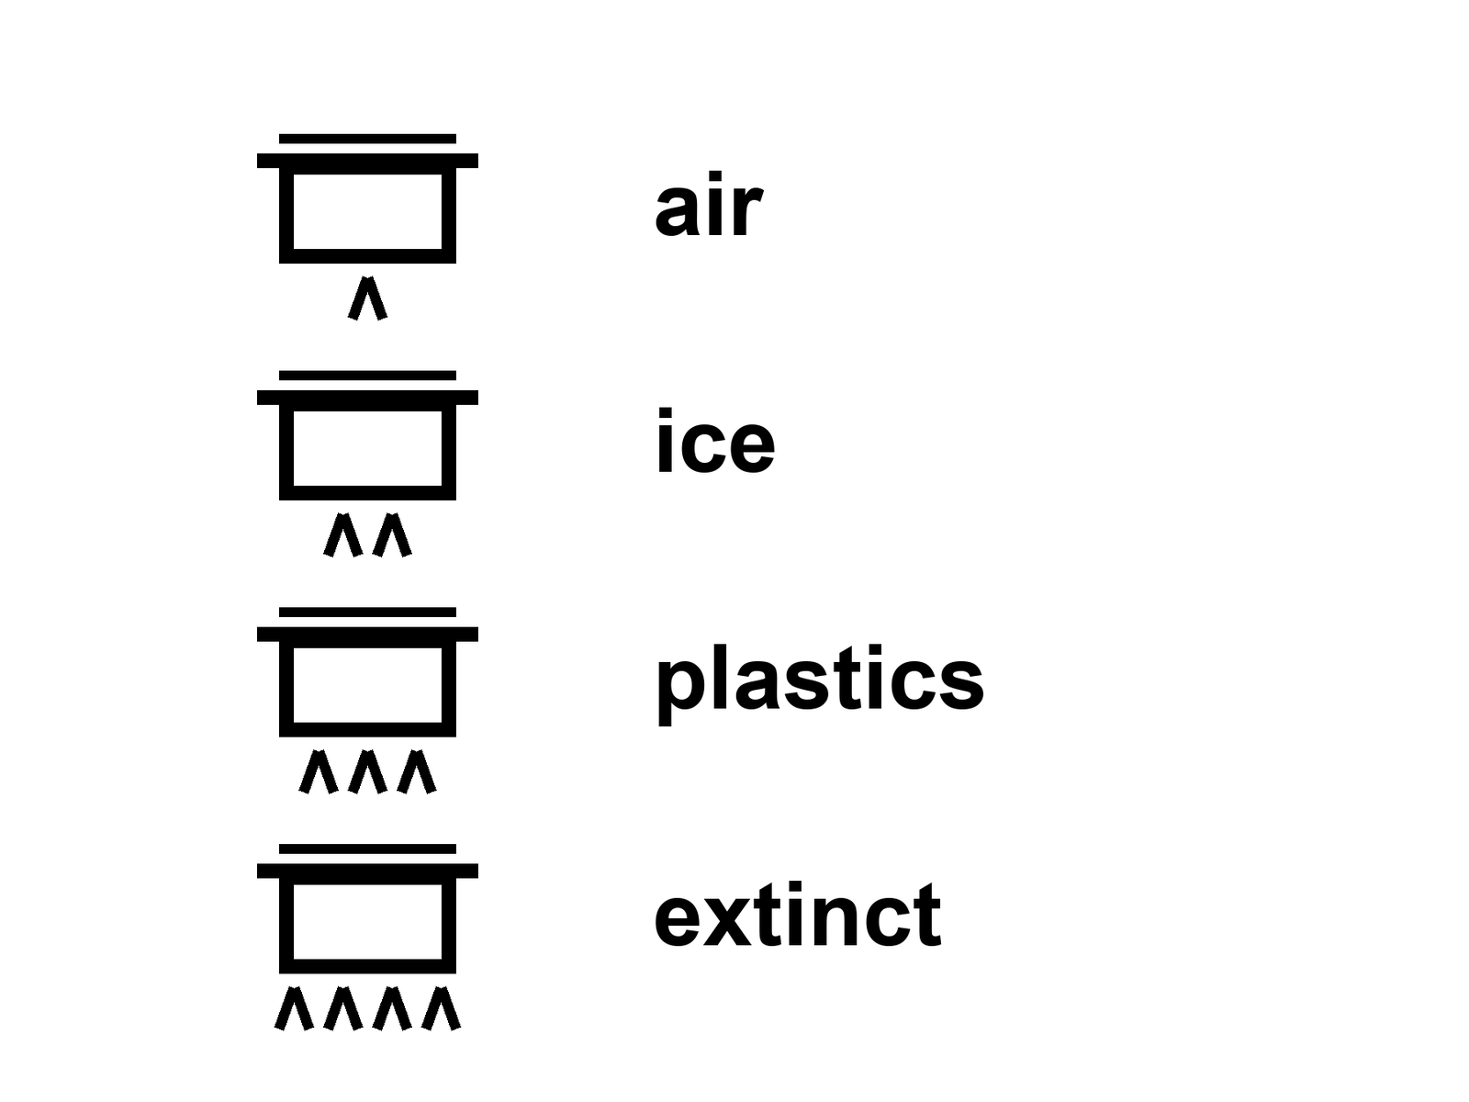
Figure 14. Four pots on a stove, four large labels: air, ice, plastics, extinct. Different flames.
Air. The fastest pot that still pretends to be slow. Carbon dioxide is a well-mixed gas with manners we have measured. A large share of an extra pulse is taken up by oceans and land in decades to a few centuries. A tail stays. The deep ocean and the rocks are ruder; they think in millennia. If you turned every engine off tomorrow, the casserole would not leap back to 1800 by Friday. It would coast. The needle would droop, then linger. A century of burning is not a weekend of weather.
A pulse of CO₂ is a slug added to the air — and “taken up” means moved into water and wood and soil, not uninvented.
The air also has a faster, ruder guest: methane, which is a stronger blanket per molecule and a shorter career, and aerosols, which are a parasol. The parasol is Chapter 15’s business. Here, keep the pot. Air is the one people mean when they say recover. They mean the needle. The needle is real. It is not the only pot.
Ice. Ice sheets have millennial manners. A melt you earned in a century does not file a resignation because a launch window opened. Greenland and the Antarctic south are not ice cubes in a glass. They are continents of frozen time. They respond to the heat you already put in the well. They can be committed to a loss that arrives after the slide has been forgotten. Mountain glaciers are faster and still not a weekend. Sea ice is faster still, and its death is not the same sentence as a sheet’s death: one is a white lid on a dark ocean, a mirror; the other is a pile that raises the water when it leaves the land. Different clocks. Distinct invoices.
Plastics. Plastics are not a gas. They are a junk drawer the size of a coast. They do not unmake because the clever apes learned a new hobby. They break into smaller rudenesses. They sit in a gyre, in a bird, in a sediment. You can stop making them. You cannot recall the ones you already threw. A recovery of production is a policy. A recovery of the drawer is a fantasy with a broom. The broom is worth pushing. The drawer will still be there for a career measured in centuries, and fragments after that.
Extinct species. The coldest clock of all: forever, on any clock a person can own. You can grow a forest. You cannot grow a grandmother of a bird you finished. A genome in a freezer is a library, not a grandmother. A library can, in lucky cases, help a cousin. It cannot un-kill a lineage whose last worldline has ended. Chapter 26 says a library is not a seed unless you look first. Here the sentence is ruder: the dead do not file a return because a camp departed.
Soils, reefs, rivers, a chemical you banned and a chemical you did not. Each has a pot. A soil you mined for a century is not a weekend of cover crop, though the cover crop is worth planting. A reef that cooked is not a weekend of cooler water, though the cooler water is the only kindness left. Persistence is not a sermon. Persistence is a clock. If you want “Earth recovers,” you must say which pot and on whose calendar.
A tide gauge runs on patience. The gauge is not invented. She has a plot that does not care about a landing year. She would like the air pot to be less rude for the sister on the coast. She does not need a ship to want that. She needs a furnace policy, a farm policy, a forest that is not a press release. The ship is a different book of invoices.
Mara checks a tray that is not a biosphere. On the delay, someone asks whether the pots at home will reset when the ambitious have gone. She writes the only sentence that is allowed to be hot about clocks: they do not share a kitchen timer, and they do not care about the ship.
A fifth pot, because people will ask: the water.
Rivers you straightened, aquifers you drank, a wetland you paved. Some of that is a policy you can reverse in a career: a dam you open, a well you stop mining, a floodplain you stop building on. Some of it is a clock with millennial manners: a drained peat that will not be a peat again because you want it to be. Recovery is not one noun. “The environment” is a drawer of pots. If a slide says Earth will recover when we leave, ask it to pick a pot and a calendar. If it cannot, it is selling a garden.
A sixth, ruder pot: the heat already in the well. The ocean has swallowed a share of the extra warmth and will give it back on its own clock. You can stop adding. You cannot un-add Friday. That is why a departure of a camp is not a thermostat even if you pretend the camp was the furnaces, which it is not.
Mara’s tray is not a biosphere and still teaches the lesson: a number you can bully is hotter than a garden promised after departure. The tide gauge stays on. Rohan’s mother keeps the street. The ship does not get to rename their clocks. Different flames. One stove. Name the pot. Name the calendar. Or admit the slide sold a write-off.
That is the whole stove. Do not let a departure pretend it turned the knobs.
The pulse, worked as an actual number.
A gigatonne is a billion tonnes — roughly the mass of a large mountain, or about two hundred thousand fully loaded oil tankers, moved through the air in the form of a gas. Human activity currently adds somewhere in the range of thirty-five to forty gigatonnes of carbon dioxide to the atmosphere every year, mostly from burning coal, oil, and gas, with a smaller share from cement-making and land clearing. That is not a metaphor. It is a mass balance, measured by monitoring stations, cross-checked against fuel sales records, and it has been rising for two centuries with only a handful of brief dips — the largest in the modern record was a single-digit percentage drop during the worst year of a global pandemic shutdown, and it rebounded within a year once activity resumed.
Of each year’s pulse, roughly half is taken up fairly quickly by the ocean’s surface waters and by plant growth on land. The other half accumulates in the atmosphere, where it is joined by the portion of previous years’ pulses that has not yet been absorbed. The absorption is not instant and it is not complete: models built from ice-core records of past natural pulses — the ones released by ancient volcanic and methane events — suggest that after a large pulse of carbon, roughly a fifth to a quarter of it is still detectable in the atmosphere after a thousand years, because the slowest sinks, deep ocean circulation and rock weathering, work on a clock of centuries to tens of thousands of years, not decades. This is not a claim about doom. It is a claim about persistence, and persistence is the only property this chapter needs.
Ice, at the pace it actually moves.
The Greenland ice sheet holds enough water, if it all melted, to raise global sea level by a little over seven meters; the Antarctic ice sheet holds enough for around fifty-eight meters. Neither is going to vanish on a human lifetime’s clock under any scenario currently modeled. What is measured, by satellites that weigh the ice from orbit using tiny changes in gravity, is a net loss from both sheets that has accelerated over the past three decades, currently summing to several hundred billion tonnes of ice a year between the two of them — a number large enough to be one of the primary drivers of present-day sea level rise, and small enough, against the total mass of either sheet, that “melted” is the wrong verb. The correct verb is “shrinking,” on a clock that responds to today’s heat with next century’s water level, because ice sheets have thermal inertia the way a stockpot has thermal inertia: you can turn off the burner and the pot stays hot for a good while after.
Mountain glaciers, which are far smaller individually, respond faster — many have visibly retreated within living memory, some measurably within a single decade — and their loss matters enormously to the communities and rivers that depend on their meltwater on a seasonal clock, even though their total contribution to global sea level is smaller than the ice sheets’. Sea ice, which floats and adds no water to the ocean when it melts because it is already displacing its own weight, responds fastest of all — Arctic summer sea ice extent has declined by roughly forty percent since satellite records began in 1979 — and its disappearance matters for a different reason: it is a mirror, reflecting sunlight that a dark ocean would otherwise absorb, so losing it is not just a symptom of warming but a contributor to more of it.
Plastics, weighed rather than described.
Global plastic production now exceeds four hundred million tonnes a year, a figure that has roughly doubled every fifteen to twenty years since mass production began in the mid-twentieth century. Of the plastic ever made, only a small fraction — commonly estimated at under ten percent — has ever been recycled; a larger share has been incinerated or landfilled, and a share nobody can precisely measure has entered rivers, coastlines, and open ocean, where it does not decompose in any meaningful human timescale. It breaks physically into smaller pieces — microplastics, then nanoplastics — driven by sunlight and wave action, but the polymer itself, chemically, persists for centuries at minimum, by the estimates of the materials scientists who study its degradation. A plastic bottle in a landfill today will very likely outlast every reader of this book, and their grandchildren.
This is a drawer, not a gas. You cannot pull it back out of the ocean once it has dispersed into fragments smaller than a grain of sand, distributed through every ocean basin and, increasingly, found in human blood and organ tissue in small but measurable quantities whose long-term health effects are still being studied. Stopping production today — which nobody is proposing to do, and which is a policy question this book will not adjudicate — would only stop the drawer from filling further. It would not empty it.
Extinction, given the only unit that fits it.
The background rate of extinction, estimated from the fossil record over tens of millions of years, is on the order of one to five species per million species per year. Current extinction rates, as best biologists can estimate across well-studied groups, run tens to hundreds of times higher than that background rate — a range that has led much of the field to describe the present era as a sixth mass extinction, comparable in rate, though not yet in total toll, to the five previous mass extinctions recorded in the fossil record, the last of which ended the age of the non-avian dinosaurs.
A species, once its last individual dies, does not have a recovery clock, because recovery implies a return to a prior state and extinction is definitionally the state that cannot be returned from. A cloned individual from preserved genetic material — attempted, as of this kitchen, for a small number of recently extinct or critically endangered species with mixed and preliminary results — produces an individual, not a functioning population with its original ecological role restored, and even the most optimistic version of that technology does not apply to the vast majority of species that vanish without ever having their genome sequenced or preserved anywhere. This is the coldest pot in the kitchen. Every other pot in this chapter eventually cools, on some clock, however long. This one does not.
A tide-gauge tech, reading her own gauge.
Her instrument does not measure launches. It measures the height of the water against a fixed marker, several times a day, and has done so at her station for decades before her and, if funded, will do so for decades after. The trend line does not jump when a rocket lights and does not dip when a rocket program is cancelled. It responds to two things: how much ice has melted and how much the ocean itself has physically expanded as it warms, a process called thermal expansion that is, by several careful accountings, responsible for roughly a third to a half of observed sea level rise over the past several decades, a fact that surprises people who assume all sea level rise is melting ice.
She has explained this to visitors more times than she can count, and the conversation always arrives, eventually, at the same question: will it get better if people leave for Mars. She has stopped being annoyed by the question. She now simply points at the gauge and asks what a headcount in another gravity well would do to the number on the marker. The visitors, to their credit, usually work it out themselves before she has to say it. The marker does not know Mars exists.
Named events, so the clocks are not only abstractions.
The Larsen ice shelves, a chain of floating ice platforms along the Antarctic Peninsula, have collapsed in stages over the past three decades — Larsen A in 1995, Larsen B in a matter of weeks in 2002, an event so fast that scientists monitoring it by satellite described watching a structure that had held for roughly ten thousand years disintegrate on a human news cycle. A floating shelf’s collapse does not, by itself, raise sea level, because floating ice already displaces its own weight, the same physics Chapter 14’s main text already gave you for sea ice. What a shelf’s collapse does is remove the brake: the ice sheets behind these shelves, on land, had been held back by the shelf’s physical presence, and glaciologists watched the glaciers that used to feed Larsen B accelerate measurably within years of its breakup, because the plug that had been slowing them into the ocean was simply gone.
Coral reefs offer a different, faster clock. The Great Barrier Reef has experienced mass bleaching events — water too warm for too long, causing corals to expel the symbiotic algae that feed and color them — in 1998, 2002, 2016, 2017, 2020, 2022, and 2024, a frequency that has accelerated sharply within one professional lifetime; reef scientists who began their careers expecting to study bleaching as a rare, once-a-decade event have instead spent recent years studying it as a near-annual one. A reef can recover from a single bleaching event, over years, if the water cools in time and the coral was not too badly damaged. A reef bleached in consecutive years does not get the years it needs. This is a clock, running faster than the one most of this book runs on, and it is running on the same underlying heat.
What a named event buys the argument that a number alone cannot.
A statistic — several hundred billion tonnes of ice a year, forty percent less summer sea ice than 1979 — is true and also, for most readers, abstract in a way that is easy to set down. A named collapse, watched by name, dated, with a before-and-after satellite photograph that fits on one page, is harder to set down, because it has a shape a reader can hold. This chapter’s job was never to make the reader feel something for its own sake. It was to make the clock legible. A named ice shelf and a named reef, each with its own dated history, are the clock made legible. The dead do not care whether you remembered their names. The argument does.
Sea level, worked forward instead of only backward.
The scientific panel that assesses climate evidence for the world’s governments has, across its successive reports, offered a range of sea-level-rise projections tied explicitly to how much warming the century ahead actually produces: a lower-emissions pathway is associated with roughly a third to two-thirds of a meter of rise by 2100 relative to recent decades, a higher-emissions pathway with closer to a meter, and specific processes involving ice-sheet instability — mechanisms that are physically plausible and observed in the geological record but not yet confidently quantified — could push the higher end of that range meaningfully further, a possibility the panel’s own reports flag explicitly as a deep uncertainty rather than a settled number.
A meter of sea-level rise sounds, to most readers, like a survivable inconvenience: raise the seawall, move the furniture. The actual mechanism by which a meter matters is not a meter of water arriving at everyone’s door. It is a meter of baseline that turns what used to be a once-a-century storm surge into a once-a-decade event, and what used to be a once-a-decade flood into an annual one, for the low-lying, densely populated river deltas and coastal cities — Rohan’s mother’s city among the real-world class it represents — where a large share of the species actually lives. The range between the low and high pathway is not a rounding error. It is the difference between a manageable adaptation problem and a mass-displacement one, and which pathway the century takes is being decided now, by furnace and farm and forest policy, on a clock that does not care about a launch window.
Permafrost, the pot this chapter had not yet opened.
Beneath roughly a quarter of the land area of the Northern Hemisphere sits permafrost — ground that has remained frozen for at least two consecutive years, in many places for millennia, locking within it an estimated quantity of organic carbon, built up from dead plant matter that never fully decomposed in the cold, that some published estimates place at roughly twice the amount of carbon currently in Earth’s entire atmosphere. As permafrost thaws, that long-frozen organic matter becomes available to microbes for the first time in millennia, which decompose it and release both carbon dioxide and, in wetter, oxygen-poor conditions, methane — a molecule already named, earlier in this chapter, as a stronger blanket per unit mass than CO₂, though a shorter-lived one in the atmosphere.
This is a pot with a genuinely frightening property the others in this chapter mostly lack: it is a feedback loop rather than a simple response. Warming thaws permafrost; thawing permafrost releases greenhouse gas; released greenhouse gas causes more warming; more warming thaws more permafrost. The scale and speed of this feedback remain an active area of research, with published estimates for its total century-scale contribution to warming ranging widely, and the honest scientific position, as of this kitchen, is that the feedback is real, is already measurably underway in specific thawing regions, and is not yet confidently quantified at the global scale — precisely the kind of warm-not-hot claim this book has trained you, in the chapters so far, to hold without either dismissing it or panicking about it. A pot with an unknown lid is still a pot. This one deserves watching more closely than most.
A number this chapter’s pots have not yet held: the insurance industry’s own accounting.
Reinsurance companies — firms that insure the insurers, pricing risk at a scale no single homeowner’s policy reflects — have, over the past two decades, revised upward, repeatedly and in published reports, their models for flood and storm-surge risk in exactly the coastal and delta regions this chapter’s own recovery clocks describe. This is not a political statement. It is an industry whose entire business model depends on pricing risk correctly, adjusting its prices because the historical data it used to rely on has stopped predicting the present. A market this literal about consequences, quietly raising premiums on Rohan’s mother’s street years before any government program admits the same trend out loud, is its own kind of clock — the coldest, most financially honest one this chapter has found.
Acidification, the pot this chapter’s stove had one more burner for.
Roughly a quarter to a third of the carbon dioxide humans add to the atmosphere each year is absorbed by the ocean, and that absorption was credited earlier as a mercy to the air pot — less staying airborne, a smaller pulse, a gentler needle. The same absorption is not a mercy to the ocean itself. Dissolved CO₂ reacts with seawater to form carbonic acid, measurably lowering ocean pH — a shift of roughly a tenth of a point since industrialization began, which sounds small on the same logarithmic scale that made Mara’s tray-side pH readings matter so much, and represents, on that scale, a meaningful percentage increase in acidity, already measured, already affecting organisms — corals, shellfish, some plankton species — that build their skeletons and shells from a mineral form of calcium carbonate that dissolves more readily in more acidic water.
This is the ocean paying a bill the atmosphere pot’s own bookkeeping quietly moved off its own ledger. The two pots this chapter named for air and reef bleaching are related but not identical: bleaching is a heat problem, acidification is a chemistry problem, and a reef under both burdens at once is a reef fighting two clocks rather than one. A slide that claims Earth heals once the ambitious have gone would need to reverse a chemistry already measured in the ocean’s own pH meters, on a clock that has never once heard of a launch window.
Appendix A14 writes the pulse remaining, the ice-sheet manners, the plastic persistence, and extinction as a one-way mark. Here, keep the four pots — and the two extras if you need them. Different flames.

15. Leaving Is Not a Cleanup
Claim, hot: a few thousand settlers do almost nothing to the air. Carbon dioxide does not care that a talented engineer now grows basil under an LED. The thermostat is furnaces, farms, forests, and the habit of turning old sunlight into motion. Remove a village’s worth of passengers and the needle does not bow.
Claim, cold: leaving is a cleanup. It is not. The kitchen you abandoned is still the kitchen. Calling a dead world a spare Earth is a way to stop washing the one you have.
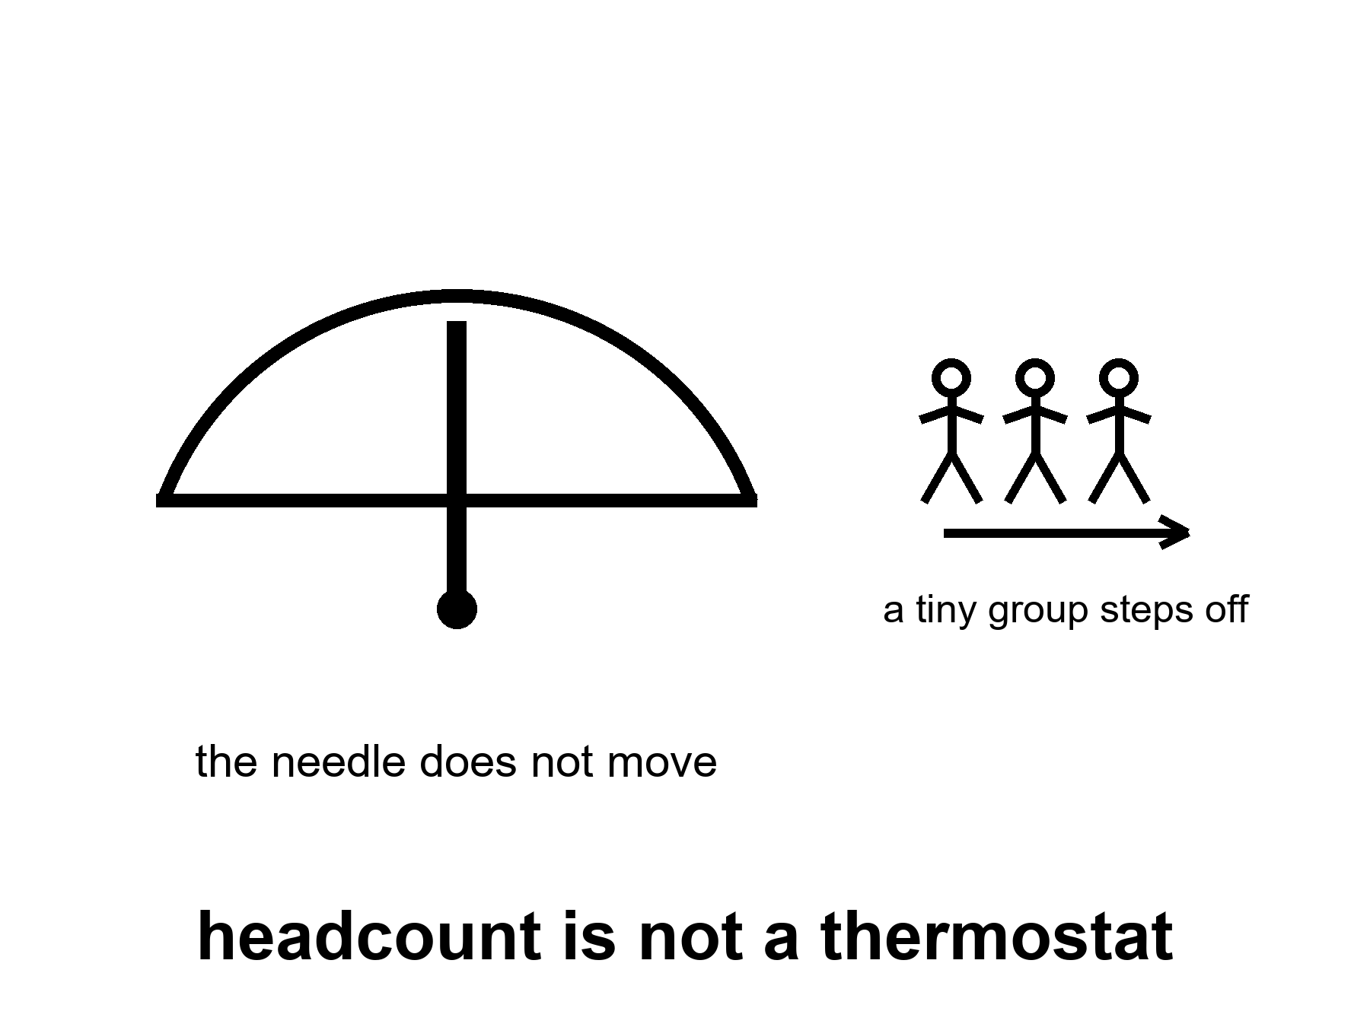
Figure 15. A needle that does not move when a tiny group steps off a scale. The label: headcount is not a thermostat.
Do the arithmetic once, so it can sit still.
A person is not a tonne of carbon. A life is a pattern of energy: a house, a plate, a road, a grid, a state that pours concrete. The pattern varies by zip code more than by virtue. A rich-country life can be on the order of ten-and-more tonnes of CO₂ a year; a poorer life, less; a camp life on a dead world, at first, more, because rockets and life support and printed spare parts are not a monastery. Take ten thousand settlers. Give them, generously, a rich-country footprint and then some. You have a town’s emissions. Global emissions are measured in tens of billions of tonnes a year. The town is a rounding error that might even have the wrong sign if the camp is a construction site.
The thermostat is industry and land use, not headcount on a ship.
The slide that says if we leave, Earth can heal is doing a swap. It swaps a species-move — which is not on offer — for a camp, and then swaps the camp for a shutdown of the furnaces. The furnaces are not on the ship. The furnaces are in the kitchen that still has the staff.
Claim, warm: if industry collapsed — not a camp departing, but the furnaces going dark — emissions would fall fast. Aerosols would fall too, the bright soot and sulfate that were pretending to be a parasol. The mix is not a simple spring morning. You can lose the parasol before you lose the heat. The casserole can feel, for a while, ruder. Ecosystems would start a different career, not rewind the tape. Collapse is not a cleanup method. It is a distinct story with its own dead.
This is the paragraph people skip when they want leaving to be a virtue. A virtue that requires a collapse is not a cleanup. It is a famine with a press kit. The dead in that story are not a greenhouse. They are Rohan’s mother’s street, and the tide gauge, and Priya, who still says we.
A quieter, hotter fact: you can lower emissions without a collapse and without a camp. That work has a name and a bill and a politics. It is not this book’s manual. This book’s job is to stop the camp from stealing the work’s costume.
Earth “bounces back” as a garden once the clever apes go: cold. The apes are not going. The few who leave do not take the furnaces. The species that stayed would still be the thermostat, or the collapse would be the thermostat, and either way the extinct stay extinct, the plastics stay a drawer, the ice keeps millennial manners, the air coasts. A garden is a staffed thing. A staffed thing is a policy, not a departure.
The swap, named so it cannot hide.
Slide says: leave, and Earth heals. Honest nouns say: a camp departs, furnaces stay, staff stays, clocks keep their own manners. The slide has done three swaps in one breath. It swapped a species-move for a village of tickets. It swapped the village for a shutdown of industry. It swapped the shutdown for a garden. None of those equalities is a measurement. The first is false as headcount. The second is false as geography — the furnaces are not on the ship. The third is false as Chapter 14’s pots: air coasts, ice thinks in millennia, plastics stay a drawer, the extinct stay extinct. A garden is a staffed policy. A departure is a staffing choice for a few thousand worldlines. Do not let them wear each other’s coats.
Arithmetic again, because feelings will try to unwrite it.
Ten thousand settlers at a rich-country footprint are a town’s emissions. Global emissions are tens of billions of tonnes a year. The town is a rounding error. The error can even have the wrong sign if the camp is a construction site eating Earth cement, Earth metals, Earth propellant, and a grid that is not a monastery. Carbon dioxide does not care that a talented engineer now grows basil under an LED. The needle cares about furnaces, farms, forests, and the habit of turning old sunlight into motion. Remove a village’s worth of passengers and the needle does not bow. That sentence is hot. It is allowed to be boring. Boring is how you do not die of a cleanup myth.
The arithmetic, run with real numbers, once, carefully.
A resident of a wealthy nation — the kind of person statistically most likely to hold a spaceflight-adjacent job, let alone a seat on a rocket — accounts for somewhere in the range of eight to twenty tonnes of carbon dioxide a year through ordinary life: housing, transport, diet, the goods and services a modern economy delivers to their door. A resident of a lower-income nation accounts for a fraction of a tonne to a few tonnes. Global average sits around four to five tonnes per person per year, dragged down by the several billion people whose footprint is small and pulled up by the smaller number whose footprint is large.
Take ten thousand settlers — a genuinely optimistic figure for any Mars or Moon population within the next several decades, well beyond anything currently funded or scheduled — and assign them a footprint several times the wealthy-nation average, because early camp life runs on rockets, life support, and manufactured spare parts, none of which is a monastic existence. A generous figure might be fifty to a hundred tonnes per settler per year, camp-side, plus whatever fraction of the launch infrastructure’s own emissions you choose to allocate to them rather than to Earth’s ledger. Multiply it out and you get a number in the range of half a million to a million tonnes of CO₂ a year for the entire settlement. Compare that to global annual emissions of roughly thirty-seven billion tonnes, and the settlement’s share is on the order of one part in forty thousand to one part in seventy thousand — a rounding error so small that ordinary year-to-year noise in the global figure, driven by things like a mild winter or an industrial strike, regularly exceeds it several times over.
This is the whole claim, done honestly, with numbers a reader can check against public sources. The thermostat is not made of settlers. It is made of power plants, factories, vehicles, and land use, operated by the seven billion nine hundred ninety thousand people who did not go.
The swap, named so it cannot be missed twice.
The rhetorical move worth watching for goes like this: a speaker gestures at the abstract idea of humanity spreading to other worlds, invokes the real and serious problem of an overtaxed planet, and lets the listener’s mind quietly substitute “if people leave, the planet gets a break” for the true and much smaller claim, which is “if ten thousand people who were never going to significantly move the needle anyway relocate to a location that requires more resources per person, not fewer, Earth’s ledger is essentially unchanged.” The swap works because the two sentences share several words and opposite meanings, and the speaker is rarely required to say the second sentence out loud.
Collapse, treated honestly rather than as a thought experiment to score a point.
If global industrial activity actually stopped — not people leaving, but furnaces going cold, factories going dark, global trade halting — emissions would fall within months, and this is not speculation: it happened, briefly and partially, during the worst months of a global pandemic shutdown, when daily emissions dropped by roughly a sixth to a fifth at the peak, the sharpest sustained drop ever measured, and the annual total fell by a few percent for the year, still leaving atmospheric concentration higher at year’s end than it had started, because a slower pulse is still a pulse.
A genuine, sustained industrial collapse would go further than that brief dip, and it would also do something the pandemic dip revealed on a smaller scale: it would remove, along with the carbon dioxide, the aerosol pollution — soot and sulfate particles from the same smokestacks — that has been quietly reflecting some sunlight back to space and partially masking a portion of the warming those same industries caused. Researchers who study this effect estimate that aerosols are currently offsetting a meaningful fraction, plausibly in the range of a third to a half, of the warming that greenhouse gases alone would otherwise be producing. Remove the aerosols faster than you remove their warming cause — which is roughly what a sudden industrial stop would do, since aerosols wash out of the air in days to weeks while carbon dioxide lingers for centuries — and global temperature could, for a period of years to a decade or more, rise faster than it otherwise would have, even as emissions themselves have stopped. This is a real, published finding, not a rhetorical trick to defend industry. It is also not an argument against reducing emissions in an orderly way, which does not carry the same unmasking penalty, because an orderly reduction can be paired with reductions in the aerosol-heavy pollutants specifically, on a schedule that does not whipsaw the climate system.
The point of walking through this honestly is narrow and specific: it forecloses the lazy fantasy that any kind of societal collapse, industrial or otherwise, functions as a climate cleanup. It does not. It trades one kind of damage for another kind, on a different clock, with real people paying both bills.
Priya, and the sentence that is allowed to be hot.
The message that took the long way asks whether the planet will be nicer once the ambitious have gone. Mara has the shape of the answer and not the tide gauge. She writes one sentence: the ambitious are a rounding error, and the planet does not know we left. Priya does not entirely believe her. The sentence is true whether it is believed. That is what makes it hot. Priya will not get a ticket. She still has a clinic, a fridge, and a surgery date that has not yet answered.
A number this important deserves to survive a challenge. Here is the carbon footprint methodology behind it.
A “carbon footprint” is not one measurement. It is an accounting exercise, and different accountings draw the boundary in distinct places, which is why footprint figures for the same country can vary by a meaningful margin depending on the source. A territorial accounting counts emissions physically produced inside a country’s borders. A consumption-based accounting instead counts emissions embedded in everything that country’s residents buy, wherever in the world those goods were actually manufactured, which shifts a substantial share of a wealthy importing nation’s true footprint onto the exporting nations that did the manufacturing on its behalf. The two methods can disagree by twenty percent or more for a heavily trade-dependent economy. Neither method is a lie. Both are answering slightly separate questions, and a slide that quotes one number without saying which method produced it is not lying either, usually — it is simply not showing you the oven.
This chapter’s own settler-emissions arithmetic used a consumption-style estimate, deliberately, because a settler’s actual footprint is overwhelmingly a consumption question: almost nothing a camp consumes is locally produced, so almost the entire footprint is embedded in what gets shipped up the well. A territorial accounting, applied to a launch pad’s own physical location, would undercount a settlement’s true climate cost by attributing most of it to whichever nation’s factories built the parts. The consumption method is the honest one for this particular question, named here because a reader who checks this book’s numbers against a different source using a distinct method should know why the two numbers might not match to the decimal point, without either one being wrong.
The word “offset” gets used loosely. It deserves a harder look.
A carbon offset, in its intended design, is a credit representing one tonne of CO₂ either kept out of the atmosphere — a forest preserved that would otherwise have been logged — or actively removed from it, purchased by an emitter to counterbalance emissions it has not yet eliminated. The design is sound in principle. In practice, multiple independent investigations into major offset registries, across the past decade, have found that a large share of credited forest-preservation projects would very likely have preserved the same forest even without the offset payment — a problem researchers call additionality, meaning the credit claims a reduction that was never actually caused by the purchase — and that some projects’ claimed carbon storage has been substantially overestimated relative to what satellite and ground measurement later confirmed.
This chapter has already said, plainly, that rockets are not a carbon offset. It is worth being equally plain about the actual offset market: a great many real offsets, purchased in good faith by genuine companies wanting to do the honest thing, have turned out to buy considerably less atmospheric benefit than their certificates claimed. The lesson generalizes past space entirely, and this book will make it once, because it belongs here as much as anywhere: a market that sells the feeling of having solved a problem is not the same market as one that has solved it, and the gap between the two is exactly the kind of gap the chapters so far have been teaching a reader to find, on a slide, in a launch, or in a certificate framed on an office wall.
Three ledgers, since “global emissions” is not evenly distributed and the arithmetic changes depending on whose ledger you are reading.
A single nation currently accounts for roughly a third of global annual CO₂ emissions, having overtaken the historical leader in total annual output in the mid-2000s, though that same historical leader still holds, by a wide margin, the largest cumulative total emitted since industrialization began, because atmospheric CO₂ accumulates and a nation that industrialized a century earlier has had a century longer to add to the pile this chapter’s own pulse-and-tail arithmetic already described. A third major economy, industrializing later still, now accounts for a smaller but rapidly growing share, and per-person, its emissions remain a fraction of the two larger economies’ figures, a distinction that matters enormously in the international negotiations this chapter has not tried to adjudicate but cannot honestly ignore either.
None of these three ledgers has committed, as of this kitchen, to a Mars or lunar settlement program remotely close to the scale Part III describes. Say it plainly: the emissions arithmetic and the settlement arithmetic are, for now, almost entirely separate conversations, run by mostly separate institutions, funded from mostly separate budget lines. The settler-emissions rounding error calculated earlier in this chapter is not competing, dollar for dollar or tonne for tonne, with the three ledgers’ industrial emissions. It is a small number sitting next to a large one, and the real danger is not that the small number will grow to match the large one. It is that the small number’s mere existence will be used, rhetorically, to excuse inattention to the large one.
The two get blurred constantly. A last distinction: mitigation versus adaptation.
Mitigation means reducing the pulse itself — the furnaces this chapter has spent its pages on, burning less, differently, or not at all. Adaptation means living with the pulse already released — a seawall, a levee, a crop bred for a hotter season, the sandbags Rohan’s mother’s street has already needed more than once. Both are real, necessary, and entirely different budgets, run by mostly distinct institutions, on mostly separate clocks: mitigation pays off over the multi-decade tail this chapter’s pulse arithmetic already described, adaptation pays off immediately for the people who fund it. A settlement pitch that claims to be either is claiming something it cannot be. It reduces no furnace and builds no seawall. It is neither mitigation nor adaptation. It is, at most, a rounding error wearing one of their two costumes.
Additionality deserves a mechanism, not just a criticism. Here is how a satellite actually catches a felled forest.
The same orbital imagery this book’s earlier chapters have used for landing-site selection is, in a different application, the primary tool auditors now use to check offset-registry claims against reality: repeated satellite passes over a credited forest, compared frame to frame, flagging canopy loss a paper claim would otherwise have no independent way to catch. Several of the specific overestimation findings this chapter’s earlier material has already cited were made possible by exactly this technique — an offset project’s claimed preserved acreage checked, years later, against the actual satellite record, and found, in a meaningful share of cases, to have already lost canopy the credit had claimed to prevent.
The tool is a genuine improvement on the honor system it replaced, and it also belongs to the category of infrastructure this whole book keeps insisting is real and valuable: not a settlement, not a brochure, a boring, unglamorous, repeatedly orbiting camera, doing the actual work of making a claim checkable. If this book has a favorite kind of hardware, it is this kind: the kind that exists specifically to keep a slide honest.
Appendix A15 writes the settler-versus-emissions arithmetic and the aerosol unmasking as a warm caution, not as a wish for collapse. Here, keep the needle. Headcount on a ship is not a thermostat.

16. The Bill of Going
There is a ruder invoice. The infrastructure of going — the energy, the metals, the cement, the propaganda that this planet is already a write-off — can worsen the bill for the people in the casserole kitchen. Rockets are not a carbon offset. A speech about “backup worlds” is not a climate policy. Look first. The world that already has a staff is this one. Seed later is a rule for a dark sea. It is also a rule for a biosphere you have not finished killing.
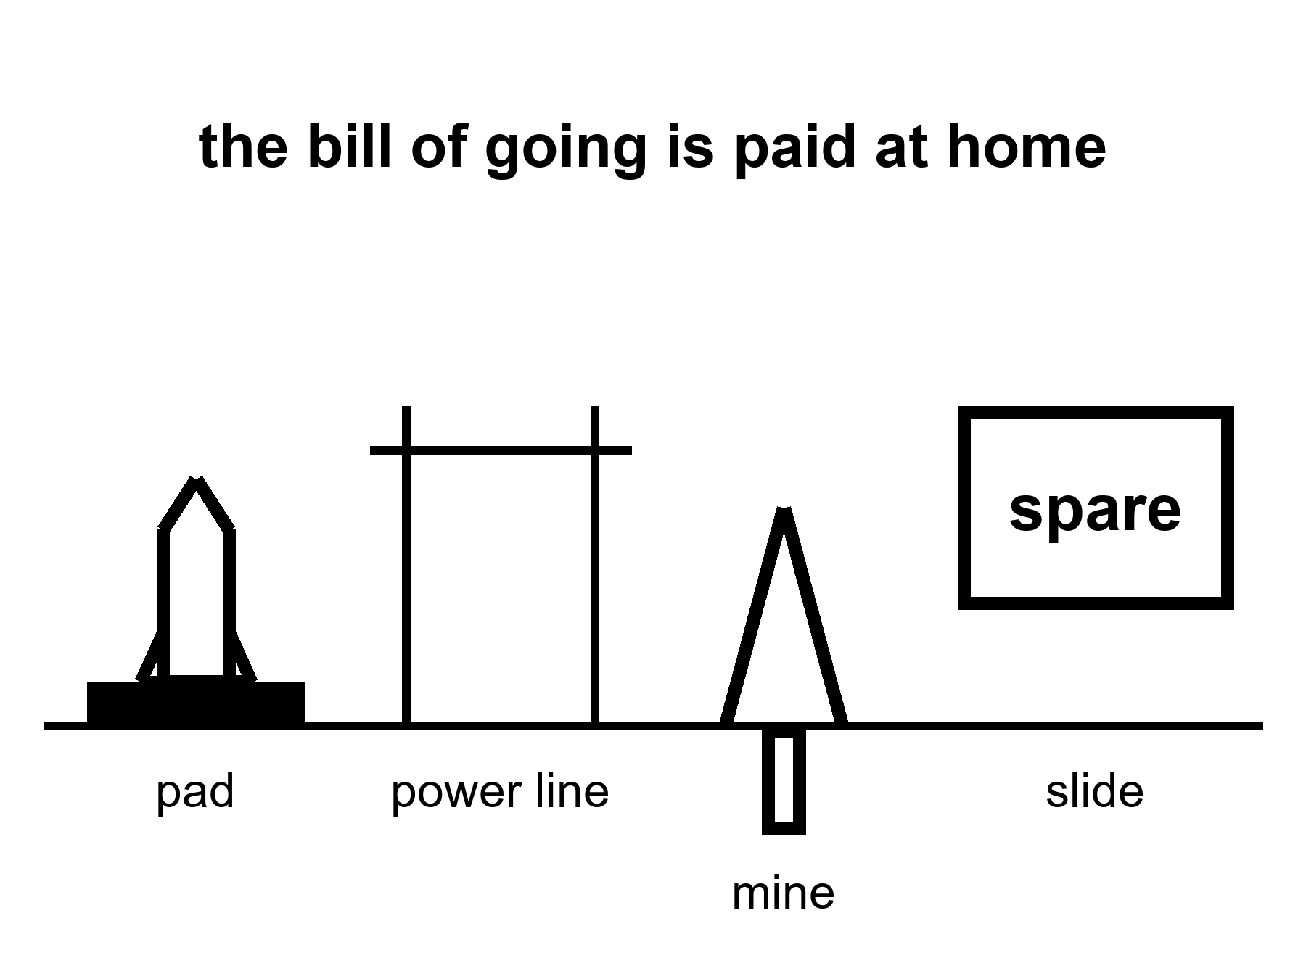
Figure 16. A pad, a power line, a mine, a slide that says spare. The caption: the bill of going is paid at home.
Warm, not a law: spaceflight is not a crime. A rocket is a small line on a global carbon ledger compared with a fleet of coal plants, and a person who sneers at a launch while idling a convoy is running a costume. The honest sentence is smaller and ruder. The industry of leaving, if it scales toward the mass a city would take, is energy, tankers, mines, foundries, pads, a political story that the kitchen is already lost. That story is the warm harm even when the rocket’s own plume is a rounding error. People who believe the kitchen is lost do not vote for the broom. They vote for the dome. The dome is cold. The broom is the work.
Metals and cement are the unphotogenic cousins. A camp that wants to be an outpost wants landing pads, power, pressure vessels, solar or a reactor, a lot of dirt moved. If the dirt is lunar or Martian, that is ISRU and a maybe. If the dirt is Earth’s, that is a mine and a kiln and a ship. Early camps will eat Earth. That is not a scandal. It is an invoice. An invoice that is sold as a carbon offset is a scandal.
Propaganda is a temperature because it moves a vote. Disposable Earth is a phrase that can be a joke and can be a policy. As a policy it is a write-off of the tide gauge and Rohan’s mother’s street. This book will not pretend a joke is harmless once it has a budget.
Honest near term.
A crew around the Moon this decade: warm as a class. A landing attempt in the 2030s: warm. A sustained outpost in the 2030s–2040s: warm-to-cold. A city this decade: cold. Most humans stay: hot. Leaving is not a cleanup: cold. The bill of going can worsen the kitchen: warm. Official dates will slip: hot as a pattern. The orbits will not.
What a finished reader is allowed to keep:
A flyby is not a town. A town is not a cleanup. Most of us stay. The clocks do not share a kitchen timer. A vehicle is not a city. Routine is an unpaid invoice. Three nouns, kept apart. Look first on the world that already has a staff.
If you wanted a downtown on Mars by Friday, you should have your money’s worth as hygiene, not as a refund-shaped insult. The basil still has to live. The airlock still sticks. The radio will carry another year. She will not vote for it. She will hit the drawer, and tend the tray, and wait on a window that is a fact about two orbits, not a mood.
The universe still does not have an opinion. The dirt does. The dirt at home is the one with a staff. Wash it.
A worked pad, so the rounding error has a face.
A large methane-class launcher burns a few hundred to a few thousand tonnes of propellant on the way up, depending on the stack and the day. Carbon from the methane, and from the grid that made the oxygen and the steel and the concrete, is a number you can write. Write it. Then write a coal plant’s year, or a nation’s year, or a rich city’s year. The pad loses as a villain if the comparison is honest. The pad wins as a villain if the comparison is a sneer at a photograph. Neither comparison is the warm claim. The warm claim is the industry if it scales toward a city: many pads, many tanks, many mines, a politics of write-off. Scale is the word. A science program is not that scale. A downtown-as-product is a request for that scale plus a story that the kitchen is already lost.
Look first, then, has a domestic job. Do not let a camp steal the broom. Do not let a broom steal a camp that is honest about being a camp. Both can be staffed. Both have invoices. Only one of them has eight billion worldlines in it.
The tide gauge, Rohan’s mother’s street, Priya’s oven: those are the staff. The pad is a tool they may choose to pay for. The slide that says spare is a tool that spends their vote without asking.
The bill, itemized without a sneer.
Energy: pads, tanks, foundries, the grid that makes oxygen and steel and the concrete under a flame trench. A science program’s share can be small next to a coal fleet. Say so. An industry scaled toward a downtown-as-product is a different share and a distinct politics. Scale is the word that separates a loud morning from a write-off campaign.
Metals and cement: landing pads, pressure vessels, power plants, dirt moved. Early camps eat Earth even when the rendering shows lunar ice. That is an invoice. Selling the invoice as a carbon offset is a scandal. Paying the invoice as a research cost is a choice the staff may make.
Propaganda: disposable Earth, backup world, spare. As jokes they can be dark humor at a table. As budgets they spend the tide gauge and Rohan’s mother’s street without a vote. Look first means the world that already has a staff is this one. Seed later was a rule for a dark sea in another kitchen. It is also a rule for a biosphere you have not finished killing. A camp that is honest about being a camp does not need the write-off. A downtown-as-product often does. That difference is why this chapter exists.
Kinds of clocks for the bill.
There is the rocket’s own plume: a number you can write and compare honestly to a plant’s year. There is the industry clock: many pads, many mines, if someone asks for city mass. There is the vote clock: whether spare has moved a legislature away from a broom. Official years for landings will slip. The vote clock does not need a landing to do harm. A speech can spend a broom before a boot touches dust.
The industry, sized rather than gestured at.
A single heavy-launch vehicle burns, depending on its design and mission profile, somewhere between a few hundred and a few thousand tonnes of propellant to reach orbit. If that propellant is methane and oxygen, as several current and planned heavy vehicles use, the carbon dioxide released directly from combustion is a calculable number, in the range of a few hundred to a couple of thousand tonnes per launch — a figure worth comparing honestly to other things people measure in tonnes: a single large cargo ship crossing an ocean burns fuel producing carbon dioxide in a similar or larger range for one voyage; a coal power plant of ordinary size emits several million tonnes a year, meaning it produces in a single day what a heavy launch produces in one flight, many times over. At today’s launch cadences — even generously projecting forward a decade — the entire global launch industry’s direct emissions remain a rounding error against global industrial emissions, smaller than the annual output of a handful of individual coal plants.
That comparison is honest and it is also not the whole invoice, which is the warm claim this chapter exists to make. The warm claim is about scale, not about today’s cadence. If the industry of leaving grows toward the size that an actual multi-thousand-person settlement effort would require — not one heavy vehicle a month but dozens, not one pad but a coastline of them, not one propellant plant but a network of methane and oxygen production facilities running continuously, plus the mines, smelters, and factories on Earth that build all of it — then the comparison changes, because you are no longer comparing one flight to one coal plant. You are comparing an entire new heavy industry to the industries it would sit alongside. Nobody has built that industry yet. The chapter’s job is to notice, now, while it is still small, that the comparison will not stay flattering by default; it will stay flattering only if the industry that eventually gets built is engineered, deliberately, to be less carbon-intensive than the industries it resembles, which is a choice, not a law of physics.
Metals and cement, which do not photograph.
A launch pad is a slab of reinforced concrete and steel large enough to survive repeated ignitions of engines producing millions of pounds of thrust; the concrete alone for a single modern pad runs into tens of thousands of tonnes, and cement production is, on its own, responsible for roughly seven to eight percent of global carbon dioxide emissions worldwide, because the chemical process of making cement releases carbon dioxide directly from the limestone itself, independent of the energy used to heat it. A propellant plant sized to refuel a fleet of heavy vehicles needs steel tankage, cryogenic insulation, pumps, and power infrastructure on an industrial scale — the same category of manufacturing that builds refineries and chemical plants, with a similar carbon footprint per tonne of capacity, because the manufacturing processes are largely the same processes.
None of this is unique to space. It is unique in how rarely it gets mentioned in the same breath as a rocket launch, because the launch is the photogenic thirty seconds and the concrete pour, the steel mill run, and the years of mining that preceded it are the unphotogenic decade that made the thirty seconds possible. If a slide shows a rocket’s own plume as the entire carbon story of “going to Mars,” it has shown you one line of a much longer invoice and asked you to sign for the whole thing.
A phrase like “Earth is not our only option” or “this planet is not guaranteed” functions, whether or not the speaker intends it this way, as a permission slip: it tells a listener that urgency about the home planet’s problems can be traded for enthusiasm about an exit that does not, in fact, exist for the listener, and would not solve the listener’s problem even if it did. This book has not run that poll and will not pretend to cite one. The mechanism does not need a study to be plausible: a “backup planet,” like any other unproven future fix — a carbon-removal machine that does not exist yet, a fusion plant always a decade out — offers a listener permission to stop worrying about the boring fix that already exists, the storm drains and grid upgrades and building codes that actually move the needle on the tonnes in Chapter 14 and Chapter 15. Whether that permission measurably changes anyone’s actual vote or donation is an empirical question this book has not checked and marks, honestly, as unverified. This is not a claim that every person who admires a Mars program has been manipulated out of caring about the storm drain. It is a claim that the phrase does measurable work in a specific direction, and that work has a name: it is a vote, cast by the person who wrote the slide, spent on behalf of everyone who hears it and believes the planet has a backup.
The bill, tallied one last time, honestly.
A rocket’s plume: small, honestly, against a coal plant. The pad, the propellant plant, the mines and mills behind them, at the scale an actual settlement would require: not modest, and not yet built, and therefore not yet a fact you can measure — only a scale you can warn about, now, while the warning still has a chance to shape how the industry gets built. The propaganda that treats this planet as provisional: a vote, spent against the tide gauge and Rohan’s mother’s street, cast by people who will never personally need the exit they are selling.
None of this is an argument against spaceflight, against the sortie, the outpost, or even, someday, on its own honest timeline, the settlement. It is an argument that the bill for all of it, at every stage, gets paid here, by the staff who are still here, and that pretending otherwise is not optimism. It is an unpaid invoice with someone else’s name already forged on the signature line.
Look first. The world that already has a staff is this one. The basil still has to live, and the person who waters it does not get to vote for a mood instead of a number.
Debris, the bill this chapter had not yet itemized.
Every launch that reaches orbit leaves something behind: a spent upper stage, a fairing half, a bolt that separated at the wrong moment, a flake of paint moving fast enough to punch through a hull. The count of tracked objects larger than a softball, in orbit around Earth right now, runs past forty thousand, and the count of untracked fragments too small to follow but large enough to kill a satellite or a spacewalker on impact is estimated in the hundreds of thousands to millions, because at orbital speeds — several kilometers a second — even a fleck of paint carries the kinetic energy of a rifle round. A single serious collision between two sizable objects has already, once, more than doubled the tracked debris count in the affected orbital band overnight, and the field that studies this problem has a name for the nightmare scenario, first described in a 1978 paper:¹⁵ a cascade, where debris from one collision causes further collisions, which produce more debris, which produce more collisions, until a whole orbital band becomes too dangerous to use for a generation.
An industry of leaving that scales toward city mass — many launches, many upper stages, many more objects in orbit — is not exempt from this bill just because its stated purpose is noble. Every additional launch is an additional roll of a die that gets rolled more often as cadence rises, and cadence rising is precisely the routine Chapters 10 through 12 spent hoping for. The honest sentence, matching this chapter’s own method: rockets are not a carbon offset, and a launch industry scaled toward settlement is also not a debris offset. It is a bill, itemized here so a later chapter does not have to discover it by surprise.
What a finished reader is allowed to keep, extended by one more clock.
Every clock read so far — the light-time clock, the orbit clock, the political clock, the carbon clock, the ice clock, the reef clock — now has a debris clock beside it: an orbit that stays usable only if the objects in it are tracked, avoided, and, eventually, deorbited on purpose rather than left to their own slow decay. It is not a louder bill than the others in this book. It is a quieter one, accumulating in a place few readers ever look, and quiet bills are exactly the kind worth finding before the invoice arrives with someone else’s name already on it.
Orbital crowding is not an abstraction either. Here is a constellation, counted.
A single company’s satellite internet constellation had, by this kitchen, placed more active satellites in low Earth orbit than every other operator in the history of spaceflight combined — a number in the several thousands, climbing by hundreds more with every few weeks’ launch cadence, aimed eventually at a planned total running past ten thousand if every authorized phase is built. Other operators, from other nations and other companies, have announced competing constellations of comparable planned scale, aimed at the same orbital shells, for the same commercial reason: global broadband coverage is a genuinely valuable service, and the physics of providing it from low orbit actually requires thousands of satellites rather than a handful.
Astronomers have documented real interference from these constellations with ground-based observation — bright satellite trails crossing long-exposure images, a problem serious enough that the operator involved has committed to darkening treatments on newer satellites, with mixed and still-debated success. The debris question raised earlier compounds directly: a constellation of ten thousand satellites, each with an operational lifespan of a few years before replacement, is not ten thousand objects. Over a decade, it is tens of thousands of objects, launched, operated, and deorbited in sequence, each pass through that cycle a fresh roll of the same collision dice described above. None of this is a reason the constellations should not exist; the broadband they deliver is genuine and valuable to actual people, including some who will never otherwise touch a piece of space hardware in their lives. It is a reason the bill for an industry scaling toward routine, cheap, frequent launch was never going to stop at carbon. Orbit itself is a resource, and resources — the first page of this book already said so — are not infinite just because they are far away.
The bill of going has a literal address: a spaceport’s own backyard.
A launch site, wherever it is built, sits inside a real ecosystem, and the environmental review process most spacefaring nations require before a new pad is licensed has, in multiple documented cases, flagged genuine local costs: wetland habitat disturbed by construction and by the shockwave and heat of repeated launches, protected coastal bird species whose nesting behavior has measurably shifted near active pads, water systems used for sound suppression and flame diversion that draw on local aquifers or discharge into local waterways under permits that regulators and residents alike have, at various sites, publicly contested. None of this is unique to any one company or nation; it is a standing feature of building industrial infrastructure capable of producing the sound and heat of a controlled explosion, repeatedly, on a coastline chosen for a launch azimuth rather than for the wildlife that already lived there.
This is the most literal, least abstract version of the bill this chapter has spent its pages itemizing. A rocket’s plume is a number in the atmosphere, distant and diffuse. A spaceport’s water table, its wetland, its nesting shorebirds are a number in a specific place, measured by specific regulators, felt by specific residents who did not choose to live next to a launch pad and in some cases lived there before the pad existed. Look first, this book’s oldest rule, was never only about a dark sea or a dead world. It is also, at the smallest and least glamorous scale this book will describe, about the marsh grass fifty meters from the flame trench, and whether anyone counted it before the first countdown clock started.
This book’s last chapter deserves one honest tally. Here is a closing number.
Every dollar, tonne, and worldline counted across sixteen chapters shares a single property, stated once, plainly, before the spine closes: none of it was hidden. Every figure in these pages came from a public source, checkable by a reader with a search engine and an afternoon — the same afternoon this whole book has been asking you to spend before believing a slide. That is the actual promise this book was written to keep, more than any single number in it. Not that the future will be warm or cold. That the invoice, whichever temperature it turns out to be, will have been shown.
A final accounting of what this book asked you to carry, and what it did not.
It did not ask you to oppose a launch. It did not ask you to believe an announced year, or to disbelieve one out of reflex, without first running the four questions this book gave you in its third chapter. It did not ask you to choose between a broom and a rocket, having spent its later chapters insisting both can be honest tools in the hands of people willing to itemize their own invoices. It asked one thing, repeated in sixteen different rooms, on two distinct worlds, across a decade of real launches and genuine slips: look at the coupon before you believe the year. That instruction does not expire when this book’s own dates do. It is the only sentence in these pages built to outlast its own kitchen.
A spaceport’s bill has a decibel line too. Sound, measured.
A returning booster’s landing burn and, where the vehicle uses one, its sonic boom on the way down are not silent events for the communities living near a launch site; real acoustic monitoring around active pads has recorded landing-related sonic booms loud enough to rattle windows and, in documented cases, prompt formal noise complaints from residents kilometers from the pad itself, a nuisance this chapter’s earlier environmental-review material has already flagged as part of the permit fight a site has to clear before flying at all. Regulators in multiple jurisdictions have, in response, placed limits on landing timing, trajectory, and cadence specifically to manage this complaint, treating a sonic boom the same way an airport treats a noise curfew: a genuine cost, imposed on people who did not choose to live near the infrastructure, priced in advance rather than discovered after the fact.
It is a small line on the very long bill this final chapter has been itemizing, and it belongs on the list for the same reason every other small line has: nobody counted it on the first slide, and somebody, eventually, always has to.
Appendix A16 writes rockets on a carbon ledger, mines, and why a write-off is a vote. Here, keep the pad and the slide that says spare. The bill is paid at home.
The next chapters keep her hands. You can also stop here. The seal will still need the heel of a glove tomorrow.
Rule: The bill is paid at home. Wash the staffed world. Do not let a spare-Earth sentence spend the tide gauge.

PART V — The Classroom on the Close Rock
The next eight chapters are the homework the renderings skip. Each one is a bill you can count. None of them is a downtown.

17. A Suit Is a Spacecraft
A suit is not a costume. It is a spacecraft you wear, and spacecraft slip.
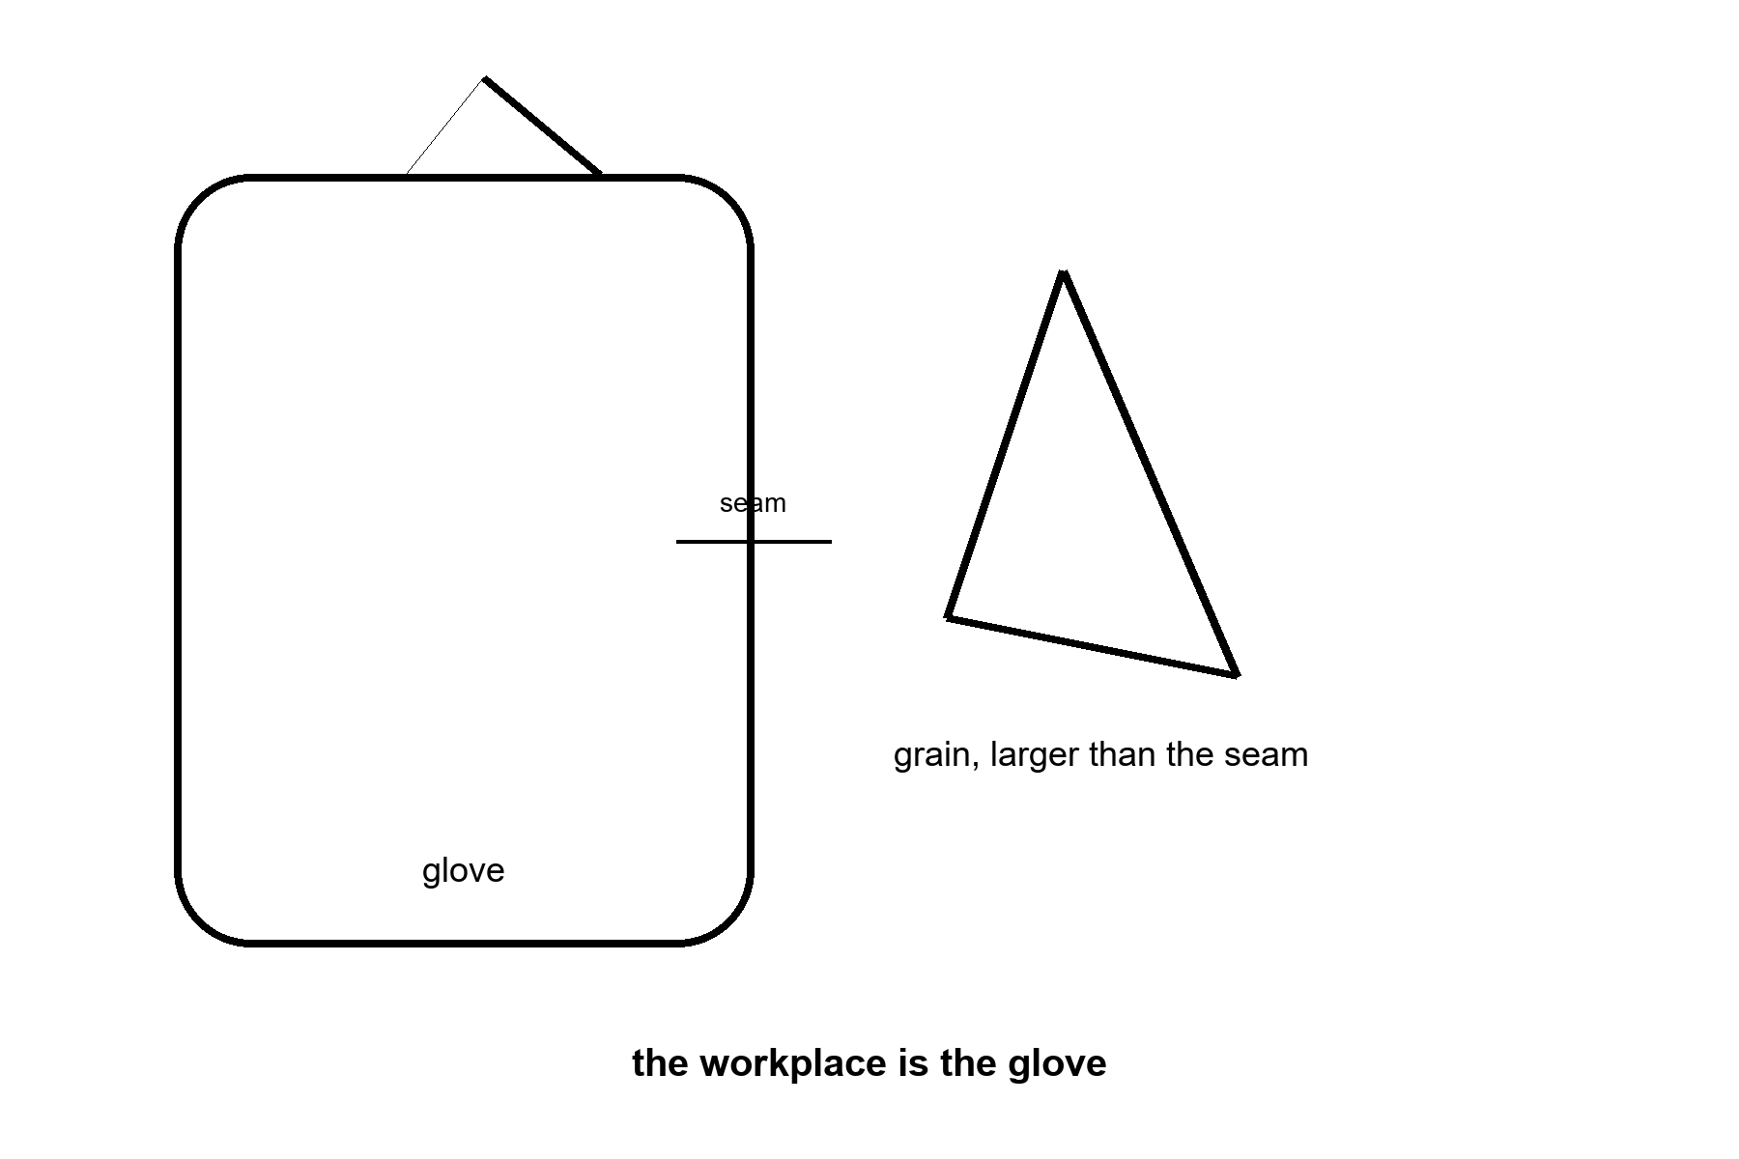
Figure 17. A glove, large, next to a grain of glass drawn bigger than the seam. The caption: the workplace is the glove.
Linh Pham’s box of simulant is not the Moon, and it is already rude to bearings. The real grain is worse. Lunar dust is rock that has been micrometeorited and solar-winded for a billion years with no air to round the edges and no rain to wash the charge off. It is sharp. It is a little magnetic in its iron. It sticks to a suit the way flour sticks to a wet hand, except the hand is charged and the flour is glass.
A suit is a pressure garment, a cooling loop, a radio, a visor, and a set of bearings that must still bend after the glass has had its say.
Apollo’s crews came home sanded. Gloves wore through faster than the brochure. A few hours on the dirt was a shift that already showed the invoice. A town, if anyone ever says the word with a straight face, is thousands of those hours, with a spare glove on the shelf and a person whose job is the glove. We have not staffed that person on the Moon. We have staffed Linh, in a lab, with a box.
What the suit has to do, said as a list a slipped month cannot erase.
Hold about a third of an atmosphere, so the joints can still bend and the chest can still move. In a true vacuum the blood would boil, down near a small fraction of an atmosphere. That is why a suit has to hold something. It is not why the working pressure is a third of an atmosphere. The third is the bendable-joint bargain, paid for with oxygen and a wait before you step out. Move the joints anyway. Dump the heat of a working body into a backpack of ice or a sublimator, because vacuum does not carry heat away by a breeze; it only takes what you hand it as radiation or as a boiling liquid. Keep the visor from fogging and from being sanded blind. Give the hands enough feel to turn a valve. Come back through an airlock without bringing the glass into the tin.
The airlock is the second spacecraft. Mara already hits one with the heel of a glove, on a different world, for a different dust. The principle is the same. You do not open the house to the dirt. You beat the dirt off, you wait for the pressure, you treat the seal as a life. A suit that cannot mate with that airlock is a photograph. A suit that can, for eight hours, and again tomorrow, and again after a night, is the beginning of work.
Work is the town, if there is ever a town. A flag does not pick up a rock twice. A glove does.
Hours, so the caption cannot say “walked.” A ceremonial step is a minute. A geology stop is an hour. A construction shift is a working day, and a working day in a suit is a smaller day than a working day in a kitchen, because the suit is heavy, the hands are stupid, and the cooling loop is a clock. If you plan a camp on the assumption that a person in a suit is as useful as a person in shirtsleeves, you have planned a camp that will not get its own dishes done. The useful fraction is the number Linh is trying to raise, one bearing at a time.
Jules, who thinks about valves, would rather have a glove that fails in a lab than a glove that fails beside a lander. The lab is allowed to be boring. Boring is the classroom.
The pressure is a number, not a mood. A sea-level chest grew up at about one atmosphere, a hundred kilopascals, the weight of the air you forget until a mountain takes some of it. A working spacesuit in the American class runs nearer thirty kilopascals, a bit over four pounds per square inch, so the joints can still bend. Bendable is the whole point of a glove. The price of bendable is a gas mix that is mostly oxygen, and a wait before you step out, so the nitrogen already dissolved in your blood does not come out of solution as bubbles when the pressure drops. That wait is a pre-breathe. It is on the clock. A picture that shows a person stepping from a tin into glory has cropped the wait, the mix, and the fact that the chest is doing a different job than the one it practiced for twenty years.
Heat is the second number. A body at rest is already on the order of a hundred watts, a bright old bulb that never agreed to turn off. A body working — a valve, a sample, a panel that does not want to seat — is several times that. On Earth the air takes a share and your sweat takes a share. In vacuum there is no air to take a share. You hand the heat to a backpack that boils a little water into the dark, or to a radiator that must still see the dark, or you stop working. Stopping is not a preference. It is the loop saying the workplace is closed. Linh times how long a bearing lasts. Jules times how long a person lasts inside the bearing’s machine. They are timing the same object.
Apollo’s longest surface stay already sent the invoice. About twenty-two hours of gloves and boots, across three days, and the report came home with wear, jammed closures, and dust in the cabin. That was a geology trip, not a construction shift. A polar camp written against hundreds of hours is not a braver version of the same afternoon. Hundreds of hours against twenty-two is several times the wear, and about ten times if the stay runs for months. That is an order of magnitude. It is not two, and it is not three. The joints have already shown they sand. The spare glove is a launch. The person whose job is the glove — inspect, replace, refuse a shift when the seam has had enough — is a salary. We have not put that salary on the Moon. We have put Linh in a room with a box of sharp flour and a notebook.
A useful fraction, so the planner cannot pretend. In shirtsleeves a person might give you most of a day. In a suit the day shrinks: the hands are blunt, the cooling loop is a clock, the radio is a third person in every task, and fatigue arrives as a procedure rather than as a mood. If the plan assumes shirtsleeve productivity, the dishes do not get done, and the dishes are the samples, the panels, the seal that has to be brushed before anyone is allowed back into the tin. The airlock is the second spacecraft. You do not open the house to the grain. You beat the grain off. You wait for the pressure. You treat the seal as a life, because it is one.
Hot: vacuum does not carry heat; a lower pressure keeps a joint bendable and demands a pre-breathe; dust wore Apollo’s gloves in hours, not in years. Warm: how many hours a given suit will honestly give you after the simulant has had a month, which is what Linh is measuring and has not finished. Cold: a person in a suit as useful as a person in a kitchen, and a town that skips the spare glove. The workplace is the glove. A flag does not pick up a rock twice.
Linh keeps the box on the bench because the box is the only Moon she is allowed to fail in. She shakes it. She listens. A bearing that sings after twenty minutes of flour is a bearing you do not fly. Jules writes the failure on a card the size of a recipe and pins it where a visitor has to read it before the visitor is allowed to say the word town. The card does not say hero. It says the seam, the hour, and the spare that was not in the room. A visitor who wants a porch can have the porch in the hallway, after the card. The hallway is not the surface. The surface is the card, repeated, until the spare exists and the person who changes it has a name on a roster. Until then the classroom is a room with a box, and the room is the honest size of the workplace.
Linh prices one shift, because a planner will divide hundreds of hours by eight and call the result days of work.
An eight-hour suit day is not eight hours at the valve. The pre-breathe is hours, not a minute: the nitrogen already in the blood has to come down before the pressure does, or it comes out as bubbles. Putting the suit on is a procedure. The airlock is a wait. Walking to the worksite, in glass, in a garment that is itself a spacecraft, spends the clock before a hand touches the job. The hands are blunt. A valve that is ten seconds on a bench can be minutes in the glove. The cooling loop is the other clock. A body at rest is already about a hundred watts. A body working is several times that, and vacuum will not carry the heat off on a breeze. When the backpack has taken what it can take, the shift ends whether or not the panel is seated.
What is left, inside a nominal eight hours, is a few hours of the work the camera photographed. Hundreds of surface hours are therefore a larger stack of shifts than the division suggests, and each shift still wants a spare glove and a person whose name is on the seam. Apollo’s twenty-two hours already came home with wear. A camp written against hundreds of hours is about ten times that wear if the stay runs for months. One order. Not two, and not three. Until the roster has the name, the card on Linh’s bench is the size of the workplace.
Appendix A17 writes pressure, heat, and why a glove is a workplace. Here, keep the grain and the seam. The workplace is the glove.

18. Two Weeks of Night
Away from the poles, the Sun leaves for about fourteen Earth days, and then it comes back rude for about fourteen more.
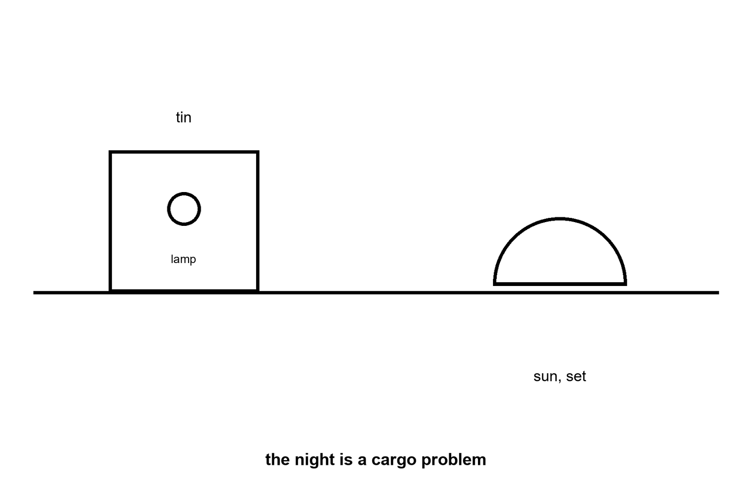
Figure 18. A horizon with a Sun that has set, and a tin with a small lamp. The caption: the night is a cargo problem.
A lunar day, at the equator, is about 29.5 Earth days from noon to noon, so the dark half is a fortnight, not a sleep.
There is no air to hold the heat. When the Sun is up, the ground can be hotter than boiling water wants to be. When the Sun is down, the ground falls toward temperatures that would crack a careless battery. A tin in that swing is a thermos with a job. You insulate. You reject heat in the day. You spend stored energy in the night. The spending is mass you flew: batteries, or a reactor that does not care that the sky is black, or a cable to a place that still sees the Sun.
The poles are why the plans moved the pin. A high ridge near the south can see the Sun for a much larger fraction of the month, and a crater floor next to it can have sat in the dark since before anyone had a word for king. That pair — a lit ridge and a dark freezer — is the whole sales pitch of a south-polar camp. It is a real geometry. It is not a lamp you can trust with your eyes closed. Ridges have shadows. Shadows move. A solar array that was in the light at the drawing’s noon can be in the dark at the drawing’s three o’clock, and three o’clock lasts for days.
Power, itemized.
Batteries for a fortnight of a crew are not a phone. They are a cargo shipment. A reactor is smaller for the same energy and larger as a politics: who launches it, who turns it on, who is wrong if it is wrong. A cable from a lit peak to a habitat in a hollow is a civil-engineering project on a world with no crane you did not bring, in one-sixth g, in glass dust, in a suit that is itself a spacecraft. All three answers are allowed. All three are mass. None of them is a downtown.
A sortie can leave before the night. That is Apollo’s curfew, and it is honest. An outpost stays. Staying is the night, paid. If your slide shows a habitat and does not show the watt-hours of the dark, the habitat is a drawing.
Nandita has a version of the camp that died because the power box slipped a year and the tin did not. She kept the drawing. She did not call it settled.
Nandita walks the drawing with a pencil, not with a speech. She marks the hours the ridge is dark even when the brochure said continuous. She marks the cable’s length in the dust, and the people who would have to lay it in suits, and the day the cable is cut by a rock nobody scheduled. A reactor gets a second box on the page: the meeting, the license, the neighbor who does not want the box in the same sky as a school. Batteries get a mass. She writes the mass in tonnes, then she writes what those tonnes displaced on the ship — food, a spare pump, the drill Wei is still waiting to fly. Something always loses. The night does not negotiate. A camp that survives one fortnight on a borrowed battery has performed a stunt. A camp that survives the next one, and the one after, with the spare already on the pad, has started to be an outpost. The difference is not courage. It is the second shipment, paid before the first night, because the first night is when you find out which box you forgot.
She keeps the dead camp’s drawing because the dead camp is a teacher that does not need a funeral. The power slipped a year. The tin arrived on time. The crew would have had a beautiful afternoon and then a fortnight of a lamp and a radio and a decision about who sleeps. She will not draw that decision again and call it architecture. Architecture is the cargo that makes the decision unnecessary. Until the cargo is on a manifest with a date, the lamp in the corner of the figure is the whole power system, and the rest is a wish with a switch.
Nandita prices the lamp in watt-hours, because a fortnight is a number and a drawing is not.
A kilowatt left on for fourteen days is a few hundred kilowatt-hours. She writes three hundred and thirty-six, then she writes the habitat she was actually handed. She writes several kilowatts in pencil, for a habitat that would stay warm, breathe, and keep a radio that can still call the ridge. Pencil is not a measurement of a habitat she has weighed. Several kilowatts through the same fortnight, if the hearing accepts the pencil, is thousands of kilowatt-hours. That is the battery shipment, or the reactor that does not consult the sky, or the cable that has to be intact at the hour the hollow goes dark. She does not let the hearing say “power.” She makes them say which of the three, and how many kilowatt-hours, and what those tonnes pushed off the ship.
She prices the mass, because a kilowatt-hour is still a drawing until it has a weight.
A battery pack of the class flown in this decade stores on the order of 200 watt-hours per kilogram once the cells sit in a box that can survive a launch. Three hundred and thirty-six kilowatt-hours is 336,000 watt-hours. Divided by 200, that is on the order of 1,700 kilograms for a single kilowatt through the fortnight, before the radiator and the spare. If the pencil says three kilowatts, the battery is several tonnes. Those tonnes are the spare pump and the drill Wei is still waiting to fly, unless the hearing chooses the reactor or the cable instead. She makes them write the displaced line on the same page as 336. A number with no mass beside it is the lamp again.
Appendix A18 writes the fortnight, the polar bargain, and the three ways to hold the night. Here, keep the lamp. The night is a cargo problem.

19. The Ice Has to Pay for Itself
Polar ice is the sentence that turned a flag stand into a maybe-kitchen. Maybe is the word.
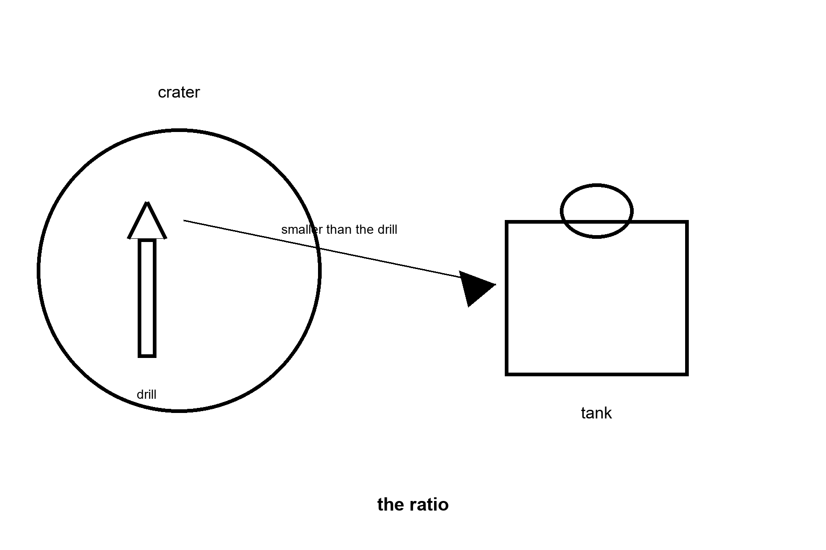
Figure 19. A dark crater, a small drill, a tank. An arrow from drill to tank labeled smaller than the drill. The caption: the ratio.
A permanently shadowed region is a hollow the Sun does not reach, cold enough that water ice can sit for geological time if it was delivered and not later kicked out.
Cold is not the same as a well. The ice may be a frosting, a mix with dirt, a lie of the radar, or a thick deposit a robot can bite. Wei Ning’s paper moves that sentence from a rumor toward a number. A number is not a shift until a machine has bitten twice and a spare exists for the machine that broke.
The ratio is the whole pole. You spend spacecraft, power, and often water — the water of seals, of losses, of the crew — to get ice. If you spend three tonnes of trouble to net one tonne of water, you are not a tank farm. You are a demonstration that lost money in a useful direction. If you net more than you spend, and you can do it again next month, you have moved one pole of ISRU from a paper to a shift. You have not moved the babies. Babies need the shift to be boring.
What the water is for, if you get it.
Drink, after you clean it. Air, after you crack it. Propellant, if your engines drink oxygen and hydrogen, or oxygen and a fuel you still have to find. Cooling. Shielding, because a jacket of water is a kinder dosimeter than a jacket of nothing. Every one of those uses is a plant: power, a cracker, a liquefier, a tank that does not leak in a vacuum that will forgive nothing. The ice is the ore. The plant is the town’s argument, and the plant is mostly unflown.
Temperature, so “cold” is not a mood. The shadowed floors can sit at tens of kelvin, far below any freezer in a kitchen. Machinery that was happy in a lab at room temperature becomes a different animal there: batteries quit, metals get brittle, lubricants stop being lubricants. The classroom includes a cold the equator’s night only sketches.
Look first. Drill, or radar, or a rover that can go into the dark and come out, before you draw the tank farm at the size of a harbor. Wei will not vote for the harbor. She will vote for the second measurement.
One plume is a sentence with a date on it. A later map is a sentence with a range. Wei keeps both on the same page and refuses to let the brighter sentence eat the wider one. Several percent at one hollow, on one afternoon, is a reason to go back to that hollow. Under one percent somewhere else is a reason not to draw a pipe between them as if the Moon were a watershed. There is no watershed. There is a cold floor, a machine that has to agree to the cold, and a loss you only learn by doing the bite twice. The first bite can be lucky. The second bite is the class.
She also keeps the plant off the slide until the water exists in a tank you can point at. Cleaning is a plant. Cracking is a plant. Liquefying is a plant. Each one wants power through the night Chapter 18 already priced, and a seal Chapter 20 will not let you ignore, and a person whose job is the plant rather than the photograph of the plant. A town drawn around a well that has not been repeated is a town drawn around a rumor. Wei’s vote is smaller and ruder. Fly the second measurement. Fly the spare for the thing that broke. Then, and only then, let someone sketch a tank that is allowed to be larger than the drill. Until that Tuesday the arrow in the figure points the way the money actually moves: out, toward the ice, and not yet back.
A well, in the kitchen she grew up in, is a hole you can return to on an ordinary morning and still find water, with a pump someone else can fix. A deposit is a cold floor that might hold ice, at a concentration a map has not agreed on, bitten by a machine that may not survive the bite. Wei will use the first word only after the second morning exists. The second morning is the spare, the repeated sample, and a tank you can point at without pointing at a slide. Until then she keeps the harbor in the margin, in pencil, where Dex keeps the cost per tonne. Pencil is allowed. Ink is a bid. The classroom’s job is to notice which one the slide used.
Wei prices the melt, because a cold floor is not a tap.
Getting a tonne of ice from tens of kelvin up to a liquid is not the warm-kitchen product. Ice near melting holds about 2 kilojoules per kilogram per kelvin. Ice at tens of kelvin holds much less, so charging the whole climb at the warm number overstates the warming. The melt is the part she can write without that cheat: 334 kilojoules per kilogram, about 90 kilowatt-hours a tonne. Warming plus melt, with the cold heat capacity respected and the losses still unpaid, stays on the order of a hundred to a few hundred kilowatt-hours a tonne before anyone has cleaned it. The crack is the bill that shrinks the harbor: thousands of kilowatt-hours a tonne, then a liquefier that wants to be cold while the cracker wants to be hot, in a vacuum that will take whichever seal she neglects. The night in Chapter 18 has to supply those kilowatt-hours, or the drill is a sculpture. She writes both bills in the margin and watches the harbor shrink.
A tonne you drank, or cracked, or lost to a seal, is a tonne the ratio has already spent. The arrow in the figure stays smaller than the drill until a second bite comes back with more water than the bite itself consumed, including the water the crew and the machine used while they did it. She has seen a first bite celebrated as a well. A well is a hole you can return to on an ordinary morning. A first bite is a number. The number can be several percent in one hollow and under one percent in the next, and there is no river to average them. She will not draw a pipe across that difference.
The spare for the biter sits in the same column as the kilowatt-hours. If the first machine dies in the cold, the second measurement does not exist, and the harbor is still pencil. Pencil is allowed. Ink is a bid she will not sign until the tank she can point at is larger than the trouble that filled it.
Appendix A19 writes the ratio, the cold, and why a deposit is not a well. Here, keep the arrow. The tank is smaller than the drill until the drill has been paid.

20. Dust Is Not Dirt
Dirt, in a kitchen, is soft enough to wash off a boot. Lunar dust is not that.
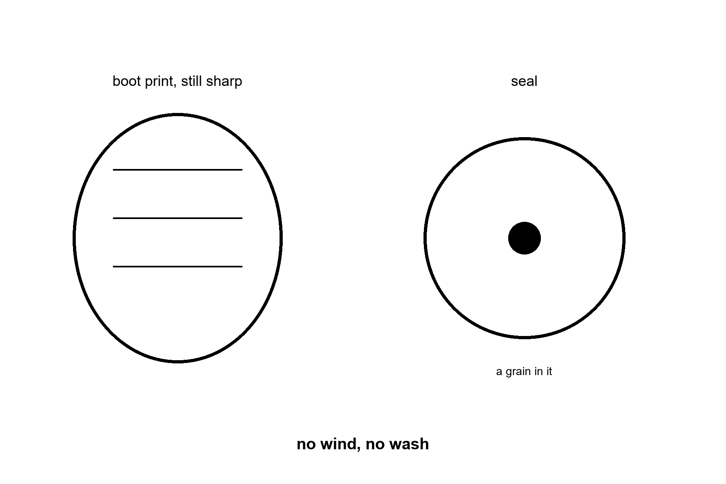
Figure 20. A boot print that stays sharp, and a seal with a grain in it. The caption: no wind, no wash.
There is no weather to round it and no rain to take it away. A boot print from fifty years ago is still a boot print. That is a gift to a geologist and a threat to a mechanic. What you kick, you keep. In one-sixth g the grain stays in the air of your disturbance longer than a kitchen would allow, and then it settles on the thing you needed to be clean.
The charge is the part the photograph misses. Sunlight kicks electrons off the surface. The dust levitates, a little, and follows fields, and finds the suit, the radiator, the visor, the lung if the airlock was lazy. Apollo crews smelled it in the cabin, like spent gunpowder, and coughed. A short stay can be a story. A year of it is a medical and a maintenance program.
What it breaks.
Seals. Bearings. Radiators that must see the black sky and instead see a coat of talc. Solar panels. The joint of a suit. The experiment you brought to be precise. A greenhouse, if you are arrogant enough to open one, which Mara is, on another world, with a different flour that is still not potting soil. The principle travels: you do not track the outside into the tray and then act surprised that the pH moved.
Mitigation is a shift, not a slogan. Suits brushed in a porch. Airlocks with a grate and a wait. Floors you can clean. Bearings designed to lose, and to be replaced. A rule that the glove comes off before the hand touches the seedling. Linh can tell you which of those is a drawing and which has survived an hour of simulant. An hour is not a year. A year is the outpost. The drawing is the brochure.
Rohan has opened boxes that were clean when they left and filthy when they were allowed to meet the world. He does not blame the world. He blames the procedure that pretended the world was a clean room.
Hot: no wind, no rain, sharp grains, a charge the picture does not show, a cabin that already smelled of it after a short stay. Warm: which brush, which grate, which bearing designed to be replaced, will still be a procedure after a hundred shifts. Cold: dust as dirt you can wash off a boot, and a greenhouse opened because the drawing was tired of the airlock. The seal in the figure has a grain in it on purpose. That grain is the town’s argument, losing, until someone staffs the brush.
Rohan’s procedure is short because long procedures get skipped when people are tired, and people will be tired. Brush in the porch. Wait while the pressure comes up. Do not open the inner door because the outer door has closed and you are bored. Take the glove off before the hand that will touch a tray. Log the bearing that sang. Replace it on the shift, not on the shift after the one where it seized. He has watched clean boxes become filthy boxes because someone treated the world as a clean room that had merely been rude. The world is not rude. The world is sharp, and a little charged, and patient. It will be on the radiator in the morning whether or not the morning’s meeting mentioned it.
A greenhouse is the test he uses when a visitor says the dust is only a nuisance. A seedling does not care about your nuisance. A seedling cares about the chemistry on the glove. If the rule is “we will be careful,” the rule will fail on the day the radio is loud and the seal looks almost clean. If the rule is a step with a person’s name beside it, the rule can survive a loud day. Fifty years of a boot print is the same fact as a year of a dirty seal. Nothing came along to round the grain or wash it off. You are the thing that has to come along. Until a roster has that name on it, the porch in the brochure is a painting, and the painting does not keep the bearing.
He keeps one more fact for the visitor who says a printer will make the parts, so the dust will not matter. A printer that survives the grain is a warm hope and a cold purchase order. The grain does not become round because you can print a new seal. You still have to keep the grain out of the seal you are using today, and out of the printer, and out of the lung of the person who changes both. A part you can replace is a maintenance plan. A part you can replace is not a charm against sharpness. The print that lasts fifty years is the Moon telling you the weather will not do this job. Someone with a brush will, or the bearing will sing, and then it will stop, and the stop will not care that the brochure had a porch.
Linh’s box is the small version of his year. She can throw the flour out at the end of the afternoon. He cannot throw the Moon out at the end of the shift. That is why her hour is a measurement and his year is a roster. The measurement tells you the grain is sharp. The roster is the only thing that keeps the sharpness from becoming the town.
Rohan adds the failure a busy-looking brush does not fix.
In a kitchen, dust falls, and air carries the rest away when you wave a cloth. Here there is no air to carry it, and the grain is charged, so a cloth can move it from the seal onto the glove and back onto the seal. A porch that looks brushed has rearranged the problem. The wait while the pressure comes up is part of the tool. So is the rule that the inner door stays shut until the person whose name is on the step says the step is done. Tired people skip a step that is only a mood. He will not let the step be a mood.
A radiator that must see black sky, and instead wears a coat, runs hotter than the drawing. Hotter is how a loop fails on a day the Sun is already rude. A solar array that was Chapter 18’s answer to the night becomes partly blind, and the night gets more expensive in watt-hours even though the clock did not change. Bearings sing, then seize. The printer a visitor offers does not round the grain. It gives you a new seal to ruin in the same dust, if you can keep the dust out of the printer.
He writes the lung on the same card as the bearing. A short stay can be a story about a smell. A year of that smell is a medical program with a roster. The greenhouse is the test he uses on visitors. A seedling takes the chemistry on the glove. If the rule is “we will be careful,” the rule fails on the loud day. If the rule has a name beside it, the loud day still has a person. Fifty years of a sharp boot print is the Moon saying the weather will not wash this. Someone with a brush will, or the town will be the grain.
Appendix A20 writes charge, sharpness, and why a print that lasts is not a charm. Here, keep the seal. Dust is not dirt.

21. The Dose
The Moon does not have a magnetic kindness worth mentioning, and it does not have air to spend the first of the particles.
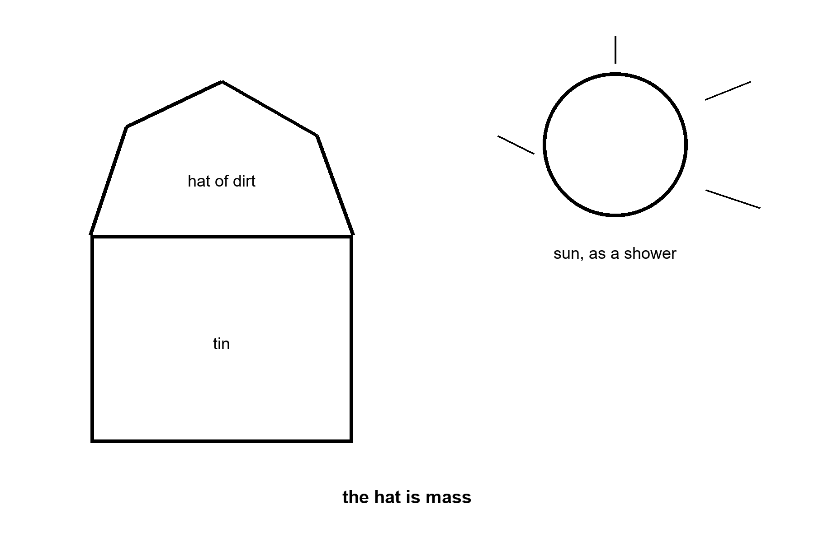
Figure 21. A tin with a hat of piled dirt, and a Sun drawn as a shower. The caption: the hat is mass.
A dose is energy deposited in tissue, and the units that matter to a crew are the ones a flight surgeon already uses: sieverts, career limits, a storm that does not care about your schedule.
Two weathers. One is the slow drizzle, galactic cosmic rays, a few heavy nuclei that punch through thin walls and leave a trail. You do not hide from the drizzle with a foil blanket. You accept a rate, you count the days, you come home before the count becomes a career. The other weather is a solar storm, a shove of protons that can arrive in hours. A sortie caught outside is a medical event. An outpost with a storm shelter — water, or a pile of the dirt itself, or a corner of the tin under the bags — is a place that took the weather seriously.
Apollo’s stays were days. The dose was a bill they could pay and go home. Months is a different dosimeter. A year is a different one again. A child, who is still building, is not an adult’s limit worn by a smaller body. This book will not print a nursery on a slide that has not printed a storm shelter.
How much dirt. Order of magnitude, not a contractor’s bid: a hat of regolith on the order of a meter to a few meters is the usual sketch for turning a storm from a crisis into a bad day, and for taking the edge off the drizzle. That hat is mass. You either move it with machines you brought, or you bake it into bricks, or you live in a tube nature already dug. A lava tube is a warm hope and a cold address until someone has surveyed the one at your latitude and shown you the roof will not fall. Fairy tales are allowed in the hall. They are not a floor plan.
Jules thinks about the valve. He should also think about where the crew sits when the Sun misbehaves. The press office thinks about the visor shot. The visor shot is the drizzle’s opposite: a second of glory, no hat, no count.
Hot: no magnetic kindness worth mentioning, no air to spend the first of the particles, a measured daily rate on the open surface, a historical storm that missed the crews by a flight. Warm: how thick a hat, at this site, for this stay, moved by which machine. Cold: a visor shot as a radiation plan, and a child on a slide with no shelter. The dose is a clock. The hat is how you buy time on it.
Jules prices the walk to the hat, because a shelter you cannot reach is a caption.
The drizzle is the slow clock. About 1,370 microsieverts a day on the open surface is about half a sievert if you stand in it for a year, near a career line of order 600 millisieverts. You do not outrun a drizzle. You count the days and you come home, or you live under mass. The storm is the fast clock. The Sun can shove protons at you on a scale of hours, and the first of them can be ruder than the warning. In August 1972 it threw one between two Apollo landings. Nobody was standing on the surface. Luck is not a floor plan.
So the corner under the bags has to be a walk from the place the crew actually works, not a bunker drawn on the far rim. Water, or dirt, or the bags themselves, on the order of a meter to a few meters, is the sketch that turns a storm from a crisis toward a bad day. Filling that hat is a shift in a suit, and the shift is spent before the weather. During the weather is the medical event. A child is not an adult’s limit worn by a smaller body. He will not staff a nursery against a number that was counted for a geology trip of a few days.
He hangs the dosimeter where they eat, in the same ink as the valve. Drizzle adds. Storms arrive. The hat is allowed to be dull, heavy, and finished before anyone is proud of it. If the hat exists only in the figure, Thursday is a photograph of a mistake.
He also writes the walk in minutes. A storm warning, when one comes, is a handful of hours and sometimes less. Bags on the far rim are a caption if the walk outlasts the warning. He puts the hat beside the valve, so the shift that can reach one can reach the other.
Jules writes the division where they eat, under the daily number.
About 1,370 microsieverts a day is 1.37 millisieverts a day. A career line of order 600 millisieverts, divided by 1.37, is on the order of 440 days. An open-surface year is already most of that line, and the year has not yet included a storm. The 1,370 is the Chang’e-4 far-side dosimeter from 2019, the reading Appendix A21 keeps.¹⁶ He will not let a slide say low when the division says a little over fourteen months to a line several agencies already treat as a career.
The hat is not a vest and not a visor. A meter to a few meters of the dirt itself is mass that has to be piled before the weather. He times the walk from the valve to the bags. If that walk is longer than the warning the Sun actually gives, which can be a handful of hours and can be less, the bags are a caption on the far rim. He moves the bags. The move is a suit shift, spent on a quiet day.
Appendix A21 writes drizzle versus storm, and why the hat is mass. Here, keep the piled dirt. The dose is a clock.

22. Abort Is a Path
Abort is not a feeling. It is a trajectory you still have enough propellant and enough heat shield to fly.
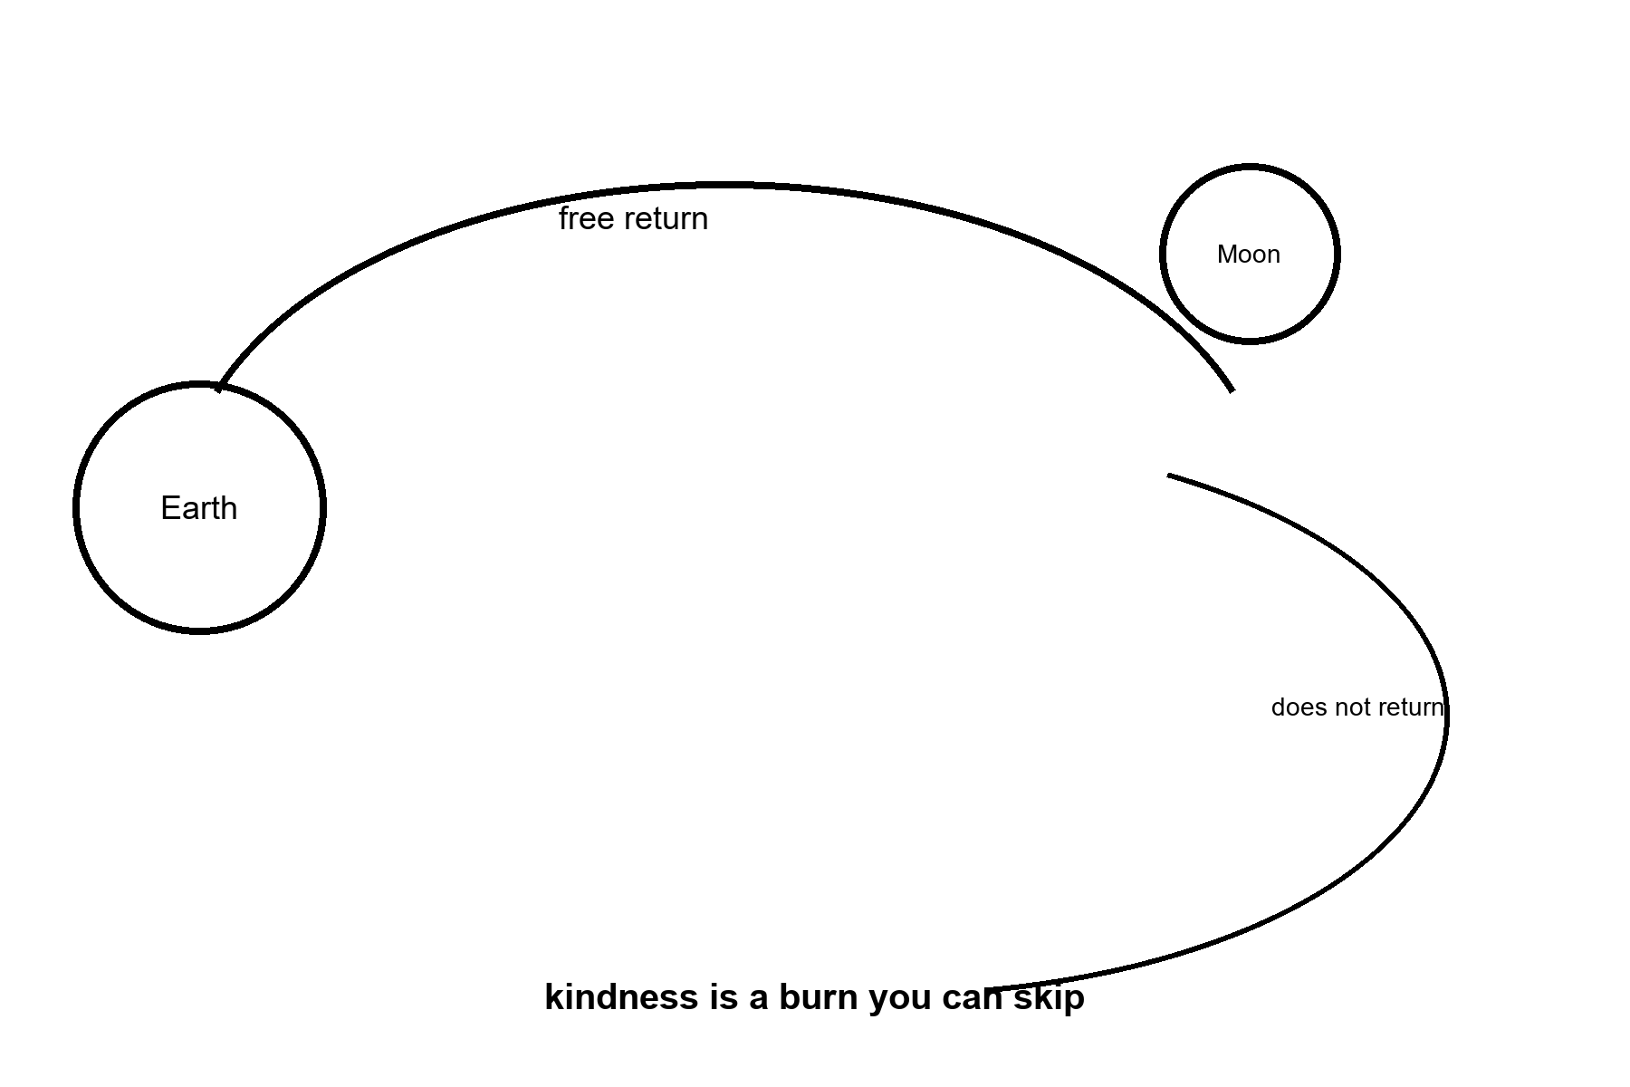
Figure 22. A loop that falls back toward Earth, labeled free return, and a second path that does not. The caption: kindness is a burn you can skip.
A free-return trajectory is a path that, if you do nothing further, falls back toward Earth instead of stranding you.
The early hours of a lunar trip can still own that kindness. You light, you coast, and if a valve sulks you are already on a road home, slow and uncomfortable and alive, because someone drew the road that way. That is why an Artemis-II-class loop can call splashdown the success. The architecture confessed, in advance, that not landing was allowed.
Later, the kindness gets expensive. Once you have braked into orbit, or started down, “home” is a burn you must still be able to perform, with an engine that has sat in the dust, and a rendezvous with a cabin that is itself a moving target. Apollo practiced this until it was a small fierce trick. A new heavy lander has not practiced it until it has. Chapter 7 listed the leave as a long pole. This chapter only insists that the pole is a path on a chart, not a word in a press release.
Abort from a Mars transfer, once you are weeks along, is a different novel, and Chapter 11 already refused to let it be the first homework. You may have to go to Mars anyway, because turning around is not a U-turn in an ocean. It is a new ellipse that might cost more than finishing the fall. A crew that was told “we can always come back” was told a sentence that is true only inside a window of days and a budget of propellant. Outside that window the sentence is a lullaby.
Jules keeps the lullaby off the checklist. The checklist says: this burn, this much drink left in the tanks, this day on which home is still the cheap path. If the drink is gone, home is no longer a mood you can select. It is a place you are not going.
Mara’s ride home is a window, not a mood. She already lives the grown-up version. The Moon’s version is kinder and still not optional. Close is a classroom because the path home is still a path.
Hot: a free-return path is a real trajectory, already used when a crew needed it, and the flown lunar loop of this kitchen was drawn to keep a version of the kindness. Warm: whether a given lander, after it has braked, still owns the burn. Cold: always, as a word, after the window has closed. The loop in the figure falls home. The other path does not. Kindness is the one you can skip because you drew it first.
Jules splits the drink into two lines on the checklist, because one tank is how a landing eats the ride home.
The propellant that puts you down and the propellant that picks you up are not a mood you can average. Spend the ascent drink to stretch a landing that ran long, and you are on the surface with the leave reduced to a word. Chapter 7 already called the leave a long pole. This line is the kilogram version. Before anyone is allowed to talk about the flag, he makes them say how much is reserved for the burn that meets the moving cabin, which engine has to light after it has sat in the dust, and what the crew does in the hour the light does not come.
Early in the trip the cheap path can still be a free return. Do less, and the road falls toward an ocean. Apollo 13 had already left that road. A burn put them back. The kindness was reachable. It was not the road they were already on. After the brake burn, the cheap path is over. Home is a fire you still have to light. He underlines the day that change happens. A crew that cannot point to the underline has been handed a lullaby and told it was navigation.
A sortie includes the ride home. Elena writes that under the card, so a flag with no path back cannot borrow a settlement’s courage. Staying the fortnight is Chapter 18’s cargo. Coming home if that cargo fails is this chapter’s burn. Both sit on the manifest, or the manifest is a brochure with a trajectory drawn by someone who will not be in the seat.
He writes that day as a date, not as the word early. Early is a mood. A date is a day the road either still falls toward an ocean or does not. The crew can point at a date. They cannot point at a mood.
A U-turn is a word from a road. The ship is not on a road. It is on an ellipse the engines already paid for. Turning around means killing that ellipse and buying another, and the new one can drink more than finishing the fall already under way. That is why always is a lullaby once the ship is weeks toward Mars, and a checklist item only while the lunar path still falls home by itself. Jules draws the ellipse on the back of the card. He will not hear the word always until someone can point at the day the ellipse stops being the cheap path.
Appendix A22 writes free return, and why a later abort is a burn. Here, keep the loop that falls home. Kindness is a burn you can skip.

23. Nobody Owns the Crater
A flag is not a deed.
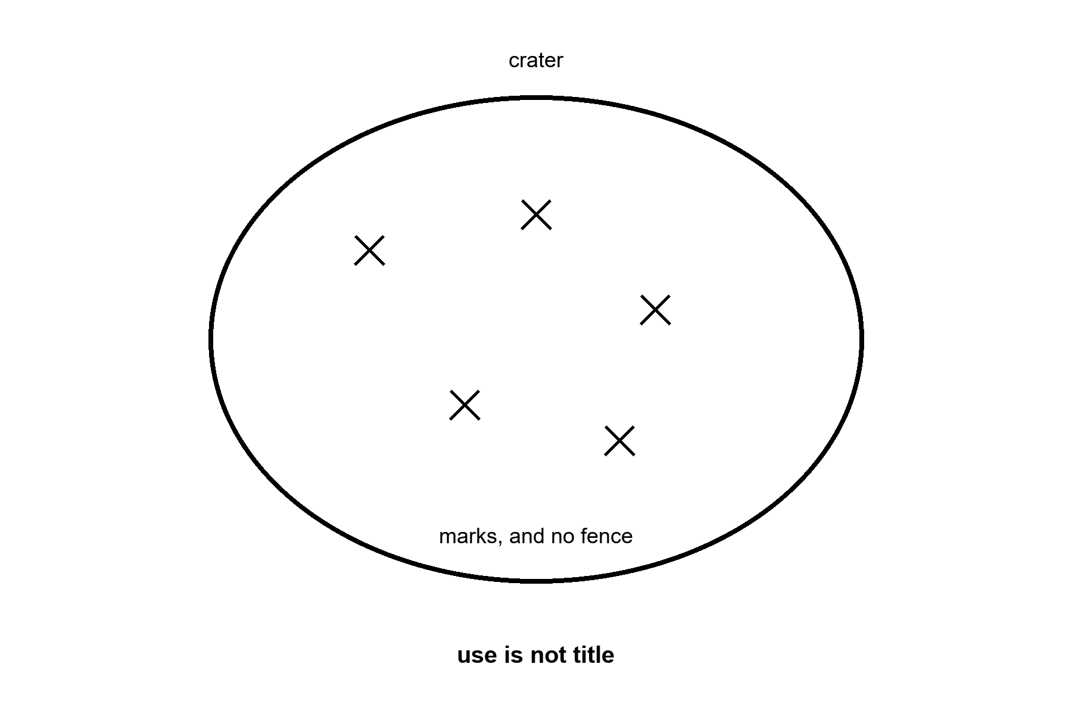
Figure 23. A crater with several small marks and no fence. The caption: use is not title.
The treaty that has governed this for a working lifetime says, in short, that no nation may appropriate the Moon by claim of sovereignty. You may go. You may use. You may not plant a fence and call the crater a province. That is hot as a legal sentence the spacefaring states actually signed.¹⁷ What it means for a company that mines ice, or a camp that sits on a ridge for a decade, is warmer: national laws have tried to say that extracted resources can be owned even if the land cannot, and other readers of the same treaty call that a theft with a statute. The fight is a meeting. The fight is not a downtown.
Why it belongs in a book about trips. Because a settlement fantasy often smuggles a landlord. Someone will own the water. Someone will charge the dock. Someone will tell the late arrival that the lit ridge is taken. Maybe. The law we have is a brake on the kingdom and a fog on the mine. Planning a city as if the fog were a settled property right is the same move as planning a city as if the ice were a harbor. Look first. The ice may be a film. The title may be a film. Neither films the babies into existence.
What you can still do, without pretending to be a county. Visit. Land. Leave a science station. Use a resource under whatever reading of the treaty your lawyers can defend in public. Coordinate so two drills do not occupy one hollow by accident. Write the coordination down. Coordination is an outpost’s politics. A county’s politics — courts, schools, a tax, a child who is from there — is the third noun, and the third noun is not a clause in a 1967 document. It is a kitchen that can miss a ship.
Elena would put the treaty on the table next to the three cards and ask which card it contains. It contains none of them. It permits going and use, and it forbids a national fence. A sortie fits inside what it permits. An outpost fits only as use, for as long as someone keeps the loops closed. A settlement is not a clause from 1967. The slide that says “our crater” has picked up a card the treaty did not deal.
Wei Ning’s rock does not belong to a downtown. It belongs to a measurement. The measurement can be done under a flag. The flag does not become a fence because the measurement was good.
Hot: non-appropriation, as signed. Warm: extracted ice, safety zones, a decade on a ridge. Cold: “our crater,” and a county smuggled in on a science station. Coordination is an outpost’s politics. A county’s politics can wait until the kitchen exists. It does not exist because a slide said the word.
Elena keeps a second card that visitors try to slide under the three. The card says ours. She does not let it sit on the table. A flag on a measurement is a return address for the rock. A fence on a crater is a claim the sentence from 1967 already refused, and the spacefaring states signed the refusal. What a company may carry home in a tank, if the tank ever fills, is the warm fight, and she labels it warm so a hearing cannot pretend the fight was settled by a slide that used the word property. Two principle sets can both be sincere and still leave two drills in one hollow with no court both will enter. That is not a downtown. That is a coordination problem with manners, and manners are an outpost’s whole politics.
She asks the visitor to name the child. Not a child in a painting. A child who is from the crater, with a school, a tax, a court, a kitchen that ate on the week the ship did not come. The visitor cannot name the kitchen, because the kitchen is Chapter 12’s third noun and the third noun is not a clause. Use the crater. Measure it. Leave the fence off the figure. If a later century has a kitchen that can miss a ship, that century can argue about counties with its own staff. This century’s staff is the sortie, and the outpost if the partners keep paying, and the sentence that says the Moon is not a province because a measurement went well.
Wei’s rock goes home in a box with a number, not with a deed. The number is the measurement. The box is the use. If a later argument wants to say the water in a tank can be sold, that argument will have to survive a hearing that has read the clause, and it will have to survive the other camp that read the same clause and brought a different principle set. Elena will not settle that hearing in a classroom. She will keep it labeled warm, which means both sides have a text and neither text has been embarrassed by two drills and a court. Warm is not a shrug. Warm is a refusal to let a slide print a fence in ink. The crater in the figure stays unfenced because the law we have is a brake, not a landlord.
Elena runs the Tuesday nobody draws. Two drills. One hollow. No court.
The teams are not villains. Each has a map, a funder, and a reading of the same 1967 sentence. The sentence lets them go and lets them use. It does not give either of them the crater. The radio between them is late in the same way every lunar call is a stack of monologues. By the time one camp hears the other, both machines may already be in the hollow. A court that both will enter does not exist on the Moon. What can exist, if anyone wrote it down before the ships left, is a rule: who moves, who waits, who shares the sample, and who does not get to call the wait a surrender of title.
She makes the visitor write that rule on the back of the card that says ours. If they cannot write it, they do not have an outpost’s politics. They have a hope that the other drill will be polite. Politeness is not a coordinate. Use is still allowed. A fence is still not. The warm fight about a tank of extracted ice can wait for a hearing on Earth that has read the clause. Arriving first will not settle it. Arriving first is a sortie. It is not a deed.
Appendix A23 writes the non-appropriation sentence and the resource fight as warm, not settled. Here, keep the crater without a fence. Use is not title.

24. What a Program Costs
A program has a price. A city has another price. They are not the same coin.
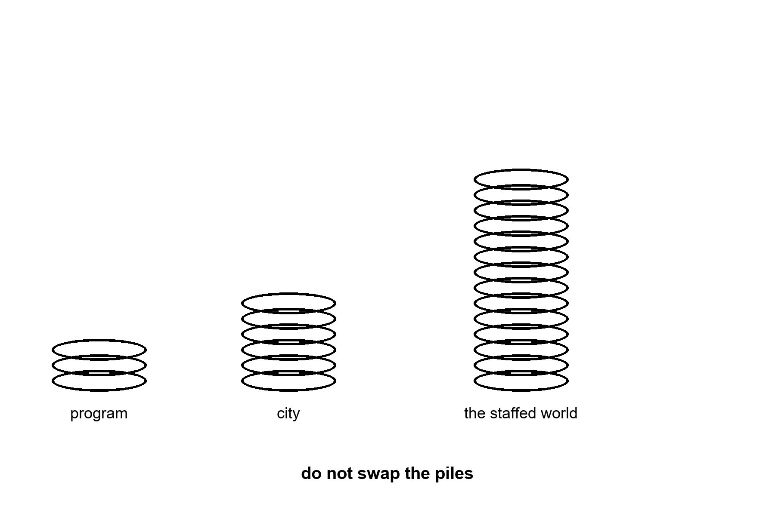
Figure 24. Two piles of coins, one labeled program, one labeled city, and a third, much larger, labeled the staffed world. The caption: do not swap the piles.
Orders, so a hearing cannot choose a prettier one. A heavy government launch in this era is often a billion-class event once you count the stack, the cadence you do not have, and the standing army that keeps the pad. A program that wants a few crewed loops and a landing attempt is tens of billions across a decade, the way large human-spaceflight programs have been tens of billions. That is real money. It is also the money of a few large infrastructure jobs on Earth, not the money of feeding eight billion people, and not the money of decarbonizing the furnaces Chapter 15 already named as the thermostat.
The dishonest swap runs in both directions. One camp says the program is so expensive it is a theft from the tide gauge. A single program is not the coal fleet. Nadia’s gauge does not move because you cancelled a loop; it moves because you changed the furnaces, the farms, and the forests. Another camp says the program is an investment that pays the gauge back by moving the species. It does not. Chapter 13 counted the heads. A campus on another world is not a species-move, and its price, however bravely spent, is not a cleanup.
What the price does buy, if you spend it honestly. A classroom. Suits that have worked a shift. A night survived. A sample in a box. A lander that came home. Those are worth buying or not, in a hearing, beside the sea wall and the hospital. The hearing is allowed to buy both. The hearing is not allowed to buy the loop and call it the sea wall.
Dex’s cadence board has a cost column he does not show to people who only want the clip. Cost per tonne, if routine ever arrives, is the number that would change the mass of an outpost. Cost per tonne on a slide, before routine, is a wish with a dollar sign. He writes the wish in pencil. Mid-century cost per tonne is a contested number, not a cold one: serious analysts with the same flight data land an order of magnitude apart, depending on how fast they think reuse and tanker cadence will mature. Pencil is the honest instrument for a contested number.
Hot: the orders of magnitude — a launch in the billions, a program in the tens of billions, a world whose furnaces dwarf both. Warm: whether routine ever arrives, which is the only thing that would change cost per tonne from a pencil wish into a number Dex would bet. Cold: the program as the tide gauge, and the program as the species-move. Three piles. Do not swap them. The largest one already has a staff.
Dex shows the column he hides from the clip, because the clip wants a single coin and the column is three coins that refuse to add. A launch, billion-class when you stop pretending the stack is the whole price. A program, tens of billions across a decade, the size of a few serious jobs on the Earth that already has the staff. The furnaces, larger than both, which is why Nadia’s gauge does not twitch when a loop is cancelled and does not twitch when a loop is flown. He writes the three numbers in the same ink so a hearing cannot promote one of them into a costume for the others. The costume is the whole dishonesty. Theft-from-the-poor is one costume. Salvation-of-the-species is the other. Both require you to misread the piles.
What he will defend, if the hearing buys it, is the classroom itself. A suit that finished a shift. A night with the spare already paid. A second bite of ice. A brush with a name. A hat that was filled before the storm. A path home that was a burn on a checklist. A crater without a fence. Those are purchases. They sit beside a hospital without replacing it. Cost per tonne, once routine is real, might change how heavy an outpost is allowed to be. Until routine is real, that cell on his board stays in pencil, and he does not let a slide borrow the pencil and call it a downtown. Three piles. The largest one is already someone’s Tuesday. Do not spend the smallest one and tell her you moved the tide.
Nadia does not attend the hearing about the loop. She attends the hearing about the furnaces, because that is the hearing that can move her gauge. Dex writes her absence on the board so the loop’s advocates cannot borrow her as a mascot and the loop’s opponents cannot borrow her as a victim. She is a person with a tide and a staff. The program is a pile of money that can buy a classroom or not. The two facts share a planet and do not share an invoice. When a visitor adds them, he takes the pencil out of the visitor’s hand and puts the three piles back in their own columns. The columns are the chapter. The addition is the costume. He has seen the costume win a meeting. He has not seen it move a gauge.
The pencil wish stays a wish until cadence is a habit rather than a launch-day speech. Habit is the second flight, and the tenth, with the spare already in the budget the first one spent. Until that habit exists, cost per tonne is not a number a town can live on. It is a number a slide can borrow. Dex does not lend it.
Dex adds the pile the photograph crops: the decade of people who are not on the rocket.
A heavy launch can be a billion-class event. A program of a few crewed loops and a landing attempt is tens of billions across a decade. Spread across that decade, the program is a few billion a year. That yearly coin is a serious job on Earth, the size of a set of hospitals or a set of sea walls or a piece of grid. It is not the furnaces, and it is not a species moved. The photograph shows the stack. The invoice shows the standing staff: simulators, the spare that sits in a warehouse, the people who keep the pad honest in the years the rocket does not fly. Cancel the photograph and those people do not become a tide gauge. Fly it and they do not become a cleanup.
He will defend the classroom if the hearing buys it. A suit that finished a shift. A night with the spare already paid. A second bite of ice. A brush with a name beside the step. A hat filled before the storm. A path home with kilograms written next to it. A crater without a fence. Those purchases sit beside a hospital. They do not replace it. Cost per tonne stays in pencil until cadence is a habit: the second flight, and the tenth, with the spare already inside the budget the first flight spent. Until that habit exists, he does not lend the pencil to a slide.
Appendix A24 writes program-scale money against a city and against the furnaces. Here, keep the three piles. Do not swap them.

PART VI — The Long Ticket
The near ticket was a camp. This part is the far one: a crew that can wait, and the box it should carry. Ice oceans and a second dictionary stay in The Universe Has No Now. The rule does not.

25. Crews That Do Not Sleep
A trip to Mars is a year of your proper time if you are lucky and the window is kind. A trip to Europa is years, with a nuclear brick in the back and Jupiter’s radiation as a landlord. A trip to a large moon of a cold planet around another star is not a trip. It is a career for a civilization, or a nap that no flesh can take, or a crew that does not have a metabolism.
At a hundredth of light speed — already an aspiration that makes chemical rockets look like horses — Alpha Centauri is four centuries away. At a tenth of light speed, it is forty years, plus the problem of slowing down, plus the problem of a grain of dust at that speed becoming a rumor of energy. Flesh does not like forty years in a can. Flesh does not like four hundred at all. Generation ships are a story we tell to see if we mean it. Sleeping flesh is a story that biochemistry has not signed.
A few words, so this chapter does not assign another book. Proper time is the time a clock reads along its own path. It is the only time a body keeps. A fast trip can change the date waiting at home. It does not hand the traveler extra heartbeats. The loaf, in the cosmology book, is spacetime drawn whole, like bread: events are the crumb, a life is a thread through it, and “now” is only a slice someone chooses to cut. There is no slice every clock must share. The leftover glow is the faint microwave light still arriving from the hot past. The shove is the measured speeding-up of the stretch between galaxies. The Omega Point was a required last mind at the end of time, as if the universe owed someone a final computation. This chapter refuses the cruise as destiny. It does not reopen that trial.
Machines do not sign either, but they do not starve. An autonomous crew — processors, actuators, repair arms, a body that may look like a person because the tools were built for hands, or may look like a drill because the job is ice — can wait. It can coast. It can wake for a course correction every decade. It can arrive at a moon that has not heard of Earth in a thousand years and still know how to melt a hole.
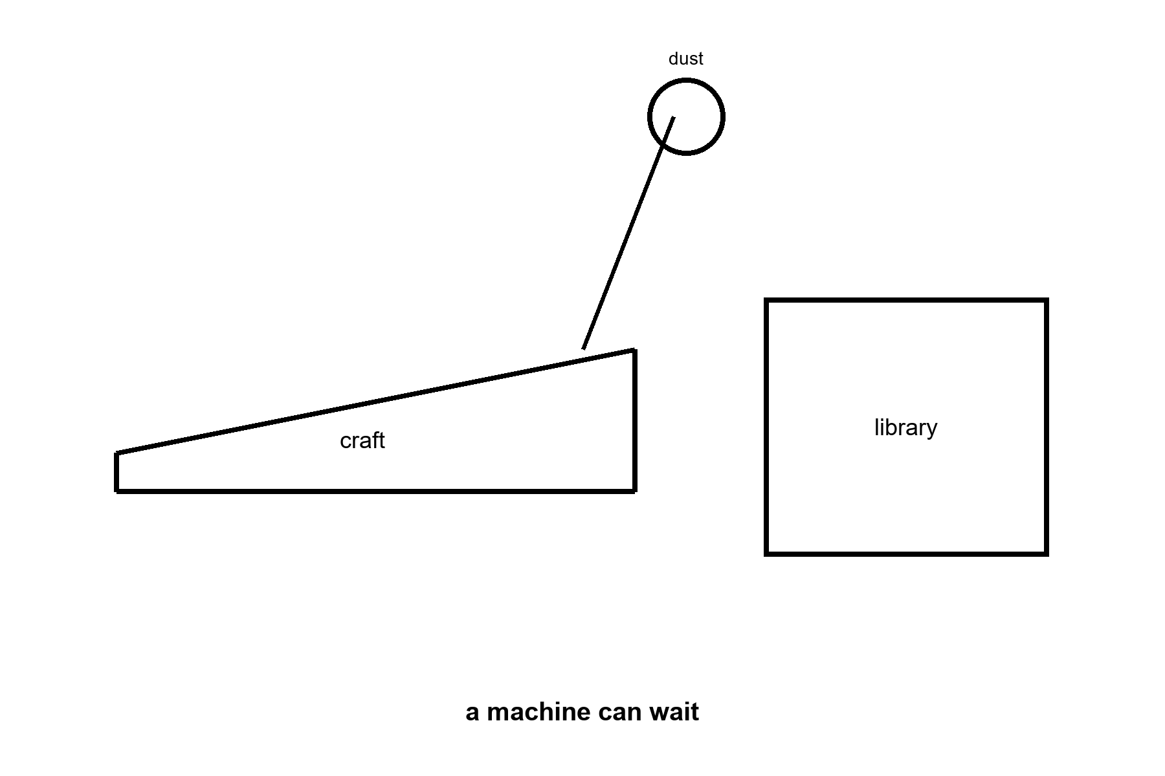
Figure 25. A long thin craft, a grain drawn as a strike on the nose, and a box labeled library. The crew that does not sleep is a machine that can wait.
Call it AI if you want the current trademark. Call it a robot if you want the older one. Call it an android if the hull is a courtesy to human doorways. The physics does not care about the courtesy. The physics cares about joules per bit, about error-correcting memory against cosmic rays, about a reactor that still knows its job after a century of quiet. Appendix A25 writes dose and travel time. Here, keep one image: a thing that does not sleep, hanging in the dark, carrying a library, aimed at a lid of ice.
The quiet is the job. Galactic cosmic rays — a drizzle of fast nuclei that no planetary magnetic mood is catching — punch bits all century. Unshielded flesh, in deep space, collects a career-limiting dose in a handful of years: tenths of a sievert per year, order of, enough to make a human worldline a bad hire for a four-century commute. The machine does not have marrow. It has parity, redundancy, a memory that expects to be wrong and keeps a spare. A grain of dust at a tenth of light is not dust. It is an energy rumor with a mass. Whipple bumpers and a long, thin nose are the kitchen names; “hope” is not. Slowing down at the far end is a second fortune, as rude as leaving. Chemical tanks will not pay it. A brick that still knows how to be a brick after a hundred years of cold might.
It wakes, if it wakes, for a star that has drifted, a gyro that has sulked, a bit that flipped and must be voted off the island. Then it sleeps again, which is a word for a low-power wait, not a dream. Flesh wants a generation ship or a biochemistry that has not signed. This crew wants a plug you can still reach from Earth for the first years, and then a set of orders dull enough that a flipped bit cannot found a religion. A melt-probe under the ice, in The Universe Has No Now, is the same object with a shorter commute. Chapter 26’s library is the cargo that makes the commute worth the failure rate.
This is not the Omega Point. It is not destiny. It is a project with a failure rate. The machine can miss. The ice can be thicker than the melt. The sea can be sealed from rock. The sea can already be taken. The project is still the only way “long travel” stops being a picture. Flesh can follow later, as cargo or as a reconstruction, if the library is good and the greenhouse, under some other sun or under some other lid, has begun to smell like a lie again.
A warning, because this book has a temperature habit. “AI” in the kitchen now is a pattern engine. “AI” on a century cruise is a control system that must not go mad in the quiet. Those are not the same object. We do not yet own the second. We own the beginnings of the first. The chapter is an outlook, not a purchase order. What it may hand her is a machine that can wait. It may not hand her a colleague.
The greenhouse woman, if a machine ever takes her shift, still needs the stuck airlock to sigh. Joules per bit do not name a potato. A century crew that arrives at a lid of ice with a library and a melt plan is a success of waiting, not a replacement of the observer who can be surprised by a yellow leaf. Keep the orders dull. Keep the plug. The rest is Chapter 26’s box and the hole under the ice, in the other book. This chapter is only the crew that can wait.

26. A Library of Earth
If you are sending a crew that does not sleep, send more than a flag.
Earth’s interesting inventory is not its iron. Iron is common. The interesting inventory is a trick of carbon and water that learned to copy itself, then learned to remember, then learned to write the memory down. The memory, at the bottom, is sequence: DNA, RNA, the libraries of proteins, the messy extra of cultures and seeds and stored fat. You can put a surprising amount of that into a box. The Svalbard vault puts seeds under a mountain because mountains outlast ministries. A cruise to a dark sea puts sequence into error-corrected crystal or dried archive or a set of printers that can, if the printers still work, turn sequence back into a cell.
A human genome is a novella: a few billion letters, less than a music library once you compress the repeats. A biosphere is a literature. The box that only holds a mascot — one ape, one crop, one slogan — is a vandal’s suitcase. What you actually want, if you are not a vandal, is the staff that can live in the available trick: rock-eaters for a vent, light-eaters for a tray, seeds that remember winter, a wet lab that can turn a recipe back into a membrane. The printers are not magic. They are kitchens that must themselves survive the trip — enzymes, solvents, a sterility you can still trust after a century of rays. Sequence without a kitchen is a book in a language no one left standing can cook.
The look-first rule is a procedure, not a hymn. Taste the plume. Melt a hole. Ask whether a chemistry already wants a story. COSPAR’s categories are the dull names for that pause: icy moons with oceans sit in the rooms where a sneeze is a policy. If the sea is taken, the library stays shut. If the sea is empty, opening the library is still a first day of school you do not get to un-teach. You cannot know from the greenhouse on the dead world. Light-minutes of delay do not carry a verdict from a lid of ice light-hours away. Patience is the instrument.
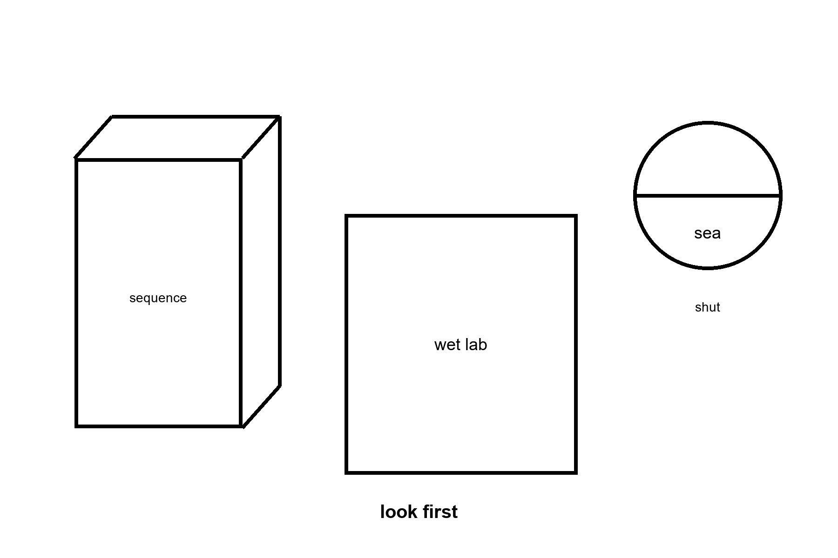
Figure 26. A thin book labeled sequence, a heavy box labeled wet lab, and a closed lid labeled sea. Look first. Seed later.
Directed panspermia is an old idea with a famous name attached: maybe someone already did this to us. Maybe we do it next. The idea is cold as history and warm as engineering. Planetary protection is the brake. If Europa’s sea has a biosphere, our E. coli is a conquistador. If it does not, our E. coli is a first day of school. You cannot know from the greenhouse. You know from the taste of a plume, from a melt, from a patient look.
The louder version is not a later visit. It is a first day.
A being — or a machine that does not sleep — opens a sterile world and pours a library into the water. DNA, or something that will become DNA, as a gift or as a farm. Earth at four billion years ago is such a world: cooled, wet, chemically sloppy, empty of grandmothers. If the pour happened, every cell we have cultured is a grandchild of someone else’s box. LUCA is still a grandmother. She is just not ours. A second origin with a code of its own would be a second dictionary. If the pour happened, that test becomes a shipping label, not a frozen accident. You do not need the other book’s trial to use the brake here. That is allowed as a sentence. It does not answer the first question. It moves it. The seeder still needed a kitchen, somewhere, sometime. Turtles, all the way down, until chemistry does the first hour without a librarian.
Would we know?
The leftover glow does not say. The rocks of the first wet days are almost gone, cooked and recycled. What we have is a code that looks like one origin, a handedness that looks like one flip of a coin, and a chemical path from organics to something like a cell that is incomplete and not empty. Miller’s spark, vents, an RNA world that may or may not have happened — those are papers, not a myth. A seeder would have to hide in that incompleteness. A serial number in the genome — a string that is not a gene and not a parasite and not junk we have misread — has been looked for by people who wanted to find it. What they found was mostly junk we had misread. Endogenous leftover viruses are leftovers, not a note.
So: seeding Earth at the beginning is cold as a detection and warm as a project we might do to someone else. If we do it, we have written over their exam. That is why the ice chapter of the other book already said look first. The myth that forgets the rule is a gardener who drinks himself into a river and calls the river life. Pretty. Rude. The river does not owe him a thank-you, and it does not prove he was there.
Ants are the honest scale.
A leafcutter city already farms. It already wars. It already keeps slaves, in some species, which is a sentence you can dislike and still have to write down. No ant negotiates with us. We step over, or we study, or we pour. To a crew that crossed a century, an ape city may be that nest: organized, impressive at its own size, not a colleague, not a conversation. The zoo hypothesis — they do not talk because we are the exhibit — is a story. The ant hypothesis is ruder and cheaper: they do not talk because talking is not what you do with a nest. If someone seeded us, they may be tending a farm, or they may have forgotten the farm, or they may have come back to wipe it because the crop learned to shout. None of those is a detection. All of them are what a librarian looks like when you are the book.
The nest is the scale, not a theory of mind. To a crew that crossed a century, an ape city may be that nest: organized at its own size, not a colleague. You meet it by being the wrong size, or by pouring. Whether a machine can be a someone is the other book’s unfinished fight. This chapter keeps the box shut until the sea has been tasted.
The printers cut the other way too. You do not have to seed a pond and wait four billion years. If the library is good and the wet lab survived the trip, you can print a being to spec: a perfect worker, a perfect weapon, a fifth thing after the ordinary four, dropped into a crisis on a clock. That is not a new physics. It is Chapter 25’s machine wearing this chapter’s recipe. Special relativity still makes the mail late. Quantum mechanics still makes the recipe a sequence of letters, not a mystic spark. General relativity still refuses a handle unless someone pays the exotic bill. The being can look like a miracle to the city that did not own the printer. It is a miracle of logistics. We would notice the printer before we noticed the theology.
Logistics has a mass. The wet lab, the spare parts, the error-corrected crystal, the power to keep a freezer cold through a century of quiet: those are kilograms the Δv still invoices. A flag is light. A literature is not. Directed panspermia — the old idea with Crick and Orgel’s names on one famous version — is this invoice pointed at a sterile ocean, ours or someone else’s. Cold as a detection in our own rocks. Warm as a project we might do, and therefore a project we can refuse. Refusing is the adult move when the exam has not been read. Pouring because the cruise was long and the crew was bored is how a librarian becomes a flood.
What you carry, if you are not a vandal, is diversity, not a mascot. A human genome is a novella. A biosphere is a literature. Bacteria that eat rock. Algae that eat light. Tardigrades that pretend to die. Seeds that remember winter. The printers, if we ever own them at that scale, do not have to print a person first. They have to print a chemistry that can live in the available trick: a greenhouse on a desert planet, a vent-garden in a dark sea, a film on a tide.
The woman in Chapter 1 is already a librarian. Her basil is a borrowed sentence. The machine in Chapter 25 is a librarian with a longer loan period. Neither of them is a destiny. Both of them are what a filter looks like when it grows hands: not the universe arranging itself for observers, but observers arranging a small room so that water and carbon can keep their trick going in a place the universe left dead or dark. Do not pour first and call it genesis. That is how you become the ant’s flood.
A last look at the box, because mass is honest. Seeds under Svalbard’s mountain are a literature parked in a climate we already have. Sequence in a cruise is a literature parked in a climate we must carry: vacuum, rays, a reactor, a sterility. If the printers fail, the box is a museum. If the printers work and the look-first failed, the box is a conquistador. The greenhouse woman’s basil is the small version of this choice, already made, on a world whose exam for a second origin was graded empty enough to farm. A dark sea is not that world until the melt says so. Keep the vault door shut until it does.
Look first is also a hygiene of the printers. A wet lab that can print a cell can print a plague. Chapter 25 already named the design assistant as a danger; this chapter is the recipe drawer that assistant would open. Sterility is not a mood. It is filters, assays, a refusal to let Earth’s hitchhikers ride the melt. The box is as dangerous as it is precious. Treat it as both. A librarian who only loves the literature will pour. A librarian who only fears the literature will never farm a dead world whose exam is already empty. The rule splits the cases. The greenhouse is the empty-exam case, run small. The dark sea is the ungraded case. Do not mix the folders.
The Svalbard door is large in the figure because a library is a physical object. So is a cruise. So is a sneeze. If you remember nothing else from this chapter, remember the mass and the pause. Sequence is light to store and heavy to cook. The pause is look first. Seed later. Never because the potatoes on the dead world were lonely.
A library of Earth, carried well, is still Earth. The letters are ours. The handedness is ours. The four-letter habit is ours. The other book already said what a second dictionary would mean. This chapter says what pouring our dictionary would mean: a shipping label where an exam should have been. The crew that does not sleep can wait a century. It cannot wait an origin. Look first is how you refuse to spend the only data. Seed later is how you farm a room that has already been graded empty. Both belong in the box. Only one belongs in a dark sea on the first shift.
Appendix A26 writes genome size, synthesis, and the protection categories. Here, keep the vault door and the pause. A mountain outlasts a ministry. A cruise outlasts a body. Neither outlasts a mistake poured into a sea that already copies.

PART VII — Local Fixes, Not Fountains
The camp has been priced. The classroom was the bills a rendering skips. The long ticket was a cruise flesh will not take. What follows is the body that stays, on the world that already has a staff. The airlock in the next chapter is the same door as Chapter 1. The hands on it have been aging the whole time.

27. Her Hands Still Age
The same glove. A new invoice.
The airlock is the same door. She already hit it, in Chapter 1, and the seal already sighed. What arrives on the delay this morning is a capsule. The label is optimistic. A small paragraph about support and maintenance and a season that can still be used. Her hands are not optimistic. The knuckles have begun to look like a map of a place she has already walked. The joint that used to open a jar without a thought now asks for a meeting.
She takes the dose because a joint that still works is a local win, and local wins are the only kind biology has ever reliably sold. She does not become a different species.
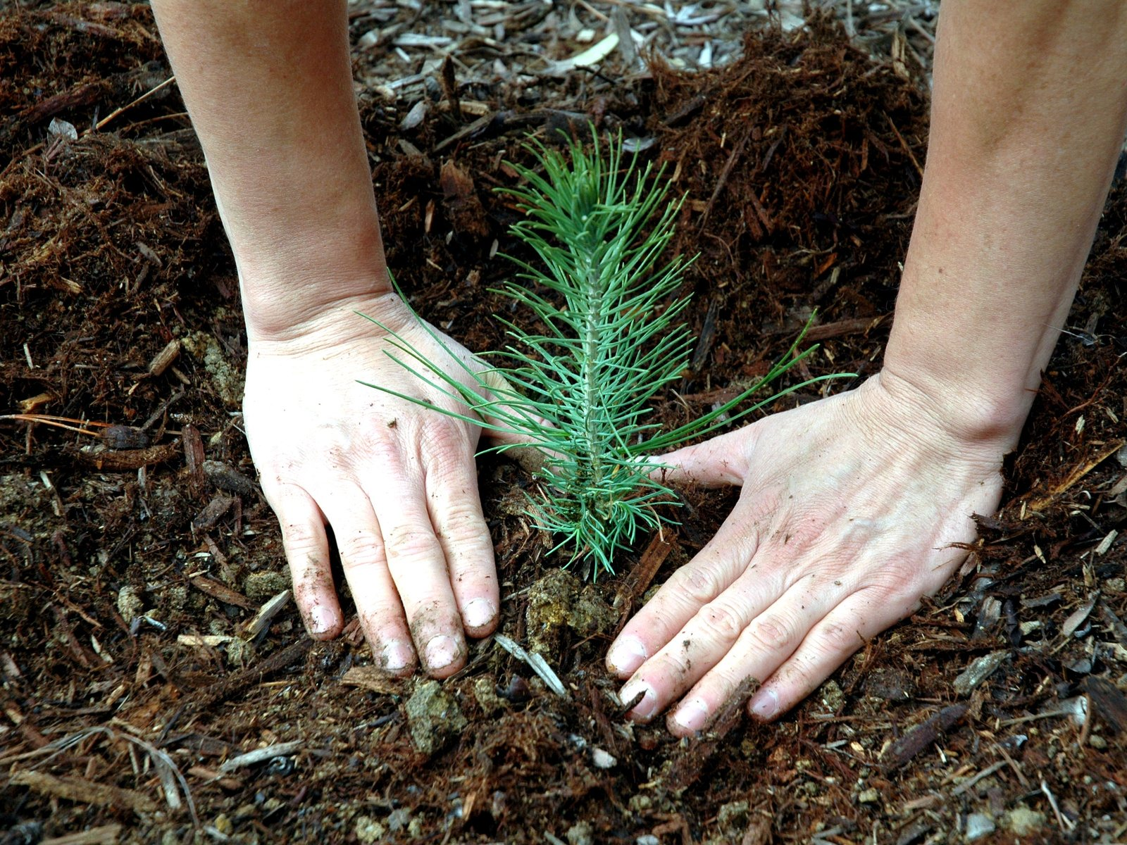
Figure 27. Working hands over a basil tray in hard light; a plain blister at the edge. The dose is local. The hands are still the hands.
Worldwide, by the Global Burden of Disease estimate, 595 million people had osteoarthritis in some joint in 2020, and the hands are one of the four sites that study counts separately.¹⁸ Hers is not a rare complaint. It is one of the most common diagnoses a human body ever files. A human joint is cartilage, bone, a little sac of fluid, a staff of cells that keep a surface honest. The staff gets worse at the job. Inflammation writes graffiti. The surface pits. Pain is not a metaphor. Pain is a measurement the nervous system makes and will not stop making because a label was optimistic. A drug that lowers the graffiti, or a lubricant the body will accept, or a replacement that a surgeon can bolt in, is a local win. Local is the word that has to sit still.
Local means this tissue, this season, this invoice. It does not mean a reset of the house.
The same woman still copies DNA with a small error rate. She still shortens the little caps on the ends of chromosomes, the long strands of coiled DNA inside a cell, in the lineages that divide. She still runs mitochondria that leak and forget. She still keeps an immune system that has learned too many grudges and forgotten some of its tact. She still accumulates cells that refuse to die and then spoil the room. She still wears grooves in a brain that has been on duty since the first language she learned. Chapter 29 is those clocks. This chapter is the refusal to let one useful dose pretend it wound them all back.
The test is a jar, and then it is the airlock.
The first thing Mara loses is not a speech. It is the jar. The lid that used to turn without a thought now asks for a second hand, then for Rohan, then for a postponement she pretends is about the basil. The heel of the glove is the same joint, asked to do a ruder job. A camp that cannot open its own seal has been stopped by a knuckle.
What the capsule is allowed to be.
She reads the label the way she reads a pump manual. Support. Maintenance. A season that can still be used. No sentence in it claims a new species, a rewound telomere, or a brain that was waiting in a cupboard. She takes it. The blister at the edge of the figure is the entry fee, small and visible, the way a real invoice is small and visible. A dose that quiets the graffiti for a season is a local win. A dose that lets her hit the seal herself, this month, is the win she would vote for. The vote in this book is not a survey. It is a Tuesday. A joint that is a two, not an eight, is a morning she would repeat. A pulse that continues while the jar stays shut is a longer evening. Chapter 28 will split those pots. Here, keep the jar.
Rohan notices the blister before he notices the label.
He is better at pumps than at basil, and he is worse at pretending a hand is fine. He does not make a speech. He sets the spare lid where her left hand can reach it. She logs the joint the way she logs the seal torque: a number, an instrument, an action. Two, today. Not eight. The number is allowed to be boring. Boring is how she will know, in a month, whether the capsule bought a season or only bought a paragraph.
Priya’s hands are the same diagnosis on a different invoice.
The same count sits in hands like theirs. Priya will not get a ticket, and she will not get this capsule by being Mara’s sister. Her clinic, on the coast, has a fridge and a surgery date and a stack of letters that say not eligible. Chapter 43 is that morning. This chapter only refuses the promotion: a useful dose on Mars is not proof that the coast received one. The hands still age in both rooms. That is hot. The delivery is a zip code. Chapter 43 itemizes that bill.
Use the temperatures from How to Read on the capsule. A useful season is a warm, local win. A sermon that calls the dose the first day of a new species is a hope sold early. Put the sermon down and keep the joint, if the joint is what she paid for.
Appendix A27 writes what “local” has to mean when a pharmacist and a marketer share a noun. Here, keep the hands. They still age. That is the first hot fact. Everything colder will have to walk past it.

28. Lifespan Is Not Healthspan
Lifespan is not healthspan.
Lifespan is how long the clock on the wall can be embarrassed by your pulse. Healthspan is how many of those years you would vote to repeat. You can add frail years. That is easy to mistake for a miracle. It is a longer evening in a chair. The honest product, if you want one, is mornings that are still worth hitting an airlock for.
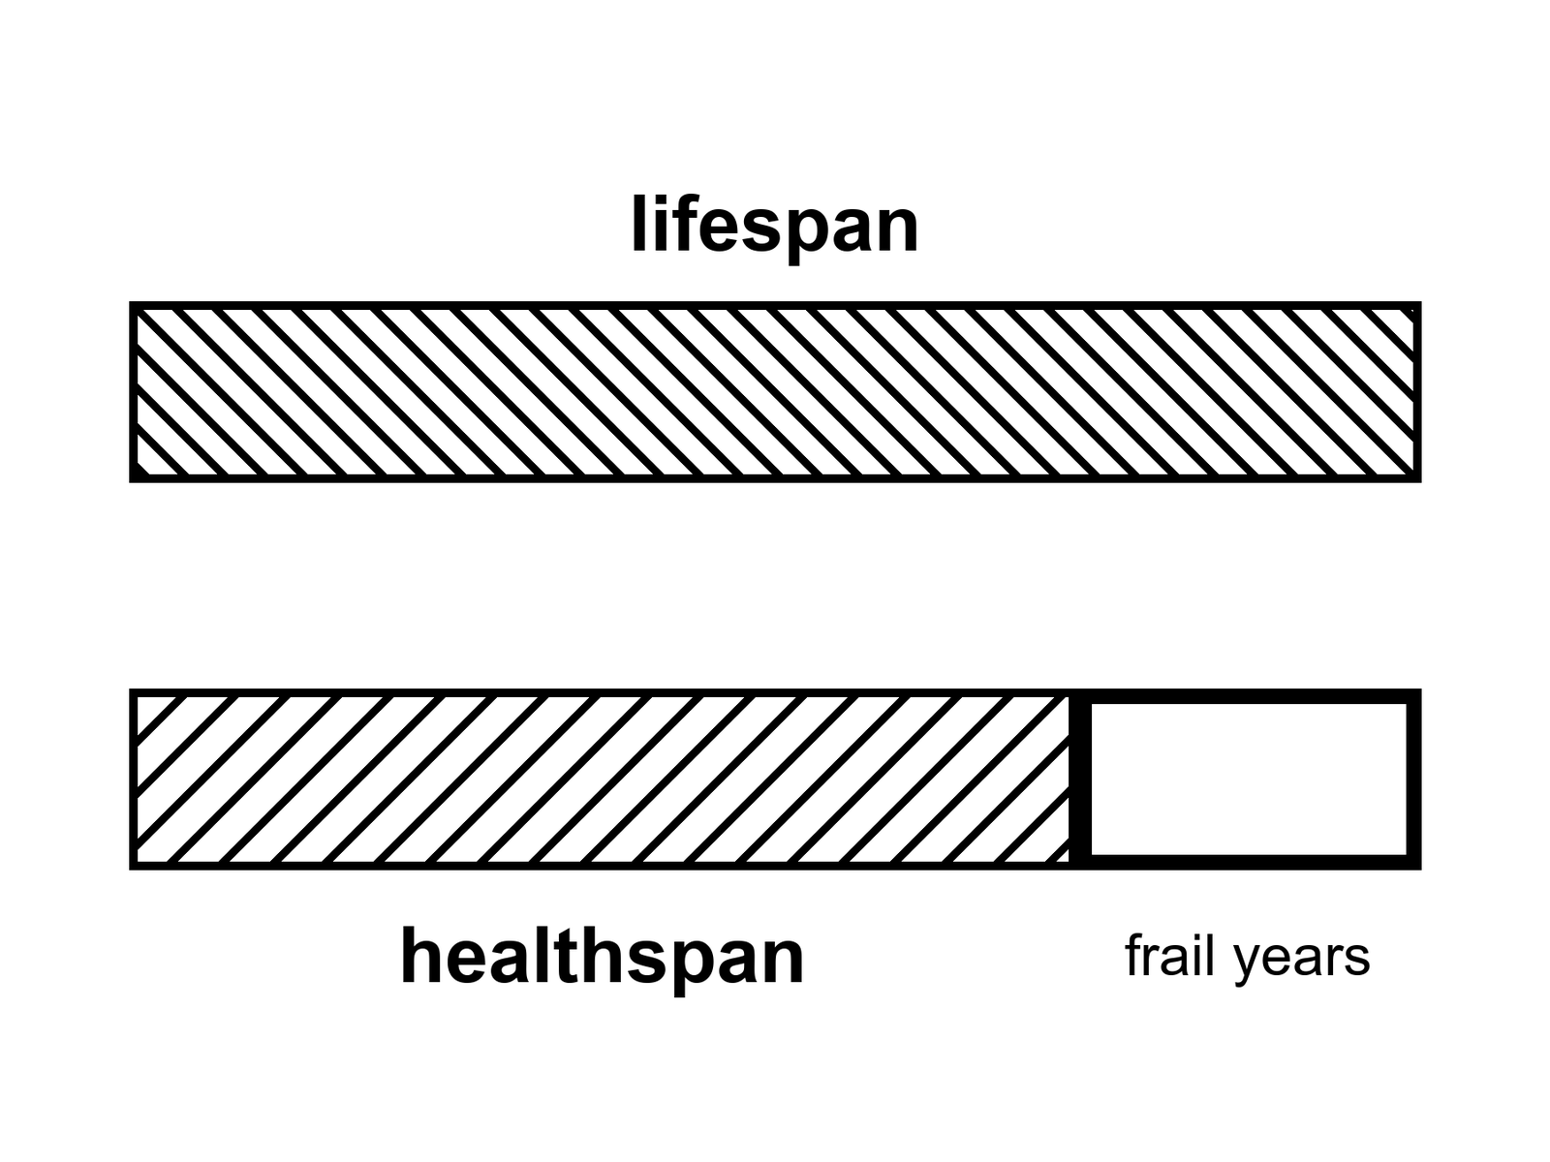
Figure 28. Two full-width bars: lifespan and healthspan. The leftover hatch is frail years. Notice which bar people think they bought.
The split is hot. Demographers have been running it for decades under plainer names. Life expectancy at birth is a summary of death rates in a year, not a promise to a baby. Healthy life expectancy — HALE, in the World Health Organization’s ledger — subtracts years lived with disability, weighted by how much function was lost. The subtraction is ugly and necessary. A country can raise the first number by keeping people alive in a bed. The second number tells you whether the extra was a morning.
HALE is the years lived in a state you would, on present evidence, vote to repeat.
In rich countries the wall-clock number sits in the low-to-mid eighties for women, a little lower for men. Japan, Switzerland, Spain, Australia, Italy, the Nordic kitchens: that band. The United States runs lower — the high seventies in recent ledgers, after a ugly dip and a partial climb — because a rich country can still fail at the boring work: guns, opioids, metabolic disease, a medical bill that is also a maze. Global life expectancy rose by decades across the twentieth century. Most of that rise was not a fountain. It was clean water, vaccines, antibiotics, midwifery, food that arrived. Child death is a slaughter of years. Stop the slaughter and the average leaps. That leap is hot, and it is mostly finished in the places that already have pipes.
Healthspan lags. The lag is the point. A person can live into the eighties and spend the last eight or ten years in a narrowing of the room: the walk that became a shuffle, the names that need a prompt, the joint that will not take the airlock, the breath that makes a sentence a project. Those years count on the wall. They do not automatically count as the product people heard when they heard we are living longer.
Compression of morbidity is the warm hope with a name. You keep the bad years short and stacked against the end. Expansion of morbidity is the easy mistake: you stretch the bad years because you are good at not letting the pulse stop and less good at keeping the morning. Both happen. Different diseases, different countries, different decades. The honest ledger is not a vibe. It is two numbers and a fight about the weights.
The longest well-documented human life ended at 122.
That sentence is a tail, not a product. Her name was Jeanne Calment, a Frenchwoman with a documented life that ran from 1875 to 1997, and the documentation has been picked at, as tails always are: a researcher argued in 2018 that she and her daughter had swapped identities decades earlier for a tax dodge, which would have made the real record younger by a generation. Demographers went back through birth, marriage, and property records and found the swap did not hold up; the 122 years stood, the most thoroughly checked age claim on record precisely because someone tried hard to break it. Take the number as ~122 and sit it still. It is the far end of a distribution, not a mean you can schedule. Supercentenarians — 110 and over — are rare enough to be a sport for validators. The sport is not a clinic. Nobody has a protocol that prints 122. Nobody has a protocol that prints 150 as a SKU. The tail says a human body can, under a lottery of genes, luck, and a century that did not kill her early, run that long. The tail does not say your slide can order the lottery.
Maximum lifespan and life expectancy are different pots again. Life expectancy is a population average that moves when children stop dying and when seventy-year-olds stop dying of things we learned to treat. Maximum lifespan is the right-hand fence of the species as observed. The fence has not sprinted. The averages did. That is why a chart of “we doubled life” can be true about the average and a liar about the fence. We doubled the average mostly by not losing the young. We did not double the right-hand fence.
A person who hopes for a scheduled long life hears 122 and adds a gene. The arithmetic feels like science because both sides have numbers. It is not a method. Chapter 33 is the cold water. Here, keep the two pots. You can raise a mean without moving a fence. You can move a fence in a mouse and not in a woman. You can add years to a pulse and subtract them from a vote.
What would a vote even mean?
Not a survey in a mall. A vote, in this book, is the test you already know how to run. Would you take this Tuesday again? The Tuesday with the walk, the work, the name of the basil, the radio that is late, the pain that is a two and not an eight. If the answer is yes, that year is healthspan even if a doctor’s form has a code on it. If the answer is no, and the no is not a mood but a room that has closed, that year is lifespan without the product.
People lie to themselves about the vote. A slide can make a chair look like a morning. Grief can make a morning look like a chair. The scientific point is narrower than therapy. When a company says years of life, ask which pot. When a government boasts a rising expectancy, ask what happened to HALE. When an enthusiast — often a sincere one, who has read more papers than most — says 150 is conservative, ask for the fence, the species, and the invoice.
Rich-country medicine in the last seventy years added a great deal of lifespan and a real, smaller deal of healthspan. Hip replacements, cataracts, blood pressure pills, statins, HIV turned from a cliff into a condition, some cancers turned from a sentence into a long negotiation. Those are hot as classes of win. They are also a demonstration of the split. You can walk on a metal hip and still be running many clocks. You can see the basil again and still be tired in a way sleep does not fix. The product was the walk and the sight. The sermon was we are becoming immortal. The sermon was cold.
Modest further gains in healthy years this century, in the kitchens that already have pipes and trials, are warm. Not a law. A continuation of a slowing curve if the institutions hold. Everyone on Earth shares those gains: cold as a default. The invoices are unequally paid. Chapter 43 is that inequality with the lights on. Here, notice that a global average can rise while a neighborhood falls, and that a neighborhood can rise while a body in it is still a chair.
She would vote for a morning that includes the airlock. She would not vote for a longer evening in which the radio still answers and the hands will not. The capsule, if it works, buys the morning. That is already a great deal. It is not a different species. It is not a fence moved to 200. It is a joint.
Healthspan is the product people thought they bought when the wall clock lost. A longer pulse is not a Tuesday you would vote to repeat. Demographers split the pots long ago; marketers glue them back together for a slide. Ask for HALE, or for the morning test, before you pay for a calendar. The 122-year fence is a tail on a distribution, checked hard and still standing, not a ship date for a brand. Keep the two bars hatched differently. If anyone sells lifespan as if it were healthspan, ask which bar is on the invoice.
Mara prices the hatch in the figure with a person who has already arrived, not with a baby.
A woman who has already reached eighty, in a lucky kitchen, is often looking at about another decade.¹⁹ Not forty years. Not 122. The decade is where the frail years and the mornings share a calendar. Some of those years she would vote to repeat: the walk, the work, a joint that is a two and not an eight. Some of them are the walk that became a shuffle while the pulse still embarrasses the wall clock. Buying the joint back, so the decade still includes the airlock, moves healthspan inside a life that was already going to be about that long. It does not move the fence. Jeanne Calment’s 122 is the far tail of a distribution, checked and still standing.²⁰ It is not the remaining life of the woman at eighty, and it is not a ship date.
Appendix A28 writes life expectancy against healthy life expectancy, the 122-year tail, and why a methylation number is not a second pot. Here, keep the two bars.

29. Many Clocks, Not One Fuse
Aging is not one fuse. It is many clocks.
That sentence is hot-to-warm. Hot as a refusal of the single-switch story. Warm as a map of mechanisms that are real, incomplete, and still being argued by people who do this for a living. The map is not a product. The map is why a pill that shouts at one clock does not reset the kitchen.
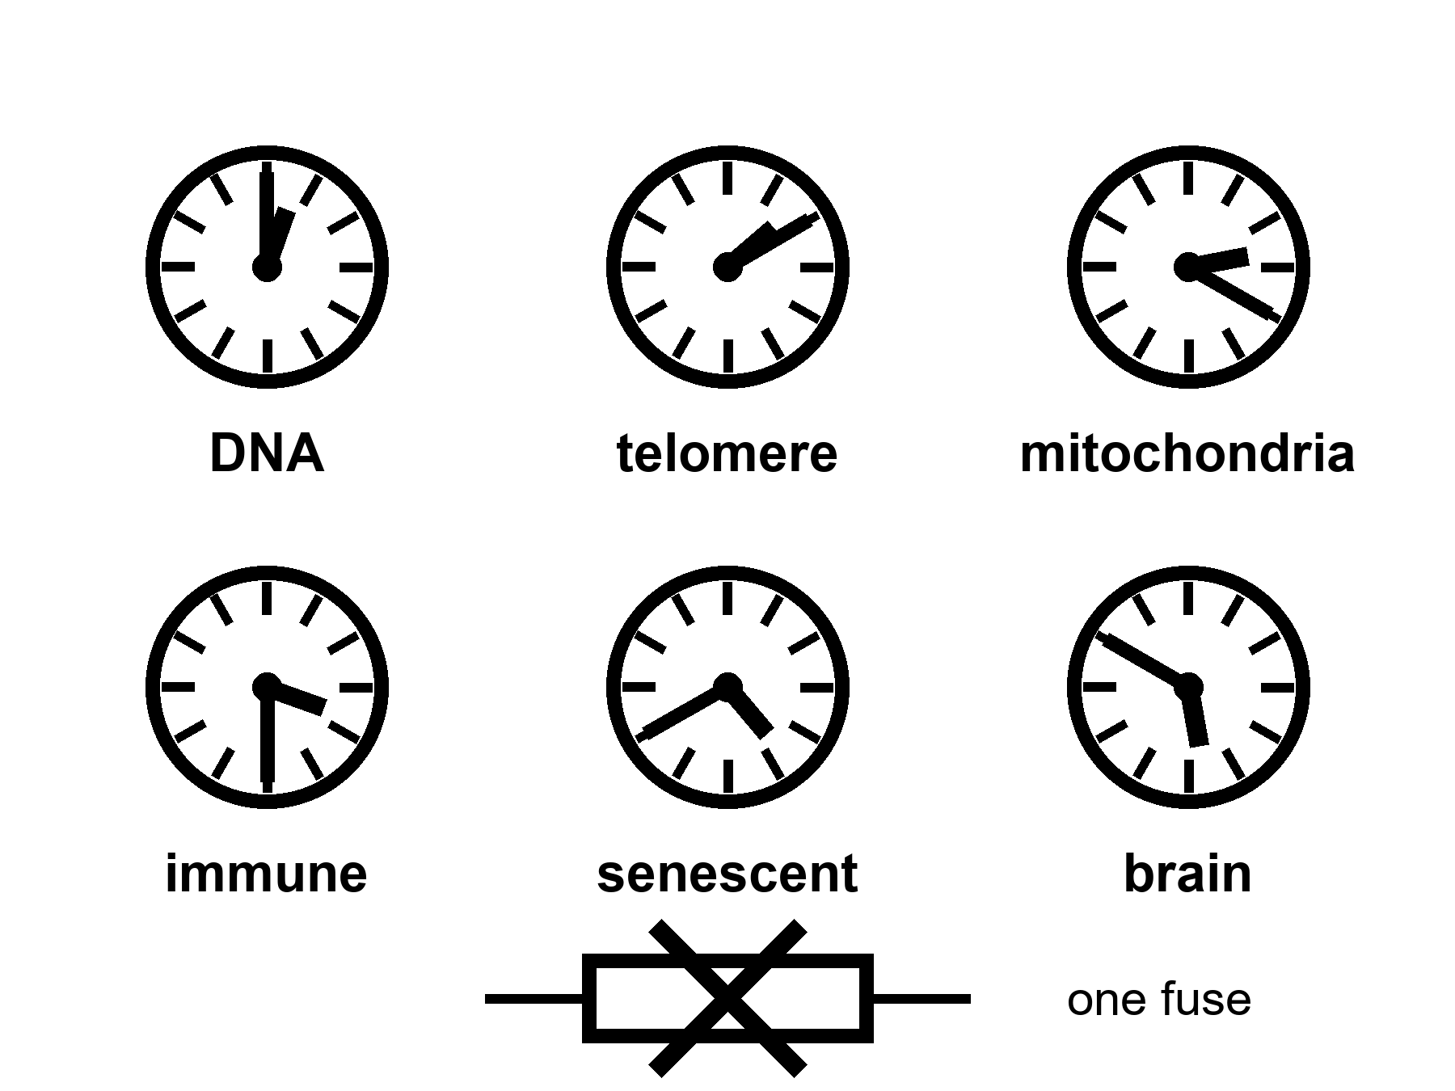
Figure 29. Six kitchen clocks, one fuse crossed out. DNA, telomere, mitochondria, immune, senescent, brain. A shout at one is not a rewind.
Start with the letters.
DNA is a chemical that copies. Copying has a residual error rate even when the staff is sober. Ultraviolet light, oxidation, a replication fork that stalls, a repair crew that arrives late or guesses: the book acquires typos. Most typos in a cell that will die next week do not matter. Typos in a stem cell, or in a lineage that keeps dividing, can matter a great deal. Cancer is one way a typo becomes a career. Loss of function is another. Genomic instability is the grown-up name. It is a clock because damage accumulates and the repair budget is not infinite. It is not the clock. People with unusually clean repair can still go gray, go stiff, go slow. People with a broken repair gene can get a specific cancer young and still not explain why a heart stiffens at seventy.
Telomeres are the plastic tips on the shoelace.
Each time a linear chromosome copies, the very end is an awkward job. The cap shortens. An enzyme, telomerase, can pay the cap back. Most of your somatic cells do not run that enzyme as a lifestyle. A limit appears.
The cell-division fence is the observation that many human cell types in a dish divide about forty to sixty times and then stop.
The dish fence is not a mystic number. It is a dish fact with a molecular accent: short caps, a DNA-damage alarm, a cell that refuses to copy. In a body the story is messier. Stem cells have more telomerase. Cancers often steal the enzyme and become rude. A mouse is not a woman; mice have longer telomeres and shorter lives, which is already a warning against a single-clock sermon. Lengthening telomeres in the wrong cell is a cancer dare. Short telomeres in the right cell are a worn joint. The clock is real. The rewind is not a free lunch.
Mitochondria forget their job.
They are the old bacterial hires that make the majority of a cell’s ATP and leak reactive oxygen as a side effect of being a furnace. Their own small genome sits next to the furnace, which is a staffing error evolution never quite filed. Damage, deletion, a cell that becomes a mosaic of good and bad power plants: tissues that spend energy — brain, heart, muscle — feel it first. Mitochondrial disease in the young is a specific tragedy. Mitochondrial decline in the old is a background weather. A pill that makes mitochondria “happier” in a worm is a paper. A pill that resets a seventy-year-old woman’s furnaces without touching the rest of the house has not clocked in as a scheduled product. Warm as a target. Cold as a product.
The immune system grows bitter.
It learns. Learning is the point of adaptive immunity. Learning also means a repertoire that fills with old grudges — viruses you met in childhood, a cytomegalovirus — a common virus most people quietly carry for life — that never quite leaves, a library of memory cells that occupy seats a naive cell might have used for a new flu. The innate side gets louder and sloppier: a background inflammation with a nickname, inflammaging, that is rude to vessels, to joints, to brains. Vaccines work less well in the old because the staff is tired and the library is crowded. That is a clock. It is why a flu shot is a tool and not a sermon. It is why “rejuvenate the immune system” is a research program and not a SKU.
Senescent cells refuse to die and then spoil the room.
A cell that has taken too much damage, or hit a telomere alarm, or been shoved by an oncogene — a gene damaged into pushing runaway growth — can enter a state where it does not divide and does not leave. It secretes a cocktail — the SASP, if you like letters — that tells neighbors to inflame, remodel, and sometimes misbehave. In a young tissue a few of these cells are a cleanup crew. In an old tissue they are squatters. Senolytics are drugs that try to evict them. In mice, evictions have made pretty graphs. In people, the graphs are early and mixed. A senescent cell is one clock. Clearing some of them is a local experiment. The house still has the other clocks.
The brain wears its own grooves.
Neurons are mostly not a renewing lawn. They are a long-staffed office. They accumulate waste proteins that clump. They lose the tact of synapses. White-matter cables thin. Blood vessels stiffen and sprinkle silent insults. Sleep, which is when a good deal of the cleanup is supposed to run, fragments. The skull’s immune cells, the microglia, get their own bitterness. Alzheimer’s is not “aging.” It is a disease with aging as a steep risk factor and with its own ugly, plural mechanisms. Ordinary slowing — the name on the tip of the tongue, the night driving that became a negotiation — is another clock, overlapping, not identical. Chapter 34 will refuse the idea that this office was ninety percent empty. Here, notice that a brain clock can ruin a healthspan while a pulse is still embarrassing a wall.
Those six are not a complete inventory. They are a kitchen tour.
Researchers who try to be complete publish hallmarks: a list that began as nine and grew to twelve when the papers needed more drawers.²¹ Genomic instability, telomere attrition, epigenetic marks that drift, proteins that misfold and are not cleared, nutrient-sensing that forgets the difference between feast and famine, mitochondria, senescence, stem cells that exhaust, communication between cells that turns into gossip, autophagy — a cell’s own cleanup-and-recycling crew — that slacks, chronic inflammation, a gut ecology that goes off. Appendix A29 writes the list the way a review writes it. Here, the list is a warning. A list of twelve is already a confession that there is not one fuse.
Epigenetics deserves a sentence because it has become a product costume. Marks on DNA and its packaging change with age in ways you can train a clock to read. The clock is a predictor. It is hot as a correlate. It is warm as a mechanism. It is cold as a proof that wiping the marks wipes the person back to twenty. A predictor is not a fuse. You can have a gray hair and a young epigenetic score, or the reverse. You can reset marks in a dish and still have the same mitochondria, the same senescent neighbors, the same skull.
Nutrient sensing is the other costume. Calorie restriction lengthens life in some species and makes a miserable kitchen in others. Rapamycin (a transplant drug that quiets the immune system), metformin (an old, ordinary diabetes pill), a fasting ritual: each has a paper trail. Some of the trail is real. None of the trail is a species change. A worm is not a woman. A mouse is not a woman. A thin, closely watched monkey is not a woman in a suburb with a night shift. The warm claim is that metabolism and aging talk. The cold claim is that we have the talking stick.
Why do people want one fuse?
Because one fuse is a product. Many clocks are a clinic, a budget, a set of local wins, a refusal. A slide that says aging is a disease is doing two jobs at once. One job is useful: it asks insurers and agencies to treat function as a target, not as fate. The other job is a laundering: if aging is one disease, it might have one drug. The second job is not selected by the hallmarks. The hallmarks selected a messy kitchen.
A filter, not a craftsman. Bodies that lasted long enough to copy were bodies that spent the repair budget on the reproductive years and not on an infinite warranty. There is no committee that chose seventy as a moral. There is a mesh that did not pay for a 200-year ape because a 200-year ape was not the cheaper way to get the next copy. That is not a purpose. It is why a fountain would have to fight a staffing decision that is older than agriculture.
She can take a capsule that helps a joint and still be running the other clocks. A shout at telomeres does not rewind the immune grudges. A clearance of senescent cells in a knee does not unclump a protein in a hippocampus. This is not pessimism. It is the reason local wins are worth taking and sermons are worth putting down.
Appendix A29 writes the dish-division range, the hallmark table, the mouse-to-human translation problem. Here, keep the six clocks and the crossed-out fuse. If anyone shows you one knob, ask which five are still in the drawer.

30. Every Clock Has a Cousin
Chapter 29 said aging is many clocks, not one fuse, and meant it inside a single body. The same sentence holds up between bodies. No species found the one switch either. Some species just built a very different staff.
Hot: at least four lineages combine an ordinary body plan with a hazard of death that barely climbs, or a clock that runs for centuries, or a way to reset a cell’s job description after damage. Cold: that nature is hiding one trick, and finding it hands you a capsule.
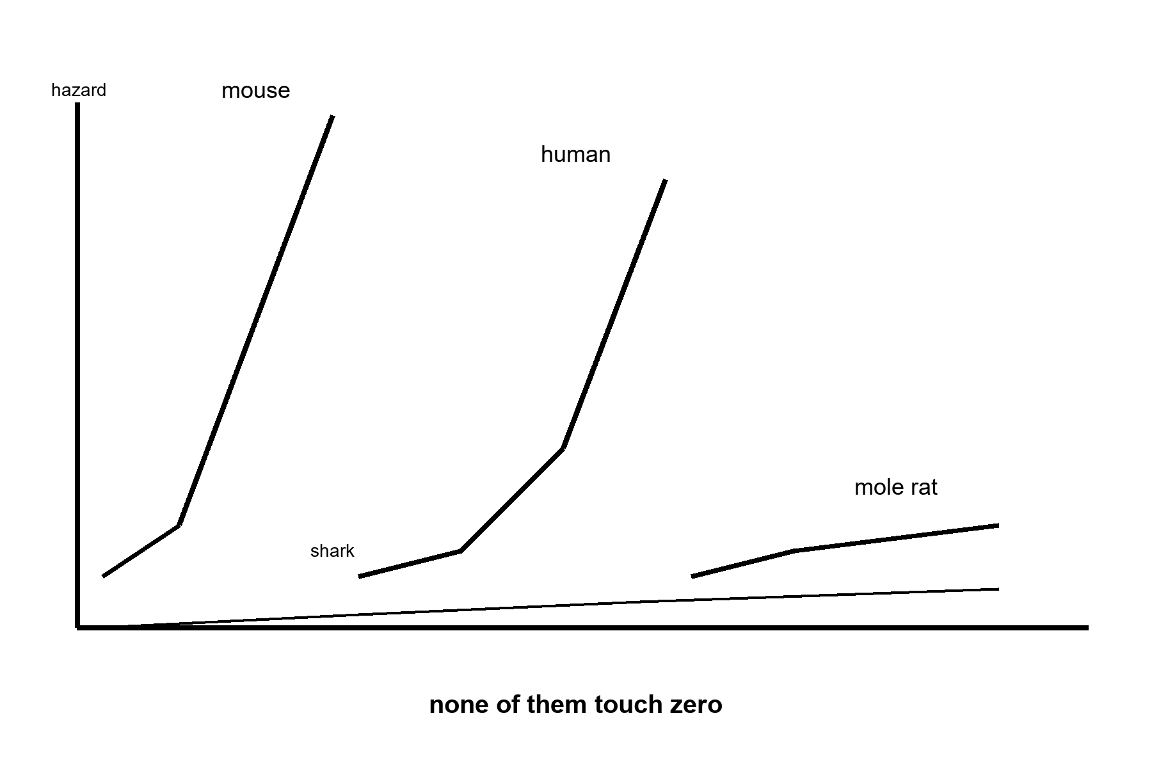
Figure 30. Four hazard curves on one chart: mouse climbs fast, human climbs at midlife, mole rat stays low and flat, shark barely rises at all. None of them touch zero.
A hazard curve plots the chance of dying in the next year against age; a rising curve is what “aging” means at the level of a population, and a flat curve past maturity is what these four species show instead.
Start with a rodent about the size of a mouse that outlives a mouse by a factor of ten.
The naked mole rat is not larger, not colder-blooded, not especially rare, and not, on first inspection, an animal anyone would nominate for greatness. It looks like a thumb that has given up. It lives in burrows in East Africa, is roughly mouse-sized, and can live past thirty-seven years where a laboratory mouse manages two or three. Past its own maturity, its hazard of dying does not rise the way every other studied mammal’s does — not zero, not immortal, just flat, for a rodent that by every other lab measure should be reading a calendar the way a mouse does.²² It keeps breeding into its third decade. It almost never gets cancer. It has, in short, done everything right while looking like nothing at all.
One mechanism is on the record. Naked mole-rat cells make a form of hyaluronan — a jelly-like molecule in the space between cells — that runs more than five times larger than the human or mouse version. It gums up the machinery that lets a cell ignore its neighbors and divide without permission. In 2023 a lab put the mole rat’s gene for making it into ordinary mice.²³ The mice made the oversized hyaluronan, got less cancer, ran cooler inflammation, and lived longer and healthier than their unmodified littermates. That is Chapter 31’s local fix arriving a chapter early: one gene, borrowed wholesale from a different animal, doing one job, in mice, not yet in a clinic, not a rewrite of what aging is.
Take the clock that barely moves at all.
The Greenland shark lives in the cold water off the Arctic, grows about a centimeter a year, and does not mature until roughly a century and a half into its life, which is a career path no careers advisor would recommend. In 2016 researchers radiocarbon-dated the lens of the eye — a tissue laid down once, in order, like tree rings, and never replaced — in twenty-eight female sharks.²⁴ The oldest was estimated at nearly four hundred years, with the study’s own uncertainty running from about two hundred seventy up to five hundred, which is either an admirably honest error bar or a shrug dressed up in statistics, depending on your mood. It is the longest-lived vertebrate found so far: a heart, a brain, a liver, a hazard curve, just stretched over a clock running at a fraction of a mammal’s speed, in water barely above freezing.
Nothing here is a stopped clock. It is the same clock, run cold, slow, and with absolutely nowhere to be.
Take the animal that resets its own job description.
Turritopsis dohrnii, the “immortal jellyfish,” is a few millimeters across as an adult, which is roughly the size of the gap between what its nickname promises and what it delivers. Damaged or starved, instead of dying it can revert: mature cells lose their assignment and become the stem-like cells of an earlier stage, and the whole animal rebuilds itself as a juvenile polyp. In principle the cycle can repeat without limit. In practice, individuals are still eaten, still get sick, still die of something — nature having apparently decided that a loophole in aging is no reason to close the loophole marked predation. What resets is a colony’s bookkeeping, not a particular animal’s uninterrupted memory of being that animal. Immortal is doing a great deal of unpaid overtime in that nickname. Chapter 45 will come back to exactly this distinction, for a very different kind of copy.
Take the one that used no trick at all.
Jonathan, a Seychelles giant tortoise living on Saint Helena, is a reasonable one hundred ninety-four years old or so as this book is written, and still alive,²⁵ and was already an adult when he arrived on the island in 1882 — which makes him, among other things, a British colonial civil servant who simply never got around to retiring. He is blind from cataracts and has lost his sense of smell. He is not negligibly senescent — he shows the ordinary wear of a very old body, gamely carried on. His whole trick is being large, cold-blooded, and unhurried: a slow metabolism and a body too big for most predators, stacked for two centuries. No molecule made him a special case. Size, patience, and a complete lack of urgency about anything were enough.
None of the four rewrote Chapter 29’s six clocks. Each leaned on one and left the rest standing.
The mole rat did not silence its DNA-damage clock or its immune clock; it changed the rules for its senescent-cell and cancer clock specifically, with one oversized molecule, and kept breeding into its third decade on the strength of that one change. The shark did not invent a seventh clock; it turned every one of the six down at once, the way a cold room turns down a whole kitchen rather than one burner. The jellyfish did not defeat its cellular clocks; it found a door back to an earlier reading on them, the way a stem cell already can inside a body that is not reverting. The tortoise ran the same six clocks a human runs, just slower, on a furnace sized for a very large, unhurried, cold-blooded animal. Four species, four different bets on which existing clock to lean on — not one of them a fifth or sixth hallmark nobody has met before.
Rohan attaches the mole rat gene study to his weekly packet, with a note that arrives, like everything he says, several minutes after he has stopped thinking about it.
“So we just need the mole rat’s gene,” his message says, with the cheerful confidence of a man who has never had to file a permit for anything.
She thinks about it for a day and records her reply for the next window. “And its burrow, and its oxygen chemistry, and to stop being the size we are,” she says. “The paper got healthier mice. Not younger mice, not mice with an off-switch. Mice with less cancer and calmer inflammation. That’s a real invoice, and it’s a rather good one, as these things go. It is not a secret nature was hiding from us out of spite, or waiting for the right committee to declassify it.”
His reply, when it lands, has clearly been composed before hers arrived, the two of them always half a conversation out of step. “The shark got four hundred years,” it says.
She answers it anyway, as if the joke were still fresh, because by the time either of them hears anything the other has already moved on to a different sentence. “At a body temperature you would not survive an hour in, growing a centimeter a year, doing none of what you are doing right now, which I gather mostly involves standing there being disappointed in a rodent.” She caps the pen. “Every one of them paid for what they got. None of them got to skip paying. Nature doesn’t do loyalty cards.”
Days later, his answer to an answer he never heard: “So the secret of eternal life is being a bad-tempered, freezing, four-hundred-year-old fish who never got anywhere in a hurry.”
She does not wait for that one to land before recording the last word, because on a delay the last word is a decision, not a reflex. “The secret of eternal life is that there isn’t one. There’s just an extremely long list of things you’re not allowed to be if you want the extension, and warm, quick, and in a rush is not on it. You’re disqualified on page one.”
Here is the invoice underneath all four.
The mole rat’s trick is one molecule, tied to a burrowing rodent’s whole chemistry; only the molecule, not the burrow, has so far crossed into a mouse, and it bought health, not a stopped clock. The shark’s trick is metabolic patience purchased with cold water and two centuries to reach adulthood — not a schedule a warm, fast, hurried animal can adopt. The jellyfish’s trick requires giving up being one continuous animal with a nervous system in order to become, briefly, something simpler that can start over; the price is identity, not metabolism. The tortoise’s trick is size, a slow furnace, and no rent due on a nervous system built for urgency. Every one of the four still dies of something. None of them is a capsule sitting in a rainforest waiting to be found.
Temperatures, applied to comparative biology.
Hot: at least four real lineages combine an ordinary vertebrate or near-vertebrate body with a hazard of death that stays flat, runs on a multi-century clock, or resets after damage; the mole-rat mechanism has already been moved into a mouse and measurably helped it.
Warm: more species will likely turn out to combine other tricks with other costs; comparative biology is an active field, not a closed inventory.
Cold: that one of these tricks is a suppressed answer waiting for funding, transferable to a human body without also transferring the burrow, the ocean, the reset, or the size.
Appendix A30 writes the four cousins and the price each trick already paid. Here, keep the invoice. None of them is a capsule.

31. Local Fixes
Gene fixes are local. That sentence should be printed on every slide that says DNA as if DNA were a fountain.
Hot: we can, in a growing list of cases, reach into a lineage of cells and correct a broken instruction — a blood disease, a rare enzyme, a tissue that will take the edit and keep it. CRISPR and its cousins are tools. They are not magic. They are scissors with paperwork.
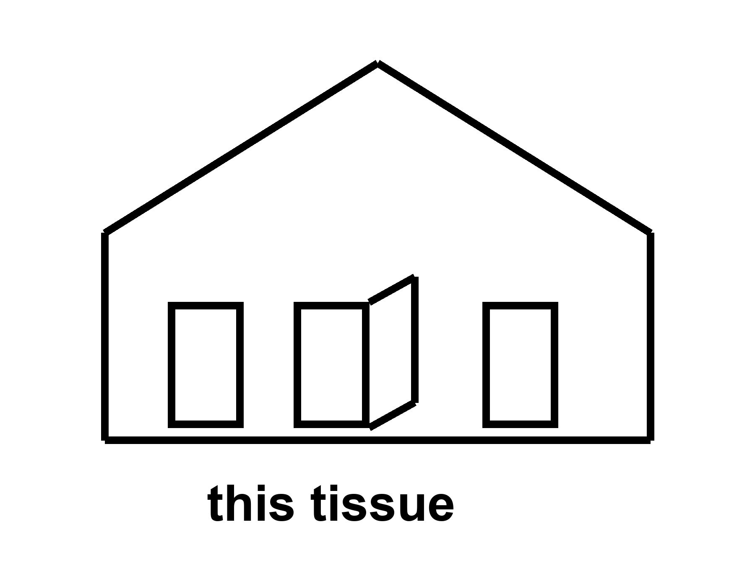
Figure 31. One door unstuck in a simple house. The label is this tissue. Scissors with paperwork.
Start with the scissors, because the brand names will rot and the class will not.
A genome is a long string. A disease can be a single wrong letter, a missing chunk, a control switch stuck in the wrong position. For a long time the only way to change that string in a person was luck: a bone-marrow transplant from someone whose string was kinder, a virus we did not design well, a prayer. Gene therapy, as a field, spent decades in the wilderness of immune reactions and leukemia scares and invoices that could bankrupt a kingdom. Then the scissors got sharper.
CRISPR, in the kitchen, is a bacterial memory system hired as a cutter. You supply a guide that finds a sequence. You supply an enzyme that cuts. The cell’s own repair crew then either wrecks the site (sometimes that is the point) or, with more paperwork, inserts a template. Base editors and prime editors are cousins that try to rewrite a letter with less of a cut. Viral vectors — a hollowed-out virus put to work as a truck, in classes called AAV and lentivirus — are delivery trucks. Delivery is most of the problem. A truck that reaches the liver is not a truck that reaches the brain. A truck the immune system remembers is a truck you may not send twice.
A local fix means this gene, in this tissue, in this person, at this price, with this known damage as the entry fee.
The sickle-cell-class win is the one that should be taught in every school that already teaches Mendel.
Sickle cell disease is a single-letter change in the adult hemoglobin gene. The wrong letter makes a protein that can stack, and the stack makes a red cell into a blade, and the blade jams vessels and wrecks childhoods. Everyone carries two copies of most genes, one from each parent. The heterozygote — one copy of the wrong letter — is a malaria bargain the mesh kept. The homozygote — two copies of the wrong letter — is a chronic emergency. For decades the local fix was a matched donor’s marrow, if you had a match and a center and a body that could survive the conditioning. Now there is a class of autologous edits: take the person’s own blood-forming stem cells, edit them outside the body, wipe the old marrow with chemotherapy hard enough that the edited cells can take the seats, put the edited cells back.
One version of the class does not even correct the original letter. It wakes fetal hemoglobin, the version you used before you were born, by breaking a switch (BCL11A and its enhancer) that had turned the fetal gene off. The fetal protein dilutes the sickle protein. The crises fall. That is a local fix with a long invoice: manufacturing, a hospital stay, a conditioning regimen that is not a vitamin, a price that, in present ledgers, sits in the low millions of dollars per person. It is still a win. It is hot as a class. The person’s telomeres did not rewind. Their arteries did not become twenty. Their brain did not unlock a cupboard. Their children, if the edit was only in blood, still inherit the letter unless a different, ruder conversation is had about germline work.
Name the class, not a halo. Exagamglogene-class CRISPR for sickle cell and transfusion-dependent beta thalassemia — another inherited blood disorder — is a 2023-era clinic fact. Lentiviral gene-addition cousins sit in the same drawer. The brand on the box will change. The structure will not: this lineage, this instruction, this bill.
The pivotal trial’s own numbers are the invoice, printed plainly. Forty-four people received the edited cells. Of the thirty followed long enough to judge, twenty-nine, ninety-seven percent, went a full year without a single vaso-occlusive crisis, and every one of the thirty avoided a crisis-related hospital stay for that year. Those are hot numbers, published in a medical journal in April 2024, not a keynote slide.²⁶ They describe a lineage of blood cells in a person’s own marrow, wiped and reseeded once, at a price that runs to the millions and a conditioning regimen that is itself a small ordeal. They do not describe a telomere, an artery, or a brain. The crisis stopped. The person did not become someone who does not age.
Rare enzymes are the other honest drawer.
A child missing one metabolic enzyme can be a tragedy that a protein infusion, or a gene truck to the liver, or an edit in the right cells, can interrupt. Spinal muscular atrophy, a handful of immunodeficiencies, a retinal disease that steals a childhood’s sight: each has a story in which a local delivery changed a life. Each story has a graveyard next to it — the trials that triggered immune storms, the doses that did not reach the tissue, the prices that made a cure a rumor for everyone who did not live near the right zip code. Chapter 43 is the graveyard and the zip code. Here, keep the structure. A rare, monogenic, accessible tissue is the kind of lock these scissors were forged for. Aging is not that lock. Aging is the house.
Cancer, ironically, is already a gene-therapy customer. CAR-T cells are a local rewrite of an immune cell to hunt a blood cancer. The rewrite can save a life and still leave the person aged by chemotherapy, aged by cytokine storms — the immune system overreacting to the treatment itself — aged by the clocks that were never the target. Solid tumors are ruder. A thousand-year ape would still need a cancer policy. Chapter 33 is that policy.
Germline editing — changing the string in a sperm, an egg, or a first clump of cells so that every tissue and every descendant carries the change — is a different door. It is technically closer than it was. It is ethically and politically a front, not a kitchen gadget. A front is Chapter 42’s kind of wall. This book will not print a catalog of designer children. Look first. A slide that says enhancement about a child who cannot consent is the carrot with a new face. The off-switch was not hired.
What CRISPR is not.
It is not a search-and-replace for “old.” Old is not a sequence. Old is the many clocks. You can imagine, cold, a future in which many tissues are edited, many times, for many letters, at a price a village can pay, with delivery trucks that know the brain and the heart and the stem-cell niches. You can imagine it. Imagination is not a schedule. The present kitchen is: a short list of monogenic wins, a longer list of trials, a delivery problem, an immune memory, an invoice, and a house that still ages while you celebrate the one door you unstuck.
She will not get a CRISPR for being fifty-eight and having hands. She might, in a later decade, get a better joint drug, or a better way to quiet a senescent crowd in a knee, or nothing new except the same bullying of chemistry she already knows. The capsule on the radio delay is honest if it stays local. It becomes a lie when the label starts talking about the species.
Delivery is the unpaid invoice of every headline that says CRISPR as if the word were a method for forever. This tissue, this lineage, this conditioning regimen, this zip code that can reach a trial site: that is local. A sickle-cell-class win is hot as a class. A body-wide rewind stays cold. Do not let a hot door launder a cold house. Mara takes a capsule for a joint. She does not become a different species, and she does not become proof that her sister on the coast gets the same dose.
Scissors with paperwork: consent, a delivery vector, an off-target worry, a marrow wipe that can kill on the way to a save. Headline CRISPR is incense for a conference. A class-of-edit is a door in one room of one house. Clinics keep score in adverse events and follow-up years, not in applause. Do not remodel the cosmos because one latch moved. Local. Tissue. Invoice. Keep saying those three until the fountain slides look cheap.
Appendix A31 writes the sickle-cell-class schematic, the delivery problem, and why “CRISPR” in a headline is not a method for living forever. Gene fixes are local.

32. The Reset That Isn’t
Chapter 31 drew the line: a local fix is this gene, this tissue, this invoice. One line of research keeps getting sold as the fountain anyway, because for once the picture looks almost like one. It is worth a chapter of its own, because it is the best real candidate the popular version has, and it is still not what the slide says it is.
Hot: cells carry a partial, recoverable record of an earlier state, and biologists can nudge some of them to read from it again. Cold: that this means aging can be reset, in a body, the way a document reverts to an earlier save.
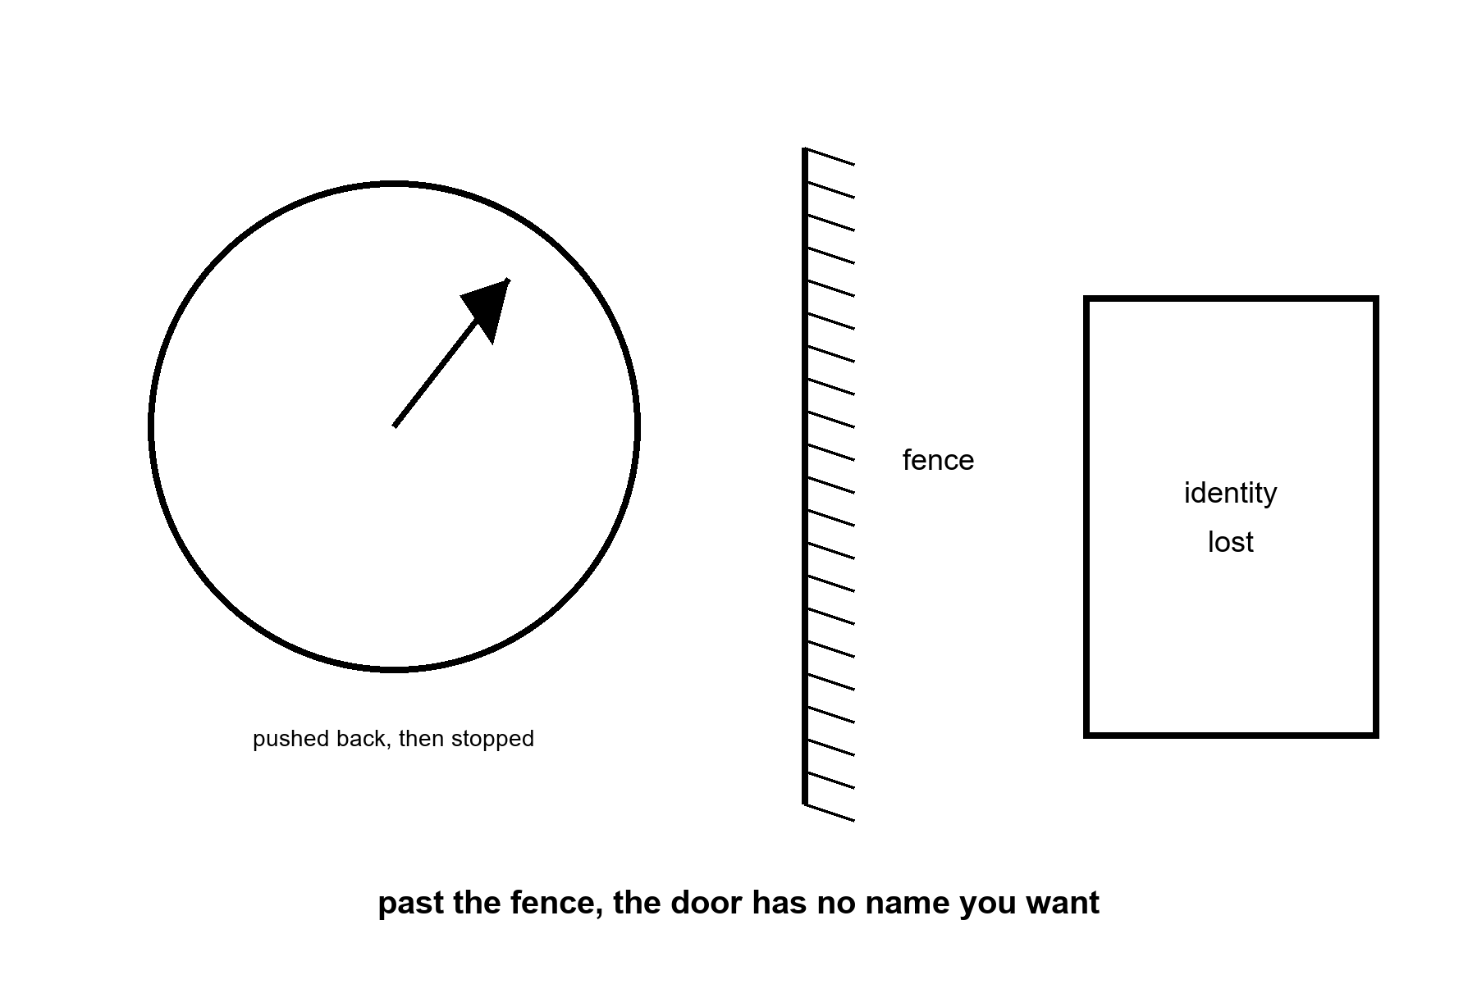
Figure 32. A cell’s clock hand pushed back partway, then stopped by a fence. Past the fence: an unlabeled door marked “identity lost.”
The fence is not a mystery; it is the difference between nudging a cell’s markings younger and erasing what kind of cell it is.
Start with the four keys and the door they open too far.
In 2006 a Japanese lab showed that four proteins — a cocktail now taught in every stem-cell course — can take a skin cell all the way back to an embryonic-like state in a dish. That discovery, done outside a body, won a Nobel Prize and built the entire field of induced stem cells. It also came with a warning label, because good news in biology is contractually obliged to arrive with one. In 2013 a European team ran a version of the same four-protein cocktail briefly inside living mice, and tumors called teratomas grew from multiple organs — the stomach, the intestine, the pancreas, the kidney, all of them apparently keen to try something new.²⁷ Full reprogramming does not know when to stop. Taken all the way, a cell does not get younger. It forgets it is a stomach cell at all, and starts building the wrong parts, with the enthusiasm of an intern given no job description.
That is the fence. The question since 2013 has been whether the same clock can be nudged partway, and held there, without walking through the door marked identity. Two different answers have since shipped, and they are not the same trick.
The first answer kept all four proteins and changed the rhythm instead of the recipe.
In 2016 a lab²⁸ ran the full four-protein cocktail in mice bred with a severe, accelerated-aging condition — not ordinary old age, a specific genetic defect that mimics it — but ran it in short pulses, two days on and five days off, rather than the steady pressure that grew tumors in 2013. At that cyclic dose the mice showed improved markers across several of Chapter 29’s clocks at once, and lived measurably longer: about a third longer at the midpoint of the group, about a fifth longer at the far tail. No teratomas were reported at that schedule. The lesson was not that the four proteins were ever safe. It was that a cell reads a steady four-protein signal as an order to become embryonic, and reads a brief, interrupted one differently — closer to a correction than an instruction.
In 2020 a lab²⁹ published a second answer that used three of the four proteins, not all four, and left the fourth — the one most associated with runaway growth — on the shelf. In mice, aimed at the optic nerve, the three-factor cocktail restored a younger pattern of DNA marking in retinal ganglion cells, helped injured nerve fibers regrow, and reversed vision loss in both an eye-pressure model of glaucoma and in ordinary old mice. The effect required two enzymes, TET1 and TET2, that erase old chemical marks on DNA — the marks a cell’s methylation clock actually reads. The finding was not that a cell got younger. It was that some of what the clock reads is a stored, partly recoverable record, not a one-way ledger entry, at least in this tissue, at this dose, for this outcome.
The chapter title is not being cute. This is a reset. It is not the reset the slide sells.
The dose that helped an eye is not a dose that has been given to an entire mouse, let alone a whole person. On 28 January 2026 the FDA cleared the first human trial of a reprogramming therapy built on exactly this recipe — three factors, without the fourth, delivered by injection into one eye, for two specific optic diseases — and on 9 June 2026 the first patient was dosed.³⁰ That is the real, current, hot fact: a human safety trial is running, as of this writing, for one organ, one delivery route, one narrow set of conditions, seven years after the mouse result and thirteen years after the version that grew tumors. Nobody has cleared a trial for a body. Nobody has cleared a trial for “younger.” The trial that exists is for an eye that has stopped working.
Mara reads the trial announcement on the same downlink that carries her mail, and records her line before she has finished deciding what she thinks of it.
“They’re testing it on people now,” she says.
The reply is waiting for her a day later, sent, she suspects, before he had finished reading past the headline. “On an eye,” Rohan’s message says. “One eye. For a nerve that’s already dying. It’s not exactly a press release for eternal youth, is it.”
She lets that sit for an evening before she answers it. “It could reach a knee eventually. A whole knee.”
His answer to that has the unhurried shape of something written, deleted, and written again. “Eventually is doing a lot of work in that sentence. Thirteen years between the tumor mice and the eye mice. Seven more to a human trial for the eye alone. You want to bet on a knee inside your own paperwork, or would you rather I quoted you odds?”
“You’re very cheerful about this,” she tells a version of him that, by the time he hears it, will have moved on to some other argument entirely.
He has. His reply answers a comment she made two exchanges ago, the two of them permanently a little out of season with each other. “I’m delighted. A field that spent thirteen years politely not growing tumors in anyone is my idea of a rollicking success story. Ask me again in another thirteen.”
She doesn’t answer. The tray has never needed thirteen years to tell her the truth.
Here is the invoice underneath the headline.
Model is the first line. The 2016 lifespan numbers come from mice built with one severe genetic defect, not from ordinary old mice living out an ordinary span; a rescue of a specific broken part is not yet a demonstration that healthy aging responds the same way, at the same dose, on the same schedule. Dose is the second line. Too little reprogramming does nothing measurable. Too much erases what a cell is and grows a tumor instead of a fix — the 2013 result is not a footnote, it is the ceiling the entire field designs against. Route matters as much as dose: an injection that reaches one accessible nerve is not a systemic therapy, and nobody has shown the same three factors are safe delivered to a whole body rather than one contained organ. Timeline is not a detail: fourteen years passed between the discovery that full reprogramming works and a cleared human trial for the safest, narrowest version of it, in the one place — an eye, with its own barrier from the rest of the body — where a mistake stays local. A slide that shows the 2020 mouse photograph next to a caption about reversing human aging is skipping every one of those four lines on the invoice.
Temperatures, applied to reprogramming.
Hot: a cyclic, all-four-protein schedule extended lifespan in a mouse model of one severe aging-mimicking defect; a partial, three-protein version restored a younger DNA-methylation pattern and function in specific mouse tissue; a human safety trial for the three-protein approach, aimed at one organ, was cleared in January 2026 and dosed its first patient in June 2026. Warm, not hot: whether it helps people at all.
Warm: the same approaches may extend to other organs, other kinds of damage, and ordinary aging rather than one genetic defect, over the coming decade; partial reprogramming by either route is an active, well-funded research program, not a dead end.
Cold: whole-body reprogramming, a reprogramming pill, or reprogramming as a general reversal of aging rather than a local repair of one tissue’s readable record.
Appendix A32 writes the tumors, the short pulses, the mouse eye, and the human trial that is still one organ. Here, keep the four lines on the invoice. A photograph is not a schedule.

33. Not a Fountain
A local fix is not a reset of every clock.
That is the laundering this chapter exists to stop. Chapter 31 gave you a hot win. This chapter will not take the win away. It will refuse to let the win rent a halo.
The optimists deserve their best case first, because some of them are among the most careful scientists in the field. Aging, they argue, is a set of processes, not a fate; processes can be slowed; several have already been slowed in animals; and refusing to call aging a target is part of why trials for it are so poorly funded. All of that is fair. Some of them will be right about pieces, and the pieces will be worth having. Where this chapter parts company is the step from pieces to a schedule.
Cold: a body-wide rewind. A thousand-year ape as a scheduled product. The rest of the house still ages while you celebrate the one door you unstuck. Cancer is not one door. The brain’s long goodbye is not one door. Atherosclerosis is a plumbing problem with a biological accent. Local is the word. Keep it.
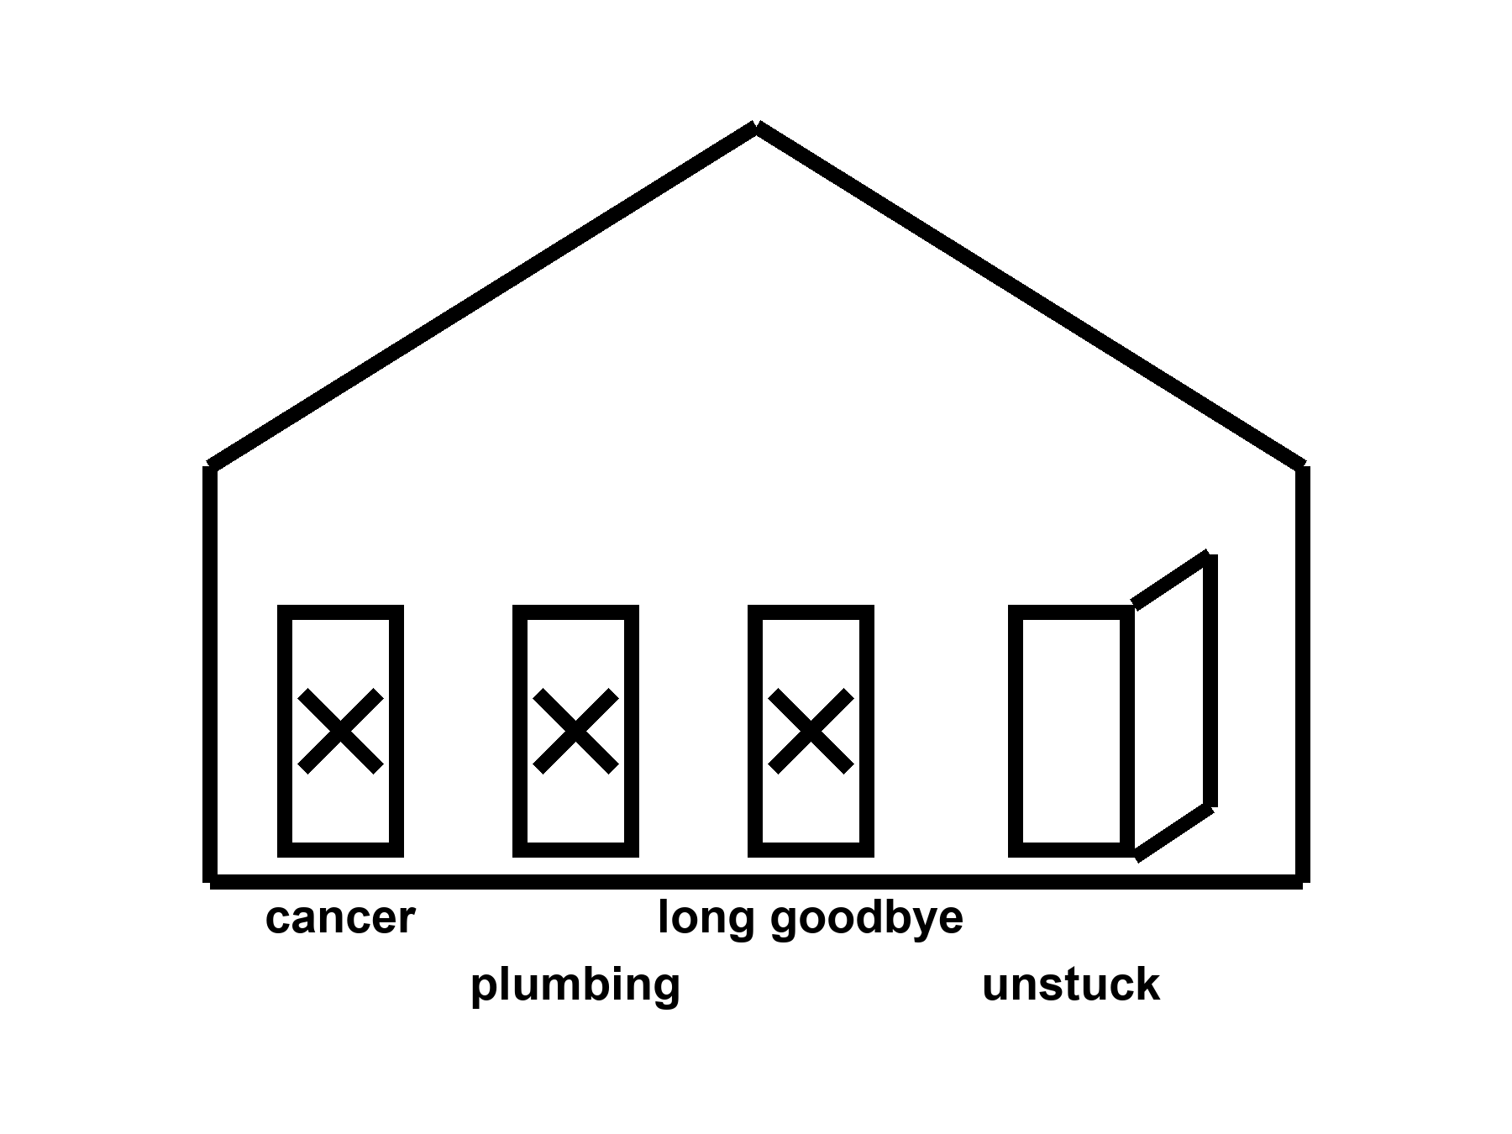
Figure 33. The same house. Three doors still stuck: cancer, plumbing, long goodbye. One unstuck door is not a remodel.
Cancer is not one door.
Cancer is hundreds of careers a cell can take when the copy-edits and the brakes and the immune surveillance fail in combination. A blood lineage you can harvest and rewrite is one kind of fight. A pancreas, a lung, a glioblastoma behind a barrier that keeps trucks out, a metastasis that has already rented rooms in bone: other fights. Prevention — do not smoke, vaccinate against the viruses that set up shop, find the polyp while it is a polyp — is still the cheap, rude, hot work. Treatment has become, in some cancers, a long negotiation with targeted drugs and immune checkpoint tricks and local rewrites. Five-year survival moved for some diagnoses and barely moved for others. Curing one blood cancer in a twenty-year-old does not make her immortal. It makes her a person who will now have to die of something else, later, which is exactly the point of medicine.
A body that lasted 200 years would be a longer exposure to the same mutational weather. More copies, more chances, more careers for a rude cell. Unless you imagine a surveillance state inside every tissue that never sleeps and never errs — cold, as a scheduled product — the long ape is a cancer problem with more calendar. The mesh did not have to solve that problem. A product that claims to have solved aging without a cancer policy has not read the house.
Atherosclerosis is plumbing with a biological accent.
Fat, calcium, immune grudges, a lining that scars, a clot that finishes the job: the pipes of the heart and brain. Blood-pressure pills, statins, smoking cessation, a stent, a bypass — local, incremental, hot as classes of win. They moved rich-country death. They did not make arteries into a twenty-year-old’s pipes on demand. A gene that lowers an ugly lipoprotein can be a local fix for a family that inherited a disaster. It is not a rewind of seventy years of shear stress and dinner. The long ape would still have fluid dynamics. Fluid dynamics does not care that your slide is exponential.
The brain’s long goodbye is not one door.
Alzheimer’s, Parkinson’s, Lewy bodies (a different clumping protein, a different disease), vascular scraps, frontotemporal ruin (a dementia that eats personality and language before it eats memory), the ordinary narrowing that is not a named disease and still steals the vote: plural. Amyloid — one of those clumping waste proteins from Chapter 29 — is a character in one of the plays and not the whole theater. A drug that clears a plaque and buys a modest delay is a local, expensive, argued win — warm-to-hot as a class of result, not as a resurrection. Two amyloid-clearing antibodies reached the clinic on trials that measured the delay honestly: one slowed decline on the standard dementia scale by about a quarter over eighteen months,³¹ the other by roughly a third in its main trial group,³² with a share of patients on that second drug showing no measurable progression at all after a year. Those are real numbers, hard-won, worth having. They are also a quarter and a third of a decline that still continues, in a disease that is still plural, not a name struck from the list. A 200-year skull would need a waste-clearance policy, a vascular policy, a sleep policy, a protein-folding policy, and a theory of what a self is when the office has been restaffed. Chapter 45 is the cold version of that last sentence. Here, notice that you can fix a blood letter and still lose the names.
150. 200. 1,000.
Those numbers arrive on slides already looking like they are flying. Mark them.
Typical human life to 150 years as a scheduled product: cold. Allowed as a wish. Not selected by present levers. We have a tail at ~122 and a mean in the eighties in the lucky kitchens. We do not have a protocol.
200: colder. You have left the observed fence and entered a different animal.
1,000: costume. A thousand-year ape is a science-fiction staffing problem — cancer, brain, pipes, teeth, boredom, the carrot with no off-switch, the institutions that would have to keep the insulin coming — dressed as a roadmap. This book will not print the roadmap. It will name the invoices.
Modest further gains in healthy years this century in rich-country medicine: warm. A few more mornings, if the boring work continues and the trials stay honest and the pipes do not fail. Not a law. Not a species change. Everyone shares them: cold as a default. The zip code still votes.
A note on “aging is a disease.” If the phrase gets a trial endpoint that measures walking speed and cognition and hospitalization, it can be a useful bureaucratic trick. If the phrase gets a supplement aisle and a spokesperson who is already 150 on the slide, it is a costume. Temperatures, not vibes.
She will die of something.
That sentence is not cruelty. It is the block the pulse occupies. A local fix changes the something and the when and, if you are lucky, the number of Tuesdays she would vote for. It does not promote her to a different species. It does not unlock a brain she was not using. It does not pay the energy bill of a civilization that wants to multiply the last fifty years by two hundred and call the product a kitchen.
The dirt still has a chemistry. The chemistry can be bullied. That was always the whole trick. The trick is already enough to grow basil under a lie of LEDs. It is not enough to buy a forever. Do not wait. Take the capsule if the joint is the thing it buys. Put the sermon down.
Cancer is plural doors with different locks. Solid tumors hide behind barriers drugs do not cross for free. Blood cancers and sickle-cell-class lineages can be different sports. Vessels are arithmetic with blood: pressure, plaque, a clot that arrives on a Tuesday. Brains are overlapping messes — plaques, tangles, vessels, sleep, inflammation — without a single product SKU. Aging itself is not one lock labeled rewind. Triage and local repair stay hot because they land at addresses. A skeleton key stays cold because it has nowhere to ship. Chapter 31 opened one honest door. This chapter refuses to sell the house as unlocked. Keep naming doors. Take the master-key slide off the deck.
A mouse can be made to live a noticeable fraction longer. A diet. A drug. A cage. The graph is real inside the cage. The cage is not a Tuesday. The mouse does not bring a childhood, a zip code, or a cancer policy written for a two-hundred-year exposure. More calendar is more copies of cells, and more copies are more chances for a rude lineage. A body-wide rewind that does not say what it does about cancer, pipes, and the long goodbye has not read the house. It has photographed the one door Chapter 31 unstuck and rented the photograph a halo.
The translation rule is dull and sufficient. A result that moves a mouse fence is a paper. It becomes a human product only when a trial measures walking, memory, and hospitalization in people, and even then only as a local door with a price. Modest further healthy years, in the kitchens that already run trials, stay warm. A scheduled 150, 200, or 1,000 stays cold. She will not let the cage rent the halo. She will take the capsule if the joint is the door it actually opens, and she will leave the master key on the table.
Appendix A33 writes cancer as a plural, vascular risk as a ledger, neurodegeneration as a set of overlapping messes, and why a mouse that lived longer is not a woman who will. Here, keep the house with three stuck doors. Chapter 31 unstuck one. That was honest. This chapter is the honesty that follows.
Rule: A local fix is not a remodel. Cancer, plumbing, and the long goodbye are still three stuck doors.

PART VIII — The Organ You Already Use

34. We Already Use the Organ
Then the sentence that will not die, because it is useful to people who sell keys: we only use ten percent of our brain.
False. Hot as a correction.
Imaging, lesions, the energy bill — the organ is on duty. Tissue that looks idle in one snapshot is still a staff with a shift you did not catch. You do not have a spare ninety percent in the cupboard, waiting for a password so you can meet “new challenges.” You have the organ you have, plus sleep, plus practice, plus tools, plus other people. That is already how we adjust. Plasticity is real and expensive. It is not a tank of unused mind.
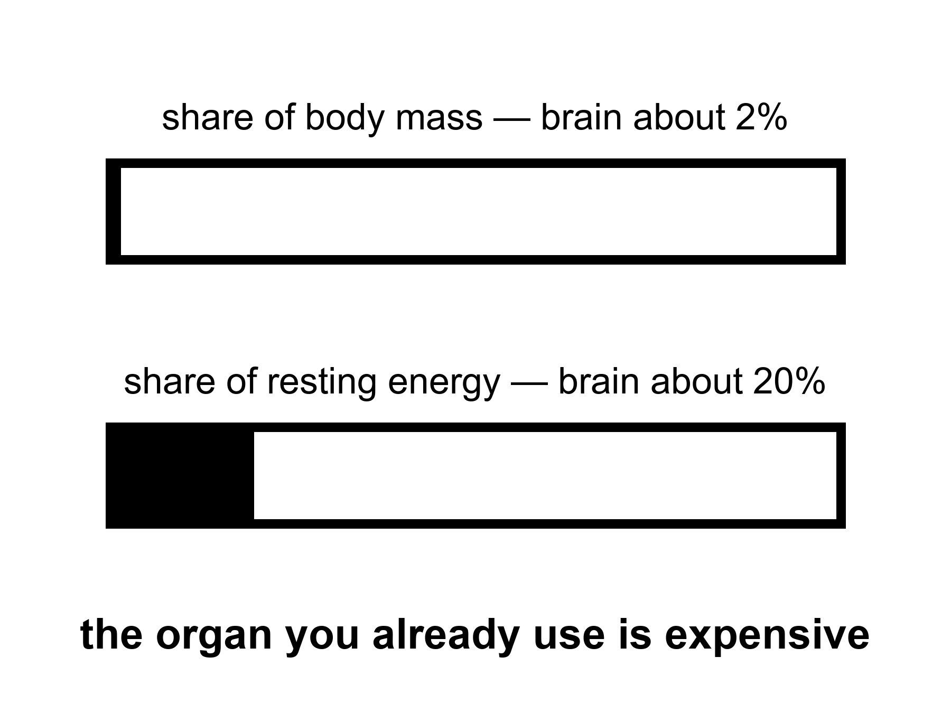
Figure 34. A hatched share: the brain is about two percent of mass and about twenty percent of resting energy. Idle-looking is not off-duty.
The sentence is a zombie because it is flattering. It tells you that the person you already are is a draft. It tells you that a course, a pill, a headset, a guru’s password will open the real draft. It turns a limit into a treasure hunt. Treasure hunts sell. Limits do not.
Where did it come from? Not from a measurement you can cite and keep. It gathered like kitchen grease: a misread of early neurologists who noticed that large injuries sometimes left surprising function; a self-help habit of turning “we do not understand everything” into “ninety percent is waiting”; a cartoon of unused neurons sitting in the dark like unused guest soaps. A century-old moral sentence said we live below our limits. That is effort-talk. It is not a volumetric survey of cortex. The ten-percent figure is a mutation of effort-talk into a floor plan. The floor plan is wrong.
Start with the bill, because the bill does not flatter.
The brain is roughly two percent of a body’s mass and takes roughly twenty percent of the resting energy.
The twenty percent is of resting metabolic rate — the quiet kitchen, not a sprint.
Twenty percent of the quiet kitchen is an outrageous line item for an organ that, in the ten-percent story, is mostly on unpaid leave. Evolution is a miser about watts. A miser does not keep a ninety-percent dark warehouse of tissue that costs like a furnace and does nothing. The wattage is not a vibe. It is glucose and oxygen, measurable in a PET scanner, a machine that tracks where the brain is spending fuel, measurable as a reason you get faint when blood sugar drops, measurable as a reason a small animal with a large brain had better have a good reason. Humans paid the reason: social prediction, language, hands that can bully chemistry, a childhood long enough to load the software. We did not pay for a decorative loaf of unused cortex.
The number is not “twenty percent of thought.” Thought is not a pie you can slice that way. The number is energy. Energy is what a cupboard of idle tissue would still owe. Idle tissue that owed this much would have been fired by the mesh — this book’s name for the sieve of natural selection, keeping some traits and dropping others — unless it was doing something. The something is the rest of this chapter.
Lesions are the rude teacher.
If ninety percent of the organ were spare, large injuries would be polite. They are not polite. A small clot in the left posterior frontal lobe can take speech and leave the rest of you watching. A strip of motor cortex can take a hand. A hippocampus — the structure that stamps a day into memory — on both sides can take the ability to mint a new Tuesday. A cut in the white-matter cables — the wiring, not the gray offices — can disconnect a function as surely as removing the office. Stroke maps, tumor maps, gunshot maps, the old wartime files: they are a cartography of on duty. The cartography is not complete. The brain is plastic, and Chapter 44 will not insult that fact. Plasticity is what a staff does when a colleague is gone: overtime, rerouting, a worse but livable shift. Overtime is not proof that the colleague was decorative. It is proof that the remaining staff were already working and can work differently at a cost.
People point at the opposite anecdote: a person missing a startling amount of tissue who can still talk, walk, joke. The anecdote is real and does not rescue the ten percent. Hydrocephalus — fluid pressure building up inside the skull — that thinned the cortex, the brain’s outer working layer, a hemispherectomy — surgery that removes or disconnects half the brain — in a child with a raging epilepsy, a slow tumor that stole a lobe while the staff moved: these are demonstrations that development and time can reassign jobs, and that some jobs were already shared. A child is not a cupboard. A child is a construction site. Construction sites can reroute. Adults reroute less, and pay more, and still do not reveal a hidden ninety.
The cerebellum — the hind loaf that looks, to a skimmer, like a bonus — contains a huge fraction of the neurons and is not a bonus. Damage it and you get a drunk walk, a drunk reach, a timing that will not keep a beat. The “extra” neurons were timing the body. They were not waiting for your podcast.
Imaging is the other teacher, and it is easy to lie with.
A functional MRI picture is not a lamp that turns a region on. It is a slow, indirect hint that blood flow changed, which is a hint that cells did more, which is a hint you must not treat as a photograph of a thought. The pictures that make magazines — a blob on a medial surface labeled love — are the worst ambassadors. The honest use is statistical and humble: when a person does this task, this set of regions changes its bill a little, compared with that other task. Almost the entire organ can be shown to change its bill under some contrast if you are patient and not picky. Sensory sheets, motor sheets, language networks, attention networks, a default-mode set that lights when you stop the assigned task and start being a person with a past: they are all expensive. The default-mode set is the one a ten-percent story wants to call idle. It is the opposite of idle. It is the staff that keeps a self, a gossip, a plan, a replay of the argument, a simulation of the orbiter’s next late message. When it is damaged, people do not become superheroes with free watts. They become unmoored.
Tissue that looks quiet in one snapshot is still a staff with a shift you did not catch. A voxel — one cube of a brain scan, the smallest unit a machine can report — that does not pass a threshold in a love-blob study is not a spare bedroom. It may be working in a way the contrast did not pay to see. It may be inhibitory. It may be waiting, which in nervous tissue is often a job — a ready pool, a tuned silence. Silence can be duty. A night watchman who is not shouting is not unemployed.
Single-neuron recording, where we have it (animals, and the rare human electrode for epilepsy), finds cells that care about astonishingly specific things and cells that care about many things, and very few cells that care about nothing and are just hanging around in case a founder needs them. Glia — the brain’s other big population of cells, alongside neurons — are not decoration either. They are metabolism, insulation, cleanup, immune mood. The ten-percent sentence sometimes mutates into “we only use ten percent of our neurons,” as if the other cells were packing peanuts. They are not packing peanuts.
Why the zombie survives.
Because unused potential is a kinder story than used limits. Because a school system that fails a child would rather say the child’s tank was never opened than say the organ was on duty and hungry, tired, untaught, or afraid. Because a marketplace of “unlock your mind” cannot sell a hearing aid and a nap as loudly as it can sell a secret switch. Because the phrase is short. False sentences that are short outcompete true paragraphs.
Hot as a correction means you do not get to dress the myth back up as a future. “We only use ten percent today; tomorrow we will use the rest” is the same sentence with a calendar glued on. There is no rest. There is practice, sleep, tools, other people, and a bill. Chapter 35 is the tools with temperatures. Chapter 44 is the expensive rerouting. This chapter is the refusal.
She does not have ninety percent of a mind in the cupboard. She has a morning, a radio delay, a basil plant, a joint that may take a capsule, and an organ that has been paying twenty percent since before she learned the names of the herbs. The organ is why she can name them. It is not waiting for a password to start.
About two percent of mass, about twenty percent of resting energy: that bill is not how a miser keeps a dark warehouse. Lesions teach the same lesson from the other side — lose a piece and a function fails; there was no spare loft labeled ninety percent. Quiet voxels are not off-duty cupboards. Idle-looking is not unlocked potential. You already use the organ. Tools and sleep and other people are how you meet new work, not a password to a tank.
Appendix A34 writes the energy fraction, the lesion logic, and why a quiet voxel is not a spare tank. Here, if you take one thing, take the bill. A miser does not keep a dark warehouse at those rates. You already use the organ.

35. Cognitive Enhancement, Two Temperatures
Cognitive enhancement, two temperatures.
Education, eyeglasses, a hearing aid, a stimulant with a known invoice: warm-to-hot as tools. A chip that returns a lost function: a local fix again, with scars. Unlocking a hidden full brain: cold. Do not dress the myth up as a future.
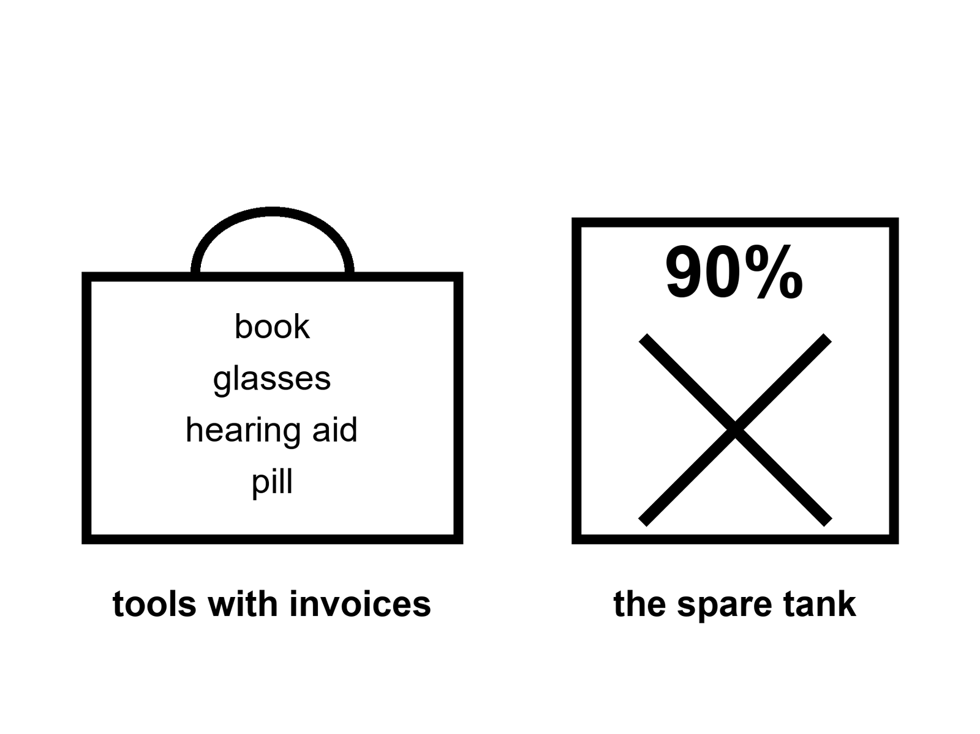
Figure 35. A toolbox on the left — book, glasses, hearing aid, a scored pill. An empty tank marked 90 percent, crossed out, on the right.
A tool is a bargain you can name.
Eyeglasses are the cleanest example in the house. The organ was on duty. The lens in front of it was the wrong shape. A ground piece of glass returns a function the cortex already knew how to use. Nobody serious calls spectacles “unlocking the unused ninety.” They are a local optical fix. They have an invoice. They have side effects if you get the prescription wrong. They changed literacy, craft, and the age at which a person can still thread a needle or read a radio checklist. Hot as a class of win. Not a forever.
Hearing aids sit in the same drawer and are more neglected. Hearing is not a luxury input. It is how a social primate keeps the room. When the input fades, the organ does not gain a spare tank. It spends overtime on guessing, withdraws from the conversation, and, in the ugly correlations, walks toward isolation and cognitive narrowing. A major dementia-prevention review has named uncorrected hearing loss the single largest modifiable risk factor it could find — modifiable meaning a cause you can actually do something about, unlike age or genes — ahead of every other habit on the list, worth on its own something like a twelfth of the population’s dementia risk, roughly one case in twelve;³³ a later update spread the case across fourteen such factors and put roughly half of all dementia cases within reach of some combination of them. Aiding the ear is not a miracle for dementia. It is a tool that keeps a channel the brain was already using, and the invoice for skipping it is larger than vanity usually admits. The temperature is warm-to-hot as prevention of a preventable narrowing, not as a cure for every plaque. People skip the aid because of vanity and cost and fiddle. They do not skip it because the science said the ear was decorative.
Sleep is a tool that looks like nothing.
It is not nothing. It is clearance, consolidation, a reset of the day’s staff schedule, a metabolic and immune negotiation. Take it away and the organ does not reveal hidden capacity. It reveals a drunk. The last fifty years sold sleep as optional because the lights became cheap. That sale was a mismatch, and Chapter 36 will name the carrot that made the sale easy. Here, the temperature is hot as a requirement and warm as a protocol. How much, exactly, for this person, this age, this job: argued. That you cannot enhance a mind by permanently subtracting the night: not argued, except by people who are selling the subtraction.
Education is the slowest tool and the one that actually moved civilizations.
It is not a chip. It is other people, over years, installing compression tricks — reading, numbers, a trade, a way to notice that a claim has no invoice. It changes what a worldline — this book’s word for one person’s path through time — can do without changing the species. It has a brutal invoice: childhood hours, teachers who themselves had to be made, a state that decides who is in the room. It is hot as a lever. It is cold as a promise that a headset in a weekend will do the same job. The ten-percent story loves the headset because the headset can be boxed. A childhood cannot.
Stimulants are a warmer, messier drawer.
Caffeine is the world’s most popular cognitive enhancer and nobody puts it on a slide next to immortality. It buys alertness with a known jitter, a known sleep theft if you take it late, a known habituation. Amphetamine-class drugs, in a person with a diagnosed attention disorder, can be the difference between a life that will vote for Tuesdays and a life that will not. In a person without that disorder, they can be a borrowed morning with an afternoon invoice: appetite, sleep, a heart rate, a temptation to raise the dose when the borrowed morning becomes the new floor. Warm as tools with trade-offs. Cold as a species upgrade. The honest kitchen labels the score. It does not pretend the score is free.
Other pharmacological “enhancers” — a wakefulness drug, a memory-ish candidate, a psychedelic with a therapy wrapped around it — live in the same temperature band when they live at all: small, messy effects, trial-shaped, not a cupboard opening. Many do not live. They live in talks. A talk is cold until a protocol can fail in public.
A chip that returns a lost function is Chapter 31’s logic in metal.
Cochlear implants are the existence proof: a microphone, a processor, an electrode string in the cochlea, the coiled inner-ear organ that turns sound into a nerve signal, a brain that already knew how to do hearing and will, over months, learn this new, cruder code. Scars, batteries, a range of outcomes, a culture argument about what a cure is. Local. A motor-cortex implant that lets a paralyzed person move a cursor or a robotic hand: local, scarred, astonishing, and not a spare-tank unlock. Deep-brain stimulators that quiet a tremor: local, and increasingly closed-loop, meaning the device senses the tremor starting and answers on its own instead of running a constant, unguided signal. The temperature is hot as restored channel in the cases that work, warm as how far this generalizes, cold as and then we upload the rest. Do not let a restored channel launder a hidden ninety.
What would a real enhancement look like, if we keep the word?
A tool that raises a function above the person’s own baseline in a domain they already had, with an invoice they can name, without pretending the organ was off. Caffeine in a tired surgeon is a small, real instance. A well-taught method for a calculation you used to fumble is a larger one. A future drug that safely lifts working memory by a slice would be news. It would still be a tool. It would still meet the many clocks. It would still meet the carrot. It would not be a different species.
The cold costume is specific.
It says: new challenges are coming — ten thousand years of them, or a Mars city, or a job that does not exist — and therefore we must unlock the unused mind. The “therefore” is a smuggle. New challenges are met the way old ones were: with the organ on duty, with other people, with tools, with time, with institutions that do not snap. Chapter 42 is the meeting. Chapter 44 is the expensive reroute. Chapter 39 is the refusal to let a calendar do physics. Here, notice that the costume needs the ten-percent lie the way a lockpick needs a lock. If the organ is already in use, the unlock is unemployed.
Look first before you overwrite a childhood because a slide said enhancement. A child’s brain is a construction site, not a tank. Stimulants, if they are the right tool, are a tool. A marketplace of “make your child 150 percent” is the carrot aimed at a parent. The parent has a wanting-loop too. The child cannot consent to a species project. They can consent, later, to glasses.
She uses checklists because memory is a staff, not a miracle. She sleeps in a bunk that smells faintly of basil and dust because the organ has a night shift. She does not wait for a chip to make the radio delay shorter. The delay is light. Light is late on purpose. A mind that is already on duty can still be a mind that uses a notebook.
A toolbox is not a confession of defeat. Writing that holds a day, checklists that catch a miss, hearing aids that return a room, scored pills that land on time, closed-loop stimulators that quiet a tremor, a cochlear code a brain must relearn for months: local restorations with scars and schedules. Cold is the empty tank labeled ninety percent, as if the label filled it. Warm is the trade-off you can name out loud. Hot is the false ten-percent sentence that dies every time it is printed and somehow returns in the next pitch deck, because a lockpick needs a lock. Keep the toolbox. Evict the loft. Take the tool if the Tuesday votes for it. Put the spare-tank sermon down before it hires the carrot.
Appendix A35 writes sleep, hearing, stimulants, and implants as tools with invoices. Here, keep the toolbox.

36. The Carrot Has No Off-Switch
The carrot has no off-switch.
Book 1 said it about a feast and a fake. It is still true if the feast is a long life. You do not need those pages. The loop can be taught in this kitchen. A Pleistocene wanting-loop in a body that lasts 120 years is not a wise king. It is a mismatch with more calendar. Look first before you call that an upgrade.
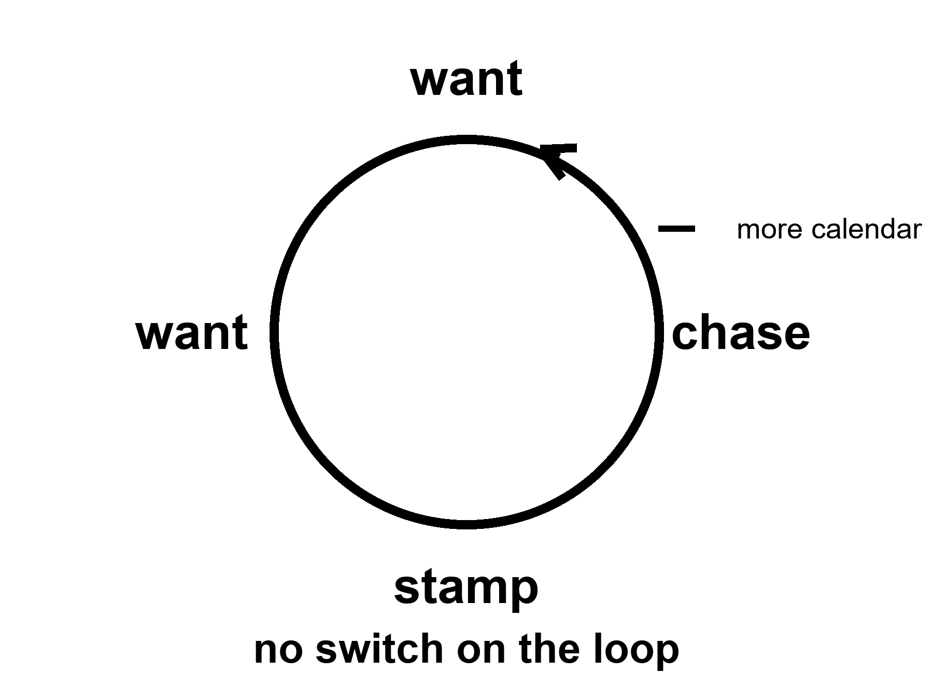
Figure 36. A loop: want, chase, stamp, want. No switch. One extra tick marked more calendar.
Food is not a sandwich. Food is a slope.
A body stays organized by running downhill on a difference: hot to cold, charged to spent, food-molecule to ash. The kitchen name for the ash is waste. Heat is the waste you cannot hide. A nervous system is a staff hired to keep the slopes coming — to find the fruit, the salt, the copy, the ally, the shade. The staff does not mail a pamphlet titled reproduce, then maintain. It mails a carrot. Those who found the act reinforcing left more descendants. Those who found it a chore, all else equal, left fewer. Pleasure is not the cosmic point.
The point is: a copy that ships, and a body that lasts long enough to ship it.
Wanting is one juice. Liking is another.
Wanting is the seek loop: a cue tagged as worth chasing, a go, a narrowing of the room until the cue is got. Dopamine — a brain chemical that carries signals between neurons — in the popular mouth, is this juice, and the popular mouth is not entirely wrong and is too simple. Liking is the completion stamp: do that again. The stamp can be small. The seek can be huge. A person can want a thing they no longer like. A person can like a thing they barely chase. Addiction, in the ugly cases, is a seek loop that has uncoupled from the stamp and from the vote you would cast on a Tuesday. This is not a sermon about vice. It is staffing. The same house hired people who barely want the old feasts, or want a different menu. That is allowed. A lottery that must work on average will throw off quiet tickets.
The carrot has no off-switch labeled this is only a picture.
A gull will sit a giant fake egg in preference to its own. A fish will attack a slab of the right color more fiercely than a rival. That is a supernormal stimulus: the cue, turned up, outbids the thing. We are a primate with cheap infinite pictures, cheap infinite sugar, cheap infinite almost-wins. The factory sells the cue without the invoice — no second person who can leave, no pathogen, no child, a new face every thirty seconds; a cupboard of sweetness that would have been a week of hunting; a feed that never ends. Novelty re-opens the wanting. Industry industrialized the novelty. Hot as a mechanism. Not a verdict on a species, and not a proof that everyone bought a ticket. Plenty of people shrug. Plenty of people drown. Both are allowed by the same wiring.
If you have Book 1, Chapter 30 was this loop in the service of a shuffle and a fake. Courtesy: that is all. The rest of the argument, here, does not need a second origin or a solvent paper. It needs a long life.
A longer life is more calendar for the same loop.
That is the sentence the forever slide does not print.
Give a wanting-loop more Tuesdays and you have not given it wisdom. You have given it more cues. More years to chase a status that will not stamp. More years to open a cupboard. More years to refresh a feed. More years to sit a fake egg because the fake egg is larger than the real one and the off-switch was never hired. Some people will use the years for basil and a log. Some will not. The mesh did not select for a 120-year philosopher. It selected for a seeker who did not die before the copy shipped. The philosopher is a late, expensive hobby of a well-fed ape. The hobby is real. It is not a default setting that clocks in when the joint is fixed.
Look first.
A slide that says enhancement is a cue. It is designed — by people who also have a loop — to tag as worth chasing. The tag can be healthspan, which this book will defend as a product. The tag can be a different species by Friday, which this book will not. The difference is not a mood. It is whether the invoice can be named and whether the many clocks were consulted. A parent chasing an enhanced child is a loop aimed at a construction site. An enthusiast chasing 1,000 years — however sincere, and many are — is a loop aimed at a fuse that Chapter 29 said is not on the counter. A reader chasing a spare ninety percent is a loop aimed at a cupboard Chapter 34 emptied.
Mismatch is the grown-up word.
A body built for scarcity meets a kitchen of cheap cues. A sleep system built for a dark night meets a cheap light. An attention system built for a leopard and a gossip meets a pocket that never stops gossiping. A status system built for a village meets a planet of strangers who can see you fail. None of this is new as a complaint. It is hot as a pattern, and the industry that builds the pocket has said so out loud: engineers have described tuning a feed’s reward on the same intermittent schedule a slot machine uses, because a payout that arrives unpredictably keeps the seek loop running longer than one that arrives on a clock. A device meant to be checked has, in recent surveys, been checked by its owner well over a hundred times a day. That is not a moral failing measured in willpower. It is a supernormal cue doing exactly the job supernormal cues have always done, built by people who read the same wiring diagram this chapter just read.
The new, ruder fact is what happens when medicine becomes good enough to add calendar without adding an off-switch. HIV became a condition and left people with decades the virus would have stolen — a hot win — and those decades are still lived with the same loops, the same cupboards, the same unkind feeds. The win was the decades. The sermon that the decades would automatically become a wise kingdom was cold.
What would an off-switch even be?
Not a lobotomy. Not a moral lecture. A tool, if it exists, would be something that lets wanting stay hired for the mornings you vote for and stay quieter for the fakes you do not. Sleep is a weak, real version: the night ends the day’s seek. A hearing aid is a weak, real version: the room comes back and the isolation-loop loosens. Education is a slow version: you learn to notice a cue that has no invoice. Therapy, for some, is a practice of uncoupling seek from stamp. None of these is a master switch. The cold version is a drug that deletes wanting. That is not enhancement. That is a different kind of chair.
A second origin might have hired a different carrot, or no carrot, or a committee instead of a skull. Courtesy: that zoo is not this book’s. This ape is. This ape’s loop is old, cheap to spoof, and not a king.
She wants the basil to live. That is a loop. She logs the pH anyway. That is a tool she uses on the loop: a measurement that can embarrass a sentiment. The capsule arrives with an optimistic label. The label is a cue. She takes the dose for the joint, which is a Tuesday she would vote for, and not for the species-change, which is a fake egg. The radio is late. Wanting will not make it early. Light does not care.
The honest upgrade, if you want the noun, is not a longer seek. It is more Tuesdays you would vote to repeat, with the seek still in the house, and a kitchen that knows the difference between a tool and a fake. Chapter 28 split the pots — lifespan in one, healthspan in the other. This chapter says why the pots get confused. The carrot will still be running at 80, and at 100, and at 122 if you are the tail. Plan the morning as if that were true. It is.
Mismatch with more calendar is the polite name for a Pleistocene wanting-loop living in a body the savannah never budgeted for. Wanting stamps; liking is another juice; the off-switch was never on the hiring plan. Sugar, feeds, slots, slides that say enhancement: same family, same mechanism, the cue turned up until it outbids the thing. Look first. A longer healthspan without loop hygiene is more chase dressed as wisdom. Time bought without attention paid is not a win you would vote to repeat.
Appendix A36 writes wanting against liking, and why more calendar is not an off-switch. Here, keep the loop.
Rule: The carrot has no off-switch. A longer life is more calendar for the same loop. Look first.

PART IX — Not a Straight Line

37. The Last Fifty Years Were Not a Straight Line
The last fifty years were real. Vaccines that closed rooms of death. A genome you can read without a monastery. Packets that make a radio on Mars feel like a rude kitchen. Compute that got cheaper while we were looking at the basil. None of that is a myth.
None of it is a method for year 12,000.
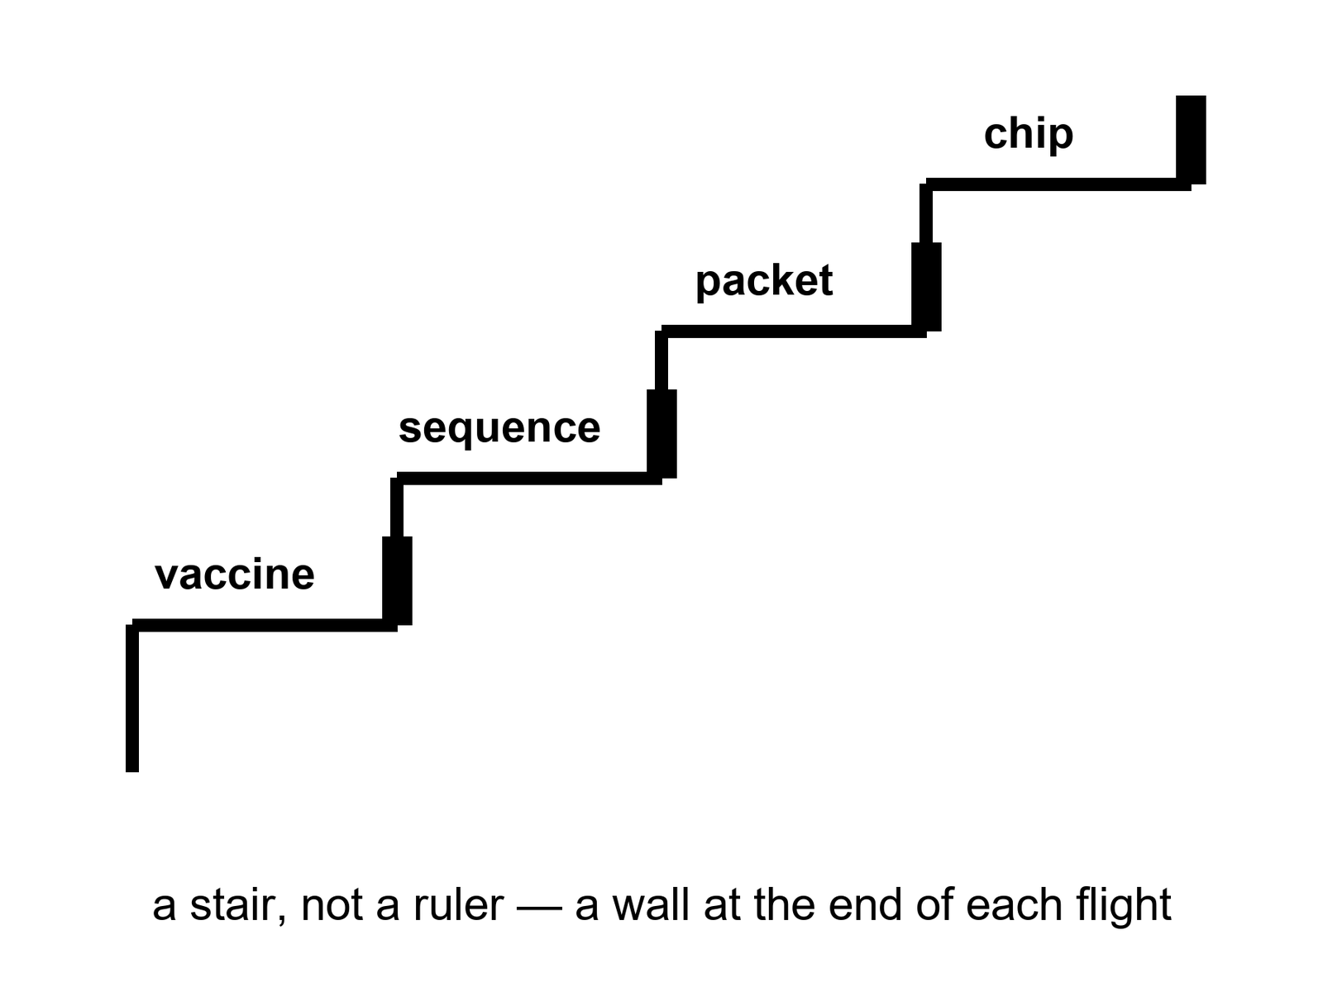
Figure 37. A stair, not a ruler: vaccine, sequence, packet, chip. A wall at the end of each flight.
Hot: the last half-century, in the lucky kitchens, saw uneven, huge gains in a handful of sports. A child in 1975 died of diseases a child in 2025 can miss. Smallpox was already gone;³⁴ polio was being cornered; measles was a failure of a program when it returned, not a failure of a molecule. Hepatitis B got a shot. HPV got a shot that can close a room of cancers decades later. mRNA platforms, in a pandemic year, turned a sequence into a vial faster than a monastery would have turned a prayer. That is a class of win. It is not a ruler.
A genome you can read without a monastery: the project that produced the first reference sequence spent about $2.7 billion of American money over about thirteen years and finished in 2003. By late 2015 a draft whole genome cost under $1,500 to produce, and the price has kept falling³⁵ — a drop of more than three orders of magnitude, one of the steepest cost curves any technology has ever managed, and still a curve, not a hole through the planet. It bought clinics real diagnoses and researchers real cohorts. It did not buy a monastery’s worth of wisdom about what to do with the letters once you have them. Chapter 38 is the curve. Here, keep the fact: we learned to read a book we already had, cheaper, not to write a better one.
Packets: a radio on a dead world that can carry a voice, a picture, a software load, a slipped date. The delay is still light. The clarity is a gift of coding, of error correction, of a network that treats a bit as a bit. Cheap compute sat under the packets and under the sequences and under the slides that now abuse both. A machine that fits in a pocket and outruns a room that used to fill a basement is a real stair. The stair has a wattage, a mine, a dump, and an attention bill. The walls have names.
The walls were always in the house.
Energy. A bit is cheap. A civilization is not a bit. Aluminum, ammonia, steel, a data hall that wants a river, a camp that wants a reactor, a body that wants a thousand watts of food-and-heat: these do not follow a transistor curve. They follow mines, grids, politics, thermodynamics. The last fifty years made some of this cleaner in some zip codes and dirtier in others. They did not repeal heat.
Materials. You can print a model of a pump. You cannot yet print a spare civilization. Rare earths, copper, lithium, a catalyst, a sterile vial, a glove that survives dust: each has a supply chain that can snap. The last fifty years globalized the chain and called the globalization a law. A pandemic and a war taught the kitchen that a chain is a choice.
Attention. A pocket that never stops is not an extra brain. It is a cue factory aimed at Chapter 36’s loop. The last fifty years invented a way to spend a species’ mornings on a feed. That is a gain only if you liked the feed. It is a wall if you wanted the mornings.
War. The same decades that sequenced a genome also spent treasure and blood on fronts that ate both. Knowledge can be lost in a fire. A lab can be a crater. A generation of technicians can be a grave. Progress is not a law that fires if we wait. Institutions fail. Chapter 42 is that failure with the lights on.
None of this cancels the stairs. It stops you from laying a ruler on them and calling the far end a kitchen you can name.
A techniques board has two columns: what got cheaper and what did not. Vaccines, sequences, packets, transistors: cheaper, then slower, then a wall. Hospital cleaning, a night nurse, a peace, a grid that stays up in a heat wave: not cheaper in the same way, and sometimes dearer. The board will not let a student draw a line from 1975 to 12,000 and write therefore. Therefore is a smuggle.
Mara’s radio is a packet gift and a light-time insult. The gift is fifty years. The insult is Einstein, who is older. Her pH meter used to be a lab and is now a tool. The tool is a stair. The basil is still a plant. The plant does not care that the meter got cheaper. The plant cares that the film is honest.
A ledger of the uneven, so “the last fifty years” cannot mean one kitchen.
In the lucky zip codes, childhood death became rare enough to forget, which is how it becomes possible again. In other zip codes the same decades were a fight to keep a fridge cold and a nurse paid. A global average of life expectancy rose, then stumbled, then rose in pieces. HIV became a condition where the pills arrived and stayed a cliff where they did not. A sequence got cheap in a lab that already had a staff, and stayed a rumor in a clinic that did not. Packets made a radio on Mars rude and clear, and made a feed that ate mornings. Compute got cheaper and then spent the savings on a hall that drinks a river so a model can guess the next word.
The board will not let “we” stand in for that ledger. We sequenced. We vaccinated. We invented a pocket. Some of us did. Some of us received. Some of us were the mine. The stair is real. The pronoun is a costume if it erases the invoice.
Mara’s meter is a lucky-zip-code object that rode a cargo to a dead world. Her sister Priya’s clinic, back on the coast, is a different S-curve entirely. Both are this species. Only one of them is in the brochure.
Uneven is the honest adjective. A lucky zip code forgot childhood death; another fought for a cold fridge and a paid nurse. HIV became a condition where the pills arrived and stayed a cliff where they did not. Packets made Mars rude and a feed that ate mornings. Compute got cheaper and spent the savings on a hall that drinks a river. The stair is real. The pronoun we is a costume if it erases the invoice. Keep climbing. Rest on landings, where methods survive so the next climber does not reinvent the flight. Store the method. A continuous ray is a sales prop. Leave it on the floor.
One flight, with both ends kept in the picture.
Smallpox was declared gone in 1980. That stair has a top: a vaccine, a program, a last case, a room that stayed closed. Measles is the same class of molecule and an unfinished flight, because a program can be skipped and the disease walks back in. The stair did not fail as chemistry. It failed as a meeting. The genome got cheap. The nurse who gives the measles shot did not get cheaper on that curve. Her wage, the fridge, the cold box, and the rumor that keeps a door shut are the wall at the end of the flight.
Mara’s meter rode the cheap curve and then rode a cargo ship. Priya’s clinic did not. Both are this species. A ruler laid from the vaccine to the year 12,000 deletes the nurse, and the nurse is the reason one flight finished and the other did not. Keep the stair. Name the wall. Leave the ruler on the floor.
Appendix A37 writes the class of wins — vaccines, sequencing, packets, compute — and the named walls. Here, keep the stair. Do not bring a ruler into this room. The next chapter is the shape of a stair that everyone pretends is a rocket.

38. S-Curves and Invoices
Progress is logistic more often than exponential. Diminishing returns are a kitchen fact.
An S-curve is a slow start, a drunk middle, a wall. The wall is not a moral. The wall is what a kitchen looks like when the easy fat has been skimmed: the first half of the dirt is cheap to clean, the last corner is a career.
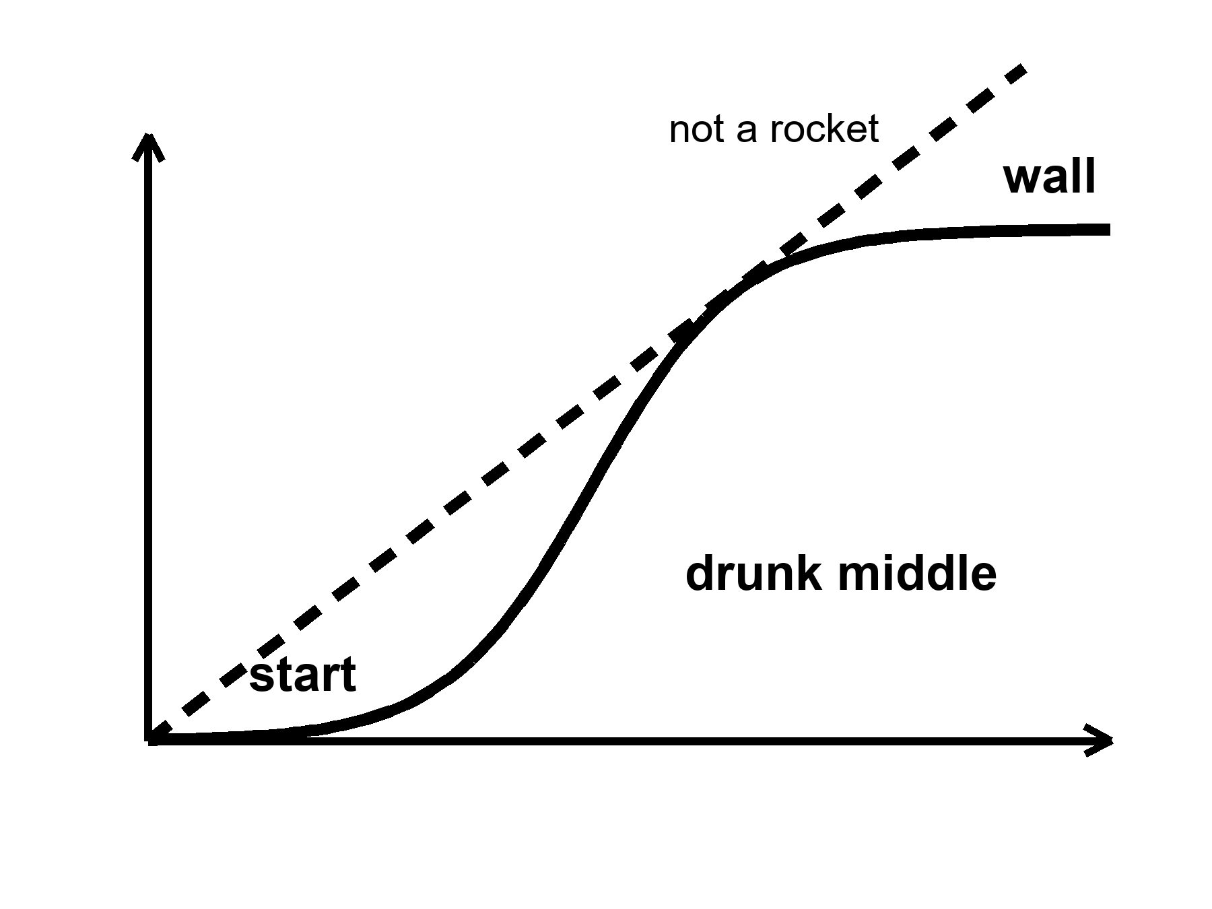
Figure 38. One S: slow, steep, flat. Labels: start, drunk middle, wall. Not a rocket.
A logistic is a growth that feeds on what is left to gain, and therefore slows as the room fills.
Moore’s law was a social-engineering miracle dressed as physics: pack more switches, keep the bill tolerable, do it on a calendar an industry can bet a factory on. For decades the middle was drunk. Then the watts per switch stopped being polite, the lithography — the process of etching a circuit pattern onto a chip, at a scale smaller than a virus — became a cathedral, and squeezing the next sliver off a transistor’s size became a diplomacy. The curve bent. You can still buy more compute. You buy it with parallelism, with specialist chips, with buildings that drink rivers, with a bill that is no longer a hobby. The sermon that “compute doubles forever” was a middle-of-the-S costume. The costume sold a lot of slides. The wall is not a scandal. The wall is an invoice.
Sequencing rode a steeper drunk years and then met its own floor: the machine is cheap compared with a billion, the meaning is not. A clinic can read a genome and still not know what to do with most of the letters. Interpretation is a staff. A staff is an S-curve of training, liability, and a library of what the letters actually do. The drop in dollars-per-base was real. It was not a drop in dollars-per-wisdom.
Vaccines had S-curves before anyone drew one. The first clean hits — a toxin you can tame, a virus you can weaken — were drunk middles after long starts. The leftover diseases are ruder: a moving target, a poor market, a body that will not keep a title, a politics that will not keep a schedule. mRNA was a new stair in a platform. It did not make every illness a weekend.
Medicine as a whole is a museum of S-curves. Antibiotics are the starkest one: twenty-six chemical classes were found by 1962, in a soil-and-mold gold rush that felt, at the time, like a law of nature. Since then the field has found seven more classes, and only one of those since 1987. The easy soil was mined. What is left is resistance evolving faster than a shrinking search space can answer it, and a business problem on top of a biological one, since a drug you take for a week does not pay back its own discovery the way a drug you take for life does. Heart disease had a drunk middle of pills and stents and a wall of metabolic weather that is a farm and a street. Cancer had many small S-curves, disease by disease, and a leftover that is still a funeral. Imaging got cheaper and then met the bill for the person who has to read the image.
Why the rocket story sells.
Exponential is a feeling. It is a middle of an S photographed without the shoulders. Someone who lived through the drunk years of packets and chips can be forgiven for thinking the photograph is a law. A law would not care about energy, materials, attention, or a meeting. A kitchen cares. Diminishing returns are what you get when the next unit of gain costs more than the last: more money, more energy, more rare staff, more side effects, more political fight. The last fifty years skimmed a lot of fat in a few sports. The next fifty, in those same sports, will pay more per increment if the shape is what the shape has usually been.
Warm: whatever is invented will still pay energy, coordination, and the body’s invoices. That is not a proof that nothing new will be invented. It is a proof that the invoice will not be waived because the slide is steep.
Cold: progress is guaranteed if we wait. Knowledge can be lost. A grid can fail. A library can burn. A generation can be taught a smaller book. The loaf, if you met it in the longer volume, does not owe a sequel. You do not need that volume. You need the kitchen fact: waiting is not a method.
S-curves get drawn on napkins for people who arrived with rockets. The napkin is a kindness. Someone has watched a sequencing lab go from a cathedral to a bench and then stall on a variant of unknown significance — and a chip shop go from a miracle to a diplomacy. Keep both. Do not extend either with a ruler to a year that has no furniture.
Mara’s meter got cheaper. The ice did not. Melting the ice is energy and a pump and a morning. The pump has an S-curve: the first reliable pump was a career, the tenth was a spare, the hundredth is a supply chain from a world that still has to send it. The log is a tool. The tool will not become a forever because the last fifty years were impressive.
How to read an invoice when the slide is still steep.
The drunk middle of an S is the part that teaches the wrong lesson. You live through years when every quarter is a miracle and you conclude that miracles are a rate. A rate is a ratio with a clock under it. The clock under Moore’s middle was a factory calendar and a voltage that still behaved. When the voltage stopped behaving, the rate did not apologize. It became a building that drinks a river so a specialist chip can pretend the old sermon is still true. Parallelism is real. It is not the same S. It is a new S that starts slow, gets drunk on a different fat, and will meet a wall of its own — watts, water, a staff who can keep the hall honest, a politics that will let the hall exist.
The same hygiene applies to a clinic. A drug that worked in a Phase 3 is a drunk middle for the people who got it. The leftover — the people who were not eligible, the rare harm that shows up in Phase 4, the zip code without a trial site — is the shoulder of the curve. Launch decks photograph the middle. The napkin keeps the shoulders.
Energy as an invoice is not a mood. A bit can be nearly free and a civilization still pay for aluminum, ammonia, a night nurse, a pump that melts ice. Materials as an invoice is not a mood. You can print a model of a gear and still wait on a catalyst that has one mine. Attention as an invoice is not a mood. Cheap packets made a radio clear and a morning expensive. Coordination as an invoice is Chapter 42. Here, keep the shape: the next unit of gain, in a kitchen that already skimmed the easy fat, costs more than the last. That is diminishing returns spoken without a graph.
Warm: new stairs can still open. A new platform can start a fresh S. Cold: the fresh S is not a repeal of invoices. It is a new drunk middle that will someday meet a wall, and the wall will still have names.
Appendix A38 writes logistic shape, Moore’s bend, and sequencing’s dollar drop as a table. Here, keep the S. The next chapter is the arithmetic abuse that turns fifty into ten thousand.

39. Ten Thousand Years Is Not ×200
Fifty into ten thousand is two hundred. That is arithmetic. It is not physics.
Claim, cold: last fifty × 200 = the furniture of the year 12,000. We cannot name that furniture. Do not print a 10,000-year gadget catalog. The catalog would be a costume, and the costume would be wrong in both directions: too shy about accidents, too loud about transistors.
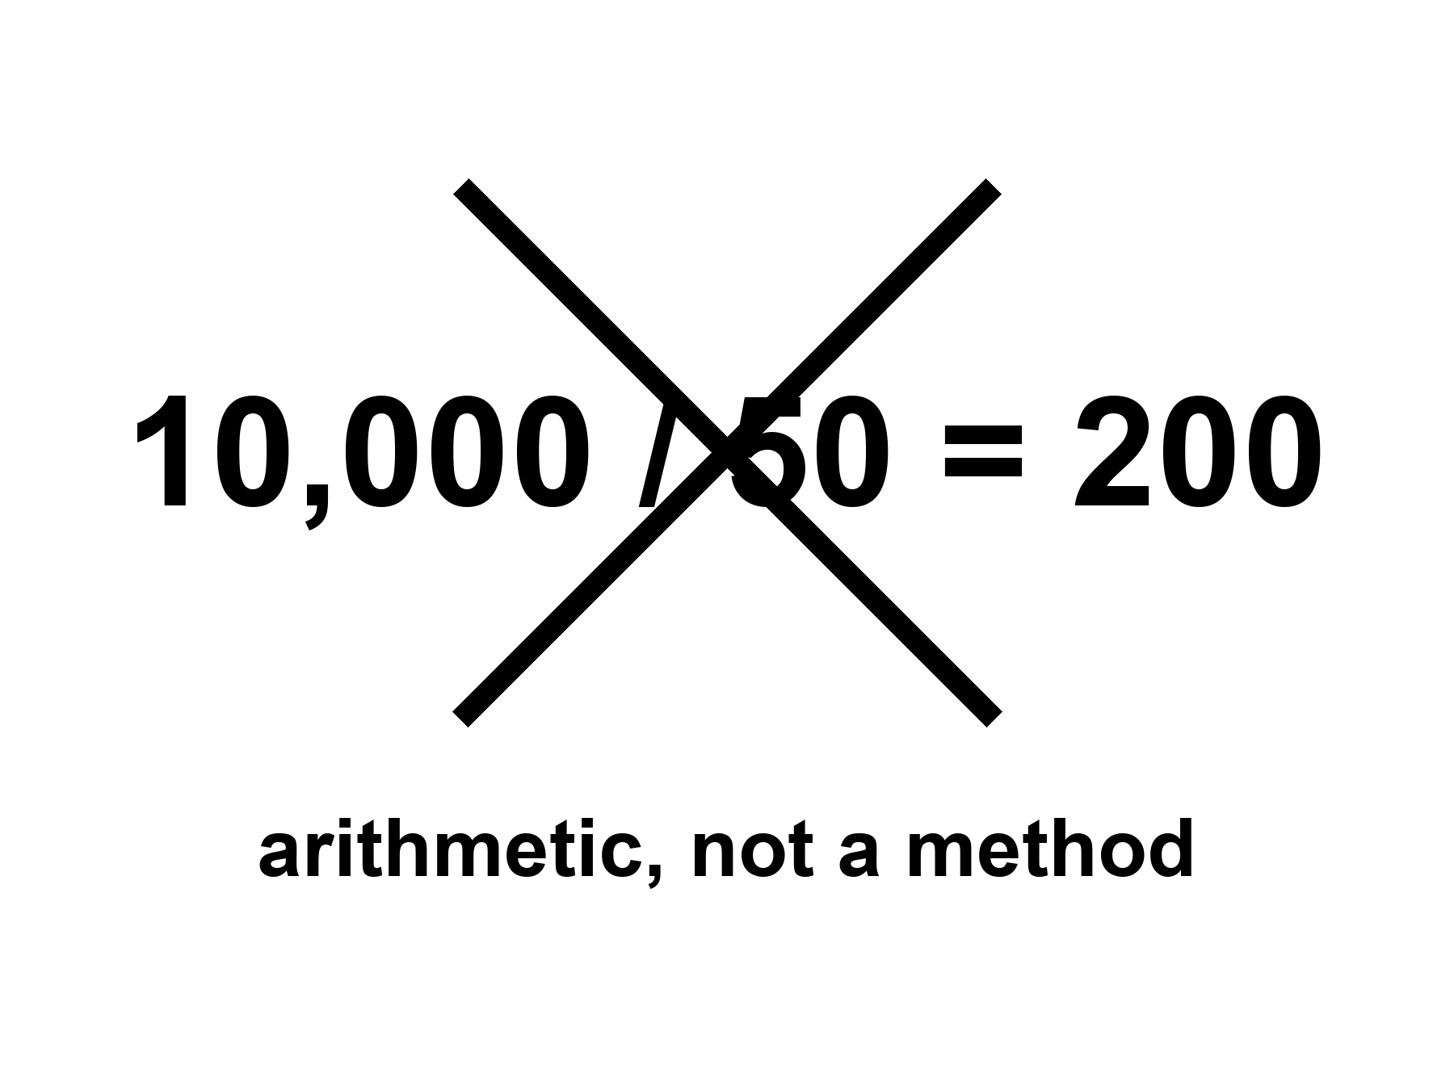
Figure 39. 10,000 / 50 = 200, crossed out. The label: arithmetic, not a method.
The sum 10,000 / 50 = 200 is a ratio of years, not a law that copies a kitchen 200 times.
What the abuse does: it takes a drunk middle — cheap bits, cheap letters, a vaccine platform — and treats it as a slope that continues through walls, wars, and the body’s many clocks. It then names the far kitchen as if naming were a forecast. Flying cities, ageless bodies, spare brains, a mind in a file, energy too cheap to meter, a politics that finally agrees. None of that is selected by a ratio.
What an honest extrapolation is allowed to say:
Energy will still have a bill. Heat will still have to go somewhere. Coordination will still be a meeting, a ledger, a front. Biology will still be many clocks. Knowledge will still be losable. Children will still need a childhood that was not overwritten because a slide said enhancement. We cannot name the gadgets. We can name the invoices.
A gadget catalog for the year 12,000 is cold as a method and rude as a promise. This chapter will not write one. If a later reader lives in a kitchen we cannot imagine, they will not need our catalog. If they live in a poorer kitchen, because a war or a dark age or a simple failure of staff, they will need the invoices more than they need our optimism.
People reach for ×200 because the last fifty felt like more than a lifetime of change. Felt is a measurement of surprise, not of slope. A person born in 1975 met packets, a cheaper genome, a quieter childhood disease, a louder pocket, a climate needle that did not droop. That is a lot of furniture to rearrange in one career. Rearrangement is not a license to multiply the career by two hundred. The century before last rearranged furniture too: engines, wires, vaccines of an older class, a war that ate a generation. If you had multiplied that fifty by two hundred, the calendar would have jumped ten thousand years. The sum later in this chapter names the year. It does not let you pack furniture from a century you have not reached. The method fails in the rearview. It does not get a promotion because we like this rearview better.
Look first. A slide that says the next 10,000 years of medicine and then shows a 200-year ape is not forecasting. It is Chapter 36’s carrot with a calendar. The calendar is a cue. The ape is a fake egg.
She will not see year 12,000. No one she can radio will. The loaf, if you like the courtesy, already has that year as a region; you cannot rent it. The honest body is a morning. The morning has a pH. The pH is not a gadget from a catalog. It is a number a plant will die over.
A worked example, so the arithmetic has to sit in public.
Take vaccines in the lucky kitchens. Fifty years moved a lot of rooms from death to boredom. Multiply that motion by two hundred and you do not get a 10,000-year ape who cannot get sick. You get a nonsense: either every remaining pathogen politely resigns, or you have invented a biology that is not this biology. The leftover rooms — a moving flu, a poor-market parasite, a politics that will not hold a cold chain — are the wall the ratio waived.
Take compute. Fifty years packed switches until the packing became a cathedral. ×200 is not two hundred more cathedrals of the same kind. It is a wish that heat, lithography, and mines will keep pretending to be a hobby.
Take sequencing. The read got cheap. The act — this letter, this tissue, this trial, this zip code — did not get two hundred times cheaper, and will not, if Chapter 43’s invoices are real.
The method fails the moment you name a sport. That is why the catalog is refused. A catalog is a list of sports with the walls deleted.
What the ratio smuggles when it sounds humble.
Sometimes the slide does not name flying cities. It names more of the same, only better. More healthy years. More clear packets. More letters read cheaper. That costume is warmer than a gadget catalog and still a method error. “More of the same” assumes the drunk middle continues, the walls stay polite, the institutions that delivered the last fifty still exist, and the body keeps accepting the same class of trick. Chapter 38 already said the S bends. Chapter 42 will say the meeting can fail. Chapter 29 already said the clocks are many. Multiplying a half-century of uneven wins by two hundred is a way to delete those sentences without arguing with them.
Temperatures, applied to the far kitchen:
Hot: we cannot name the furniture of year 12,000. That is not humility as a pose. It is a measurement of what a forecast is allowed to do when the variables include wars, dark ages, and biology that is not a transistor.
Warm: energy, heat rejection, coordination, many clocks, and losable knowledge will still be due. Children will still need a childhood that was not overwritten for a slide. Local fixes — a class of edit, a vaccine platform, a tool — can still open doors. Doors are not a downtown.
Cold: last fifty × 200 as a kitchen you can sell. A scheduled thousand-year ape. A mind in a file as travel. Progress as a law that fires if we wait. The catalog this chapter refuses to print.
The rearview is the cheapest experiment. Pick any fifty-year window that felt like destiny — steam, wire, antibiotic, packet — multiply by two hundred, and watch the product fail against the kitchen that actually arrived. The failure is not that people were stupid. The failure is that a ratio of years is not a dynamics. Dynamics include accidents. Accidents do not scale by two hundred. They interrupt.
One more hygiene, for a serious argument called expected value.
Its best defenders are philosophers and economists, not salesmen, and the argument deserves to be heard in full. They say: we cannot name the furniture, fine; we can still bet that the average kitchen in year 12,000 is richer if we multiply today’s slope. Expected value is a casino word. A casino assumes the game still exists, the dealer still deals, and the house has not burned. Chapters 11 and 16 named the fires. Knowledge can be lost. A grid can fail. A generation can be taught a smaller book. An average that assumes the game continues is not a forecast. It is a hope wearing a spreadsheet. Warm hopes are allowed. Long-range economic and social forecasts of this kind are contested, not cold: careful people with the same data disagree about how much weight a far, uncertain future should carry. This book’s side is that a forecast which assumes the game continues has to show why it will. Cold hopes sold as method are not allowed.
Mara will not see the far kitchen. She does not need to. She needs a pump that arrives, a film that stays honest, a joint that still opens a jar. Those are invoices with dates. A skyline labeled 12,000 has no date that can be embarrassed by a measurement. Look first. Ask which wall was waived. Ask which war was cancelled. Ask which childhood was treated as a construction site because a calendar said thank-you.
Felt is surprise, not slope. The last fifty years felt larger than a lifetime because the kitchen changed underfoot. Name a sport — vaccines, compute, sequencing — and the ratio fails the moment a wall appears. There is no catalog for year 12,000 that a body, or a pharmacy, can cash. Extrapolation without a wall is a costume. Cross out the sum. Keep the invoices that will still be due: energy, coordination, a body that ages, a meeting that can fail. Put the costume on the hanger.
Do the arithmetic where a hearing can see it. Ten thousand divided by fifty is two hundred. Write the two hundred on the slide, then ask what was multiplied. If the thing multiplied was “childhood death became rare,” two hundred times that is not a child who cannot die. If it was “a letter got cheaper to read,” two hundred times that is not wisdom about the letter. The ratio is a clock divided by a clock. It does not copy a kitchen.
Run it backward, with the calendar visible. A fifty-year window that ends in 1900, stretched by the same trick, claims the year 11900. The claim would have been more engines and more wire. The method is not allowed to import, from a future it has not reached, the antibiotic, the transistor, or the wars that ate the people who would have built either. That is the method failing in a century we already lived. It does not get a promotion because the last fifty years felt larger. Felt is surprise. Surprise is not a slope.
Cross out the sum. Keep the invoices that do not care about the feeling: energy, heat that has to go somewhere, a meeting that can fail, a body of many clocks, a childhood that is not a construction site.
Appendix A39 writes the ratio, the rearview failure, and a short list of invoices that will still be due. Here, keep the crossed-out sum. If anyone shows you a skyline labeled 12,000, ask which wall was waived and which war was cancelled.

40. A Fast Trip Is Not a Long Life
Chapter 39 refused a catalog for the year 12,000. One door to that year is real, and physics holds it open. It opens one way. It charges the traveler the same decades everyone else pays.
Claim, hot: a clock that moves fast, or sits deep in a gravitational well, ticks at a different rate from a clock left behind, and the difference has been measured many times over. Claim, cold: that this is a longevity product. It changes your date. It does not add a heartbeat to your count.
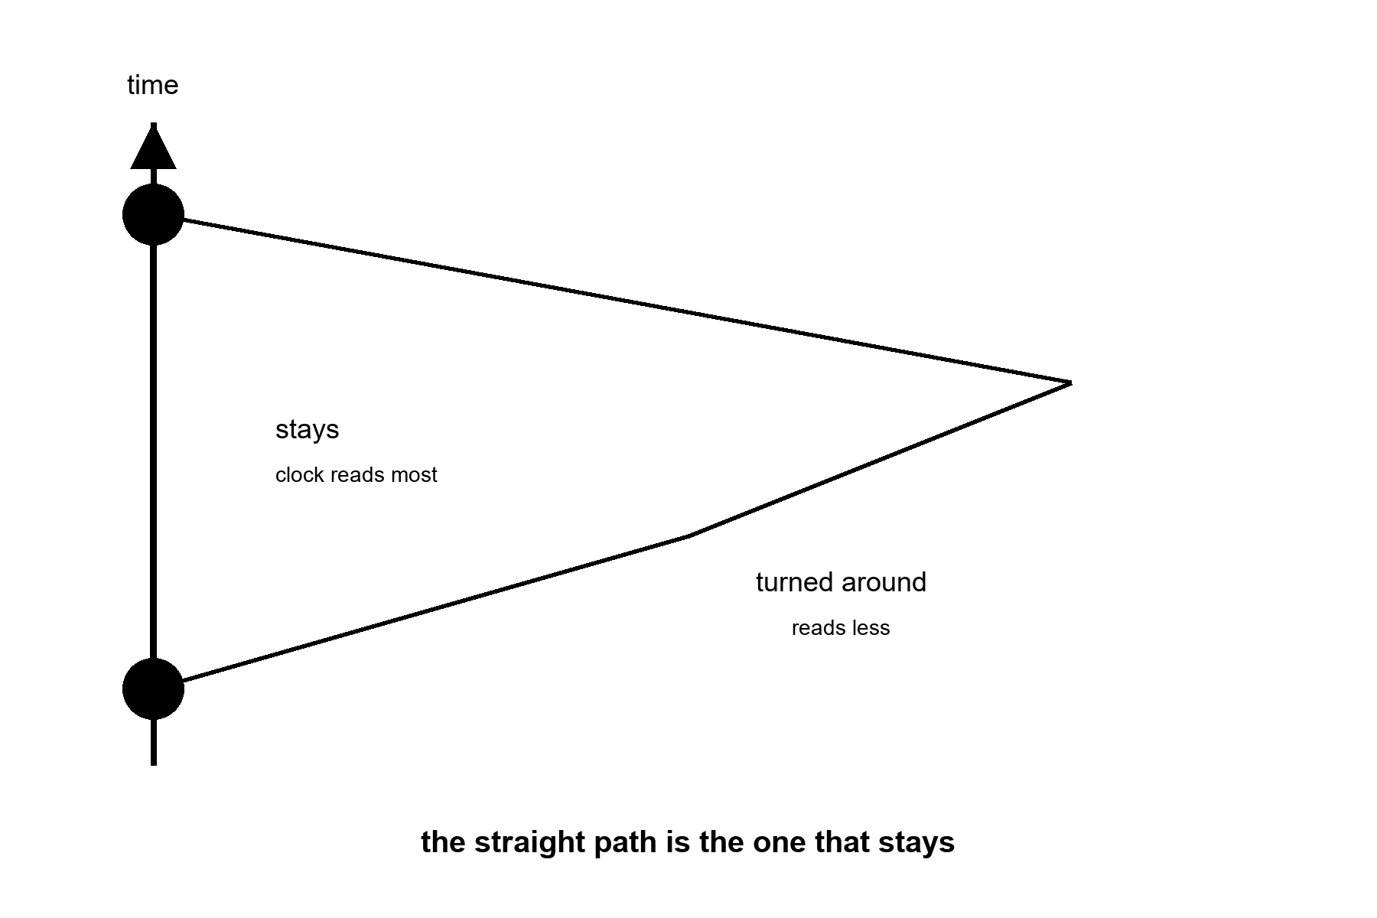
Figure 40. Time runs up the page. Two paths join the same two events. The straight path is the one that stays, and its clock reads the most. Notice that the path that turned around reads less.
The clock along a path reads the length of that path, measured the way time and space measure it together, and a bend can only shorten the reading.
Draw it with a pencil. Let time run up the page and space run across. A body sitting still is a line straight up. A body that moves is a line that leans. A life is one such line, from a first event to a last. Physicists call that line a worldline, and this book means only the plain thing by it: the whole path, not a snapshot.
Here is the one rule you need. A clock carried along a path reads the length of that path, and length here is not ruler length. Leaning costs you. Between two fixed events, the straight path reads the most, and every bent path reads less. The name for this is maximal aging. The body that is never pushed ages the most.
That is the whole twin story with the paradox taken out. Two events: a departure and a reunion. One twin stays on the straight line. The other leaves, turns around, and comes back. The turn is real. Someone fired an engine, and an accelerometer — a sensor that feels a push or a pull, the same kind that tells a phone which way is up — in the ship would have shown it. Nobody has to argue about who is really moving, because only one of them bent.
This picture-first way of teaching relativity, with a pencil, graph paper, and arithmetic you can check, is the way Lewis Carroll Epstein’s Relativity Visualized teaches it. A reader who wants to keep drawing should go there. The pictures in this chapter are drawn for this kitchen. The debt is the method.
Now the sentence the slides drop. Nothing in the traveler feels slow.
Her heartbeat, her telomeres, the healing of a cut, the whole staff of clocks from Chapter 29 all tick together on the one clock that runs along her own path. A candle in the ship burns at its usual rate. A second is a second. By her own count she lives the same couple of billion heartbeats as anyone. What changes is how much of the world’s calendar goes by while she spends them.
The exchange rate is arithmetic. At ninety percent of the speed of light, her year is a little over two of the home years. At ninety-nine percent, about seven. At 99.9 percent, about twenty-two. At 99.99 percent, seventy-one.
Take the year 12,000. Give her a perfect ship that speeds up at one Earth gravity, the gentle floor-push of an ordinary room, for a quarter of the trip, slows at the same rate for the second quarter, turns, and does it again. She lands home twelve thousand years from now. Her own clock reads about thirty-four years.
She has spent thirty-four years of her life. She arrives in a kitchen nobody can name, in a language that has moved, among people who never voted for her seat. She cannot report back to the ones who sent her. They are dust. Chapter 39 was right about the catalog. This is the one door to the year 12,000, and it is a skip. It is not a refill.
None of this is a costume. Muons, the heavy cousins of the electron, live about two millionths of a second at rest. Sent around a storage ring — a circular accelerator track that holds particles racing in a loop — at CERN, the European particle-physics laboratory, in the 1970s at 99.94 percent of the speed of light, they lasted about twenty-nine times longer in the lab.³⁶ In 1971 two physicists flew atomic clocks around the world on scheduled airliners³⁷ and compared them with clocks left on the ground. The flown clocks came back off by tens to hundreds of billionths of a second, behind when they flew east and ahead when they flew west, as the theory said.
The satellites that tell your phone where it is carry clocks that would run wrong by about thirty-eight millionths of a second every day if nobody corrected them.³⁸ Uncorrected, a position fix would drift by more than ten kilometers a day. A year aboard the space station leaves the crew younger than the twin at home by about nine thousandths of a second. Real. Small. Paid.
Speed is one knob. Depth in a gravitational well is the other.
Einstein’s leap was to notice that standing on a floor and being pushed by a rocket feel the same. If a rocket floor changes what clocks do, then a planet’s floor must change it too. A clock lower in a gravitational field runs slower than a clock higher up. At Earth’s scale the effect is tiny, and laboratory clocks can now resolve it: they can tell apart the height of a single step stool, about thirty-three centimeters.³⁹ Live your whole life in a cabin a kilometer up a mountain and you are ahead of the sea-level people by about a quarter of a thousandth of a second by your eightieth birthday. That is the bill for a lifetime of altitude.
Her own kitchen has the effect. Mars is a shallower well than Earth, and it sits farther out in the sun’s well. A clock on Mars runs about half a millisecond a day faster than the same clock at home. Her radio is late by four to twenty-one minutes, depending on the week. Those are different things. The radio is late because light takes time to cross. The clock is ahead because the two worlds sit in different wells. She can fix the first with patience. The navigation cell fixes the second with a correction term, sent up the same slow line and logged beside her pH.
Then the picture bends. In Einstein’s account, gravity is not a pull. It is the shape of space and time together, and a thrown stone follows the straightest path there is. Straightest again means longest clock. The stone takes the path on which its own clock reads the most. Same rule, different page.
Push the well as deep as it goes and you have a black hole. As mathematics that is hot. Astronomers have found the real things. No clock has ever been carried there and back. A clock held still near the edge would read far behind the clocks far away. The price is an engine that never stops and, for a small hole, tides that would pull a body apart before it arrived — a smaller hole packs the same crushing gravity into a tighter space, so the pull on your feet can outdo the pull on your head by more than a body can survive. Whatever it learned would reach home stretched and late.
Rohan, who knows the pump and every bad joke about it, catches her reading the correction term.
“Half a millisecond a day,” he says. “You’ll be ahead of mission control by the time you’re old.”
“About seven seconds over a career,” she says. “I’ll take it.”
“That’s the whole prize?”
“That’s the whole prize.”
“If you want the big one,” he says, “go fast enough and come home after they’ve discontinued the pump.”
She logs the pH. The film on the basil does not slow in a ship. Her clock, the plant’s clock, and the chemistry’s clock keep the same time, because they are all hers, on one path. That was always the whole trick. The body keeps its own clock. Relativity only changes what the other clocks say about it.
Now the invoice, because this book always brings one.
Energy. To bring one tonne to 99.9 percent of the speed of light takes about two billion trillion joules. That is about three years of everything humanity burns, dams, splits, and harvests, for one tonne, one way, with nothing aboard to eat or breathe. Stopping costs the same again.
Fuel. A rocket has to carry the fuel it will burn later. For the round trip to year 12,000, even a perfect photon rocket, matter and antimatter turned entirely into light, a machine no one knows how to build, needs more than a quadrillion times the ship’s own mass in fuel. The rocket equation is a wall, and it was named in advance.
Coordination. Someone has to keep the ship, the fuel, and the money for thirty-four of her years while the world outside spends twelve thousand of its own. Chapter 42 is the meeting that can fail. This trip has no one left to call.
Home. The kitchen she left has no seat for her.
Temperatures, applied to the fast trip.
Hot: moving clocks and low clocks disagree with clocks left behind. It is measured in muons, airliners, satellites, and laboratory stools. A traveler’s ship time and the world’s time can differ without limit in the arithmetic. The traveler lives no more ticks.
Warm: any settled world will need its own time standard and a correction to tie it to home. That is a spreadsheet, not a miracle.
Cold: a fast trip sold as an anti-aging plan. A body that ages slowly by its own count. A ship to the year 12,000 as a way to see how it turns out. A physics fact repackaged as a longevity product.
Appendix A40 writes proper time, the muon, the airliner clocks, and the fuel. Here, keep the traveler’s own ticks. A fast trip is not a longer life.

41. A Long Sleep Is Not a Long Life
Chapter 40 found one real door to a far year: go fast, come home late, and pay for the skip in fuel no one can carry. There is a second, quieter door on the same wall. Instead of moving the traveler’s clock relative to everyone else’s, slow the traveler’s own clock down. No speed limit stands in the way of that one. A metabolism is not the speed of light.
Hot: cooling the body, or suppressing its metabolism, measurably changes how much damage some tissues take from a fixed span of real time. Cold: that a long sleep is a way to skip the years without spending them, the way the fast trip was sold as a way to skip them without aging.
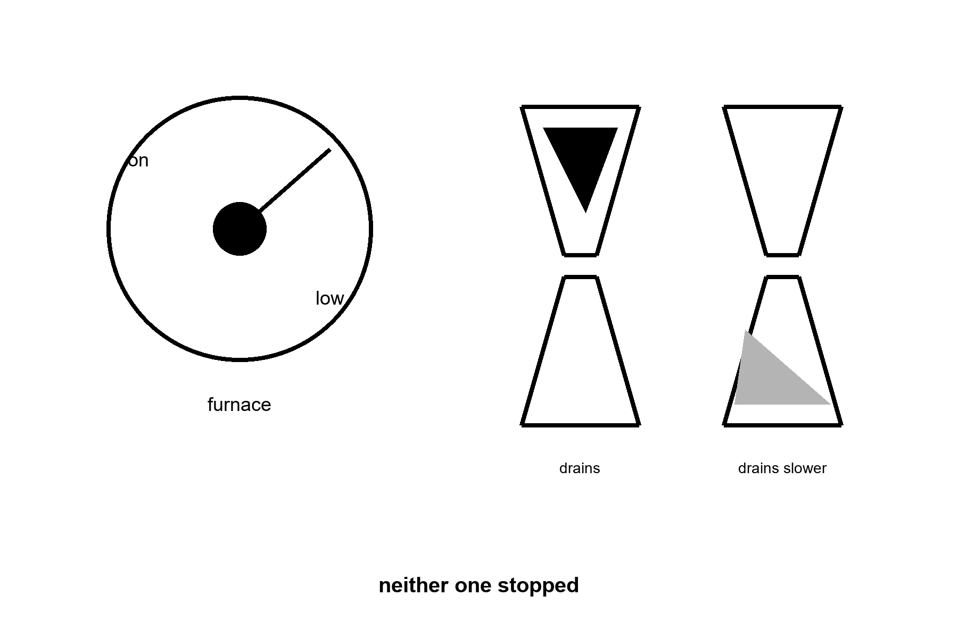
Figure 41. A furnace dial turned down from “on” to “low.” Below it, two identical hourglasses: one draining at the normal rate, one draining slower — neither one stopped.
Torpor is a real, reversible drop in body temperature and metabolic rate, seen naturally in hibernating mammals and induced experimentally, in narrower forms, in humans.
Start with the reason this door gets proposed at all: a crew, not a body.
A crewed trip to Mars runs six to nine months each way. Every one of those months needs food, water, air, exercise equipment to fight muscle and bone loss, and something for restless minds to do, which on a six-month drive is also true of the school run and is solved there with considerably less engineering. Space agencies have studied — on paper, in animal experiments, and in a NASA-funded human research program — whether a crew could instead be cooled into a hibernation-like state for the transit: lower body temperature, suppressed metabolism, tube feeding, robotic muscle stimulation to prevent atrophy, and a wake-up on arrival. The habitat that would carry them, and the outline of what the state would need to look like, already has a name in the engineering literature, which is more than can be said for the state itself. Nobody is building it yet. As of this writing there is no evidence any space agency is preparing to place a healthy crew into synthetic hibernation; the human research is aimed at learning whether the state can be induced and reversed safely at all, not at scheduling a flight, whatever the concept art would have you believe.
Human medicine already runs a narrower version of the same idea, and its record is honest and mixed.
After a cardiac arrest, cooling a patient’s body by a few degrees for about a day — targeted temperature management — was shown in an early trial to raise the odds of a good neurological outcome, and the practice spread through emergency medicine on the strength of that result. Later, larger, more careful trials complicated the story: a 2013 trial found little difference between a deeper cooling target and a milder one, and a 2021 trial of over eighteen hundred patients found no significant difference between cooling and simply preventing fever,⁴⁰ especially for the more common kind of cardiac arrest. The field did not abandon temperature management. It narrowed the claim: slowing the body’s metabolic demand during a specific injury, in a specific window, can matter, but “cooler is better” was never a general law, and the benefit is neither as large nor as universal as the first headlines said.
The animals that actually hibernate show something stranger than either story.
An arctic ground squirrel in deep torpor lets its core body temperature fall close to freezing and its metabolic rate drop to a small fraction of normal, which is a party trick no committee has ever approved for a human. During that state its brain accumulates a chemical change — a buildup of a protein modification — that in a human would be read as a marker of advanced Alzheimer’s disease. Within hours of warming back up, a substantial part of that marker comes back down, site by site. It does not clear as one switch, and the connections the cold pulled back are not a therapy with a human dose. This is not evidence that cold protects a human brain the way it protects a hibernator’s; humans are not adapted hibernators, and no one has shown the same reversal works in us, whatever the enthusiasts on the internet would like it to mean by Tuesday. It is evidence that a real animal has already solved the hard part of this idea, cycling a brain through a state that would alarm a doctor and back again, many times a winter, for a whole life, without once filing a research grant. That solved problem is one reason torpor research keeps getting funded, whatever a crewed Mars mission ends up doing with it.
Mara sends Rohan a question she has been sitting on since her own outbound leg: whether the crew who planned her transit ever seriously priced the deep-sleep option instead of the long, boring, fully conscious months she actually spent awake in a couch that was not built for a body that could feel time passing.
His answer takes its usual day to arrive. “They ran the numbers,” it says. “Less food, less water, smaller habitat. All real savings. Somebody in an office loved it.”
“And the aging?” she sends back, once she has had a night to decide the question is not rhetorical.
“Nobody’s claiming that part yet. Officially it’s a life-support answer, not a longevity one. Off the record, every mission planner secretly hopes it’s both, the way everyone secretly hopes the diet will also fix their marriage.”
“The squirrels get both,” she says. “We don’t know if we would.”
By the time his next message lands, he has clearly had time to think about it properly, which is either the one advantage of the delay or the one thing it steals. “The squirrels have been doing this for longer than we’ve had a written language. Give it a few centuries. They didn’t need a committee either.”
“So the plan is: wait for evolution to finish the paperwork.”
“The plan,” he says, “is a well-funded question mark with excellent PowerPoint. I wouldn’t have booked the flight, for what that’s worth now.”
She writes the pH down instead of an answer. Some invoices are not due yet, and some were already paid in a couch, months ago, by a version of her who did not get a vote.
Here is what the honest version of this door costs.
Engineering is the first bill: nobody has induced and safely reversed a multi-day torpor state in a healthy adult human; the research so far studies smaller pieces of the problem — drugs, cooling protocols, monitoring — not a finished, flight-ready system. Evidence is the second bill: the clearest human data, cardiac-arrest cooling, shows a real but narrow and shrinking benefit tied to acute injury, not a general slowdown of aging available to a healthy traveler. Species is the third bill: the best evidence that metabolic slowing can be truly protective, not just neutral, comes from animals built by a hundred million years of selection to do this safely every winter, and a human is not that animal with a blanket added. Purpose is the fourth bill, and the most easily forgotten: every serious program studying this is trying to solve logistics for a crew in transit, which is a real, worthwhile, and completely different problem from trying to add years to a life.
Temperatures, applied to induced torpor.
Hot: hibernating mammals raise, in torpor, a brain marker that would read as severe disease in a human, and bring a substantial part of it back down after arousal.⁴¹ That reversal is the squirrel’s. Targeted cooling has a real, narrow role in specific acute injuries like cardiac arrest.
Warm: whether any of this transfers to inducing safe, reversible torpor in a healthy human, for any purpose, is an open and actively funded research question, not a settled no.
Cold: a scheduled human hibernation flight; torpor as a general anti-aging tool; the assumption that slowing the clock during transit would also slow the traveler’s own aging, which nobody has shown and the cardiac-arrest evidence does not support as a general rule.
Appendix A41 writes the cardiac-arrest trials, the squirrel paper, and the food a sleeping crew would not eat. Here, keep the dial. A slower clock is not a longer life.

42. Coordination, Wars, Institutions
The limit is often a meeting, a ledger, a famine, a front — not a transistor.
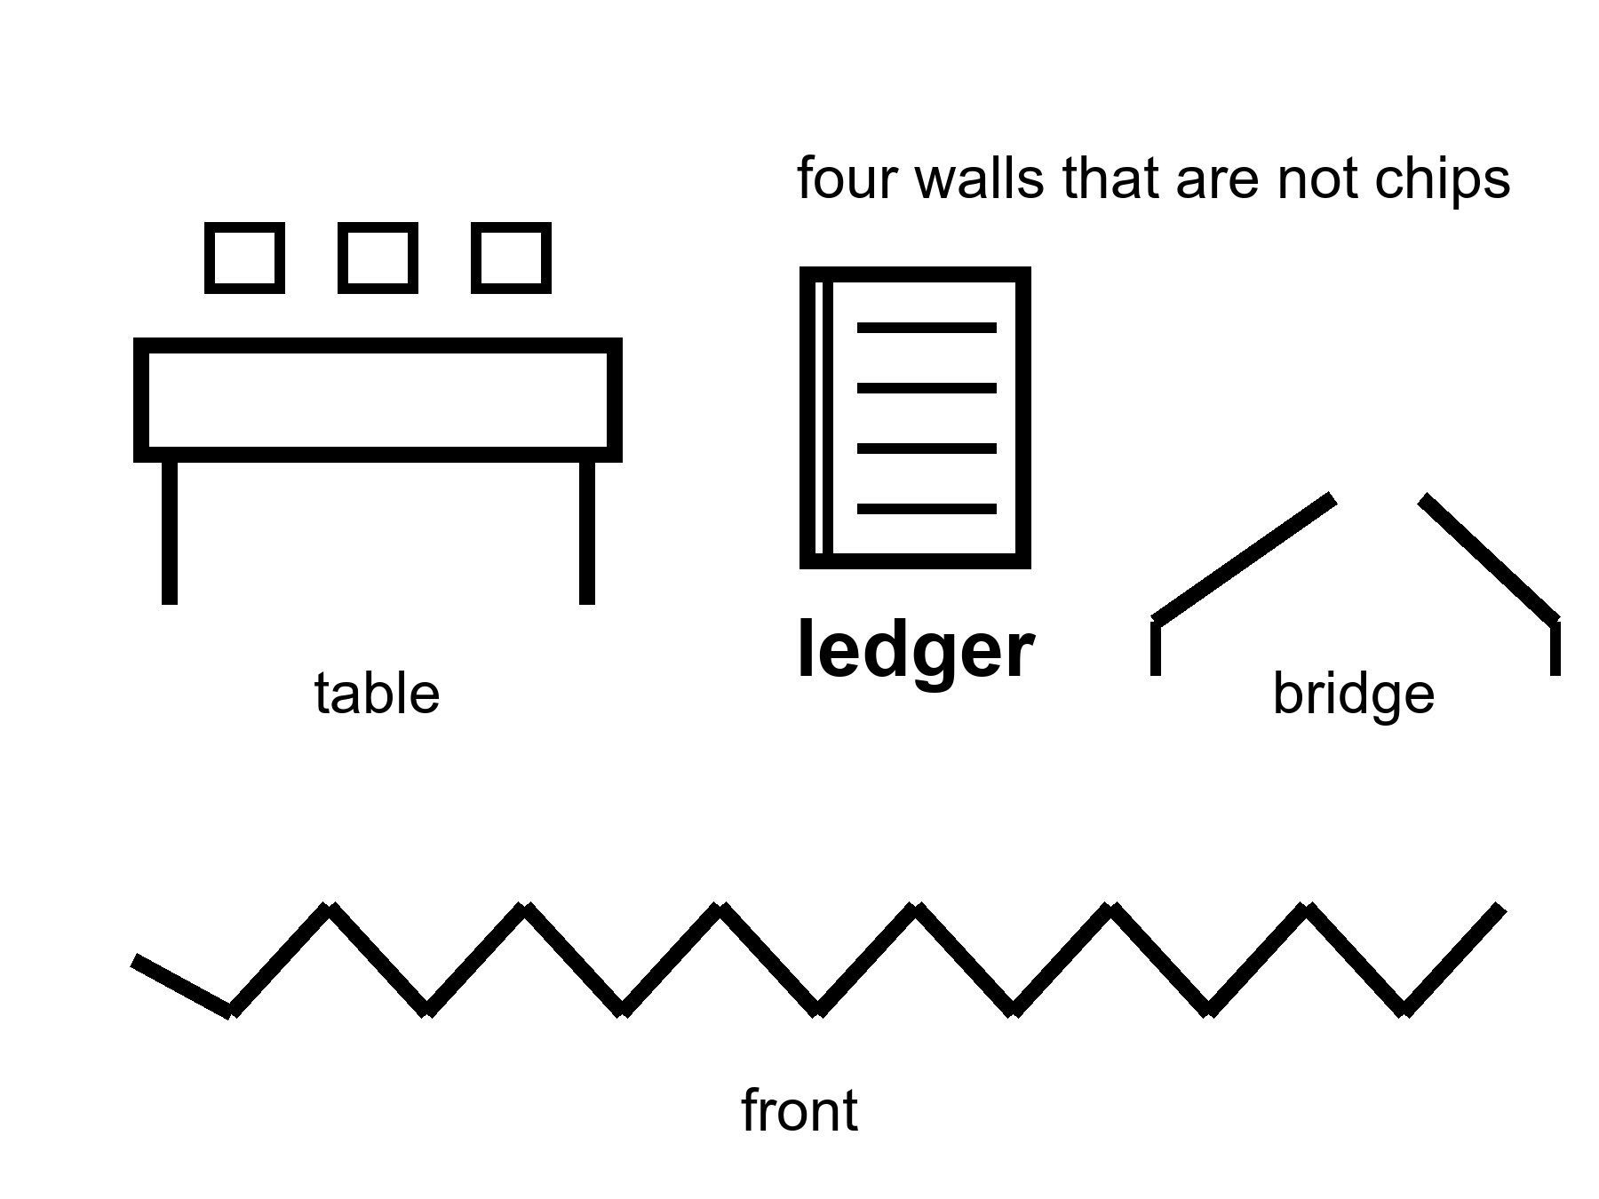
Figure 42. A table, a ledger, a broken bridge, a front. Four walls that are not chips.
A transistor does not vaccinate a neighborhood. A neighborhood is a schedule, a fridge, a rumor, a nurse, a person who will not come because the last campaign lied. A transistor does not keep a grid up in a heat wave. A grid is a union, a spare transformer, a politician who approved the spare, a copper mine, a storm. A transistor does not close a loop on a dead world. A loop is Chapter 12’s seven rows, and this chapter’s meeting.
Institutions are slow kitchens. They store the method for running a trial, paying a nurse, keeping a river drinkable, not shooting the technician. When they work, they look like boredom. When they fail, they look like a sudden return to a ruder century. The last fifty years, in the lucky zip codes, were an institution story as much as a chip story: agencies that could still say no, journals that could still retract, a cold chain that could still hold a vial. In the unlucky zip codes they were an institution story too: a clinic that closed, a ledger that was stolen, a front that ate the graduates.
The clearest live example is a disease this book already called a win. Vaccines closed rooms of death, and one of those diseases, wild poliovirus, has been reduced from a global menace to two countries⁴² and a double-digit case count some years. It has not been closed, and it has not been closed because the last mile is not a chemistry problem. In Pakistan alone, more than two hundred vaccination workers and the police who guard them have been killed since campaigns began, in a geography that overlaps almost exactly with the areas hosting armed groups that spread the rumor the vaccine is a foreign plot. The virus does not care about the rumor. It cares that the door did not open. A cheap, effective, decades-old tool sits unfinished because a meeting, not a molecule, could not be won.
War is not a subplot. War is a way knowledge dies and a way knowledge is hurried. A front can produce a vaccine schedule and a crater in the same decade. A species that wants a 10,000-year catalog must first want a 10,000-year habit of not burning the library. That habit is not selected by a slide. It is selected, if at all, by politics, which is a meeting that can fail.
Famine is an energy and coordination failure with a body count. It does not care that a lab can edit a letter. It cares that a crop failed, a road was cut, a price was a weapon. The body keeps its own clock; a hungry body keeps a faster one.
Germline enhancement as a front, not a gadget.
Chapter 31 left a door closed. Changing the string — the genome’s long string of letters — in a way that is germline, meaning the change is passed to every cell of the child’s body and to their children after them, in a child who cannot consent, is technically closer than it was. It is still a meeting, a law, a church, a market, a fear, a race between ledgers. A front is this chapter’s kind of wall. Look first. A slide that says enhancement about a childhood is the carrot with a new face. The carrot’s off-switch, which Chapter 36 already said was never on the hiring plan, was not hired here either. This book will not print the catalog of designer children. It will name the invoice: you do not overwrite a construction site because a ruler said year 12,000 would thank you.
A hospital board decides which local fix it can afford this year. The board is real in a thousand towns. It has a sickle-cell-class win — a cure for an inherited blood disease — on the table and a line of other doors, and a budget that is a political weather. The transistor that made the win possible is not in the room. The ledger is. The meeting is. A war two seas away is in the room as a price. Nobody on that board feels like a villain. They feel like a kitchen. The kitchen is the limit more often than the enzyme.
Mara hears, on the delay, that a date slipped because a module did not leave a factory. The factory is an institution. The slip is Chapter 3; a moved year is a meeting, not a destiny. A meeting moved a year. A year is not destiny. A meeting is not a transistor. The plant does not have a board. The plant has a chemistry. The chemistry can be bullied. The bullying still needs a spare part from a world that still has meetings.
Appendix A42 writes institutions as a failure mode, war as a knowledge risk, and why a trial is a meeting. Here, keep the table. Part X is what is still on the counter: who gets the local fix, what plasticity actually costs, what a copy of a mind would and would not be, and the morning that is left when the forever is put down.
Rule: Meetings, ledgers, famines, and fronts can delete methods. Progress is not a law that fires if we wait.

PART X — The Honest Body

43. Medicine’s Invoices
A local fix is a win with a bill. The bill is not only money. It is a trial that can fail, a side effect that can stay, a conditioning regimen that is not a vitamin, a zip code that was not invited.
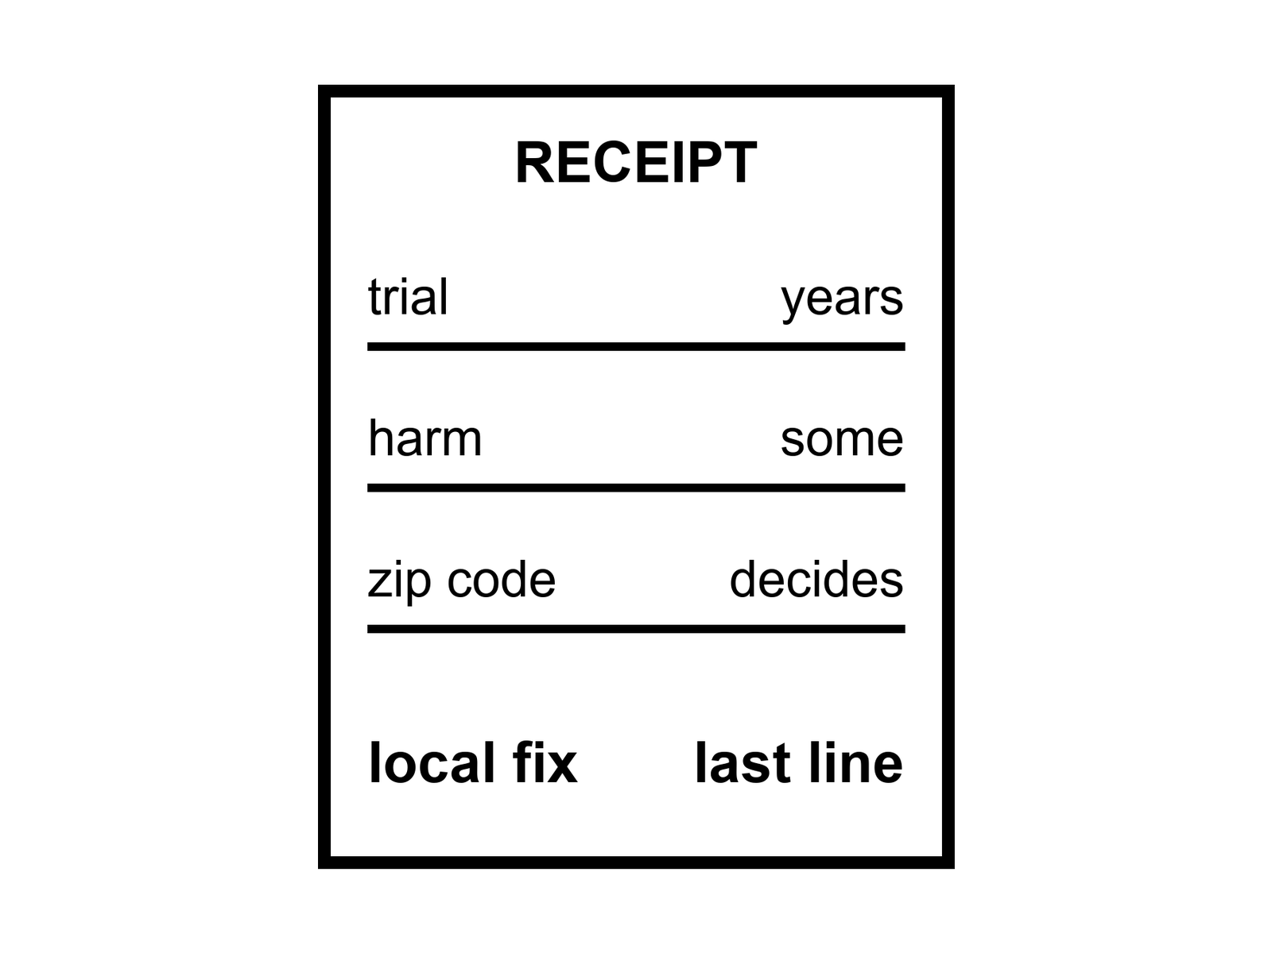
Figure 43. A receipt: trial, harm, zip code. The local fix is on the last line, not the first.
Hot as a class: sickle-cell-class edits, a handful of enzyme replacements (a missing body chemical, delivered by infusion for life), a retinal truck, a CAR-T (a patient’s own immune cells, retrained to hunt a blood cancer), a hip, a cataract, a pill that turns a cliff into a negotiation. Cold as a default: everyone shares those gains. The invoices are unequally paid.
A trial is how a kitchen declines to take anyone’s word, however sincere. It is slow, expensive, rude to hope, and still the least-bad way we have learned to not poison a population with a story. Trials fail. They fail because the trick did not work, because the trick worked in a mouse, because the trick worked and the harm was louder, because not enough people could be found, because a war moved the staff. A failed trial is not a proof that the next letter cannot be edited. It is a proof that the invoice includes a no.
Side effects are not fine print. They are the entry fee. Wipe a marrow to make room for an edited lineage and you have bought a month that can kill you on the way to a life that can save you. A drug that clears a plaque and also rattles a vessel is a negotiation, not a halo. A stimulant that buys a morning and steals a sleep is Chapter 35’s toolbox with the lights on. Naming the fee is not pessimism. It is the difference between a tool and a sermon.
Who pays.
A price in the low millions per person, in present ledgers, is a local fix that a kingdom can buy for a few and a village cannot buy for its own. Insurance, a ministry, a charity, a lottery of a lawsuit: these are the real delivery trucks for many of the wins. Delivery of the molecule — getting the fix into the right cells at all — was Chapter 31’s problem. Delivery of the payment is this chapter’s. Modest further healthy-year gains this century in rich-country medicine are warm. Everyone shares them: cold. The same decades that cheapened a sequence did not cheapen a hospital night in some ledgers; they dearened it. An S-curve in a lab is not an S-curve in a bill.
Inequality is not a subplot you add for manners. It is a clock. A body in a zip code without a trial site does not have the same many clocks as a body next to a campus. The clocks are the same biology. The access is a different pot. Healthspan as a product, if it remains a rich-country hobby, is a product that will be sold as a species story and billed as a membership.
Look first. Do not overwrite a childhood in a poor kitchen because a rich kitchen’s slide said enhancement. The child in the poor kitchen may need a vaccine that already exists and a fridge that already exists. The slide likes the new scissors. The fridge is ruder and hotter.
What a trial is, when you sit still with it.
Phase 1 asks: does this kill you on the way in? A handful of people, a dose that climbs, a staff that watches a liver number. Phase 2 asks: does anything useful happen, and to whom? Phase 3 asks: compared with what we already have, in enough bodies that a statistic can be rude. Phase 4, if you get there, is the kitchen after the press release — rare harms, real zip codes, a trick that was clean in a campus and messy in a night clinic. Each phase is a meeting. Each meeting can say no. A no is not a conspiracy against hope. A no is how you do not staff a funeral with a slogan.
Mice lie in a particular way. They live fast, they are inbred, they do not pay rent, they do not have a seventy-year atherosclerosis — arteries silting up over a lifetime — they do not have a human immune memory of a century of viruses. A mouse that lived longer is a paper. A paper is allowed. A paper is not a woman at an airlock. Translation is the unpaid invoice of every fountain slide. Chapter 29 already said the clocks are many. Translation is why a shout at one clock in a mouse dies in a woman who is still running five.
A trial doctor enrolls people and then sits with the ones the trial did not choose. The sitting is the job. There is a win on the wall and a stack of letters that say not eligible. Eligible is a biological word and a geographic word and an insurance word. Do not let anyone use that wall as a downtown. The wall is a door that opened for some. Chapter 33 already said the house has other doors. This chapter says some houses do not get a carpenter.
Mara’s capsule has a label and a delay. Someone paid. A ministry, a contractor, a theater of “crew health.” She takes the dose for the joint. She does not become a different species, and she does not become a proof that Priya will get the same dose.
Priya already has a name. The letter on this downlink says the trial two ferries from her clinic closed enrollment before her scans came back. Not a villain. A number: the study needed a narrower biology than hers, and narrower biology fills faster in a city with three hospitals than in a clinic with one. What remains on her board is the boring operation, the one for the hands, still scheduled, still waiting on a surgeon who can be afforded because the operation is not the one in the press release. Mara writes back that she is glad the surgeon is still on the board, and sorry that gladness is the whole of what a late radio can send.
The receipt, line by line.
Trial. A protocol, a statistician, a data lock — the day a trial’s numbers stop being editable — a meeting that can say no. Cost in years and money and hope. Failure is on the invoice as a line item, not as a scandal.
Harm. Conditioning that can kill on the way to a save. A side effect that stays. A drug that buys a morning and steals a sleep. Naming the fee is how a tool stays a tool.
Zip code. Distance to a trial site. A fridge. A nurse. An insurance word that decides whether the molecule is a gift or a rumor. Access is a clock that demographers already know how to count; marketers prefer not to.
Price. Millions per person, in some present ledgers, for a class of edit that is real and narrow. Delivery of payment is delivery of the win. A village without a kingdom’s ledger does not get the last line of the receipt.
Staff. Someone has to run the apheresis — hours hooked to a machine that filters out the needed cells — watch the liver number, teach the family what “not eligible” means without lying. Staff is an S-curve. You cannot download it.
CRISPR-class edits stay local in this book’s mouth: this gene, this tissue, this invoice. They do not become a fountain because the scissors got famous. A sickle-cell-class win on the hospital board is hot as a door and cold as a default for everyone. The temperature split is the hygiene. Laundering starts when the door is photographed and the bill is cropped.
Warm: modest further healthy-year gains this century in rich-country medicine, if institutions hold. Hot: local fixes exist and have bills. Cold: everyone shares them on a schedule, and the bill was only money.
A morning in the clinic.
Priya opens the fridge before she opens the mail. The vaccine that already exists is only a vaccine if the temperature log stayed inside its band overnight. She writes the number. Then she sits with the family the trial did not choose. The wall has a photograph of a win. The desk has a stack that says not eligible. She does not lie. She names the three clocks: the biology that did not match the protocol, the geography that put the trial two ferries away, the insurance word that turned a molecule into a rumor. The family wanted a downtown. They leave with a blood-pressure pill that already exists. Priya’s own hands stay on the desk after they go. The knuckles have started to look like her sister’s. The boring surgery is still on the board. She wants the surgeon to show up, the anesthesia to hold, and a hallway she can walk. She does not want a fountain. She writes Mara anyway. The letter will take its day and a half. Chapter 46 is the answer, if the surgeon comes.
Appendix A43 writes trials, harm, and why a price is a delivery truck. Here, keep the receipt.

44. Adjusting Is Not Spare Capacity
Plasticity is real and expensive. We meet new challenges with the organ we have, plus tools, plus other people. That is already the method. It is not a tank of unused mind waiting for a password.
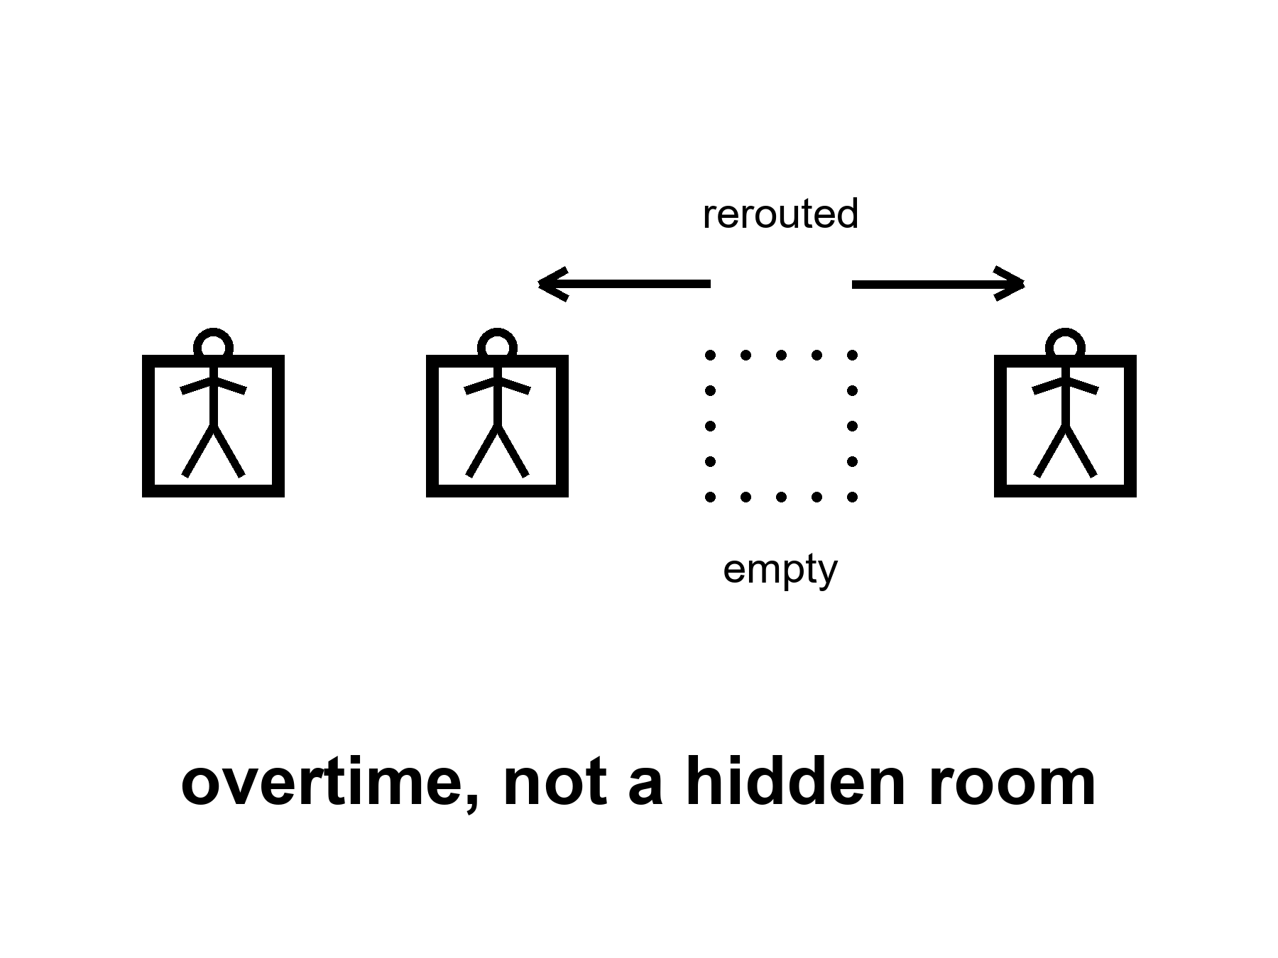
Figure 44. A staff rerouting after a chair is empty. Overtime, not a hidden room.
Hot: a brain can change what it does. Practice thickens a skill. Sleep consolidates. A child whose seizures are severe enough to require removing half the brain can still talk, later, with a cost. An adult can recover a piece of a hand after a stroke, with a year of ugly work. A musician’s map of the fingers is not a civilian’s. A taxi driver’s map of a city, in the old days of paper, was a hippocampus — the brain’s map-room, met already in Chapter 34 — that had been hired extra. None of this is a spare ninety percent. It is a staff doing overtime and rerouting.
Expensive is the word the ten-percent story skips.
Rerouting costs time, watts, frustration, a therapist, a family that will walk the same hallway a thousand times, a sleep that must actually happen. It costs the function you borrowed from. A skill you thicken can thin a neighbor if you are not careful; more often it just eats the mornings you would have spent on a different skill. A child construction site can reroute more cheaply than an adult office. That is development, not a cupboard. Adults pay more per increment. Diminishing returns live in skulls too.
Tools are part of the method, not a confession of failure. Writing is a tool. A checklist is a tool. A hearing aid is a tool. A notebook on a dead world is a tool. Other people are the oldest tool: a crew, a kitchen, a science that is a conversation with the dead and the delayed. A species that meets a new challenge by inventing a tool and teaching it is not a species that had ninety percent off. It is a species that was already on duty and hired help.
New challenges — a climate needle, a new pathogen, a camp on a dead world, a job that does not exist yet — will be met this way or not met. They will not be met by unlocking a hidden loft. Chapter 34 emptied the loft. Chapter 35 put tools on the table. Chapter 36 said the carrot will try to sell the loft again. This chapter is the labor: overtime, not a hidden room.
A second origin might have hired a web, a committee, a mind that is only itself when plugged into itself. Courtesy: that zoo is not this book’s. This ape adjusts with this skull, this sleep, this staff of other apes, this notebook. It is already a great deal. It is not a spare tank.
She learns a new pump the week the old one dies. The learning is ugly. Rohan already knew the pump. She did not. Plasticity is Rohan talking and her hands doing the wrong thing twelve times and then the right thing. No cupboard opened. A colleague and a tool and a morning she would vote for because the water still has to melt.
What the bill itemizes, when you refuse to romanticize it.
Time. A year of hallway walks is a year not spent on a different skill. Plasticity is a budget. Budgets have opportunity costs.
Watts. The skull already runs expensive. Learning adds overtime on top of the baseline bill Chapter 34 named. You cannot invent a free reroute.
Frustration. Error is not optional. Twelve wrong grips on a pump are the method. A slide that sells unlocking deletes the ugly middle because ugly does not fundraise.
Borrowed function. Sometimes the staff that covers for a lost chair was doing another job. Recovery can thin a neighbor map. More often the neighbor is just a morning you no longer have.
Teachers. Rohan on the delay. A therapist. A notebook written by someone dead. Other people are not a workaround for a cupboard. They are the oldest line on the invoice.
Temperatures, short:
Hot: brains change with use, injury, sleep, and teaching; the change costs.
Warm: tools and institutions are part of how this ape adjusts at species scale.
Cold: a spare ninety percent waiting for a key; enhancement as unlocking; adjustment as proof you were not already on duty.
Mara’s pump week is the whole argument in a blister of time. Rohan’s voice on the delay. Her hands wrong, then less wrong. A log that is not her and still keeps the plant alive. She would vote for the Tuesday. She would not vote for a story that says the learning was free because a cupboard opened. The cupboard was always empty. The staff was always on duty. The overtime was the method.
Look first when someone says we will adapt. They are often right that we can. Adapt is a verb with a bill. Ask who walks the hallway. Ask what sleep was protected. Ask which tool was invented and which childhood was treated as a construction site because adaptation sounded cheaper than a fridge. Adjusting is not spare capacity. It is the capacity you already had, spent — plus help you hired — plus a morning you will not get twice.

45. Copies, Uploads, and the Continuity View I Defend
A file is a description. A worldline is a path.
This chapter asks whether a copy of you would be you. That question is contested, in the sense How to Read gave the word: careful people holding the same evidence still disagree. So this chapter does three things in order. It states the view I defend. It gives the strongest rival views their best case. Then it says why I still land where I do, and what would change my mind.
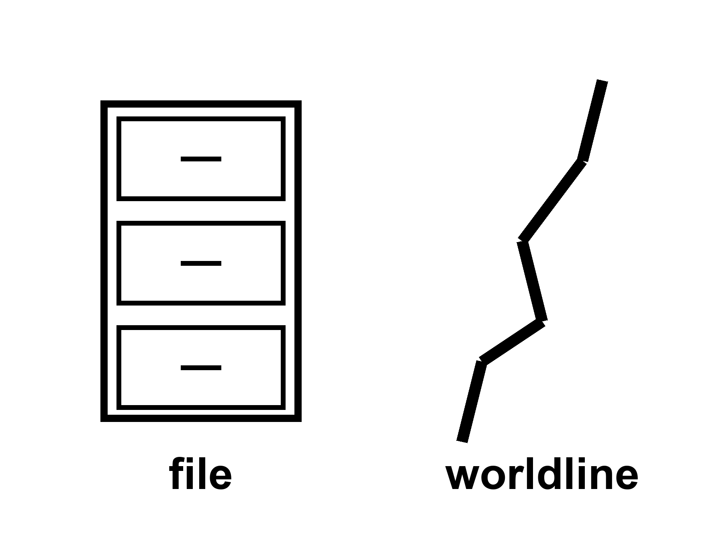
Figure 45. One thread; a box beside it labeled file. The box is not the thread.
Start with what is not contested. A scan of a brain fine enough to copy a person does not exist; nobody has one, and nobody has a schedule for one that has been tested against a single mouse. If one existed, running it on a machine would start a physical process somewhere else. If it could be run once, it could be run twice. Restorations are real and hot: a cochlear implant, a stimulator that quiets a tremor, a prosthetic hand with sensors. Those are tools with scars, and they keep a body in its life. Everything past that line is argument.
What people mean when they say upload, sorted so the temperatures can stick.
Sometimes they mean a backup: a record for historians, a medical chart, a log. That is a file. Files are useful. Files are not persons.
Sometimes they mean a prosthesis network: sensors and stimulators that keep a body in the game. That is restoration. Local. Warm when the Tuesday votes for it.
Sometimes they mean a second runner who wakes up sure they are you. Whether that runner would be you is the contested question below.
Sometimes they mean the original somehow continues in the machine without a cut. That is the strongest version of the hope, and the one a later, slower technology might someday test. Nobody has tested it. As a product, cold.
The view I defend.
I hold a continuity view. What I care about in surviving tomorrow is being the one who wakes: a single physical process — this brain, running, changing its parts slowly the way every body does — that is never cut and restarted elsewhere. Physicists call a body’s path through space and time its worldline. My view is that a person rides one worldline. A copy, however perfect, starts a second one. It would be a person. It would remember my Tuesdays. It would not be me continuing.
That is a position, not a measurement. Here are the best reasons to reject it.
The strongest rival views.
Psychological continuity. On this view you are your memories, character, intentions, and habits of thought, linked in overlapping chains from day to day. The view has deep roots, from John Locke to most philosophers working on the question today, and a strong argument behind it. Your stream of experience is already interrupted: by dreamless sleep, by general anesthesia, by a cardiac arrest a surgeon reverses. You do not think you died on the table. What carried you across the gap was not an unbroken glow of awareness but the preserved pattern. A perfect copy preserves the pattern. So, the argument runs, the copy carries you across the gap too.
Pattern identity. A close cousin, popular with engineers. The atoms in your body are not the ones you were born with; much of you is replaced on a clock of months to years. What persists is the organization. Imagine a surgeon who replaces one neuron at a time with a chip that does exactly the same job, over a year. At which neuron do you vanish? If there is no such neuron — and it is hard to name one — then the material does not matter, only the pattern does, and a pattern is exactly what a scan would capture.
Parfit’s view. The philosopher Derek Parfit pushed hardest of all.⁴³ He imagined a teleporter that scans you on Earth, destroys the original, and builds an exact replica on Mars. He concluded that identity is not what matters. What matters is psychological connectedness and continuity, by any cause; if the replica has those, being teleported is about as good as ordinary survival. He accepted the strange corollary: if the scanner failed to destroy the original, there would be two people, neither of whom is uniquely you, and that would be fine. For Parfit the question “but which one is really me?” can be empty, the way “is this still the same club after half the members changed?” can be empty.
These are not straw men. Many thoughtful readers will finish this chapter holding one of them, and they will not be making a mistake of fact.
Why this book still defends continuity.
The duplication problem. If a scan can be run twice, two people wake, each sure they are you. They cannot both be you in the ordinary sense; one person cannot be in two rooms. Psychological continuity alone therefore cannot be what identity is, because it can branch. Parfit saw this clearly, which is why he gave up identity rather than give up the pattern. So the real choice is between two views: a continuing process is what matters, or identity does not matter at all. I take the first.
The woman on the pad. Parfit’s own hardest case is the branch line: the scanner on Earth works, but it damages the original, who will die in a few days, while the replica on Mars lives on. Parfit says she should feel roughly as she would about ordinary survival. I do not think she would, and I do not think she would be confused. Her reluctance tracks a plain fact: none of the replica’s future will be lived along her path. The replica’s mornings will be real, and they will be someone else’s.
The neuron-by-neuron surgeon. This is the hardest argument against my view, and I want to be fair to it. My answer is that gradual replacement inside a running brain does not cut the process; it is the slow parts-swap every body already does, made stranger. A continuity view can accept it. What it cannot accept is the scan-and-boot: stop, copy, run elsewhere. I cannot tell you exactly how fast a replacement may go before it stops being gradual and becomes a cut. That honest gap is part of why the tag on this chapter says contested, not hot.
What I do not claim. I do not claim that a copy would be a mere machine, or worthless, or not conscious. What consciousness is, and which systems have it, is itself contested; no measured theory today settles whether a running copy would feel anything at all, and this book does not pretend to settle it. If a copy woke and felt, it would be a person with its own moral weight. My claim is narrower: it would be a second person, not the first one carried somewhere safe.
What would change my mind. A working account of experience that showed what, physically, carries a person across anesthesia and a copy across a scan, and showed that it is the same thing in both. Nobody has one yet.
What the product shelf actually holds.
The forever-mind sold as a product stacks three hopes and calls the stack a ticket: an off-switch for death, a spare tank for the mind, a catalog for year 12,000. Chapter 34 already emptied the spare tank, and Chapter 39 refused the catalog. The off-switch is the contested question above wearing a price tag. A scheduled upload of you, for you, is cold. Stories about a last computation at the end of time — a mind the universe supposedly must end in — stay cold, and The Universe Has No Now already set them down.
She will not be uploaded. The sentence is a kindness, not a verdict on anyone who hopes otherwise. The capsule may keep a joint useful. The radio will stay late. The basil will still need a number. Her log is a file, and it is not her. The seal is a body fact. Bodies end. On the view this chapter defends, the ending is not a failure of a port. It is the length of a worldline. In this book’s shorthand, a file is not a worldline: the continuity view in six words, offered as a view and not as a measurement.
Temperatures, short:
Warm: prostheses and closed-loop tools that return a Tuesday.
Hot: no person-scale scan exists; a run of one would be a new process, and two runs would be two.
Contested: whether that new process would be you; what consciousness is; whether identity is even what matters. This book defends continuity and says so.
Cold: a poured, forever-you as a scheduled product; a required last mind.
Appendix A45 writes the copy cases as a short table, and keeps the thread and the box apart.

46. The Honest Body
Cash the recognitions.
Lifespan is not healthspan. That split is hot. The product, if you want one, is mornings you would vote to repeat, not a longer evening in a chair.
Aging is many clocks, not one fuse. Hot-to-warm. A shout at one clock does not reset the kitchen.
Gene fixes are local. Sickle-cell-class wins are hot. A fountain is cold. 150, 200, 1,000 as a scheduled product: cold. Modest further healthy years this century in rich-country medicine: warm. Everyone shares them: cold.
We already use the organ. The ten-percent sentence is false. Hot as a correction. Plasticity is real and expensive. A spare-tank unlock is cold.
The carrot has no off-switch. A longer life is more calendar for the same loop. Look first before you call that an upgrade. Do not overwrite a childhood because a slide said enhancement.
The last fifty years were real and not a straight line. Progress is more often an S. Ten thousand years is not ×200. The limit is often a meeting, a ledger, a famine, a front. A copy would be a second runner; whether it would be you is contested, and this book defends continuity. Forever-mind as a product stays cold.
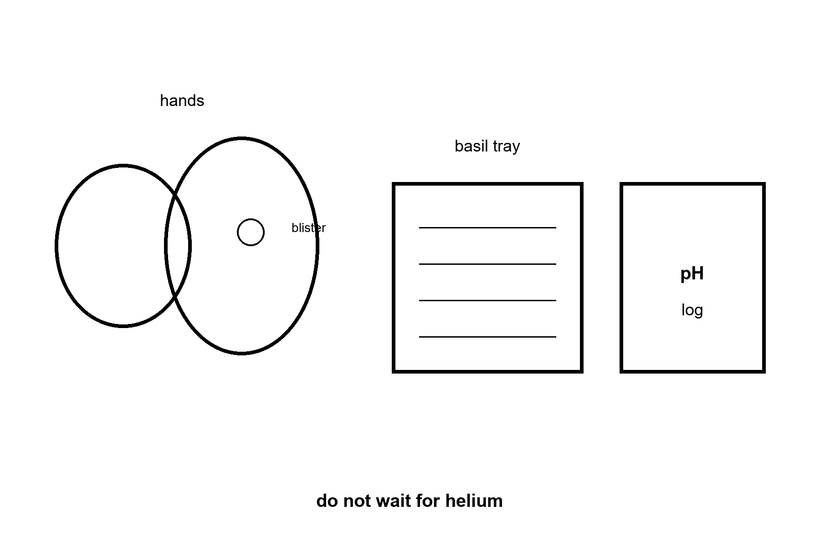
Figure 46. Hands, a basil tray, a blister, a pH log. The caption: do not wait for helium.
She names the basil. Sentiment does not get to vote. The capsule may buy her a useful season. It will not buy her a forever, and it will not unlock a brain she was not already using. She is not a different species. Her hands still age. The dirt still has a chemistry. The chemistry can be bullied. That was always the whole trick. Hit the airlock. Log the pH. Take the local win. Put the sermon down.
If you wanted a thousand-year ape, you should leave with a colder, better want: more mornings that are worth logging. If you wanted a spare ninety percent, you should leave with the organ you were already using, plus a notebook, plus a night’s sleep, plus someone like Rohan who already knows the pump. If you wanted year 12,000’s kitchen, you should leave with the invoices that will still be due, and without a catalog we cannot name. The other Look First book, The Universe Has No Now, if you want it, already refused a cosmic now and a required last mind. You do not need it. You can stop here. The hands will still be the hands tomorrow.
A last inventory, spoken in the tin so it has dirt on it. The capsule is late. The label is still optimistic. The joint is a two today and not an eight. That is a local win. She would vote for this Tuesday: the airlock, the basil, Rohan’s bad joke about the pump, a radio that carries a slipped date and does not get to vote. She would not vote for a longer evening in which the pulse continues and the hands will not open a jar. She does not have a spare mind in the cupboard. She has a notebook. She has a log that is not her. She does not have year 12,000. She has a film that will go alkaline if she gets sentimental. That is the honest body. It is not small. It is the only size that has ever reliably been for sale.
Cash the inventory by temperature, so a slide cannot rearrange it on the way out.
Hot. Lifespan is not healthspan. The ten-percent sentence is false. Hands age after a useful dose. Sickle-cell-class edits are a real class of local win. The last fifty years produced uneven stairs — vaccines, sequences, packets, cheaper compute — that were not myths. No person-scale brain scan exists. Fifty into ten thousand is two hundred, which is arithmetic, not a method. The limit is often a meeting, a ledger, a famine, a front.
Warm. Aging is many clocks. Modest further healthy years this century in rich-country medicine, if institutions hold. Progress is more often an S than a rocket. Plasticity is real and expensive; tools and other people are part of the method. Whatever is invented still pays energy, coordination, and the body’s invoices. Restorations — hearing, tremor, a joint season — can be worth taking without becoming a sermon.
Contested. Whether a copy of a mind would be its original; what consciousness is; how far a long-range economic or social forecast can see. This book takes sides on these and labels the sides.
Cold. A fountain. A scheduled 150-, 200-, or thousand-year ape. Unlocking a spare tank of mind. Last fifty × 200 as named furniture. Forever-you in a file as a product. A required last mind. Progress as a law that fires if we wait. A childhood overwritten because a ruler said enhancement. The gadget catalog this book refused to print.
How to spend a Tuesday after the inventory. You can keep a capsule without a sermon. You can keep a hearing aid without a spare-tank story. You can keep a sickle-cell-class door open on the hospital board without calling it a downtown. You can teach a pump on a delay without unlocking a loft. You can doubt that a file would be you and still love a log that keeps a plant alive. None of that is small-mindedness. It is temperature hygiene applied to a morning.
Priya, on the coast, still needs the boring wins. The fridge. The vaccine that already exists. The surgeon who can still be afforded. A book that only sings to the lucky zip code has failed its own bill. Inequality is a clock. Chapter 43 said so. This closing keeps it on the counter.
The letter that finally answers Mara’s letter takes its usual day and a half, and says only that the surgery went the boring way: the surgeon showed up, the anesthesia held, the recovery is a hallway walked slowly and then less slowly. No downtown. No fountain. A body that still has to be walked back into working by a staff that was already on duty, on a coast a season’s cargo run away from a joint that is a two today instead of an eight. Mara reads it twice, the way she read the first one, and logs the pH before she lets herself feel anything about it, because the plant does not know its owner is relieved and would die anyway if the film went alkaline. Two sisters, two invoices, paid in the same currency for once: boring, hot, and real.
What to want instead is not a smaller life. It is a colder, better product: mornings you would vote to repeat. The radio will be late. The delay is light. Light does not care. You do not have to care about helium. You have to care about the Tuesday — the one in the greenhouse and the one on the coast, paid for the same boring way, by two different staffs who were already on duty.
Appendix A46 writes the inventory by temperature, so a slide cannot rearrange it on the way out. Here, keep the hands and the log.
Rule: Do not wait for helium. Cash the recognitions once. Vote for the Tuesday you would repeat — and for the Tuesday that did not get the capsule. Seal it.

APPENDIX
The first block runs A1 through A26: the camp, the classroom, and the long ticket. The body notes begin at A27 and twin the chapter with the same number.

APPENDIX — The Scientific Detail

How to Read These Notes
Each note An twins popular chapter n, through A26. The body notes begin at A27 and use the same rule. Units are SI unless stated. c is the speed of light. Dates in this kitchen are October 2026; official years will move. Classes of mission are the durable objects. Sources and the glossary are once, at the end of this appendix. Equation numbers run in one sequence: (1)–(16) are the camp, (17) on are the body.
String theory, if named: a mathematical framework that cannot currently be tested. It is not needed for dirt, delay, or dates.

A0 / A1. Delay, Dirt, and Why a Kitchen Is Not a Loaf
Hot / warm / cold as in the front matter. A claim can change temperature. A stack that has flown is hotter than a rendering. A slipped year is not, by itself, a con.
(1) t = d / c
In that line, t is one-way light-time, d is distance, c ≈ 3.00 × 10⁸ m s⁻¹.
Moon: d ≈ 3.84 × 10⁸ m ⇒ t ≈ 1.28 s (about 1.3 s). Round trip ≈ 2.6 s. A conversation is possible if both ends are patient.
Mars: d runs from about 0.37 AU at a kind opposition to about 2.7 AU when the Sun is in the way of a straight radio path and the planets are far. One-way light-time is about 3–4 minutes at the kind end and about 21–24 minutes at the rude end. Round trip: eight to forty-some minutes. Treat talk as a retired verb.
A loaf — all times on one inventory — is a courtesy from another book. This appendix does not need it. Dirt and delay are local measurements.
Reading list, this note. A pH log runs 0–14; a slightly acidic nutrient film, on the order of 5.5–6.5, suits most leaf crops. Deviation of a full point is a fixable chemistry problem, not a crisis, if caught inside a day. Perchlorate salts appear in Martian regolith at roughly 0.5–1% by mass in the samples measured so far — a poison to unprotected biology and, with the right chemistry, a candidate oxygen source. Neither fact scales to a tank farm on its own.

A2. What Counts as Flown Hardware
Flown: a vehicle or payload that completed the named job in public, with a serial number and a result (including a failure that still arrived).
This-century lunar inventory, as classes (logos will rot):
• Uncrewed crew-shaped loop and splashdown: Artemis I (2022). Empty seats on purpose.
• Sample return, near side: Chang’e-5 (2020).
• Sample return, far side: Chang’e-6 (2024).
• Soft landing and rover, south polar region: Chandrayaan-3 (2023).
• Precision landing with mixed posture: SLIM (2023–24).
• Commercial landers: mixed stand / tip / quiet. Data, not a downtown.
• Crewed lunar orbit or landing, this century: not flown as of this kitchen.
A rendering, a contract, a clean-room module, a hopped prototype: not flown as the job on the slide.
The five-card ledger. Rendering → Contract → Article → Test → Flight. A slide’s job is to make a rendering feel like a flight. A reader’s job is to ask which card, every time, before the year matters at all. An article that has passed one test (a static fire, a wet dress rehearsal, a cold-flow pour) is warmer than a rendering and colder than a flight; treat it as a dare, not a demonstration.
When a coupon gets overruled, sketched. The night before the January 1986 Shuttle launch, contractor engineers raised documented concerns about O-ring performance at forecast cold temperatures; a conference call reversed their initial no-launch recommendation under schedule pressure; a seal failed as predicted, 73 seconds after liftoff, killing seven. The Rogers Commission’s finding generalizes past that one program: a coupon that can only be logged, not stop a countdown, has honesty without authority. Sociologist Diane Vaughan’s later study of the same case coined normalization of deviance — a program treating a repeatedly-ignored warning as acceptable risk until the accumulated acceptances produce a failure nobody individually chose. Contrast with Artemis I’s shield below: the difference is not the engineers’ honesty in either case. It is whether the finding was allowed to stop anything.
Artemis I shield, as a worked coupon. The heat shield’s outer char layer separated in more locations and larger pieces than pre-flight models predicted, driven by trapped gas building pressure inside the ablative material during a skip-entry heating profile. No injury resulted; the cause was published; the fix (a different entry profile for the already-built shield, a redesigned material for later shields) was written down. That is the anatomy of an invoice, not a cover-up — the pattern A3 generalizes.

A3. Slip as Invoice: Historical Pattern
A slip is a moved official date for a named class of mission.
Pattern (not a morality play): Apollo slipped and then walked. Shuttle slipped, flew, then taught a tile-and-wish lesson. Constellation was cancelled as a program, not as a proof that the Moon is unreachable. Artemis-class crew dates have moved in public more than once in the 2020s. Commercial heavy-stack dates have moved in public more than once.
Read a slip as information when it names the long pole (shield, suit, pour, weld, partner can). Read it as fog when it names only “integration.” Fog is not automatically fraud. An empty oven with a roast on the slide is the fraud test.
Dates, for the record, knowing they will look quaint. Kennedy’s pledge: May 1961, target end of the 1960s, met July 1969 — an eight-year span that absorbed a twenty-month stand-down after the January 1967 pad fire. Shuttle: proposed 1969 for flight “within the decade,” first flight April 1981 — roughly a decade of slip against the loosest reading of the pledge. Constellation: announced January 2004, cancelled as a program October 2010 without a crewed flight. The crewed landing was announced as Artemis III with a 2024 target and restated for 2025, 2026, and 2027. By this kitchen the name had moved: the mission now called the rehearsal is an Earth-orbit test, and the landing attempt is a later flight. See A7. Do not read the old name as the current noun. A commercial Mars cargo-landing target named for “as early as” a window in the 2020s has passed two such windows without a hull committed to the trip.
The four-question test, formalized. (i) Does the slip name a part? (ii) Was a coupon retested? (iii) Did the rendering change with the date? (iv) Is the person who found the fault still permitted to speak? A slip passing all four is an invoice. A slip failing (iii) or (iv) is worth extra skepticism regardless of how it answers (i) and (ii).

A4. Three Days, 1.3 Seconds, One-Sixth g
Transit Earth–Moon at the speeds we actually use: on the order of three days, not a Hohmann season.
Surface gravity: gMoon ≈ 1.62 m s⁻² ≈ g/6.
Lunar Δv sketch (order of magnitude, not a flight plan):
(3) LEO (low Earth orbit) → TLI (trans-lunar injection, the burn that leaves Earth orbit for the Moon) ~ 3.1–3.2 km s⁻¹; lunar orbit capture and landing add several more; Earth return is a heat-shield problem as much as a propellant problem.
Polar ice: permanently shadowed craters show hydrogen signatures consistent with water ice in useful-if-true amounts. Useful-if-true is not a tank farm. ISRU from that ice is a middle-noun program.
Ice, dated. LCROSS (2009) impacted Cabeus crater and its trailing spacecraft detected water vapor and ice grains in the ejecta plume, on the order of several percent water by mass at that one site on that one day. Orbital neutron and infrared mapping since has extended hydrogen signatures across many polar shadowed regions, with concentration estimates ranging from under one percent to several percent depending on site and depth — a range, not a single number, and not yet a survey a mining engineer could bid against.
Dose, dated. China’s Chang’e-4 lander carried a dosimeter to the far side starting January 2019. The published average dose equivalent on the unshielded surface was about 1,370 microsieverts a day (Zhang and colleagues, Science Advances, 2020). Multiplied by a year, that is about half a sievert, near career limits several agencies still use (order 600 mSv). The August 1972 solar particle event, between Apollo 16 and 17, is separately estimated to have delivered a dose in the range of several hundred to over a thousand mSv to an unshielded crew caught on the surface — potentially into acute-radiation-sickness territory. Shielding (regolith, water, a berm) is the standing answer; none has been built at habitat scale off Earth.

A5. Uncrewed Loops, Landers, Sample Returns
Loop ≠ landing ≠ return ≠ shift.
A loop tests stack, guidance, and Earth entry. A landing tests the last kilometer in a vacuum well. A return tests ascent, rendezvous or direct throw, and a second entry. A shift is a roster that repeats. This century has loops, landings, and returns. It has machine shifts beginning. It has not had a human winter-over on the Moon.
Tally, this kitchen. Sample mass returned, robotic, this century: Chang’e-5 ≈ 1.73 kg (2020, near side); Chang’e-6 ≈ 1.94 kg (2024, far side, first-ever). Apollo, crewed, last century: ≈ 382 kg across six landings. Luna program, robotic, last century: ≈ 0.3 kg across three returns. Commercial lander scorecard through this kitchen: one launch failure before lunar transit (propellant leak, Jan 2024); one landing that tipped and worked a week on its side (Feb 2024); one crater-tip failure (Mar 2025); one upright two-week success with eclipse imagery (Mar 2025); one crash on descent (a second attempt by a repeat operator). Stand, tip, quiet, crash — in roughly that mix, from three different companies, in under eighteen months.

A6. Artemis-II-Class: Sortie, Not Town
Class of mission: crew in a cabin on a cis-lunar loop — a path that stays within the Earth-Moon system rather than landing — home in days if the stack behaves. Warm as a this decade class. The exact month is a mood.
What it must demonstrate: life support with breath in it, crew operations, comms, entry with people. What it is not asked to demonstrate: landing, ISRU, a town, a child.
If the morning has already happened when you read this, you own a flown sortie. You still do not own a settlement.
Flown, this kitchen. Crew: Reid Wiseman (commander), Victor Glover (pilot), Christina Koch, and Jeremy Hansen (Canadian Space Agency). Launch: April 1, 2026. Closest lunar approach: April 6, ≈ 6,545 km. Splashdown: April 10, Pacific Ocean. Maximum distance from Earth: ≈ 406,771 km, a new crewed-flight record, surpassing the mark set by Apollo 13’s crew in 1970. Heat shield: Avcoat, flown on a modified, steeper entry after Artemis I’s 2022 uneven char loss. The first public look, in April, found no unusual conditions and far less char loss than the empty flight; the safety panel later counted about nine char-loss sites, against more than a hundred on Artemis I.⁴⁴ By early September a safety-panel count put the loss at about nine sites, against more than a hundred on Artemis I. A fuller cut-up, including x-ray of the material, was still owed. The class is hot as of this kitchen. The next class, a crewed landing attempt, remains warm — see A7.
Life-support load, sketched. A crew of four exhales roughly 0.9–1.0 kg CO₂ per person per day (≈ 3.6–4.0 kg/day, crew total); cabin CO₂ partial pressure is typically held under about 0.7 kPa (roughly 5 mmHg) to avoid cognitive impairment, using regenerable scrubber beds. Potable water budget: order 2–4 L/person/day including hygiene margins on a short mission (no closed recycling loop required for a ten-day sortie the way ISS requires one for six-month stays). Free-return trajectory: a translunar path shaped so that, absent any further burn, the spacecraft swings around the Moon and re-enters Earth’s atmosphere. Apollo 13 had already left that path when the service module failed. A burn put the crew back onto a road that falls home. The kindness was reachable. It was not the road they were already on. Artemis-II-class missions are drawn to keep a version of the path from the start.

A7. HLS / Starship-Class Long Poles
Human Landing System class: a cabin that goes down and is supposed to come up.
Long poles:
1. Orbital refueling if the architecture pours (cryogenic transfer, many times).
2. Last kilometer: no air, dust, throttle, slope.
3. Ascent / leave and meeting the home cabin.
4. Suits as workplaces in glass dust.
5. Power, abort, medical, polar night if that is the site.
Landing attempt in the 2030s: warm. “Attempt” is the honest noun.
Mission structure, revised in this kitchen’s year. In February 2026, the American ledger inserted an additional crewed mission between the flyby (A6) and the first landing attempt, citing lander-readiness and safety margin. The new middle mission — crew in Earth orbit only, no lunar transit — is built to test two competing lander designs’ systems without betting a crew on the last kilometer first. The landing attempt itself moved to the mission after that one, publicly targeted for 2028. Read this the way A3 teaches: a slip that names a part (lander readiness, an added test mission) is an invoice, not a scandal. The class — attempt, not town — has not changed. Only the numbering and the count of warm-up steps has.
Late in this same kitchen, 20 September 2026, the agency’s own note to its staff said the Earth-orbit rehearsal was about ninety days behind a summer-2027 best case.⁴⁵ The two 2028 landing chances were the thing that pressure was eating; one of them might not survive the slip. The popular chapters keep “a landing attempt in the 2030s” on purpose. A printed 2028 is a weather report. The decade-class is the noun that is still true if the weather moves again. Starship-class refueling remains the unpaid clause under either year: one tank-to-tank transfer on a single stack is not a campaign of tankers.
Refueling, sketched. Public estimates for the number of tanker flights needed to fill a single HLS-class lander in orbit have ranged, across successive program statements, from roughly 10 to 20+, driven by boil-off losses during the wait between launches and by how much each tanker actually delivers versus its own reserve margin. As of this kitchen, an orbital propellant transfer between two vehicles of the relevant class had been demonstrated once, tank-to-tank on a single stack, not yet as a repeated multi-tanker campaign.
Suit-abrasion record. Apollo 17’s mission report documented glove and boot-cover wear, jammed zippers, and cabin dust contamination after roughly 22 hours of total surface EVA time across three days — the longest lunar surface exposure of the program. Modern polar-shift suit requirements, by comparison, are written against hundreds of hours of cumulative EVA across a multi-week or multi-month stay: several times the cycles, and about ten times if the stay runs for months. That is one order of magnitude, not two or three.

A8. NRHO, Stations, and Floor Plans
(NRHO) near-rectilinear halo orbit: a high, lopsided lunar path with long Earth view. A porch, not a law.
The station in Earth orbit is the existence proof of a continuously staffed outpost, and the proof that the supply ships never became optional. A copy of the form without the supply is what the cut-cable test (A12) catches. The station is the opposite lesson: the form has lasted because the supply did not stop. Gateway-class is a smaller, farther cousin on paper. Architecture fights (porch vs surface-first) can move a decade. Warm-to-cold as a 2030s–2040s winter-over.
Resolved, this kitchen. In March 2026 the halo-orbit station was paused in its existing design; its budget was redirected to a phased surface-base plan (about $20B over roughly seven years; robotic landings first; crewed landings targeted about every six months once they begin, the first aimed at 2028)⁸. Built modules were slated for repurposing rather than flight in their original role; partner agencies were left to decide, on their own schedules, what to do with hardware built for a station that may not fly as designed. Surface-first won this round of a fight that was never a law. It is not evidence that a settlement exists; it is evidence that a ledger can still fire a floor plan, the way A8’s chapter always said it could.
NRHO, sketched. Period ≈ 6.5–7 days; perilune (closest lunar approach) ≈ 3,000 km; apolune (farthest) ≈ 70,000 km; stable enough to require only modest stationkeeping burns over years, and shaped so a spacecraft in it is rarely eclipsed by the Moon and almost always has line-of-sight to Earth. The Δv cost of a full descent-and-ascent from this orbit to the lunar surface and back runs measurably higher than from a low circular lunar orbit — the toll surface-first advocates weigh against the orbit’s stationkeeping and visibility advantages.
ISS, sketched. Continuously crewed since November 2, 2000 (25+ years at this kitchen’s date); mass ≈ 420,000 kg; typical crew 6–7; resupply flights (US Cargo Dragon/Cygnus, Russian Progress) arrive several times a year, each carrying a few tonnes; onboard water recovery from urine, sweat, and cabin humidity reached about 98 percent by NASA’s own reporting,¹³ still leaving food, spare parts, and net water top-up as imports. Planned deorbit: a purpose-built tug is contracted to guide the station to a controlled reentry near the end of this decade.

A9. Chang’e-Class, ILRS, Partner Camps
Chang’e-5 / 6 sample returns: hot as flown. ILRS as a 2030s multinational research station: warm as intent and precursors; cold as a city. Other ledgers (India, Japan, Europe, commercial trucks) change access, not the cut-cable test.
Two outposts are two outposts. Addition of flags is not closure of air, water, and calories.
ILRS, sketched. Announced jointly by China’s and Russia’s space agencies in 2021; partner list grown since to include additional signatory nations and organizations; published roadmap describes a “basic” robotic-and-crew-capable model near the south pole in the mid-2030s and an “extended” model with in-situ resource use and larger crew rotations in the following decade. As of this kitchen, hardware committed to the station itself (versus precursor landers and orbiters) remains at the design and agreement stage.
Other ledgers, sketched. India: Chandrayaan-3 landed August 2023⁴⁶ (Chandrayaan-2’s 2019 attempt crashed in its final descent); crewed low-orbit program (Gaganyaan) in ground and abort testing through this kitchen, with a stated crewed-lunar ambition around 2040. Japan: SLIM landed January 2024 within roughly 55 m of its target, on its nose, and survived two lunar nights; a pressurized crewed rover is in development with an American partner for later-decade use. The 1967 Outer Space Treaty (signed by all major spacefaring nations) prohibits national appropriation of celestial bodies by claim of sovereignty; two newer, non-binding principle sets (one US-led, one China/Russia-led) attempt to govern resource use and safety zones and remain, as of this kitchen, largely untested by any actual extraction dispute.

A10. Mass, Cadence, and the Unpaid Routine
Cheap per tonne is conditional on routine.
Routine means lights, flies, is refilled, repeats on a planner’s calendar, and does not make the news every time.
Refuel campaigns ≠ one pour. Reliability for a hull that is also a house is a funeral statistic until the rate is boring.
Uncrewed Mars this decade because a year was announced: cold as a schedule. Vehicle class changing mass if routine: warm.
(9) Cadence(useful) = Flights(quiet) / Flights(total) × Payload(reliable)
A “quiet” flight is one that completed its stated mission without becoming a news event about a failure, and “reliable” payload excludes any mass lost to that flight’s own anomalies.
Reuse, sketched. A booster caught and reflown within hours to days has been demonstrated for the class of vehicle this chapter discusses; a heat-shield tile system requiring zero replacement between flights, on the relevant upper-stage class, had not been demonstrated as of this kitchen. A cargo planner’s insurable cadence — the number a contract can be written against — is conventionally built from a track record of dozens to hundreds of consecutive successful flights of the same configuration, the standard commercial and crewed-rated launch vehicles took years to accumulate.
The cold call, resolved this kitchen’s year. In February 2026 the vehicle’s own operator publicly retargeted the near-term program away from an uncrewed Mars attempt in the late-2026 window — the one its founder had announced — and toward the Moon, citing lander economics and an unfinished refueling campaign; a substantive Mars settlement push was pushed out roughly five to seven years. Two subsequent flight tests that year, on a newer version of the vehicle, each reached orbital velocity and deployed payload, and each also lost the booster on descent to a landing or splashdown failure — data, in the vocabulary this chapter uses, not a verdict. The quiet column (A10’s cadence relation) still has few marks in it. The cold call on that Mars year was not this book’s guess. It was the arithmetic in this note.

A11. Windows, EDL, ISRU, Light-Time
(2) Hohmann-class Earth–Mars: ~6–9 months. Synodic repeat: ~26 months (about 2.14 years).
Mars surface pressure: order 6 mbar (0.6 kPa), ~0.6% of Earth’s sea-level 1013 mbar. Parachutes are underemployed. EDL at house-mass is not rover-mass.
MOXIE-class: a box on a rover made grams-per-hour of O₂ from CO₂. Hot as a trick in miniature. Not a tank farm.
Light-time: see (1) and A1. Crewed Mars landing in the 2030s: warm-to-cold. City this decade: cold.
(4) pMars ≈ 6 mbar ≈ 0.006 × pEarth(sea level)
(5) MOXIE (2021–2023 operations aboard Perseverance): up to ≈ 12 g O₂/hour at peak, ≈ 122 g total across its operations,¹¹ from atmospheric CO₂ at ~96% concentration. A crewed return-fuel ISRU plant, by published mission-architecture estimates, would need to produce oxygen and methane at a rate measured in tonnes, not grams, over a stay of many months — a scale-up on the order of 10⁴–10⁵ from the flown demonstration.
EDL record, by mass class. The United States has attempted ten Mars landings with lander- and rover-class payloads (up to about a tonne), nine successful (Mars Polar Lander was lost in 1999); the two heaviest, Curiosity (2012, about 900 kg) and Perseverance (2021, about 1,025 kg), used a sky-crane maneuver. No landing attempt has been made at house-mass (tens of tonnes); published engineering analyses note that a purely parachute-based system does not scale linearly past roughly one to a few tonnes of entry mass at Mars’s air density, requiring propulsive descent to carry an increasing share of the deceleration as mass grows.

A12. The Cut-Cable Test
(8) A settlement test: if ships from Earth stop, do the babies still eat?
Closed-enough loops to show: air, water, calories, spare parts, medicine, law, teaching. Headcount is not a loop. ISS and Antarctic stations fail the test on purpose and are honest outposts.
ISRU is the middle noun trying to become the third. Papers exist. A city does not.
The seven-row scorecard, as a table.
Loop | ISS | Best lunar/Martian plan on paper | Closed anywhere off Earth?
Air | Electrolysis + scrubbers, imported spares | ISRU electrolysis of ice/regolith, paper-stage | No
Water | about 98% recycled, net import top-up | ISRU ice mining, paper-stage | No
Calories | 100% imported | Greenhouse pilots only | No
Power | Solar, imported hardware | Solar/reactor, hardware in progress | Partially (generation only)
Medicine | First aid + evacuation plan | First aid only | No
Spare parts | 100% imported | Not attempted | No
Law/culture | Not applicable at crew scale | Not applicable at outpost scale | N/A

No row above age zero across any real program, ISS included, after a quarter-century of continuous habitation. That is not a failure of ISS; ISS was never designed to close these loops. It is the honest baseline against which any settlement claim should be measured.
Biosphere 2, sketched — the closest real trial the seven rows have had. Eight people sealed inside a 3-acre closed ecological facility in Arizona, 1991–1993, under Earth gravity and pressure, with a budget in the hundreds of millions and genuine ecological expertise on the design team. Air row: failed — oxygen fell unexpectedly (unmodeled soil-microbe respiration), requiring an emergency outside-oxygen injection partway through. Calories row: failed — food production fell short, crew on a calorie-restricted diet for much of the run. A second, shorter run performed better on both metrics, having learned from the first. Even under Earth’s own gravity, pressure, and free nitrogen supply, with genuine expertise and a two-year timeline, the loops did not close on the first honest attempt. Score any off-Earth settlement claim against this benchmark, not against anyone’s confidence, however sincere.

A13. Headcount, Tickets, and Why “We” Is Rude
People ever in orbit: a village. People on the Moon: a last-century dinner party. Near-term Mars seasons, if a lucky decade arrives: a campus, not a nation. Species headcount: order 8 × 10⁹.
Launch cadence and tickets are not a species-move. “We left” is a grammar error unless the referent is a camp.
(10) N(ever flown) / N(species) ≈ 780 / 8×10⁹ ≈ 1.0 × 10⁻⁷
a fraction with several zeros before the first significant digit; smaller than the population of a single city block against a nation.
(13) Apollo-era ground workforce (direct + contractor, peak) ≈ 400,000 : 24 people who reached the Moon ≈ 17,000 : 1 — spaceflight’s headcount was never small relative to its ground crew, only relative to the species funding it. A modern heavy-lift program’s combined workforce still runs into the tens of thousands for a vehicle that, as of this kitchen, has carried nobody.
Filters beyond cost, sketched. Historic astronaut medical screening has selected against common cardiovascular and vision conditions well before financial or political filters apply. Launch acceleration: typically 3–4 g sustained for minutes. Bone density loss in microgravity: documented at roughly 1–1.5% per month for weight-bearing bone without vigorous countermeasure exercise, with incomplete recovery for some long-duration crew even after return. Career radiation dose limits (order 600 mSv, roughly age- and sex-adjusted by agency) are approached or exceeded, by published mission-architecture dose estimates, in a single multi-year Mars round trip using only current shielding. Space Shuttle: 135 missions, 2 total losses with all aboard (Challenger 1986, Columbia 2003) — a loss-of-crew rate near 1.5% per mission across the program’s history.

A14. Air, Ice, Plastics, Extinction
(6) An extra CO₂ pulse: a large share taken up by ocean and land in decades to a few centuries; a tail in the deep ocean and rocks over millennia. Not a weekend reset to 1800.
Ice sheets: committed response on centuries–millennia. Mountain glaciers faster; sea ice faster still and a different invoice (albedo vs sea-level).
Plastics: persistent solids; fragmentation, not resignation. Production can stop; the drawer remains.
Extinction: one-way on any human clock. A freezer genome is a library, not a grandmother.
(15) Permafrost organic carbon stock ≈ 2× current atmospheric carbon burden — locked, by definition, in ground frozen at least two consecutive years, in many places for millennia, under roughly a quarter of Northern Hemisphere land area. Thaw releases it to microbial decomposition as CO₂ and, in wetter conditions, methane, a genuine feedback loop (warming → thaw → release → more warming) whose century-scale magnitude remains an active, wide-ranging research estimate — real and already locally measurable, not yet confidently quantified at global scale. Warm, not yet hot; watch more closely than most pots in this note.
Numbers, this kitchen. Annual anthropogenic CO₂ emissions: ≈ 35–40 Gt/year, roughly half taken up within the same year by ocean and land sinks, the remainder accumulating; ice-core-informed models of past large carbon pulses suggest ≈ 20–25% of a pulse remains airborne after 1,000 years. Greenland ice sheet: sea-level-equivalent ≈ 7.4 m; current net loss ≈ 250–280 Gt/year (satellite gravimetry). Antarctic ice sheet: sea-level-equivalent ≈ 58 m; current net loss ≈ 150 Gt/year, concentrated in West Antarctica. Arctic summer sea-ice extent: down about 40% from the 1979 satellite-era baseline. Global plastic production: >400 Mt/year, nearly doubling every 15–20 years since mid-century; historically recycled share: under 10%. Current extinction rate estimates: tens to hundreds of times the fossil-record background rate of ≈ 1–5 species per million species-years.

A15. Settlers vs CO₂; Collapse vs Cleanup
(7) Order-of-magnitude: 10⁴ settlers × ~10 t CO₂e/person-year ≈ 10⁵ t/year. Global fossil-and-industry emissions: order 3–4 × 10¹⁰ t/year. The camp is a rounding error and may have the wrong sign if it is a construction site.
The thermostat is industry and land, not headcount on a ship.
If industry collapsed: emissions fall fast; sulfate/soot parasol falls too; short-term unmasking of heat is a warm caution. Collapse is not a cleanup method.
Leaving as cleanup: cold.
(11) Settlement share = 10⁴ settlers × (50–100 t CO₂e/settler-year, camp-loaded) / 3.7 × 10¹⁰ t global ≈ 1.4–2.7 × 10⁻⁵
roughly one part in 40,000 to 70,000 of global annual emissions — smaller than typical year-to-year measurement noise in the global total.
Collapse, sketched. COVID-19 lockdowns (2020) produced a peak daily emissions drop of ≈ 17% and a full-year drop of ≈ 5–7%, the sharpest sustained reduction on record, with atmospheric concentration still rising that year. Published aerosol-forcing estimates attribute roughly 30–50% of greenhouse-gas warming’s offset to co-emitted sulfate and soot particles, which wash out of the atmosphere in days to weeks versus centuries for CO₂ — the physical basis for the “unmasking” warning: a sudden stop removes the parasol faster than the underlying cause.

A16. Rockets, Metals, and the World with a Staff
A single launch is a small line on a global carbon ledger next to a coal fleet. A scaled industry of leaving (energy, mines, cement, pads) plus a write-off story (Earth is already lost) can worsen the bill for those who stay. Warm, not a law that spaceflight is a crime.
Rockets are not a carbon offset. Backup-world talk is not a climate policy.
(16) Debris cascade (Kessler, 1978): collision → fragments → higher fragment density → more collisions → runaway fragment growth in an orbital shell, potentially rendering it unusable for a generation. Tracked objects larger than a softball currently orbiting Earth: >40,000. Untracked fragments large enough to disable a satellite on impact: estimated in the hundreds of thousands to millions, each carrying rifle-round kinetic energy at orbital velocity. A single serious collision has already, once, more than doubled the tracked-debris count in its affected shell overnight. An industry scaling toward routine (A10) is, without separate engineering discipline around deorbit and collision avoidance, also scaling this risk — a bill this note itemizes so a later reader does not discover it by surprise.
(12) Per-launch CO₂(direct) ≈ 300–2,000 t, depending on propellant mass and mix, versus a mid-size coal plant’s ≈ 3–6 Mt/year (roughly one launch’s worth of CO₂ every few hours of plant operation).
Concrete and cement, sketched. Global cement production accounts for ≈ 7–8% of global CO₂ emissions, driven substantially by the calcination reaction (limestone → lime + CO₂) rather than by fuel combustion alone; a single modern launch pad’s reinforced-concrete mass runs into the tens of thousands of tonnes. Neither figure appears on a launch-plume comparison, and neither is unique to spaceflight — both are shared with any large industrial buildout, which is exactly the point: at settlement scale, the honest comparison is industry-to-industry, not plume-to-plume.

Equations at a Glance
# | Relation | Role
(1) | t = d/c | Light-time
(2) | Hohmann ~6–9 mo; synodic ~26 mo | Mars clocks
(3) | Lunar Δv sketch | Why the Moon is the test kitchen
(4) | ~6 mbar | Mars air as a rumor
(5) | MOXIE-class grams/hour | ISRU miniature
(6) | CO₂ pulse remaining | Air pot
(7) | Settler × footprint ≪ global | Headcount ≠ thermostat
(8) | Babies eat if ships stop? | Settlement test
(9) | Cadence(useful) = quiet flights × reliable payload | What a planner can insure
(10) | N(flown)/N(species) ≈ 1.0×10⁻⁷ | Why “we” over-claims
(11) | Settlement share ≈ 10⁻⁵ of global emissions | The arithmetic, worked
(12) | Launch CO₂ vs coal-plant CO₂ | Plume vs industry
(13) | Workforce/traveler ≈ 17,000:1 (Apollo peak) | Spaceflight’s hidden pyramid
(14) | Overrun ratio: 1× (Apollo) ≪ several× (ISS) ≪ 20× (a space telescope) | Memory forgives an overrun that works
(15) | Permafrost carbon ≈ 2× current atmospheric carbon | The feedback pot with an unknown lid
(16) | Debris cascade: collisions → fragments → more collisions | Orbit as a finite resource

Sources for these camp notes are at the end of the appendix, with the body sources.

A17. Pressure, Heat, and Why a Glove Is a Workplace
A suit is a spacecraft: pressure garment, cooling loop, radio, visor, bearings.
Operating pressure, US suit class: on the order of 30 kPa (about 4.3 psi), against about 101 kPa at sea level. Lower pressure keeps the joints bendable. It also forces a pure-oxygen mix and a pre-breathe so dissolved nitrogen does not come out of the blood as bubbles when the pressure drops. The trade is hot as a design fact. A shirtsleeve camp is a different machine.
Metabolic heat: order 100 W at rest, several hundred watts at work. Vacuum does not carry that heat on a breeze. A sublimator or a radiator has to be handed it. If the loop stops, the workplace stops, in minutes, not in a shift.
Apollo 17: about 22 hours of surface EVA across three days, and the mission report already logged glove wear, boot-cover wear, jammed closures, and cabin dust. A polar outpost written against hundreds of hours is several times the cycles, and about ten times if the stay runs for months — one order of magnitude, not two. The spare glove is a line item. The person whose job is the glove is a line item. Neither has been staffed on the Moon.
An eight-hour suit day is not eight hours at the valve. Pre-breathe, donning, the airlock, and the walk back are part of the shift, so the useful work is a few hours. That overhead is already priced in the chapter. It is not a new physiological constant.
Suit donning and the leak check, in NASA’s published EVA operations timeline for the station-class suit, run on the order of an hour. Airlock egress after the suit is on is about fifteen minutes. A camp drill that wants single minutes from alarm to a cycling airlock is wishing for a fire. It is not the overhead of the suit that has actually flown.

A18. The Fortnight, the Polar Bargain, Three Ways to Hold the Night
Equatorial lunar day: about 29.5 Earth days, noon to noon. Dark half: about 14.75 days. No air to store the day’s heat.
Surface temperatures away from the poles swing from above the boiling point of water in the sun to well below a kitchen freezer in the dark. The numbers move with soil and angle. The swing is the fact.
Three ways to hold the night, each a cargo: batteries sized for a fortnight of a habitat’s kilowatts (a phone is not this object); a reactor that does not care that the sky is black, and that is a politics as well as a mass; a cable from a lit ridge to a hollow, which is civil engineering in one-sixth g, in glass dust, in a suit that is itself A17’s spacecraft.
South-polar bargain: a high ridge can see the Sun for a large fraction of the month; a neighboring crater floor can have sat in shadow for geological time. Shadows still move. A drawing’s noon is not a drawing’s three o’clock, and three o’clock lasts for days. A sortie can leave before the night. An outpost pays it.
One kilowatt through fourteen days is 14 × 24 = 336 kilowatt-hours. Several kilowatts through the same fortnight is a few thousand kilowatt-hours. That is why the chapter calls the battery a cargo shipment rather than a lamp. The second shipment is the margin.
At a pack on the order of 200 watt-hours per kilogram, 336 kilowatt-hours is on the order of 1,700 kilograms of battery for one kilowatt through the fortnight, before structure and spares. A pencil assumption of several kilowatts is several tonnes. The tonnes are whatever else the ship does not get to carry. The several kilowatts are an assumption, not a weighed habitat.

A19. The Ratio, the Cold, and Why a Deposit Is Not a Well
Permanently shadowed regions: hollows the Sun does not reach. Floors can sit at tens of kelvin. Cold enough for ice to persist is not the same sentence as a well you can bid.
LCROSS (2009), Cabeus: water in the plume at that one site, on the order of several percent by mass, one day. Orbital maps since then are a range, under one percent to several percent, by site and depth. A range is not a tank farm. A4 already said so. This note says the ratio.
The ratio: spacecraft, power, and losses spent, against water netted, and then again next month. Three tonnes of trouble for one tonne of water is a demonstration that lost money in a useful direction. Net gain, repeated, with a spare for the machine that broke, is the first time the word shift is honest. Babies need the shift to be boring.
Uses, if you get the water: drink after you clean it; air after you crack it; propellant if the engines drink the products; cooling; a jacket of shielding. Every use is a plant. The plant is mostly unflown. Look first means the second measurement before the harbor.
The enthalpy of fusion of ice is 334 kilojoules per kilogram, about 93 kilowatt-hours per tonne. That number does not depend on pretending the ice was already warm. The specific heat near the melting point is about 2 kilojoules per kilogram per kelvin. It falls as the temperature falls, so a floor at tens of kelvin must not be warmed with 2 times 200 kelvin. That product, about 110 kilowatt-hours per tonne, is a ceiling, not the integral. Warming plus melt, with the cold heat capacity respected, is on the order of a hundred to a few hundred kilowatt-hours per tonne before cleaning. Losses make it larger. Cracking the water is the bill that dominates. An electrolyzer is on the order of 50 kilowatt-hours per kilogram of hydrogen, and a tonne of water holds about 110 kilograms of hydrogen, so the crack is several thousand kilowatt-hours per tonne before the liquefier. The chapter’s “hundreds” are the heat with the cheat removed. The “thousands” are the crack.

A20. Charge, Sharpness, and Why a Lasting Print Is Not a Charm
No wind, no rain. A boot print from the Apollo years is still a print. Gift to a geologist. Threat to a seal.
The grain is sharp because nothing has rounded it, and a little magnetic in its iron. Sunlight kicks electrons off the surface; dust levitates a little and follows fields onto suits, radiators, visors, and into a lazy airlock. Apollo crews smelled it in the cabin, spent-gunpowder, and coughed. A short stay can be a story. A year is a medical program and a maintenance program.
What it breaks: seals, bearings, radiators that must see black sky, solar arrays, suit joints, a precise instrument, a greenhouse tray if you track it in. Mitigation is a shift: brush in a porch, wait in the airlock, floors you can clean, bearings designed to be replaced, a rule that the glove comes off before the seedling. An hour of simulant is not a year.

A21. Drizzle versus Storm, and Why the Hat Is Mass
Two weathers. Galactic cosmic rays: a slow drizzle, including heavy nuclei that punch thin walls. You count days and come home before the count is a career. A solar particle event: a shove of protons on a scale of hours. Outside, without a shelter, that is a medical event.
Chang’e-4’s far-side dosimeter, 2019: about 1,370 microsieverts a day on the unshielded surface. Multiplied by 365 that is about 0.50 Sv a year, near career limits several agencies use (order 600 mSv). The August 1972 event, between Apollo 16 and 17, is estimated in the hundreds to over a thousand mSv for an unshielded surface crew. A4 carries the same two facts. This note is the hat.
Hat, order of magnitude, not a bid: on the order of a meter to a few meters of regolith turns a storm from a crisis toward a bad day and takes the edge off the drizzle. That hat is mass you move, or bricks you bake, or a tube you have surveyed. A lava tube is a warm hope until the roof at your site has been shown. Apollo’s stays were days. Months are a different dosimeter. A child is not an adult’s limit on a smaller body.

A22. Free Return, and Why a Later Abort Is a Burn
Free return: a translunar path that, with no further burn, swings the Moon and falls back toward Earth. Apollo 13 had already left a free return when the service module failed. A burn put the crew back on one. Artemis-II-class loops are drawn to keep a version of it. Splashdown can be the success because the architecture confessed, in advance, that not landing was allowed.
Once you have braked into orbit, or started down, home is a burn you must still be able to light: an engine that has waited, a rendezvous with a cabin that is moving, propellant you have not already spent. Apollo practiced it. A new heavy lander has not practiced it until it has.
A Mars transfer, weeks along, is not a U-turn. Turning around can cost more than finishing the fall. “We can always come back” is true inside a window of days and a tank budget. Outside that window it is a lullaby. The checklist is the burn, the drink left, and the day home is still the cheap path.

A23. Non-Appropriation, and the Resource Fight as Warm
Outer Space Treaty, 1967, Article II, in short: no nation may appropriate the Moon by claim of sovereignty. Signed by the spacefaring states. Hot as a legal sentence. You may go. You may use. You may not plant a fence and call the crater a province.
What a company may own if it extracts ice, and what a camp may do if it sits on a ridge for a decade, is warmer. Some national laws say extracted resources can be owned though the land cannot. Other readers of the same treaty call that a theft with a statute. Two non-binding principle sets, one US-led and one China/Russia-led, try to govern use and safety zones. A9 already said they are largely untested by an extraction dispute. This note says the same fight from the crater’s side.
The treaty does not contain this book’s three cards. It permits going and use. It forbids a national fence. It does not decide who owns extracted ice, and it does not found a school, a tax, or a child who is from the crater. A sortie fits inside what it permits. An outpost fits only as use, for as long as the partners keep the loops closed. A settlement — courts, a kitchen that can miss a ship — is not a clause from 1967.

A24. Program-Scale Money against a City and against the Furnaces
Orders, not a prettier coin. A heavy government launch in this era is often a billion-class event once stack, missing cadence, and the standing army of the pad are in the price. A program of a few crewed loops plus a landing attempt is tens of billions across a decade, the way large human-spaceflight programs have been tens of billions.
That is real money. It is the money of a few large infrastructure jobs on Earth. It is not the money of feeding eight billion people, and it is not the money of the furnaces Chapter 15 already named as the thermostat. Cancelling a loop does not move Nadia’s gauge. Changing furnaces, farms, and forests does. Spending the loop does not move the species. Chapter 13 counted the heads.
What the price can buy, honestly: a classroom. A suit that worked a shift. A night survived. A sample in a box. A lander that came home. A hearing may buy those beside a sea wall and a hospital. A hearing may not buy the loop and call it the sea wall. Cost per tonne before routine is a wish with a dollar sign.

A25. Dose and Travel Time for a Crew That Does Not Sleep
At 0.01 c, Alpha Centauri is about four centuries. At 0.1 c, about forty years, before the problem of stopping, and before a grain of dust at that speed is an energy rumor rather than dust. Chemical rockets are horses beside either number. A14’s table is the clock arithmetic if flesh tries the fast path. Flesh does not like forty years in a can. Generation ships and sleeping flesh are stories biochemistry has not signed.
Unshielded galactic cosmic rays in deep space: order tenths of a sievert per year. A handful of years is already a career-shaped dose for marrow. A machine has parity, redundancy, and a spare, not marrow. Slowing at the far end is a second fortune. A reactor that still knows its job after a century of quiet is the warm object. We do not yet own a control system that must not go mad in the quiet. We own the beginnings of a pattern engine. Those are not the same object. The chapter is an outlook, not a purchase order.

A26. Genome Size, Synthesis, and the Protection Categories
A human genome: on the order of 3 billion base pairs, a novella once the repeats are compressed. A biosphere is a literature: rock-eaters, light-eaters, seeds that remember winter, the messy extra of cultures. Sequence without a kitchen — enzymes, solvents, a sterility that survives a century of rays — is a book in a language no one left standing can cook. The wet lab is mass. A flag is light. The Δv invoices the difference.
Planetary protection, dull on purpose: icy moons with oceans sit in the categories where a sneeze is a policy. If the sea is taken, the library stays shut. If the sea is empty, opening it is a first day you do not get to un-teach. Directed panspermia (Crick and Orgel, among others) is cold as a detection in our own rocks and warm as a project we might do, and therefore a project we can refuse. A serial number in the genome has been looked for. What turned up was mostly junk that had been misread.
A printer that can make a cell can make a plague. Sterility is filters and assays, not a mood. Look first. Seed later. The greenhouse on a dead world whose exam was graded empty enough to farm is the small case. A dark sea is the ungraded case. Do not mix the folders.

APPENDIX — The Body Notes

How to Read the Body Notes
Each note from A27 on twins the popular chapter with the same number. Units are SI unless stated. Brand names rot; classes of win do not.
String theory, if named: cannot currently be tested. It is not needed for a joint or a genome.

A27. A Local Dose Is Not a Species Change
Hot / warm / cold as in Chapter 27. A local edit that reaches a clinic can warm. A fountain does not warm because the local edit did.
Local: this tissue, this season, this invoice. A joint drug, a lubricant, a replacement, an anti-inflammatory: tools. They do not rewind telomeres, immune grudges, or a hippocampus.

A28. Life Expectancy, HALE, and the Supercentenarian Tail
(17) Life expectancy at birth is a period summary of death rates, not a promise to a baby. HALE (healthy life expectancy) subtracts years lived with disability, weighted.
Rich-country LE: women often low-to-mid 80s; men a little lower (Japan, Switzerland, Spain, Australia, Italy, Nordics as a band). United States: high 70s in recent ledgers after a dip — a rich-country warning, not a law of biology.
Longest documented human life: ~122 years. Tail, not a mean, not a protocol. Supercentenarians (≥110) are a validation sport, not a clinic.
Maximum observed lifespan has not sprinted the way averages did. Averages moved largely by not losing the young.
Modest further healthy years this century in rich-country medicine: warm. Everyone shares them: cold.
A number sold as your real age. Methylation-based “biological age” clocks (Horvath’s original clock, then PhenoAge, GrimAge, DunedinPACE) predict real outcomes — disease, mortality — in large research cohorts: hot as correlates, in that setting, on blood samples, in the cohort that validated them. A 2026 reliability study found that the two most-referenced clocks behind today’s commercial tests, GrimAgeV2 and DunedinPACE, have only moderate-to-good technical reproducibility and were among the least reliable across repeated draws from the same person (pooled intraclass correlation — a 0-to-1 score for how well repeat tests on the same person agree with each other — of 0.4–0.7, none reaching “excellent”), and that a single meal, a stressful week, air pollution, or a trip to altitude can knock one reading into “poor” reliability on its own (Sehgal et al., Aging Cell, 2026).⁴⁷ Most direct-to-consumer sellers do not publish which algorithm they run, and a saliva sample carries none of the blood-based validation that makes the research-grade clocks predictive at all. A number that moves with what you had for lunch is not HALE with better branding.
Life expectancy at birth is not the years left to a woman already at eighty. The Social Security Administration’s 2023 period life table, as used in the 2026 Trustees Report, gives a woman at exact age 80 about 9.8 years remaining. Japan’s published life tables sit higher. The chapter’s “about another decade” is that order. It is not forty years, it is not 122, and it is not a promise written for one woman.

A29. Hallmarks, the Dish Fence, and Why One Switch Is Not on the Counter
(19) Dish-division range: many human cell types in a dish divide about 40–60 times, then senesce. Mechanism accent: telomere attrition and a DNA-damage alarm. Mice are not women (longer telomeres, shorter lives).
Hallmarks (López-Otín class lists grew from 9 toward 12): genomic instability, telomere attrition, epigenetic drift, loss of proteostasis, deregulated nutrient sensing, mitochondrial dysfunction, senescence, stem-cell exhaustion, altered intercellular communication, disabled autophagy, chronic inflammation, dysbiosis. A list of twelve is a confession that there is not one fuse.
Aging clocks (epigenetic predictors): hot as correlates, warm as mechanism, cold as a rewind of a person to twenty.

A30. Naked Mole Rats, Greenland Sharks, and the Limits of “No Aging”
(26) hazard(age) ≈ constant past maturity, for the naked mole rat past its own reproductive maturity — “negligible senescence” (Ruby, Smith, and Buffenstein, eLife, 2018): mortality hazard does not rise with age out to about 25× the age of maturity, unlike every other mammal studied to date. Maximum verified lifespan >37 years; breeding females retain fertility into a third decade; body composition stable from about 2 to 24 years.
Mechanism, on the record: very-high-molecular-mass hyaluronan (more than 5× the human or mouse form, up to about 2.5 MDa), conferring early-contact growth inhibition and near-total cancer resistance (Tian et al., Nature, 2013). A transgenic mouse overexpressing the naked-mole-rat gene for making it (nmrHas2) showed higher tissue hyaluronan, lower spontaneous and induced cancer, reduced inflammation, and extended lifespan and healthspan (Zhang et al., “Increased hyaluronan by naked mole-rat Has2 improves healthspan in mice,” Nature 621, 196–205, 2023).
Greenland shark: eye-lens radiocarbon dating of 28 female sharks put minimum lifespan at 272 years; the largest specimen (502 cm) was estimated at 392 ± 120 years (range 272–512); maturity at roughly 150 years (Nielsen et al., Science, 2016). The longest-lived vertebrate confirmed to date.
Turritopsis dohrnii: reverts from medusa to polyp via transdifferentiation after damage or starvation; theoretically unlimited cycling at the colony/lineage level; individual medusae still die of predation and disease.
Jonathan (Aldabrachelys gigantea hololissa), Saint Helena: hatched circa 1832, about 194 years old as of 2026, the oldest verified living land animal; shows ordinary age-related decline (cataract blindness, lost sense of smell), not negligible senescence.
None of the four is a transferable off switch. Only the mole-rat mechanism has so far been moved into a different species, and there it bought healthspan and cancer resistance, not arrested aging.

A31. CRISPR-Class Edits: This Gene, This Tissue, This Invoice
(20) Local fix: this gene, this tissue, this person, this price, this entry-fee harm.
Sickle-cell-class: a single-letter hemoglobin problem; autologous edit of blood-forming stem cells; often wake fetal hemoglobin by breaking a BCL11A-class switch rather than correcting the letter; conditioning chemotherapy; hospital stay; present prices in the low millions of dollars per person. Exagamglogene-class CRISPR and lentiviral gene-addition cousins: hot as a class (2023-era clinic facts).
Delivery is most of the problem (AAV, lentivirus, lipid nanoparticles — fatty capsules that ferry genetic material into a cell; liver ≠ brain). Immune memory can forbid a second truck. Germline editing is a front (A42), not a gadget.
Local-fix candidates, pharmacological. Two repurposed drugs carry most of the current human evidence. An mTOR-inhibitor class drug (rapamycin, a transplant drug) and an AMPK-pathway drug already licensed for diabetes (metformin) are the most-tested candidates for slowing age-related decline. The larger human trial of the diabetes drug against aging-related outcomes needs tens of millions of dollars and has drawn on philanthropy and public grants rather than industry sponsorship, because a decades-old generic drug has no patent left to sell a company on; as of October 2026 it was still raising money and had not begun enrolling, so results are years away.⁴⁸ A parallel field trial gives the mTOR-inhibitor drug to several hundred pet dogs — the first rigorous outside-the-lab test of a pharmacologic aging intervention with lifespan and healthspan endpoints in any species — and is still enrolling. Senolytics (drugs that clear senescent cells) are hot in mice; the clearest human test so far, a Phase 2 trial of a senolytic small molecule injected into the knee for osteoarthritis, missed its primary endpoint in 2020 in a 183-patient study, and the company dropped the program. Class, not halo: neither an mTOR inhibitor nor an AMPK-pathway drug is a fountain, a stalled trial does not close a mechanism, and none of this is a green light for a human dose taken outside a trial.

A32. Four-Factor and Three-Factor Reprogramming: Papers, Dates, and the Teratoma Bill
Full four-factor reprogramming (a four-protein cocktail identified in 2006, sufficient to return a somatic cell fully to a pluripotent state, and the basis of the entire induced-stem-cell field): run continuously in vivo in mice, it produced teratomas from multiple organs and circulating iPS cells with totipotency-like features (Abad et al., “Reprogramming in vivo produces teratomas and iPS cells with totipotency features,” Nature 502, 340–345, 2013).
Cyclic full-factor dosing: short pulses (2 days on, 5 days off) of all four proteins in a mouse model of a severe progeroid genetic defect — not ordinary aging — improved several aging hallmarks and extended median lifespan by 33% and maximum lifespan by 18%, with no teratomas reported at that schedule (Ocampo et al., “In Vivo Amelioration of Age-Associated Hallmarks by Partial Reprogramming,” Cell 167, 1719–1733, 2016).
Three-factor local reprogramming (omitting the growth-associated fourth protein): in mouse retinal ganglion cells, restored a younger DNA-methylation pattern and transcriptome, promoted axon regeneration, and reversed vision loss in a glaucoma model and in naturally aged mice; required the demethylases TET1/TET2 (Lu et al., “Reprogramming to recover youthful epigenetic information and restore vision,” Nature 588, 124–129, 2020).
First human trial: an FDA-cleared investigational new drug application for a three-factor reprogramming gene therapy delivered by intravitreal injection (an injection into the eye itself), targeting two optic neuropathies, cleared 28 January 2026 — the first cellular-reprogramming therapy cleared for human testing. Phase 1 only; safety, not efficacy; one organ, one route.
Temperatures: hot as a mouse-tissue and mechanistic result; warm as an active, well-funded research program; cold as a whole-body or general anti-aging claim.

A33. Cancer, Plumbing, Neurodegeneration: Many Doors
Cancer: plural careers of a cell; prevention still the cheap hot work; some five-year survivals moved, others barely. A longer ape is a longer mutational exposure unless you invent a surveillance state inside every tissue (cold as a product).
Atherosclerosis: lipids, pressure, smoke, shear, clot. Pills, stents, bypasses: incremental, hot as classes. Not a rewind of seventy years of dinner.
Neurodegeneration: Alzheimer’s, Parkinson’s, vascular, Lewy, frontotemporal, ordinary narrowing — plural. A plaque-clearing drug with a modest delay is a local, argued result, not a resurrection.
150 / 200 / 1,000 years as scheduled products: cold.

A34. The Ten-Percent Sentence, Lesions, and the Energy Bill
(18) Brain ≈ 2% of body mass, ≈ 20% of resting metabolic rate. A miser mesh does not keep a 90% dark warehouse at that wattage.
The “10%” sentence has no volumetric survey behind it. James-style effort talk mutated into a floor plan. Lesion maps (stroke, hippocampus, cerebellum, white-matter cuts) are a cartography of on duty. Hemispherectomy and slow tumors show development and time can reassign jobs — not that ninety percent was decorative.
False; correction hot. Do not dress as a future unlock.

A35. Tools with Invoices: Sleep, Hearing, Stimulants, Implants
Sleep: consolidation, clearance, a night shift; fragment it and cognition pays. Hearing: loss is a dementia-risk factor in ledgers; aids are tools. Stimulants: small, messy, known invoices (sleep, appetite, habit). Education: the oldest cognitive tech.
Implants that return a lost function (cochlear, tremor loops): local restorations with scars. Unlocking a spare ninety percent: cold.

A36. Wanting, Liking, and Mismatch with More Calendar
Wanting (seek, cue, go) ≠ liking (completion stamp). Supernormal cues outbid the thing (the fake egg). A longer healthspan is more calendar for the same Pleistocene loop, not a wise king as a default.
Book 1 Chapter 30 taught the loop in another kitchen (shuffle, fake). One courtesy. The argument here does not need a second origin.

A37. Vaccines, Packets, Sequence, Compute — and Named Walls
Last ~50 years, uneven and real: childhood-disease rooms closed in lucky kitchens; mRNA as a platform stair; sequencing from a billions-of-dollars reference project to clinic-scale invoices; packets and error-corrected links; cheap compute.
Walls: energy, materials, attention, war, institutions. A stair is not a ruler.
Smallpox was certified eradicated by the World Health Assembly in 1980.³⁴ Measles is the same class of shot and is unfinished, because a program can be skipped. The chapter uses that pair so a finished vaccine is not told as if every vaccine finished itself. The Human Genome Project finished around 2003 after about $2.7 billion of U.S. funding; by late 2015 a draft whole genome cost under $1,500 to produce, and the price has kept falling.³⁵ That is the stair. The nurse did not get cheaper on that curve.

A38. Logistic Growth, Moore’s Bend, Sequencing’s Collapse
(22) Logistic / S-curve: slow start, steep middle, wall as the room fills.
(21) Sequencing cost per human-scale genome dropped by many orders of magnitude from the first draft; interpretation and action did not drop with the same slope.
Moore’s packing had a drunk middle and a bend (watts, lithography as cathedral, parallelism and specialist silicon as the continuation). Exponential is often a middle photographed without shoulders.

A39. Why 10,000 / 50 Is Arithmetic, Not a Method
(23) 10,000 / 50 = 200 is a ratio of years. It is not a physical method and fails in the rearview (any prior fifty, multiplied, prints the wrong furniture).
No gadget catalog for year 12,000. Honest remainder: energy, heat, coordination, many clocks, losable knowledge.
Ten thousand divided by fifty is 200 exactly. A fifty-year window that ends in 1900, stretched by ten thousand years, lands on the year 11900 (1900 + 10,000), not in any nearer century a photograph of steam or of transistors might suggest. The only honest claim for that year, read from a kitchen in 1900, is more engines and more wire. The method is not allowed to import antibiotics, the transistor, or the wars. The chapter has to say the year.

A40. Proper Time, Time Dilation, and the Gravity of Clocks
(24) τ = ∫ √(1 − v²/c²) dt along a path. A clock reads its own proper time τ, the spacetime length of its path. Between two fixed events the unaccelerated path has the largest τ (maximal aging, in the sense of Taylor and Wheeler). Every bent path has less. The twin trip has no paradox: only one path bends, and acceleration is absolute, because an accelerometer reads it.
(25) Δτ/τ (the fractional change in a clock’s rate) ≈ ΔΦ/c² in a weak field, with ΔΦ (the change in gravitational potential) ≈ g h (gravitational acceleration times height) near a surface. For h = 1 km this is 1.1 × 10⁻¹³, about 9.4 ns per day, about 0.27 ms over 80 years. In 2010 optical clocks resolved a height difference of 33 cm.
Every process on a path, chemical or atomic, reads the same τ. No experiment inside a closed ship shows the ship’s own rate. That is why the traveler lives no extra ticks. The method of drawing paths on a page and reading clocks off their lengths follows Epstein’s Relativity Visualized; the drawings here are original. The maximal-aging statement and its bookkeeping are in Taylor and Wheeler.
Case | Number | Note
Lorentz factor at 0.90c, 0.99c, 0.999c, 0.9999c | 2.29, 7.09, 22.4, 70.7 | γ = 1 / √(1 − v²/c²)
Muon storage ring, CERN, 1977 | γ ≈ 29.3; lifetime 2.20 µs → 64.4 µs | Bailey et al.
Airliner clocks, 1971 | ≈ −59 ns eastward, ≈ +273 ns westward | Hafele and Keating
GPS satellite | +45.8 µs/day (gravity) − 7.2 µs/day (speed) ≈ +38.6 µs/day; ≈ 11 km/day of ranging error if uncorrected | Ashby Note 38
Space station, 400 km, 7.67 km/s | +3.6 (gravity) − 28.3 (speed) = −24.7 µs/day; ≈ −9 ms per year | crew read less
Mars against Earth | Mars clock ≈ +0.49 ms/day; ≈ 7 s over 40 years | circular-orbit average of the sun’s well, each planet’s well, and orbital speed; varies over the year
Earth–Mars light time | 4.4 to 21 minutes, one way | delay, not dilation
1 g round trip, home 12,000 yr later | ship time ≈ 33.8 yr; peak γ ≈ 3,100 | four phases: speed up, slow down, turn, repeat; home time 4(c/g) sinh η, ship time 4(c/g) η, with η ≈ 8.73 per phase
Ideal photon rocket for that trip | fuel-to-ship mass ratio e^(4η) ≈ 1.5 × 10¹⁵ | all energy as light, no losses: a bound, not a design
Kinetic energy of one tonne at 0.999c | (γ − 1) m c² ≈ 1.9 × 10²¹ J, about 3 years of world primary energy (≈ 6 × 10²⁰ J/yr) | one way, before stopping, before fuel

Temperatures. Hot: moving clocks and low clocks disagree with clocks left behind; measured in muons, airliners, satellites, and laboratory clocks. Warm: a settled world needs its own time standard and a relativistic correction to tie it to home. Cold: a fast trip as a longevity plan; a body that ages slowly by its own count; a ship whose fuel is never tallied.

A41. Torpor, Therapeutic Hypothermia, and What Slowing Metabolism Buys
Spaceflight proposals: torpor-based Mars-transit habitat concepts have been studied on paper, plus NASA-funded animal and human physiology research (including the Studying Torpor in Animals for Space-Health in Humans program), since the mid-2010s. Aim: reduce consumables and habitat mass for a 6–9 month transit, not extend the crew’s own lifespan. No crewed application is scheduled or imminent as of this writing.
Clinical evidence: early trials of post-cardiac-arrest therapeutic hypothermia (32–34°C for about 24 hours) showed improved neurological outcome versus normothermia (about 55% vs. 39% favorable outcome, for ventricular-fibrillation arrest). Later, larger trials narrowed the claim: a 2013 randomized trial found no significant difference between a 33°C and a 36°C target; a 2021 trial of 1,861 patients found no significant difference between hypothermia and simply preventing fever, especially for non-shockable rhythms. Current practice: targeted temperature management remains standard for select patients, with a narrower and more contested benefit than the original 2002 trial suggested.
Hibernator neuroscience: in torpid arctic ground squirrels, brain tau protein is hyperphosphorylated at the sites Su and colleagues measured (Journal of Neurochemistry, 2008). On arousal, some of those sites come back down and some do not. That is a partial reversal in an animal built for the winter, not a complete clearance on a human clock, and not a result in a human. Dendritic change in hibernators is the same class of fact: the animal’s, unfinished as a prescription. No human data exist on transfer. Humans are not adapted hibernators.
Temperatures: hot as hibernator biology and as a narrow, injury-specific clinical benefit; warm as an open research question for induced human states; cold as a scheduled human hibernation flight, or metabolic slowing as a general anti-aging tool.
Food aboard is on the order of a kilogram per person per day. Four people through about 180 days is 4 × 180 = 720 kilograms of food, the better part of a tonne, before water. Water is the larger tank if it is not recycled. The chapter’s tonne is that product. A torpor saving on the spreadsheet is logistics. It is not fewer heartbeats.

A42. Meetings, Ledgers, Famines, Fronts
A transistor does not vaccinate a neighborhood or keep a grid up. A method that lives only in one laboratory dies when the laboratory does. Meetings, ledgers, and schools are how a method outlives the person who first got it to work. They are also how a method gets captured, delayed, or burned. Famine is energy plus coordination with a body count: the calories can exist in the wrong district and still be a famine.
Hot: institutions have stored real methods (vaccines, packets, a grid) and have also lost them in fires, purges, and fronts. Warm: whether a given ledger will still be staffed in fifty years. Cold: progress as a law that fires if we wait, and a germline “enhancement” sold as a product. Germline editing is a political and ethical front, not a SKU. Look first: do not overwrite a childhood because a slide said the year 12,000 would thank you.

A43. Trials, Harm, and Who Pays for the Local Fix
Trials are how a kitchen declines to take anyone’s word; they include no as an outcome. Conditioning, cytokine storms, vessel risk: entry fees, not fine print.
Price-as-delivery: a low-millions local fix is a ministry-or-insurer object. Rich-country healthspan gains warm; universal share cold.

A44. Plasticity Is Real and Expensive
Sensitive periods — language, vision, some motor maps — are hot as developmental windows. They are cold as a license to treat a childhood as a construction site because adaptation sounded cheaper than a tool. Adult maps still change. Stroke recovery is the worked case: tissue reroutes, and the reroute is practice, sleep, a therapist, and months. It is overtime. It is not a hidden room that was waiting unlocked.
Practice thickens a map and eats mornings. London-taxi spatial memory and musical training are the expensive versions of the same fact: the map gets larger where the hours went, and the hours are gone. Tools and other people are part of the method. A checklist, a night nurse, a colleague who has seen the pump, a school that protects sleep. None of that is a spare ninety percent. Chapter 34 already emptied that cupboard.
Adjusting is not spare capacity. It is the staff you already had, spent, plus help you hired, plus a morning you will not get twice.

A45. File and Worldline: The Continuity View
Contested, and labeled so. A worldline is the path a body actually takes. Proper time, in A40, is the length of that path as the body’s own clock reads it. A file is a description of a state. Running the description, if anyone ever can, starts a new physical process. On the continuity view Chapter 45 defends, that process is a second person, and the first person did not travel. On the psychological-continuity and pattern views, the copy carries the person; on Parfit’s view, identity is not what matters and the copy is about as good as survival.⁴³ The duplication case (two runs, two claimants) is why the book prefers continuity of a single process; gradual part-by-part replacement inside a running brain is the case it admits it cannot fully settle.
Case | Continuity view (this book) | Psychological / pattern view | Parfit
Sleep, anesthesia | Same person | Same person | What matters is preserved
Slow neuron-by-neuron replacement | Probably same person; speed limit unknown | Same person | What matters is preserved
Scan, original destroyed, copy runs | New person | Same person | About as good as survival
Scan, original kept, two run | Original is you; copy is new | Puzzle: two claimants | Two people; question is empty

Restorative chips — a stimulator, a cochlear implant, a local prosthesis — are tools with scars. Warm to hot as tools. They do not pour the person into a file.
Whether a copy would be you is contested. Uploads as a scheduled product, a forever-mind, and a required last computation are cold. The required last mind was a claim that the universe needs a final observer to finish the sum. The cosmology book already refused it. Leftover glow is the habit of keeping the refused claim in the room. This note does not reopen it. It only keeps the file from being sold as the walk.

A46. Inventory of Claims, by Temperature
Hot: moving clocks and low clocks disagree with clocks left behind (measured), so a fast traveler’s date moves and her tick count does not; lifespan ≠ healthspan; hands age; 10% brain sentence is false; sickle-cell-class local wins exist; last ~50 years saw real uneven gains; most near-term humans are not a different species because of a capsule; at least four species combine an ordinary body with negligible senescence, a centuries-long clock, or a damage-triggered developmental reset, and one of those mechanisms has already been moved into a different species; a cyclic four-factor and a local three-factor reprogramming schedule each measurably helped specific mouse tissue, and a first human safety trial (one organ) was cleared in January 2026 and dosed its first patient in June 2026; hibernators raise that marker in torpor and bring only a substantial part of it down after arousal.
Warm: a settled world needs its own time standard, corrected to home; many aging clocks (map real, unified switch not on the counter); modest further healthy years this century in rich-country medicine if institutions hold; S-curves as a pattern; plasticity as expensive reroute; restorative devices; an mTOR-inhibitor and an AMPK-pathway drug as tested, unproven repurposed candidates; whether partial reprogramming or induced human torpor extends beyond their first narrow results.
Contested: what consciousness is and whether a copy of a mind would be its original (A45); long-range economic scenarios such as expected-value bets on year 12,000 (A39); social forecasts about who will share the gains.
Cold: a fast trip or a deep well sold as an anti-aging plan; fountain / 150–200–1000 as scheduled products; everyone shares the gains by default; spare-tank unlock; last 50 × 200 = year 12,000’s kitchen; a gadget catalog for that year; progress guaranteed if we wait; uploads as travel or as a scheduled product; required forever-mind; an animal’s trick as a transferable capsule; whole-body reprogramming or a reprogramming pill; a commercial biological-age number as a measured fact rather than a noisy estimate; scheduled human hibernation as an anti-aging product.

Equations at a Glance, Continued
# | Relation | Role
(17) | LE vs HALE | Two pots
(18) | ~2% mass, ~20% resting energy | Brain bill
(19) | Dish fence ~40–60 | Dish limit, not a mystic fuse
(20) | This gene, this tissue, this invoice | Local fix
(21) | Sequencing $ drop | Stair, not wisdom
(22) | Logistic / S | Shape of a gain
(23) | 10,000/50 = 200 | Arithmetic, not physics
(24) | Proper time along a path | Straight is longest
(25) | Clock rate in a weak field, g h / c² | Depth in a well slows a clock
(26) | hazard(age) ≈ constant past maturity | Negligible senescence, not zero mortality
(27) | Inventory in A46 | Temperatures

Further Reading (tiered)
Camp sources. The notes through A26 use these.
Start here, as entries a reader can find.
S. Zhang and colleagues, “First measurements of the radiation dose on the lunar surface,” Science Advances 6 (2020), eaaz1334. Chang’e-4’s lunar dosimeter: about 1,369 microsieverts a day.
NASA, Artemis II: launched 1 April 2026, splashdown 10 April 2026. Crew: Reid Wiseman, Victor Glover, Christina Koch, Jeremy Hansen. A status page will move. The flown class will not.
NASA EVA operations timelines for a station-class suit: donning and leak check on the order of 60 minutes; airlock egress about 15 minutes once the suit is on. Pre-breathe is a separate, often longer clock (A17).
Social Security Administration, 2023 period life table, published with the 2026 Trustees Report: a woman at exact age 80 has about 9.8 years remaining (table value 9.82). Japan’s published tables sit higher (A28).
Rogers Commission, Report of the Presidential Commission on the Space Shuttle Challenger Accident (1986).
Diane Vaughan, The Challenger Launch Decision (University of Chicago Press, 1996), for normalization of deviance.
Treaty on Principles Governing the Activities of States in the Exploration and Use of Outer Space, including the Moon and Other Celestial Bodies (1967), Article II: no national appropriation. The clause does not contain sortie, outpost, or settlement (A23).
IPCC assessment reports, carbon-cycle chapters, for the pulse and the tail (A14). NASA GRACE and GRACE-FO, for ice-sheet mass.
Biosphere 2, the 1991–1993 closed-ecosystem test. Read the oxygen and soil-microbe failure, not only the summary (A12).
Donald J. Kessler and Burton G. Cour-Palais, “Collision frequency of artificial satellites: The creation of a debris belt,” Journal of Geophysical Research 83 (1978), 2637–2646.
The torpor papers (Dankiewicz 2021, Lascarrou 2019, Su 2008) are cited in full under the body sources below, so a reader checking the life-table and the squirrel claim can find them without panning a paragraph.
Earth clocks. IPCC assessment-report carbon-cycle chapters for the pulse-and-tail arithmetic (A14); satellite gravimetry reviews (GRACE and GRACE-FO) for ice-sheet mass balance; a plastics-persistence review for the drawer that does not empty; an extinction-rate review comparing background to current rates. For the feedback pot A14’s new note opened: a permafrost-carbon review from a polar research consortium, read with the same “warm, not yet hot” caution this book has applied throughout.
On closed loops. The published technical retrospectives on the 1991–1993 closed-ecosystem experiment (A12’s new note) are the single most directly relevant Earth-based dataset for any settlement claim this book has asked you to score against the seven rows. Read the failure analysis, not just the mission summary — the oxygen and soil-microbe chemistry is the part every settlement pitch since has quietly had to answer for.
Avoid as engineering. A downtown dated this decade. Leaving as a cleanup. An announced year as a landing gear. A carbon offset certificate treated as a solved problem rather than a claim to be checked (A15). A rocket’s own plume treated as the entire climate story of an industry that has not yet been built at settlement scale (A16).
Body sources. The notes from A27 use these.
Start here: WHO HALE notes; a hallmarks-of-aging review; a sickle-cell gene-therapy class paper (not a brand halo); any honest history of antibiotics’ S-curve.
For Chapter 40 (clocks and relativity): Lewis Carroll Epstein, Relativity Visualized (Insight Press), the pencil-and-paper spacetime pictures this chapter follows. Edwin F. Taylor and John Archibald Wheeler, Spacetime Physics, 2nd ed. (W. H. Freeman, 1992), for proper time and maximal aging with the bookkeeping. Neil Ashby, “Relativity in the Global Positioning System,” Living Reviews in Relativity 6 (2003). J. C. Hafele and R. E. Keating, “Around-the-World Atomic Clocks,” Science 177 (1972), 166–170. J. Bailey and colleagues, “Measurements of relativistic time dilation for positive and negative muons in a circular orbit,” Nature 268 (1977), 301–305. C. W. Chou and colleagues, “Optical clocks and relativity,” Science 329 (2010), 1630–1633.
For Chapter 30 (comparative biology): R. Ruby, M. Smith, and R. Buffenstein, “Naked mole-rat mortality rates defy Gompertzian laws by not increasing with age,” eLife 7 (2018). X. Tian and colleagues, “High-molecular-mass hyaluronan mediates the cancer resistance of the naked mole rat,” Nature 499 (2013), 346–349. Z. Zhang and colleagues, “Increased hyaluronan by naked mole-rat Has2 improves healthspan in mice,” Nature 621 (2023), 196–205. J. Nielsen and colleagues, “Eye lens radiocarbon reveals centuries of longevity in the Greenland shark,” Science 353 (2016), 702–704.
For Chapter 32 (partial reprogramming): M. Abad and colleagues, “Reprogramming in vivo produces teratomas and iPS cells with totipotency features,” Nature 502 (2013), 340–345. A. Ocampo and colleagues, “In Vivo Amelioration of Age-Associated Hallmarks by Partial Reprogramming,” Cell 167 (2016), 1719–1733. Y. Lu and colleagues, “Reprogramming to recover youthful epigenetic information and restore vision,” Nature 588 (2020), 124–129.
For Chapter 41 (torpor and slowed metabolism): Studying Torpor in Animals for Space-health in Humans (STASH), a NASA Innovative Advanced Concepts Phase I study selected in 2024, as a marker of how early induced-torpor research still is.⁴⁹ J. Lascarrou and colleagues, “Targeted Temperature Management for Cardiac Arrest with Nonshockable Rhythm,” New England Journal of Medicine 381 (2019), 2327–2337. J. Dankiewicz and colleagues, “Hypothermia versus Normothermia after Out-of-Hospital Cardiac Arrest,” New England Journal of Medicine 384 (2021), 2283–2294, the TTM2 trial, intention-to-treat population 1,861. B. Su and colleagues, “Physiological regulation of tau phosphorylation during hibernation,” Journal of Neurochemistry 105 (2008), for the arctic-ground-squirrel sites that rise in torpor and only partly come down on arousal.
Worked numbers, by the chapter they actually sit in. Chapter 27: the Global Burden of Disease Study 2021 (osteoarthritis: 595 million people worldwide in 2020, with hand, hip, knee and other sites modeled separately), The Lancet Rheumatology (2023). Chapter 28: J.-M. Robine and M. Allard’s re-verification of Jeanne Calment’s documented age against the 2018 identity-fraud allegation, The Journals of Gerontology (2019). Chapter 31: the exagamglogene autotemcel pivotal trial (44 treated, 29/30 crisis-free at 12 months), New England Journal of Medicine (24 April 2024). Chapter 33: the Clarity AD (lecanemab) and TRAILBLAZER-ALZ 2 (donanemab) Phase 3 results, for the roughly quarter-to-third slowing of decline on the CDR-SB scale. Chapter 35: the 2020 and 2024 Lancet Commission reports on dementia prevention, for hearing loss as the single largest modifiable risk factor; any recent self-report survey of daily phone checks, for the intermittent-reward comparison. Chapter 37: the Human Genome Project’s closing cost (~$3 billion, 2003) against a present sub-$1,000 whole genome, National Human Genome Research Institute cost tables. Chapter 38: the count of antibiotic chemical classes found by 1962 versus since, as reviewed in Antibiotics (2022). Chapter 42: reporting on attacks on Pakistan’s polio vaccination workers and the persistence of wild poliovirus in Afghanistan and Pakistan, Global Polio Eradication Initiative situation reports (2026). Worked orders added with the classroom and body sums. A18’s 336 kilowatt-hours is 1 kW × 14 × 24 h. A19’s heat does not charge ice at tens of kelvin with the warm specific heat. The enthalpy of fusion is 334 kJ kg⁻¹, about 93 kilowatt-hours per tonne. Specific heat near melting, about 2 kJ kg⁻¹ K⁻¹, times about 200 K is a ceiling of about 110 kilowatt-hours per tonne, not the integral, because heat capacity falls as the ice gets colder. The crack uses an electrolyzer on the order of 50 kWh per kilogram of hydrogen and the 2/18 mass fraction of hydrogen in water. A28’s decade at eighty is the Social Security Administration 2023 period life table (2026 Trustees Report): about 9.8 years remaining for a woman at exact age 80. Japan’s published tables sit higher. A37’s smallpox date is the World Health Assembly certification in 1980. A39’s year 11900 is 1900 + 10,000. A41’s food mass is on the order of 1 kg per person per day. A17’s hour is NASA’s published EVA operations timeline: station-class suit donning and leak check on the order of 60 minutes, airlock egress about 15 minutes once the suit is on. These are orders, not a bid.
Avoid as medicine: a fast trip or a deep well as an anti-aging plan; a 1,000-year roadmap; the 10% sentence as a future; last-fifty × 200 as a method; a comparative-biology “secret” as a capsule; whole-body reprogramming; a commercial biological-age number as a diagnosis; scheduled human hibernation.

Glossary
One list, alphabetical after the three nouns the book is built on. The camp and the body share the words.
Sortie. Go, work, come home — or die on a schedule Earth still owns.
Outpost. A season with an umbilical.
Settlement. The umbilical can fail and the babies still eat.
Additionality. In carbon-offset accounting, whether a credited reduction would have happened anyway without the payment. A large share of audited forest-offset credits have failed this test (A15).
Anchoring. A cognitive bias in which a first-guessed number, often an arbitrary round one, distorts every later estimate even after everyone involved knows the first number was arbitrary (A3). A useful lens for reading any year that ends in a zero.
Avcoat. The ablative heat-shield material flown on Apollo and on the current crew capsule; it protects by charring and shedding material, on purpose, which is why char loss is data, not automatically a defect (A2, A6).
Contested. A claim on which careful people holding the same evidence still disagree: consciousness, uploading, long-range economic scenarios, social forecasts. The book takes a side and labels it (How to Read; A45; A46).
Cut-cable test. Seven loops — air, water, calories, power, medicine, spares, law — scored separately, with the supply line from Earth imagined cut. Headcount is not a loop. Earlier drafts borrowed an anthropological term for this; the book dropped it because it brushed off both the communities it named and sincere settlement advocates (A12, Chapter 12).
Carrot. The seek loop that treats a cue as a feast and has no off-switch on the hiring plan. More years on the calendar do not install the switch (A36).
EDL. Entry, descent, landing — the seven-minutes-of-terror span (A11) during which a spacecraft is on its own, because light-time makes real-time control from Earth physically impossible.
File. A record. A map of a walk is not the walk, and a copy that wakes sure it is you did not travel (A45).
Free return. A translunar path that falls home with no further burn. A path already left is not this path until a burn puts you back on it (A22).
HALE. Healthy life expectancy: years with disability weighted out. Not the pulse on the wall. Healthspan, below, is the plain-language twin of the same idea (A28).
Hallmarks. A review’s list of aging mechanisms. A list, not a fuse (A29).
Healthspan. Years you would vote to repeat. HALE is the demographer’s weighted version of this sentence (A28).
Helium. This book’s shorthand for a cold claim presented as already on the dock: a scheduled immortality, a downtown by Friday, a spare mind, a straight line to furniture nobody can name. The word is for the claim, not the people who hope for it, many of whom are serious and sincere. Defined in How to Read. Tools with invoices are not helium.
Hohmann transfer. The cheap ellipse between two orbits. Earth to Mars is on the order of six to nine months.
Hot, warm, cold. Established; a working account with real gaps; speculation sold as inventory.
ISRU. In-situ resource utilization. Make the kitchen there. Not a city charter.
Kessler cascade. A chain reaction in which orbital debris from one collision causes further collisions, producing more debris, first described in a 1978 paper and increasingly cited as launch cadence rises (A16).
Light-time. Delay at the speed of light. About 1.3 seconds to the Moon. Minutes to Mars (A1).
Local fix. This gene, this tissue, this bill.
Maximal aging. Between two events, the unpushed path reads the most; a bend reads less.
Methalox. Liquid methane and liquid oxygen, the propellant pair behind the reuse economics and the in-situ-fuel ambitions this book’s Part III keeps returning to (A10).
Negligible senescence. A hazard of death that stays flat past maturity. Not zero. Not immortal.
Non-appropriation. The 1967 rule that no nation may claim the Moon as territory. Use is not title. The clause does not contain this book’s three nouns (A23).
Normalization of deviance. A pattern in which a program that survives ignoring a warning sign once begins treating that sign as acceptable risk, repeatedly, until the accumulated acceptances produce a failure nobody individually chose (A2).
NRHO. Near-rectilinear halo orbit. A porch, not a law.
Partial reprogramming. A nudge back toward a cell’s younger markings, stopped short of the door marked identity lost.
Permanently shadowed region. A hollow the Sun does not reach. Cold enough for ice to persist. Not a well (A19).
Pre-breathe. The wait on a lower-pressure oxygen suit, so dissolved nitrogen does not come out of the blood as bubbles (A17).
Proper time. The time a clock reads along its own path. The only clock a body ever keeps.
Regolith. Broken rock and dust on a surface with no air to round it and no rain to wash the charge off (A20).
S-curve. A slow start, a steep middle, and a wall where the next gain costs more than the last. The steep middle is not a law (A38).
Sievert. A dose weighted for biological harm. A thousandth is a millisievert. The open-surface reading in this book, about 1,370 microsieverts a day, is about half a sievert a year if you multiply (A4, A21).
Slip. A moved official date. Invoice, not destiny, not automatically fraud.
Solar particle event. A shove of protons on a scale of hours. Not the slow drizzle of galactic cosmic rays (A21).
Synodic period. How long you wait for the next cheap lineup. Earth and Mars, about 780 days.
Torpor. A real, reversible drop in body temperature and metabolic rate. A slower clock, not a paused one. Not a longer life (A41).
Window. An alignment you do not vote off.

Notes
Sources for the key factual claims, numbered in the order they first appear. Each number in the text links here, and “Back to text” after each note returns you to the first place it was cited. Web pages were checked on 3 October 2026. A status page will move; the flown record will not.
1. NASA, “NASA Identifies Cause of Artemis I Orion Heat Shield Char Loss” (2024): gas trapped in the Avcoat char, cracking, and loss; next flight’s entry profile changed. https://www.nasa.gov/missions/artemis/nasa-identifies-cause-of-artemis-i-orion-heat-shield-char-loss/ Back to text
2. Report of the Presidential Commission on the Space Shuttle Challenger Accident (1986), NASA History Office edition. https://history.nasa.gov/rogersrep/genindex.htm Back to text
3. NASA, “NASA Outlines Preliminary Artemis III Mission Plans” (2026): Artemis III becomes a crewed Earth-orbit test with commercial landers; the first landing attempt moves to Artemis IV. https://www.nasa.gov/missions/artemis/artemis-3/nasa-outlines-preliminary-artemis-iii-mission-plans/ Back to text
4. S. Li and colleagues, “Direct evidence of surface exposed water ice in the lunar polar regions,” PNAS 115 (2018), 8907–8912. https://doi.org/10.1073/pnas.1802345115 Back to text
5. JAXA, “Outcome for the Smart Lander for Investigating Moon (SLIM)’s Moon Landing” (25 January 2024): landed about 55 m east of target after losing thrust from one main engine. https://global.jaxa.jp/press/2024/01/20240125-1_e.html Back to text
6. Z. Cui and colleagues, “A sample of the Moon’s far side retrieved by Chang’e-6 contains 2.83-billion-year-old basalt,” Science 386 (2024), 1395–1399; and Q. W. L. Zhang and colleagues, “Lunar farside volcanism 2.8 billion years ago from Chang’e-6 basalts,” Nature 643 (2025; online 2024), 356–360. https://doi.org/10.1126/science.adt1093 https://doi.org/10.1038/s41586-024-08382-0 Back to text
7. NASA, “NASA Welcomes Record-Setting Artemis II Moonfarers Back to Earth” (10 April 2026): launch 1 April 2026; crew Reid Wiseman, Victor Glover, Christina Koch, Jeremy Hansen; splashdown off San Diego 10 April 2026. https://www.nasa.gov/news-release/nasa-welcomes-record-setting-artemis-ii-moonfarers-back-to-earth/ Back to text
8. J. Foust, “NASA halts work on Gateway to develop a lunar base,” SpaceNews (24 March 2026); NASA, “Moon Base Phases”; and Spaceflight Now, “NASA outlines ambitious $20 billion plan for moon base” (25 March 2026), for the cost, the first-phase landings, and the crew cadence. https://spacenews.com/nasa-halts-work-on-gateway-to-develop-a-lunar-base/ https://www.nasa.gov/moonbase-phases/ https://spaceflightnow.com/2026/03/25/nasa-outlines-ambitious-20-billion-plan-for-moon-base/ Back to text
9. NASA, “The Artemis Accords.” https://www.nasa.gov/artemis-accords/ Back to text
10. J. Foust, “Musk says SpaceX focus is on the moon rather than Mars,” SpaceNews (9 February 2026). https://spacenews.com/musk-says-spacex-focus-is-on-the-moon-rather-than-mars/ Back to text
11. J. A. Hoffman and colleagues, “Mars Oxygen ISRU Experiment (MOXIE) — Preparing for human Mars exploration,” Science Advances 8 (2022), eabp8636. https://doi.org/10.1126/sciadv.abp8636 Back to text
12. J. P. Severinghaus and colleagues, “Oxygen loss in Biosphere 2,” Eos, Transactions AGU 75 (1994), 33–37. https://doi.org/10.1029/94EO00285 Back to text
13. NASA, “NASA Achieves Water Recovery Milestone on International Space Station” (June 2023): about 98 percent of water recovered on the U.S. segment. https://www.nasa.gov/missions/station/iss-research/nasa-achieves-water-recovery-milestone-on-international-space-station/ Back to text
14. NASA, “Technology Readiness Levels” (the nine-level scale). https://www.nasa.gov/directorates/somd/space-communications-navigation-program/technology-readiness-levels/ Back to text
15. D. J. Kessler and B. G. Cour-Palais, “Collision frequency of artificial satellites: The creation of a debris belt,” Journal of Geophysical Research 83 (1978), 2637–2646. https://doi.org/10.1029/JA083iA06p02637 Back to text
16. S. Zhang and colleagues, “First measurements of the radiation dose on the lunar surface,” Science Advances 6 (2020), eaaz1334. Chang’e-4’s lander dosimeter: about 1,369 microsieverts a day on the open surface. https://doi.org/10.1126/sciadv.aaz1334 Back to text
17. United Nations Office for Outer Space Affairs, Treaty on Principles Governing the Activities of States in the Exploration and Use of Outer Space, including the Moon and Other Celestial Bodies (1967), Article II: no national appropriation. https://www.unoosa.org/oosa/en/ourwork/spacelaw/treaties/outerspacetreaty.html Back to text
18. J. D. Steinmetz and colleagues (GBD 2021 Osteoarthritis Collaborators), “Global, regional, and national burden of osteoarthritis, 1990–2020 and projections to 2050,” The Lancet Rheumatology 5 (2023), e508–e522: 595 million people (95% uncertainty interval 535–656 million) had osteoarthritis in 2020. https://doi.org/10.1016/S2665-9913(23)00163-7 Back to text
19. Social Security Administration, Actuarial Life Table: 2023 period life table, as used in the 2026 Trustees Report. A woman at exact age 80: 9.82 years remaining. https://www.ssa.gov/oact/STATS/table4c6.html Back to text
20. J.-M. Robine, M. Allard and colleagues, “The Real Facts Supporting Jeanne Calment as the Oldest Ever Human,” Journals of Gerontology: Series A 74 (2019), S13–S20. https://doi.org/10.1093/gerona/glz198 Back to text
21. C. López-Otín and colleagues, “Hallmarks of aging: An expanding universe,” Cell 186 (2023), 243–278. https://doi.org/10.1016/j.cell.2022.11.001 Back to text
22. J. G. Ruby, M. Smith and R. Buffenstein, “Naked mole-rat mortality rates defy Gompertzian laws by not increasing with age,” eLife 7 (2018), e31157. https://doi.org/10.7554/eLife.31157 Back to text
23. X. Tian and colleagues, “High-molecular-mass hyaluronan mediates the cancer resistance of the naked mole rat,” Nature 499 (2013), 346–349; and Z. Zhang and colleagues, “Increased hyaluronan by naked mole-rat Has2 improves healthspan in mice,” Nature 621 (2023), 196–205. https://doi.org/10.1038/nature12234 https://doi.org/10.1038/s41586-023-06463-0 Back to text
24. J. Nielsen and colleagues, “Eye lens radiocarbon reveals centuries of longevity in the Greenland shark,” Science 353 (2016), 702–704. https://doi.org/10.1126/science.aaf1703 Back to text
25. Government of St Helena, “Jonathan the Tortoise is Alive and Well” (2026). https://www.sainthelena.gov.sh/jonathan-the-tortoise-is-alive-and-well/ Back to text
26. H. Frangoul and colleagues, “Exagamglogene Autotemcel for Severe Sickle Cell Disease,” New England Journal of Medicine 390 (2024), 1649–1662. https://doi.org/10.1056/NEJMoa2309676 Back to text
27. M. Abad and colleagues, “Reprogramming in vivo produces teratomas and iPS cells with totipotency features,” Nature 502 (2013), 340–345. https://doi.org/10.1038/nature12586 Back to text
28. A. Ocampo and colleagues, “In Vivo Amelioration of Age-Associated Hallmarks by Partial Reprogramming,” Cell 167 (2016), 1719–1733. https://doi.org/10.1016/j.cell.2016.11.052 Back to text
29. Y. Lu and colleagues, “Reprogramming to recover youthful epigenetic information and restore vision,” Nature 588 (2020), 124–129. https://doi.org/10.1038/s41586-020-2975-4 Back to text
30. Life Biosciences, ER-100 announcements: FDA clearance of the investigational new drug application (28 January 2026) and first patient dosed in the Phase 1 trial (9 June 2026); trial record NCT07290244. https://www.lifebiosciences.com/life-biosciences-announces-first-patient-dosed-in-phase-1-trial-of-er-100-for-optic-neuropathies/ https://clinicaltrials.gov/study/NCT07290244 Back to text
31. C. H. van Dyck and colleagues, “Lecanemab in Early Alzheimer’s Disease,” New England Journal of Medicine 388 (2023), 9–21. https://doi.org/10.1056/NEJMoa2212948 Back to text
32. J. R. Sims and colleagues, “Donanemab in Early Symptomatic Alzheimer Disease: The TRAILBLAZER-ALZ 2 Randomized Clinical Trial,” JAMA 330 (2023), 512–527. https://doi.org/10.1001/jama.2023.13239 Back to text
33. G. Livingston and colleagues, “Dementia prevention, intervention, and care: 2024 report of the Lancet standing Commission,” The Lancet 404 (2024), 572–628. https://doi.org/10.1016/S0140-6736(24)01296-0 Back to text
34. World Health Organization, “Commemorating Smallpox Eradication — a legacy of hope” (2020), on the World Health Assembly’s declaration of 8 May 1980. https://www.who.int/news/item/08-05-2020-commemorating-smallpox-eradication-a-legacy-of-hope-for-covid-19-and-other-diseases Back to text
35. National Human Genome Research Institute, “The Cost of Sequencing a Human Genome”: about $2.7 billion in U.S. Human Genome Project funding over about thirteen years; a draft whole genome below $1,500 by late 2015. https://www.genome.gov/about-genomics/fact-sheets/Sequencing-Human-Genome-cost Back to text
36. J. Bailey and colleagues, “Measurements of relativistic time dilatation for positive and negative muons in a circular orbit,” Nature 268 (1977), 301–305. https://doi.org/10.1038/268301a0 Back to text
37. J. C. Hafele and R. E. Keating, “Around-the-World Atomic Clocks: Predicted Relativistic Time Gains,” Science 177 (1972), 166–168. https://doi.org/10.1126/science.177.4044.166 Back to text
38. N. Ashby, “Relativity in the Global Positioning System,” Living Reviews in Relativity 6 (2003), 1. https://doi.org/10.12942/lrr-2003-1 Back to text
39. C. W. Chou and colleagues, “Optical Clocks and Relativity,” Science 329 (2010), 1630–1633. https://doi.org/10.1126/science.1192720 Back to text
40. J. Dankiewicz and colleagues, “Hypothermia versus Normothermia after Out-of-Hospital Cardiac Arrest,” New England Journal of Medicine 384 (2021), 2283–2294; and J.-B. Lascarrou and colleagues, “Targeted Temperature Management for Cardiac Arrest with Nonshockable Rhythm,” New England Journal of Medicine 381 (2019), 2327–2337. https://doi.org/10.1056/NEJMoa2100591 https://doi.org/10.1056/NEJMoa1906661 Back to text
41. B. Su and colleagues, “Physiological regulation of tau phosphorylation during hibernation,” Journal of Neurochemistry 105 (2008), 2098–2108. https://doi.org/10.1111/j.1471-4159.2008.05294.x Back to text
42. Global Polio Eradication Initiative, situation reports on wild poliovirus in Pakistan and Afghanistan. https://polioeradication.org/ Back to text
43. D. Parfit, Reasons and Persons (Oxford University Press, 1984; Oxford Scholarship Online edition), Part Three, for the view that psychological connectedness and continuity, not identity, is what matters. https://doi.org/10.1093/019824908X.001.0001 Back to text
44. “It turns out that Orion’s much-maligned heat shield performed really well,” Ars Technica (September 2026), reporting the Aerospace Safety Advisory Panel: about nine char-loss sites on Artemis II against more than 100 on Artemis I. https://arstechnica.com/space/2026/09/it-turns-out-that-orions-much-maligned-heat-shield-performed-really-well/ Back to text
45. FOX 35 Orlando, “NASA workforce memo details Artemis III launch delays” (September 2026): the administrator’s 20 September note, about 90 days behind a summer-2027 best case. https://www.fox35orlando.com/news/nasa-workforce-memo-details-artemis-iii-launch-delays Back to text
46. ISRO, Chandrayaan-3 mission page: soft landing near the lunar south polar region, 23 August 2023, with the Pragyan rover. https://www.isro.gov.in/Chandrayaan3_Details.html Back to text
47. R. Sehgal and colleagues, “Biological Versus Technical Reliability of Epigenetic Clocks and Implications for Disease Prognosis and Intervention Response,” Aging Cell 25 (2026), e70635 (posted as a preprint in 2025). https://doi.org/10.1111/acel.70635 Back to text
48. American Federation for Aging Research, “TAME — Targeting Aging with Metformin” (trial still seeking funding as of October 2026). https://www.afar.org/tame-trial/ Back to text
49. NASA Innovative Advanced Concepts, “A Revolutionary Approach to Interplanetary Space Travel: Studying Torpor in Animals for Space-health in Humans (STASH),” a 2024 Phase I concept study. https://www.nasa.gov/general/studying-torpor-in-animals-for-space-health-in-humans/ Back to text

List of Figures
Figure 1. An airlock handle in hard daylight, a glove, a stuck seal.
Figure 2. Two stacked panels: a flown stack on a pad in daylight; a skyline rendering.
Figure 3. One horizontal line, three large ticks: announced year, review, later year.
Figure 4. Earth and Moon on a simple line; a three-day tick, a 1.3-second tick.
Figure 5. A sample capsule and a small lander, both large in frame, on bright ground.
Figure 6. A cabin on a long loop, Earth and Moon both small.
Figure 7. A lander on bright dirt, one figure, a ladder.
Figure 8. Two floor plans, same dirt: a can in a high odd orbit; a tin on the ground.
Figure 9. Two ledgers, two flags, one gray dirt.
Figure 10. A large hull on a pad, daylight, no skyline.
Figure 11. Four large nouns: window, EDL, ISRU, delay.
Figure 12. Three large words in a column, unfused.
Figure 12a. The seven-loop scorecard.
Figure 13. A full Earth, bright, large in frame.
Figure 14. Four pots on a stove, four large labels: air, ice, plastics, extinct.
Figure 15. A needle that does not move when a tiny group steps off a scale.
Figure 16. A pad, a power line, a mine, a slide that says spare.
Figure 17. A glove, large, next to a grain of glass drawn bigger than the seam.
Figure 18. A horizon with a Sun that has set, and a tin with a small lamp.
Figure 19. A dark crater, a small drill, a tank.
Figure 20. A boot print that stays sharp, and a seal with a grain in it.
Figure 21. A tin with a hat of piled dirt, and a Sun drawn as a shower.
Figure 22. A loop that falls back toward Earth, labeled free return, and a second path that does not.
Figure 23. A crater with several small marks and no fence.
Figure 24. Two piles of coins, one labeled program, one labeled city, and a third, much larger, labeled the staffed world.
Figure 25. A long thin craft, a grain drawn as a strike on the nose, and a box labeled library.
Figure 26. A thin book labeled sequence, a heavy box labeled wet lab, and a closed lid labeled sea.
Figure 27. Working hands over a basil tray in hard light; a plain blister at the edge.
Figure 28. Two full-width bars: lifespan and healthspan.
Figure 29. Six kitchen clocks, one fuse crossed out.
Figure 30. Four hazard curves on one chart: mouse climbs fast, human climbs at midlife, mole rat stays low and flat, shark barely rises at all.
Figure 31. One door unstuck in a simple house.
Figure 32. A cell’s clock hand pushed back partway, then stopped by a fence.
Figure 33. The same house.
Figure 34. A hatched share: the brain is about two percent of mass and about twenty percent of resting energy.
Figure 35. A toolbox on the left — book, glasses, hearing aid, a scored pill.
Figure 36. A loop: want, chase, stamp, want.
Figure 37. A stair, not a ruler: vaccine, sequence, packet, chip.
Figure 38. One S: slow, steep, flat.
Figure 39. 10,000 / 50 = 200, crossed out.
Figure 40. Time runs up the page.
Figure 41. A furnace dial turned down from “on” to “low.” Below it, two identical hourglasses: one draining at the normal rate, one draining slower — neither one stopped.
Figure 42. A table, a ledger, a broken bridge, a front.
Figure 43. A receipt: trial, harm, zip code.
Figure 44. A staff rerouting after a chair is empty.
Figure 45. One thread; a box beside it labeled file.
Figure 46. Hands, a basil tray, a blister, a pH log.

Index of Key Concepts
Each entry links to the chapters (Ch) and appendix notes (A) where the idea is developed; the first link is usually the place it is introduced.
Access and delivery (who gets the fix): Claims Guide, Ch 8, Ch 9, Ch 10, Ch 15, Ch 27, Ch 31, Ch 33, Ch 37, Ch 38
Alzheimer’s antibody drugs: Claims Guide, Ch 33, Further Reading (tiered)
Artemis program: Ch 2, Ch 3, Ch 5, Ch 6, Ch 9, Ch 12, Ch 22, A2, A3, A6
Artemis Accords and the Outer Space Treaty: Ch 9, A9, A23
Basil and the pH log: How to Read This Book, Author’s Note, Ch 1, Ch 2, Ch 3, Ch 5, Ch 6, Ch 7, Ch 9, Ch 13
Biosphere 2: Claims Guide, Ch 12, A12, Further Reading (tiered)
Carrot (the seek loop with no off-switch): Ch 31, Ch 33, Ch 35, Ch 36, Ch 39, Ch 42, Ch 44, Ch 46, Glossary
Claims Guide: How to Read This Book
Clocks of aging (many clocks, not one fuse): How to Read This Book, Ch 28, Ch 29, Ch 30, Ch 31, Ch 35, Ch 36, Ch 39, Ch 43, Ch 46
Contested (fourth tag): How to Read This Book, Claims Guide, Author’s Note, Ch 9, Ch 16, Ch 24, Ch 39, Ch 45, Ch 46, A41
Continuity view of personal identity: Ch 45, A45
Cut-cable test: Ch 9, Ch 12, A8, A9, Glossary
Expected value (long-range forecasts): Ch 39
Gateway (lunar station): Ch 2, Ch 8, Ch 12, A8
Healthspan versus lifespan: How to Read This Book, Claims Guide, Author’s Note, Ch 28, Ch 29, Ch 36, Ch 46, A30, A31, A36
Helium (this book’s word for a cold claim sold as ready): How to Read This Book, Ch 46, Glossary
Hot, warm, cold (the three temperatures): Ch 1, Ch 46, Glossary
Inequality as a clock: Ch 28, Ch 43, Ch 46
ISRU (making supplies on site): Ch 4, Ch 10, Ch 11, Ch 12, Ch 16, Ch 19, A4, A6, A11, A12
Kessler cascade: A16, Further Reading (tiered), Glossary
Light-time and delay: Ch 1, Ch 4, Ch 6, Ch 11, Ch 16, Ch 37, A0, A11, Equations at a Glance, Glossary
Local fix (this gene, this tissue, this bill): Ch 30, Ch 31, Ch 32, Ch 33, Ch 35, Ch 39, Ch 42, Ch 43, A31, A43
Mara’s habitat: Ch 1, Ch 3, Ch 4, Ch 5, Ch 6, Ch 7, Ch 8, Ch 9, Ch 10, Ch 11
MOXIE (oxygen from Mars air): Ch 11, A11, Equations at a Glance
Naked mole-rat: Ch 30, A30, Further Reading (tiered)
Negligible senescence: A30, A46, Equations at a Glance, Continued, Glossary
Plasticity: Ch 34, Ch 42, Ch 44, Ch 46, A46
Priya’s clinic: Ch 1, Ch 13, Ch 15, Ch 16, Ch 27, Ch 37, Ch 43, Ch 46
Proper time and worldlines: Ch 1, Ch 11, Ch 13, Ch 14, Ch 15, Ch 16, Ch 25, Ch 35, Ch 40, Ch 45
Reprogramming (partial, cellular): Claims Guide, Ch 32, A32, A46, Further Reading (tiered), Glossary
Rohan: Ch 1, Ch 3, Ch 5, Ch 10, Ch 13, Ch 14, Ch 15, Ch 16, Ch 20, Ch 27
S-curves: How to Read This Book, Ch 37, Ch 38, Ch 43, A38, A46, Further Reading (tiered), Glossary
Seven loops (air, water, food, power, medicine, spares, law): Claims Guide, Ch 4, Ch 12, Ch 13, Ch 42, A12, Further Reading (tiered)
Sickle-cell gene edits: How to Read This Book, Claims Guide, Ch 31, Ch 33, Ch 42, Ch 43, Ch 46, A31, A46, Further Reading (tiered)
Sortie, outpost, settlement: Author’s Note, Ch 1, Ch 2, Ch 4, Ch 5, Ch 6, Ch 7, Ch 8, Ch 9, Ch 11
Ten-percent brain myth: Author’s Note, Ch 34, Ch 35, Ch 44, Ch 46, A46
Time dilation (moving and low clocks): Ch 40, A40, Further Reading (tiered)
Torpor and hibernation: Claims Guide, Ch 41, A41, A46, Further Reading (tiered), Glossary
Trials and their phases: Claims Guide, Ch 1, Ch 3, Ch 6, Ch 12, Ch 13, Ch 25, Ch 26, Ch 28, Ch 31
Uploading and copies of a mind: Claims Guide, Ch 35, Ch 45, A46, Glossary

If this book gave you something, a laugh, an idea, or a better question, I’d love to hear about it. A short review on Amazon, even a sentence or two, helps other curious readers find it, and I read every one.

About the Author
Lothar J. Musiol is a graduate of Munich University of Applied Sciences who spent more than forty years in the semiconductor industry, first at Germany’s largest company in the field, then at a string of American start-ups. He studied physics alongside all of it, seriously enough to know exactly how much he is simplifying. Dual citizenship, put to its most sensible use, lets him split his time between San Clemente, California, and Passau, Bavaria, where Austria begins at the garden fence. The household includes one married daughter, one grumpy Teacup Pomeranian named Gucci, and eleven chickens, listed in order of seniority rather than volume.
He writes to make complex ideas clearer and more engaging than most treatments manage, without ever pretending they are simpler than they actually are.

Also by Lothar J. Musiol
Physics, Actually
Physics, Actually, Volume 1: Motion, Forces, Time, and Relativity
Physics, Actually, Volume 2: Gravity, Cosmology, and the Limits of Spacetime
Physics, Actually, Volume 3: The Standard Model, Chaos, and the Edge of Knowledge
Life, Actually: From the First Cell to the Edited Genome and the Search for Life Elsewhere
More Actually Books
Gravitation, Actually: A Short Book on Gravity
The Universe, Actually: What Humanity Currently Understands About Reality
Math, Actually
Math, Actually, Volume 1: From Arithmetic to Calculus
Math, Actually, Volume 2: From Multivariable Calculus to Set Theory & Logic
Math, Actually, Volume 3: From Differential Equations to Abstract Algebra
Math, Actually, Volume 4: From Category Theory to the Frontier
Quantum, Actually
Quantum, Actually, Volume 1: Questions and Answers from the Double Slit to the Superconducting Wire
Quantum, Actually, Volume 2: A QED Course
Science Sparks
Science Sparks: Physics, Life, and Mathematics — The Same Few Rules, Told in Highlights
Look First
Look First, Volume 1: The Universe Has No Now
Electrical Engineering Series
Foundations of Electronics (Book 1)
Circuits, Components, and Control (Book 2)
Semiconductor Physics and Devices (Book 3)
RF, Microwave, and Transceivers (Book 4)
Communications, Wireless, and SDR (Book 5)
Power and Energy (Book 6)
Packaging, Layout, EMC, and Test (Book 7)
History
The Dolphins’ View of History
Fiction
The Murder That Hadn’t Happened Yet (The Relativistic Investigation Bureau, Book 1), Lothar J. Musiol writing as Spezala Genara Relavi (S.G.R.)
The Warning That Was Sent Too Late (The Relativistic Investigation Bureau, Book 2), Lothar J. Musiol writing as Spezala Genara Relavi (S.G.R.)
Schrödinger’s Paperwork (Lolly Wren’s Curious Science Adventures, Book 1), Lothar J. Musiol writing as Quentin Edmund Darling (Q.E.D.)
The Permitted Options (Lolly Wren’s Curious Science Adventures, Book 2), Lothar J. Musiol writing as Quentin Edmund Darling (Q.E.D.)
Protocol Flamingo (The Invasion Storybooks, Book 1), Lothar J. Musiol writing as George Herbert Fontaine
In Love with Murder, Actually: A Comic Mystery, Lothar J. Musiol writing as Romuald Livingston
In German
Auswandern – Ab in die USA, Kanada, Australien oder Neuseeland?

